EIMBox - DBBL Rocket Bill Payment Integration Specification
Document Version: 1.1
Target Audience: DBBL Rocket Technical Integration Team, Aggregator Developers, System Administrators
Protocol: HTTPS / REST (JSON)
Production Base URL: https://console.eimbox.com/api/payment/v1/
Staging / Test URL: http://localhost/eimbox-dashboard/eimbox-materio/api/payment/v1/
Standard Compliance: Dutch-Bangla Bank Limited (DBBL) Bill Payment Module Specification v1.1

1. Overview & Architecture
The EIMBox Educational Institution Management System provides automated student fee settlement and billing integration for Dutch-Bangla Bank Limited (DBBL) Rocket Mobile Banking.
Through this integration:
- Guardians or students select the EIMBox Biller in their Rocket Mobile App or dial USSD (*322#).
- The user inputs their Student ID / Reference Number.
- Rocket queries the EIMBox Validation API, which dynamically calculates real-time unpaid dues and returns the student's name, class, section, roll, and payable amount.
- Upon user confirmation and successful pin verification in the Rocket engine, Rocket dispatches a transaction notification to the EIMBox Confirmation API, which instantly updates the student finance ledger (stfinance), issues a receipt voucher (stpr), and logs transaction audit trails.
- In case of network timeout or reconciliation, Rocket's automated batch scheduler calls the Inquiry API to verify settlement status.
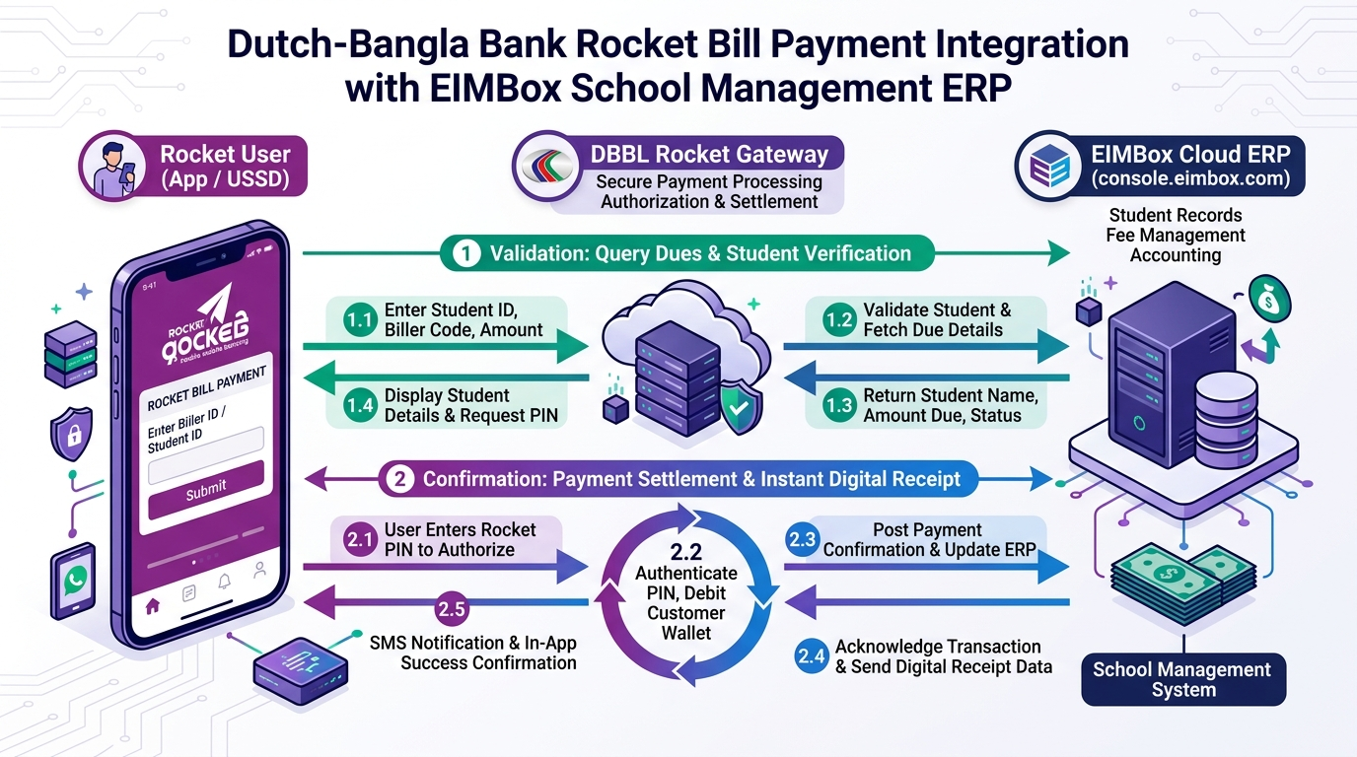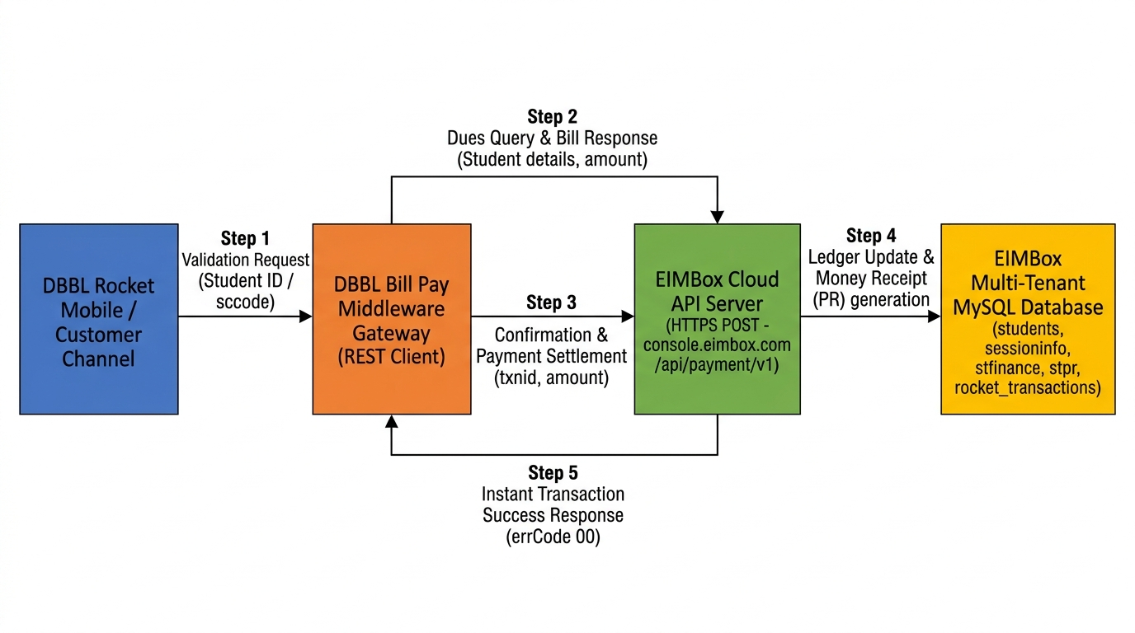
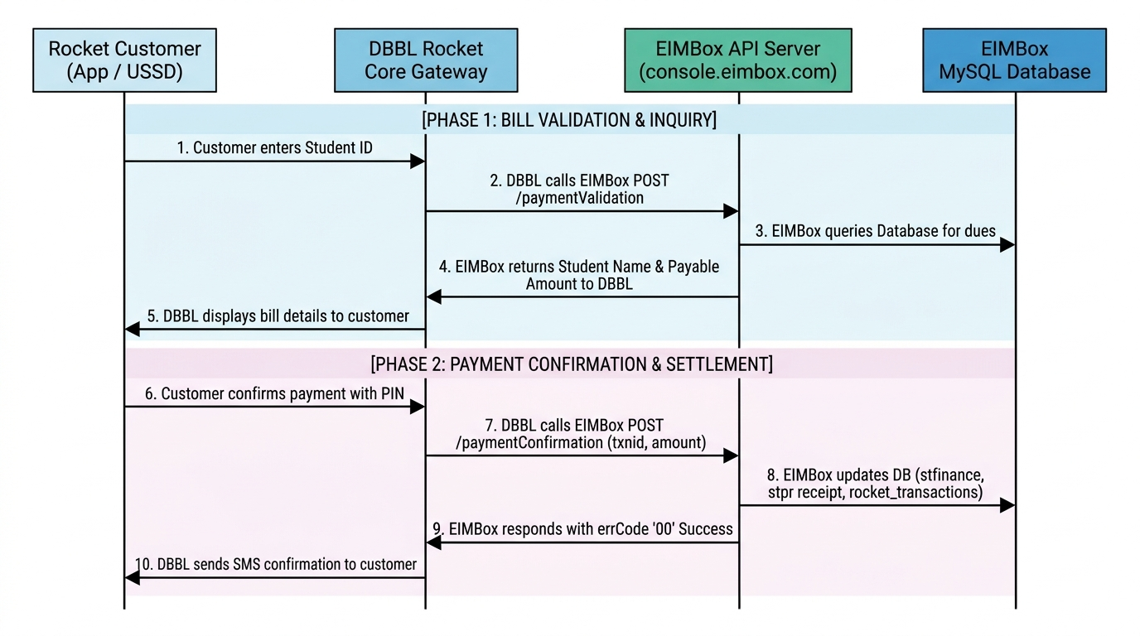
┌──────────────┐ ┌──────────────────────┐ ┌──────────────────┐
│ │ 1. Validation │ │ Query Dues │ │
│ Rocket User │────────────────▶│ Rocket Gateway │────────────────▶│ EIMBox Server │
│ (App / USSD) │◀────────────────│ (DBBL Server) │◀────────────────│ (console. │
│ │ Shows Amount │ │ Name + Dues │ eimbox.com) │
│ │ │ │ │ │
│ │ 2. Pay Bill │ │ Post Txn │ │
│ │────────────────▶│ │────────────────▶│ Settle stfinance │
│ │ Success SMS │ │◀────────────────│ Generate Receipt │
│ │◀────────────────│ │ Confirmed (00) │ │
└──────────────┘ └──────────────────────┘ └──────────────────┘

2. Security & Authentication
Communication between DBBL Rocket and EIMBox must be over TLS 1.2+ (HTTPS).

2.1 HTTP Basic Authentication Header
Every HTTP request must include the Authorization header containing the Base64-encoded credentials:
Authorization: Basic <base64_encode(User_ID:Password)>
Content-Type: application/json; charset=UTF-8

2.2 Payload Credentials
As mandated by the DBBL specification, requests also transmit user credentials directly in the JSON body:
- usrid / userid: Biller User ID
- pswrd / password: Biller Password

2.3 Authentication Models Supported:
- Global Aggregator Model (Default): All requests authenticated against central DBBL Biller partner credentials (Rocket / Rocket123).
- Multi-Tenant / Per-Institute Model: For institutions holding independent Biller IDs with DBBL, the gateway checks the payment_gateway_keys table matching biller_id, api_key, and secret_key against the specific sccode.

3. Reference Parameters Convention
DBBL Rocket provides 3 reference fields (refNo1, refNo2, refNo3). EIMBox handles standard flexible mapping:
Parameter | Data Type | Requirement | Description | Accepted Formats
refNo1 | Alpha-Numeric (25) | Mandatory | Primary Student Identifier | • sccode-stid (e.g. 1001-10502)  • Student ID only (e.g. 10502)
refNo2 | Alpha-Numeric (25) | Optional | Institution Code (sccode) | If refNo1 contains only Student ID, refNo2 specifies the school code (e.g. 1001).
refNo3 | Alpha-Numeric (25) | Optional | Academic Session Year | Academic Year (e.g. 2026). Defaults to active academic year if left blank.

4. API Endpoints Specification

4.1 Validation API (/paymentValidation)
Validates student existence, queries real-time dues from stfinance, and returns the student name and exact amount payable.
- Endpoint URL: https://console.eimbox.com/api/payment/v1/paymentValidation
- HTTP Method: POST
- Type: Amount Provided from Partner API (DBBL Doc Section 4.2.b)

Request Fields:
Parameter | Type | Required | Description
usrid | String | Yes | Biller User ID
pswrd | String | Yes | Biller Password
refNo1 | String | Yes | Student Reference (e.g. 1001-10502)
refNo2 | String | No | Institution Code (sccode) if not in refNo1
refNo3 | String | No | Session Year (e.g. 2026)

Sample Request:
{
"usrid": "Rocket",
"pswrd": "Rocket123",
"refNo1": "1001-10502",
"refNo2": "",
"refNo3": "2026"
}

Response Fields:
Parameter | Type | Description
errCode | String | 00 on success; error code on failure
errMsg | String | Status description message
customerName | String | Student Full Name (from students.stnameeng)
optionalInfo1 | String | Student Class and Section (from sessioninfo)
optionalInfo2 | String | Student Roll Number and Academic Session
optionalInfo3 | String | Institution Code / Biller Info
amount | String | Total calculated unpaid dues

Sample Success Response (200 OK):
{
"errCode": "00",
"errMsg": "Successful",
"customerName": "RAKIBUL HASAN",
"optionalInfo1": "Class: Nine (A)",
"optionalInfo2": "Roll: 05 | Year: 2026",
"optionalInfo3": "Institute SC: 1001",
"amount": "1500"
}

Sample Error Response (200 OK):
{
"errCode": "01",
"errMsg": "Student Not Found for given ID and Institution"
}

4.2 Confirmation API (/paymentConfirmation)
Dispatched by DBBL Rocket immediately after the user confirms payment. Settles student finance ledgers, generates receipt record (stpr), and logs audit entry.
- Endpoint URL: https://console.eimbox.com/api/payment/v1/paymentConfirmation
- HTTP Method: POST
- DBBL Doc Reference: Section 4.1.b & 4.2.c

Request Fields:
Parameter | Type | Required | Description
userid | String | Yes | Biller User ID
password | String | Yes | Biller Password
txnid | String (15-60) | Yes | DBBL Rocket Unique Transaction ID
txndate | String (25) | No | Transaction Timestamp (e.g. 11-Sep-2026 04:50:00 AM)
refno1 | String | Yes | Student Reference
refno2 | String | No | School Code / Secondary Reference
refno3 | String | No | Session Year
amount | Numeric | Yes | Paid Amount in BDT

Sample Request:
{
"userid": "Rocket",
"password": "Rocket123",
"txnid": "DBBL202609110001",
"txndate": "11-Sep-2026 04:50:00 AM",
"refno1": "1001-10502",
"refno2": "",
"refno3": "2026",
"amount": "1500"
}

Idempotency & Duplicate Protection:
If Rocket sends a retry with the same txnid, EIMBox verifies existing records in rocket_transactions. If already applied, it does not deduct dues twice; instead, it immediately returns errCode: "00" with Payment Information Updated Successfully.

Sample Success Response (200 OK):
{
"errCode": "00",
"errMsg": "Payment Information Updated Successfully"
}

4.3 Inquiry API (/getPaymentStatus)
Used by the DBBL Rocket automated scheduler to verify transaction settlement status during timeouts or network drops.
- Endpoint URL: https://console.eimbox.com/api/payment/v1/getPaymentStatus
- HTTP Method: POST
- DBBL Doc Reference: Section 4.1.c & 4.2.d

Request Fields:
Parameter | Type | Required | Description
userid | String | Yes | Biller User ID
password | String | Yes | Biller Password
txnid | String | Yes | Transaction ID to inquire
refno1 | String | No | Student Reference

Sample Request:
{
"userid": "Rocket",
"password": "Rocket123",
"txnid": "DBBL202609110001",
"refno1": "1001-10502"
}

Sample Success Response (Transaction Found):
{
"errCode": "00",
"errMsg": "Payment Information Updated Successfully"
}

Sample Error Response (Transaction Not Found):
{
"errCode": "01",
"errMsg": "Transaction Not Found"
}

5. Standard Error Codes Table (DBBL Appendix A)
Error Code | Error Message | Description / Remediation
00 | Successful / Payment Information Updated Successfully | Transaction / operation completed successfully.
01 | Invalid Authentication / Student Not Found | Authentication failed or student record could not be located.
02 | Invalid Host Authentication | Host IP whitelisting validation failed.
05 | Payment Reference Number Missing | refNo1 or sccode parameter was not provided.
06 | User ID Missing | Biller User ID header or body parameter was omitted.
07 | Password Missing | Biller password was omitted.
10 | Couldn't find the request body | HTTP POST body payload is empty.
11 | Not a valid JSON in request body | Malformed JSON payload syntax.
12 | IP Not Allowed | Origin IP is not permitted.
99 | Unable to process / Invalid Parameters | Database error, invalid amount, or unhandled exception.

6. Integration Testing & Verification

6.1 Testing with cURL

Validation Test:
curl -i -X POST "https://console.eimbox.com/api/payment/v1/paymentValidation" \
-H "Content-Type: application/json" \
-u "Rocket:Rocket123" \
-d '{
"usrid": "Rocket",
"pswrd": "Rocket123",
"refNo1": "1001-10502",
"refNo3": "2026"
}'

Confirmation Test:
curl -i -X POST "https://console.eimbox.com/api/payment/v1/paymentConfirmation" \
-H "Content-Type: application/json" \
-u "Rocket:Rocket123" \
-d '{
"userid": "Rocket",
"password": "Rocket123",
"txnid": "TEST_TXN_001",
"txndate": "11-Sep-2026 05:00:00 AM",
"refno1": "1001-10502",
"amount": "1500"
}'

Inquiry Test:
curl -i -X POST "https://console.eimbox.com/api/payment/v1/getPaymentStatus" \
-H "Content-Type: application/json" \
-u "Rocket:Rocket123" \
-d '{
"userid": "Rocket",
"password": "Rocket123",
"txnid": "TEST_TXN_001"
}'

6.2 Testing with PowerShell
$headers = @{
"Content-Type" = "application/json"
"Authorization" = "Basic " + [Convert]::ToBase64String([Text.Encoding]::ASCII.GetBytes("Rocket:Rocket123"))
}

# 1. Validation
$valBody = @{
usrid = "Rocket"
pswrd = "Rocket123"
refNo1 = "1001-10502"
refNo3 = "2026"
} | ConvertTo-Json

$valRes = Invoke-RestMethod -Uri "https://console.eimbox.com/api/payment/v1/paymentValidation" -Method Post -Headers $headers -Body $valBody
$valRes | ConvertTo-Json

# 2. Confirmation
$confBody = @{
userid = "Rocket"
password = "Rocket123"
txnid = "DBBL_" + (Get-Random -Minimum 100000 -Maximum 999999)
txndate = (Get-Date).ToString("dd-MMM-yyyy hh:mm:ss tt")
refno1 = "1001-10502"
amount = $valRes.amount
} | ConvertTo-Json

$confRes = Invoke-RestMethod -Uri "https://console.eimbox.com/api/payment/v1/paymentConfirmation" -Method Post -Headers $headers -Body $confBody
$confRes | ConvertTo-Json

7. Audit & Troubleshooting Logs
All transaction exchanges are recorded in:
- Log File: /api/payment/v1/logs/rocket-YYYY-MM-DD.log
- Audit Database Table: rocket_transactions
- Voucher Ledger: stpr
- Student Finance Ledger: stfinance
For technical support or sandbox whitelisting, contact the EIMBox Engineering Team at support@eimbox.com.

