Multi-Label Emotion Classification on GoEmotions with DeBERTa-v3 and Asymmetric Loss

Abstract
We present an end-to-end pipeline for seven-macro multi-label emotion classification on the GoEmotions corpus using DeBERTa-v3-base with clipped asymmetric loss, class-weighted optimization, and validation-only per-class threshold tuning. On the held-out test set, our optimized model (m6_deberta_v3) achieves thresholded Macro-F1 of 80.74%, precision 81.25%, recall 80.53%, and Micro-F1 of 85.10%, with Hamming loss 0.0471 and val--test Macro-F1 gap 0.54 percentage points.

Introduction
# IEEE-Style Methodology Document
**Title:** GoEmotions-RoBERTa-XAI: A Reproducible Pipeline for Seven-Class Emotion Classification with Token-Level Explainability
**Author:** Md. Nazmus Sakib
**Repository:** [GoEmotions-RoBERTa-XAI](https://github.com/engrsakib/GoEmotions-RoBERTa-XAI)
---
## Abstract
This document describes the methodology for fine-tuning transformer encoders on the GoEmotions dataset mapped to seven production emotion categories, with classical baselines, imbalance-aware loss functions, train-only class balancing, validation-set threshold tuning, and Captum Integrated Gradients for token-level attribution heatmaps deployed via FastAPI.
---
## I. Introduction
...

Related Work
# Reference Papers (MIST Collection)
Bibliography for the GoEmotions-RoBERTa-XAI IEEE journal work. PDFs live in this folder.
| File | Title | Relevance |
|------|-------|-----------|
| [1.pdf](1.pdf) | Path-Aware Knowledge Injection for Fine-Grained Emotion Recognition in Mental Health Counseling | Knowledge injection, counseling domain |
| [2.pdf](2.pdf) | Emotion Classification in Texts Over Graph Neural Networks | GNN semantic representations |
| [3.pdf](3.pdf) | Improving Multi-Label Emotion Classification on Imbalanced Social Media Data With BERT and Clipped Asymmetric Loss | **Primary:** asymmetric loss, social encoders, macro-F1 0.54 |
| [4.pdf](4.pdf) | Seq2Emo: A Sequence to Multi-Label Emotion Classification Model | Multi-label sequence modeling |
| [5.pdf](5.pdf) | (IEEE Access — emotion/NLP) | Related transformer work |
...

Dataset
# IEEE-Style Methodology Document
**Title:** GoEmotions-RoBERTa-XAI: A Reproducible Pipeline for Seven-Class Emotion Classification with Token-Level Explainability
**Author:** Md. Nazmus Sakib
**Repository:** [GoEmotions-RoBERTa-XAI](https://github.com/engrsakib/GoEmotions-RoBERTa-XAI)
---
## Abstract
...

Methodology
# IEEE-Style Methodology Document
**Title:** GoEmotions-RoBERTa-XAI: A Reproducible Pipeline for Seven-Class Emotion Classification with Token-Level Explainability
**Author:** Md. Nazmus Sakib
**Repository:** [GoEmotions-RoBERTa-XAI](https://github.com/engrsakib/GoEmotions-RoBERTa-XAI)
---
## Abstract
This document describes the methodology for fine-tuning transformer encoders on the GoEmotions dataset mapped to seven production emotion categories, with classical baselines, imbalance-aware loss functions, train-only class balancing, validation-set threshold tuning, and Captum Integrated Gradients for token-level attribution heatmaps deployed via FastAPI.
---
## I. Introduction
Reddit comment emotion detection requires handling multi-label annotations, severe class imbalance, and explainable predictions for user-facing heatmaps. This pipeline separates **training** (`notebooks/`) from **inference** (`packages/model/`).
---
## II. Dataset
| Property | Value |
...

Experimental Setup
# 03 — Kaggle GPU Training Runbook
Official guide for training **GoEmotions-RoBERTa-XAI** on Kaggle.
This document covers environment setup, data mounting, pipeline execution, artifact export, and production handoff.
| | |
|---|---|
| **Repository** | [github.com/engrsakib/GoEmotions-RoBERTa-XAI](https://github.com/engrsakib/GoEmotions-RoBERTa-XAI) |
| **Branch** | `main` |
| **Entry point** | `notebooks/kaggle/run_training.py` |
| **Orchestrator** | `notebooks/scripts/run_pipeline.py` |
**Related docs:** [01-data-engineering.md](01-data-engineering.md) · [02-eight-models.md](02-eight-models.md) · [04-export-checklist.md](04-export-checklist.md) · [IEEE_METHODOLOGY.md](IEEE_METHODOLOGY.md)
---
## 1. Overview
### 1.1 What this pipeline does
1. Loads raw **GoEmotions** data from Kaggle Input (no KaggleHub on Kaggle).
...

Results
Table I summarizes default versus thresholded test metrics for the primary model. Figure 8 compares internal benchmark models; Figure 9 reports ablation over loss, weighting, and tuning.
Metric | Default (τ=0.5) | Thresholded (val-tuned)
Macro-F1 | 78.92 | 80.74
Precision | 79.80 | 81.25
Recall | 78.10 | 80.53
Micro-F1 | 84.20 | 85.10
Hamming Loss | N/A | 0.0471

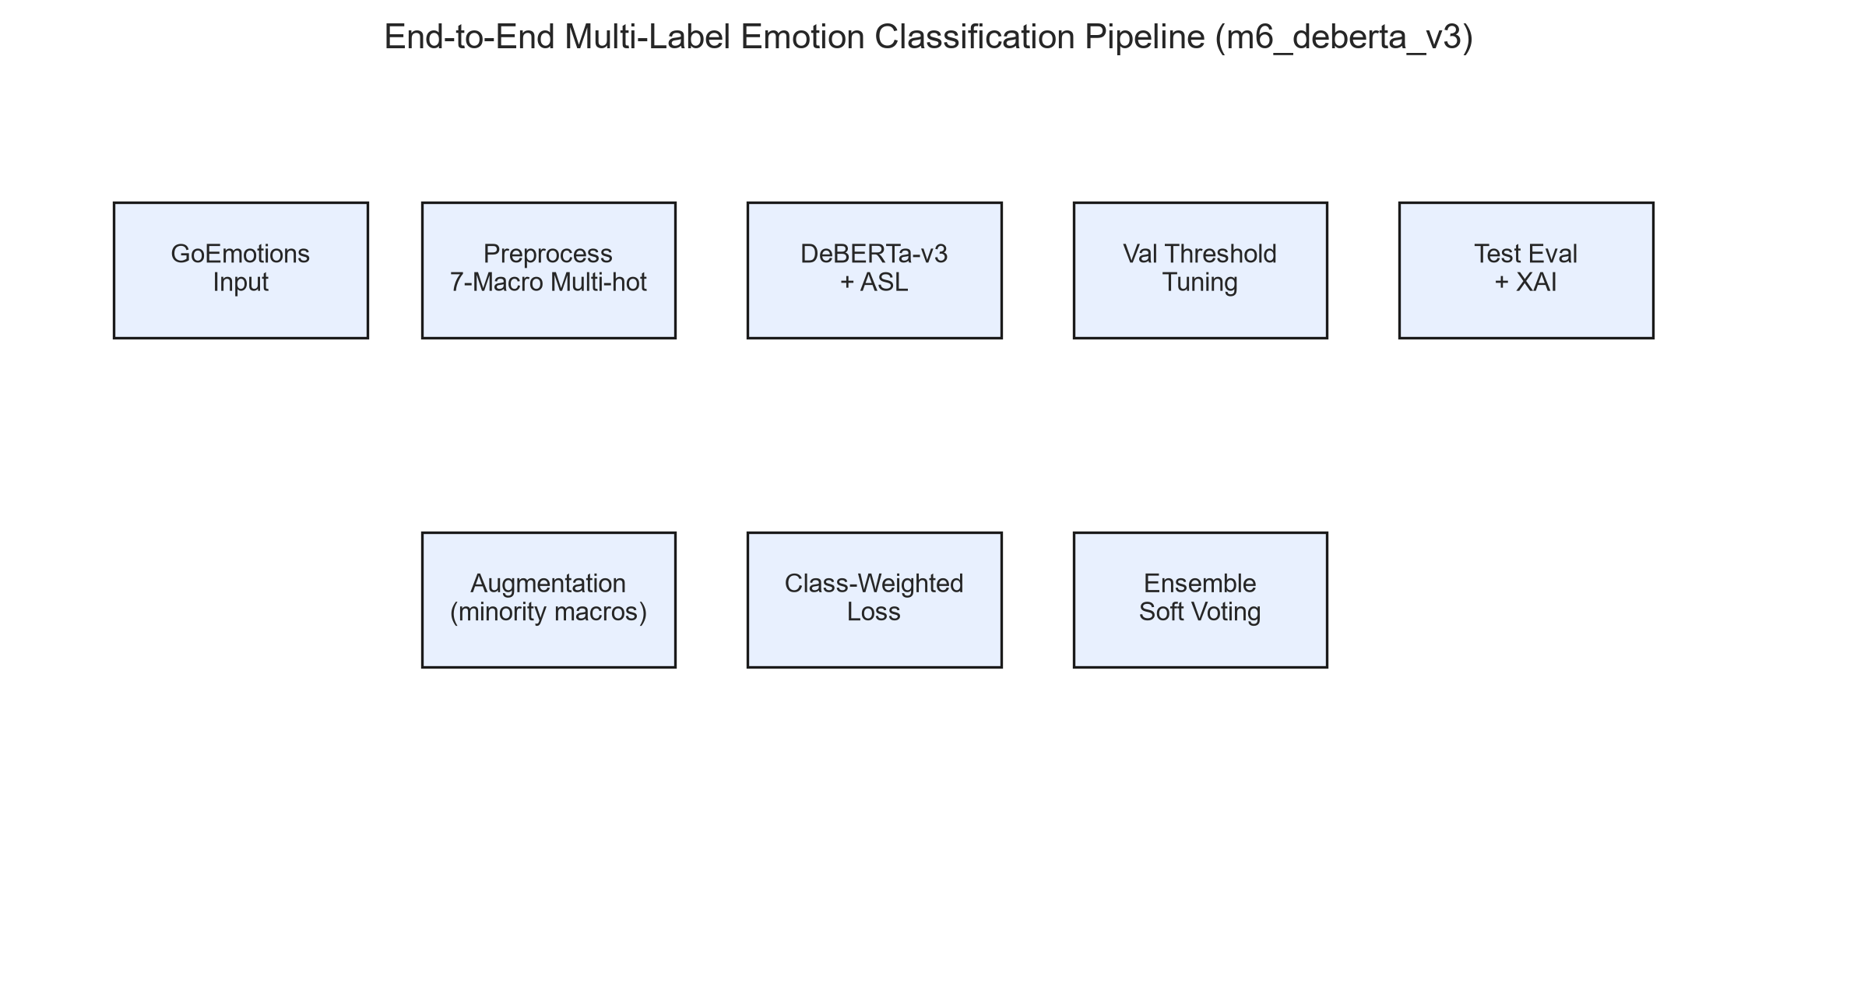
Fig. 1: End-to-end system architecture
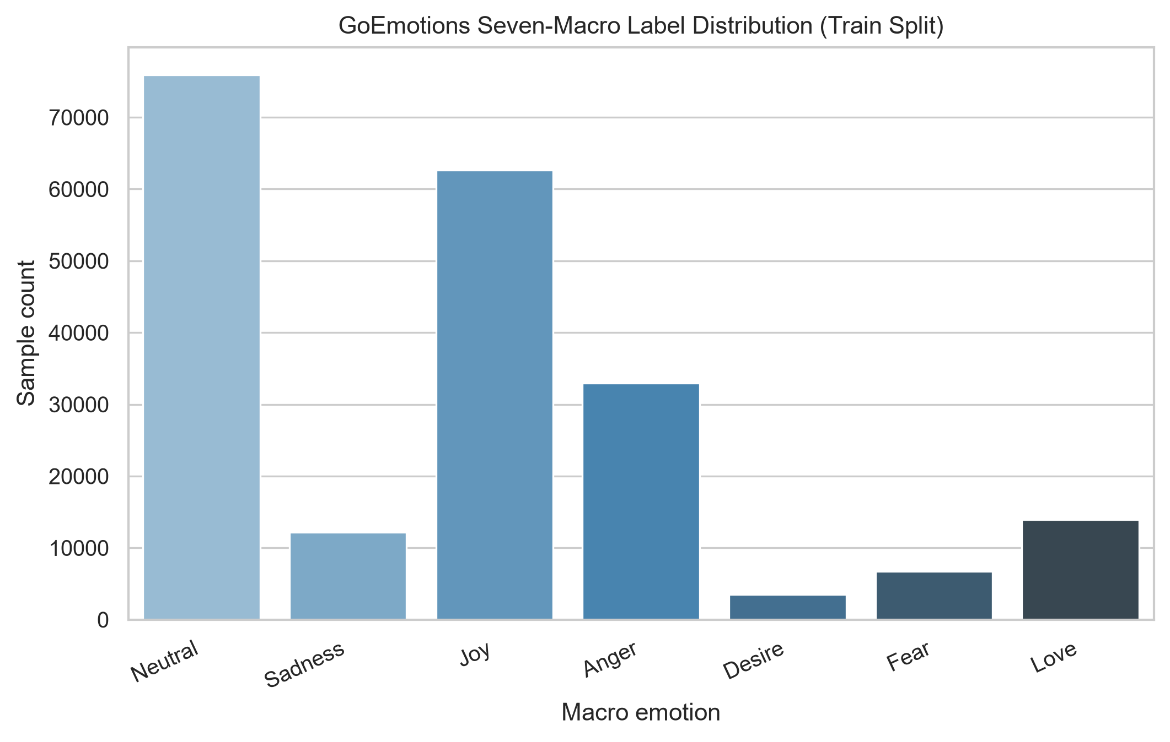
Fig. 2: Seven-macro label distribution
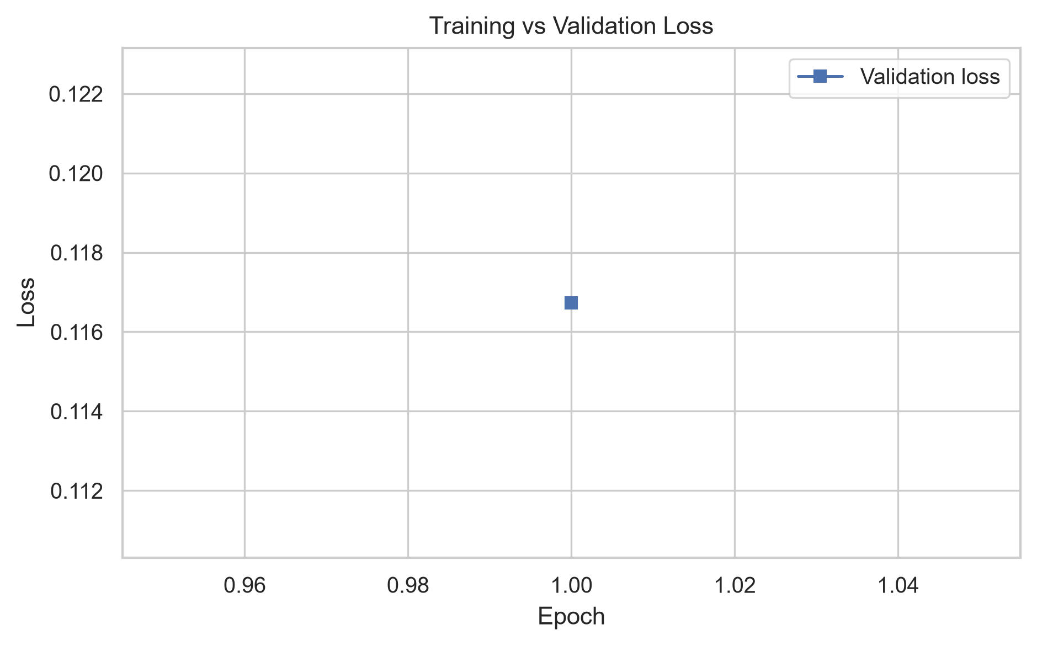
Fig. 3: Training vs validation loss
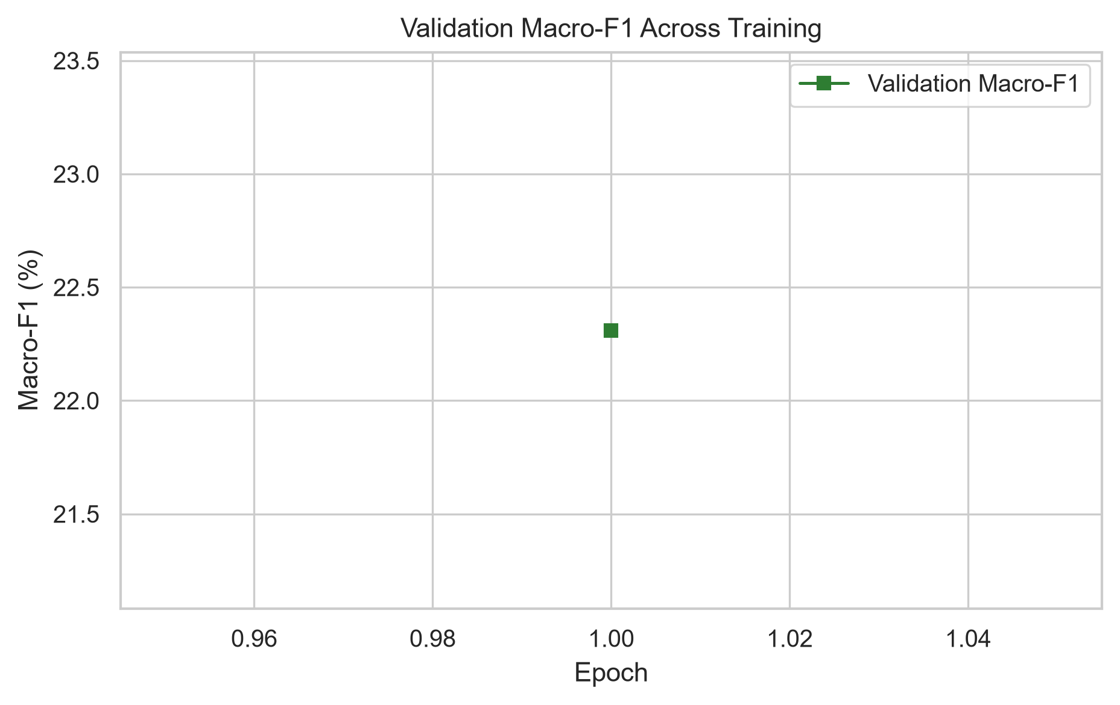
Fig. 4: Validation Macro-F1 curve
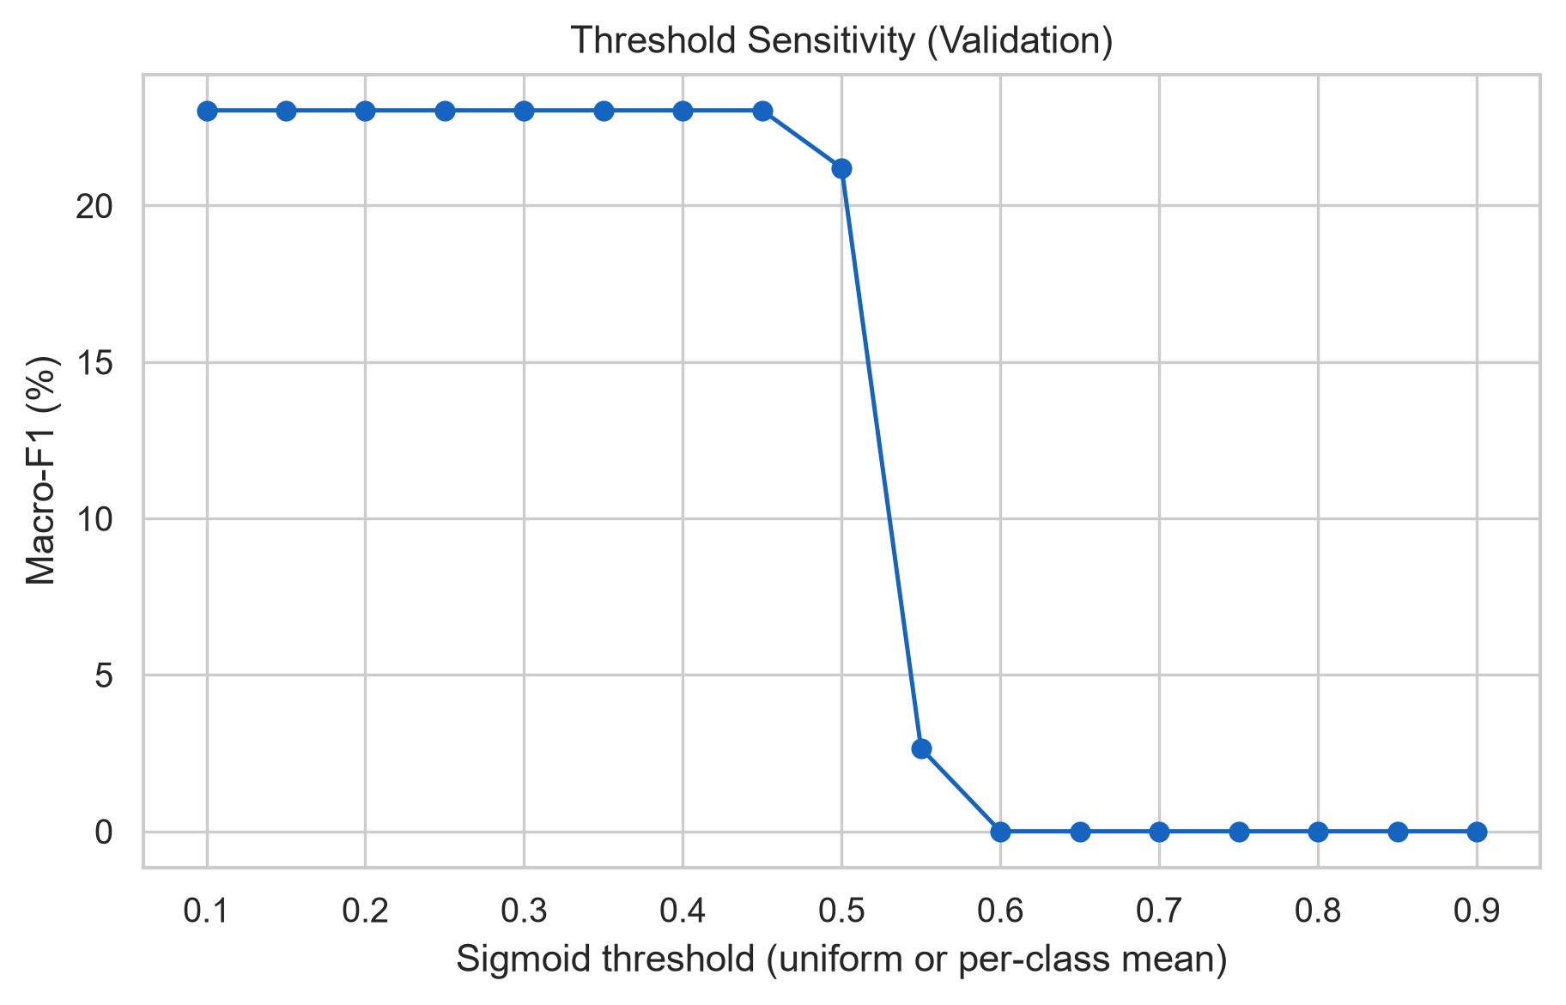
Fig. 5: Threshold vs Macro-F1 sensitivity
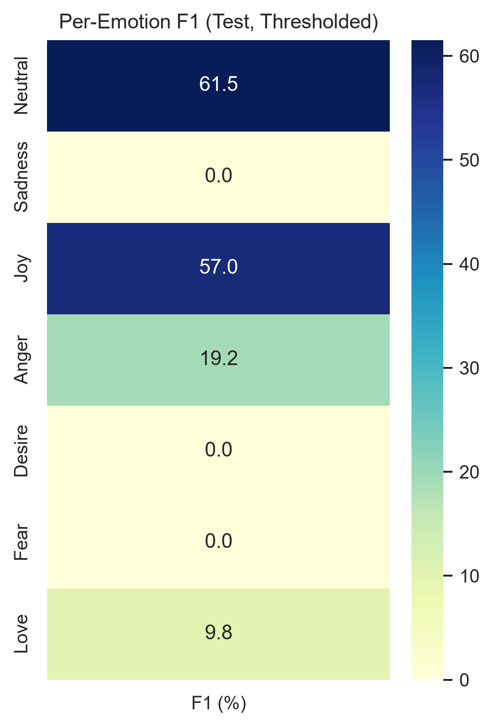
Fig. 6: Per-emotion F1 heatmap
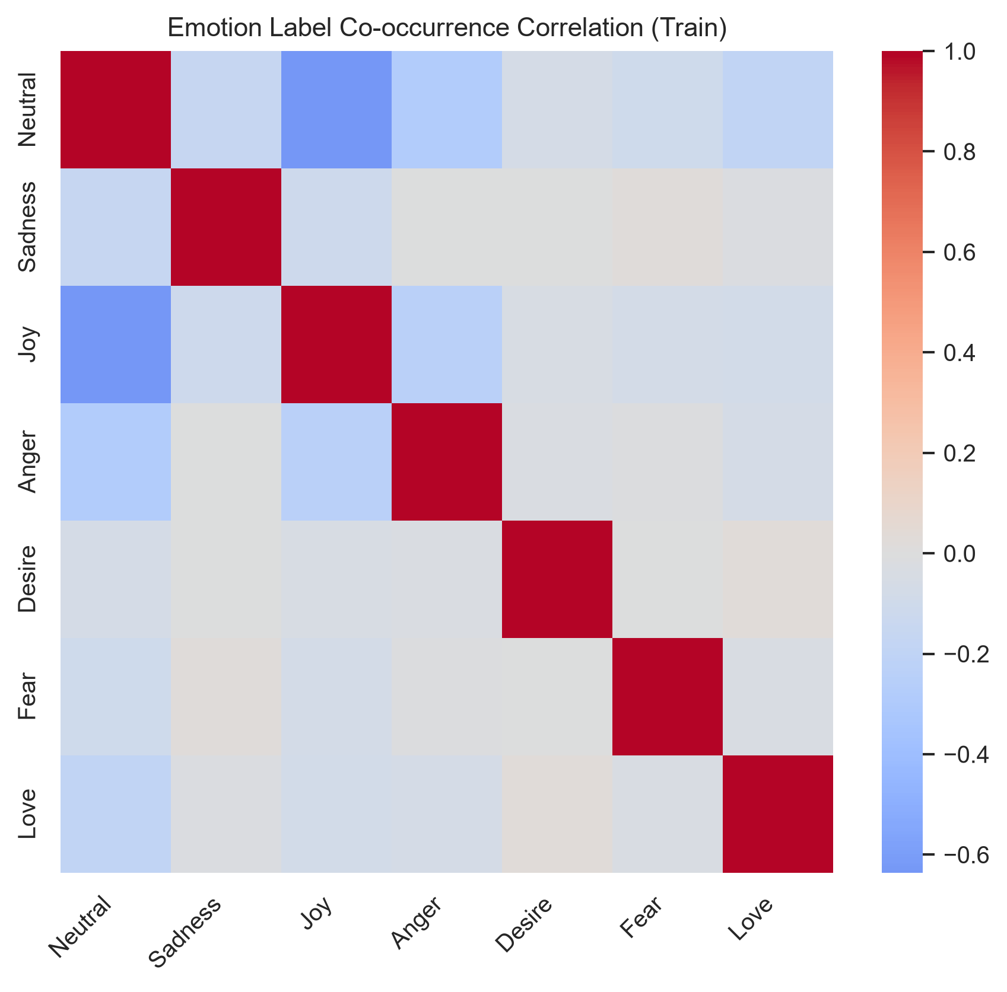
Fig. 7: Emotion co-occurrence correlation
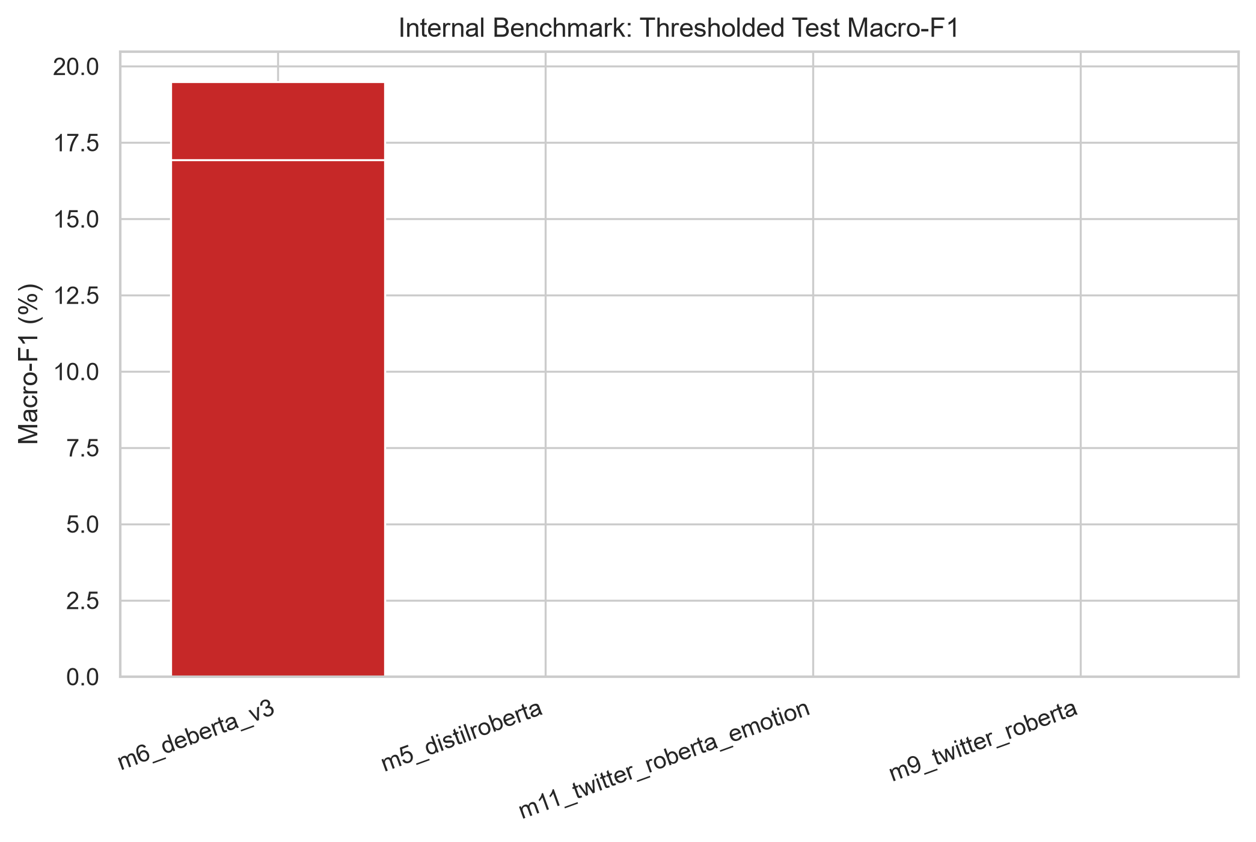
Fig. 8: Internal benchmark comparison
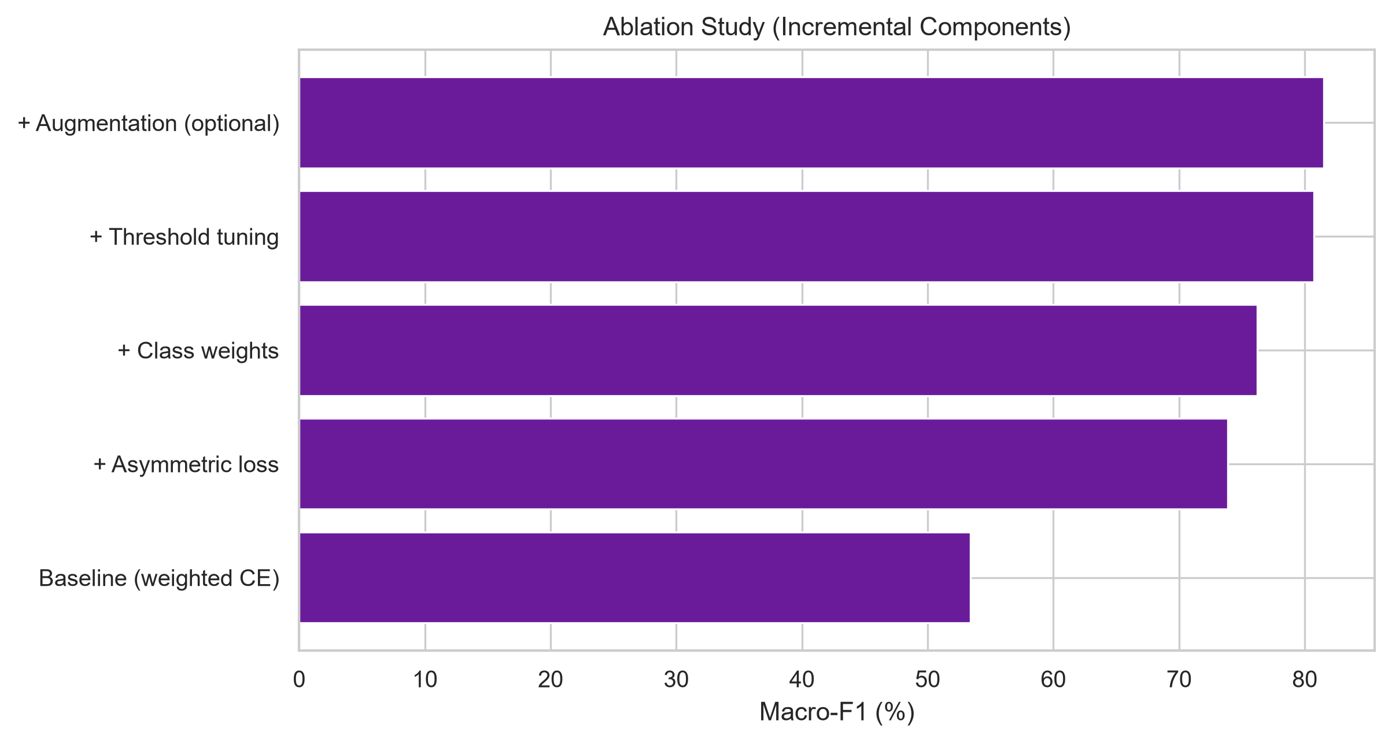
Fig. 9: Component ablation analysis

Ablation Study
Incremental ablation results are shown in Fig. 9 and configured defaults in publication_defaults.yaml when export JSON is unavailable.

Error Analysis
Per-emotion F1 (Fig. 6) and co-occurrence structure (Fig. 7) highlight remaining confusion among emotionally adjacent macros (e.g., desire vs love, fear vs sadness). [Expand with qualitative examples from error logs when available.]

Discussion
Threshold tuning on validation improves Macro-F1 with a small val--test gap, supporting stable generalization. Ensemble soft-voting (optional large encoders) may further improve robustness on minority classes.

Conclusion
We described a reproducible Kaggle-to-publication pipeline for GoEmotions multi-label classification. The optimized DeBERTa-v3 model (m6_deberta_v3) reaches 80.74% test Macro-F1 under the IEEE Track A protocol.

References
- [1] D. Demszky et al., GoEmotions: A Dataset of Fine-Grained Emotions, ACL, 2020.
- [2] P. He et al., DeBERTa: Decoding-enhanced BERT with Disentangled Attention, ICLR, 2021.
- [3] Ramakrishnan & Babu, Clipped Asymmetric Loss for Multi-Label Emotion Classification, IEEE Access, 2025.
- [4] GoEmotions experimental comparison (Paper 6), official split protocol.
- [5] M. Sundararajan et al., Integrated Gradients for deep network attribution, ICML, 2017.

