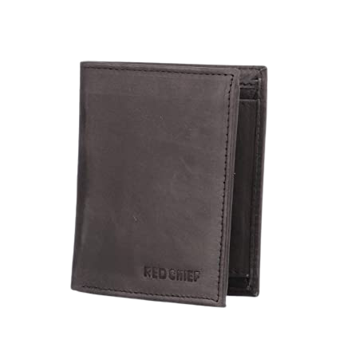

PRODUCT NAME : SATIN DOLCE

PRODUCT CODE : DG0001

PRICE : **180000/-**

AFTER DISCOUNTED PRICES

**RS: 126000/-**