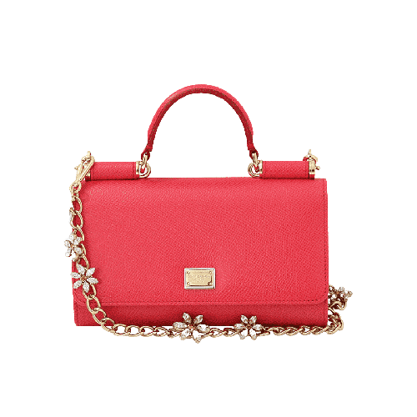

PRODUCT NAME : JACQUARD

PRODUCT CODE : DG0002

PRICE : **150000/-**

AFTER DISCOUNTED PRICES

**RS: 105000/-**