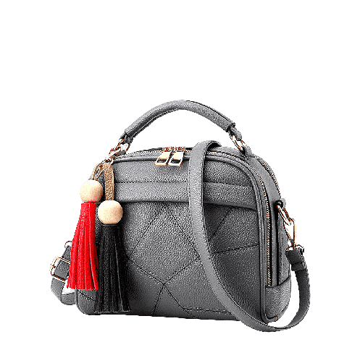

PRODUCT NAME : BROCADE

PRODUCT CODE : DG0003

PRICE : **160000/-**

AFTER DISCOUNTED PRICES

**RS: 112000/-**