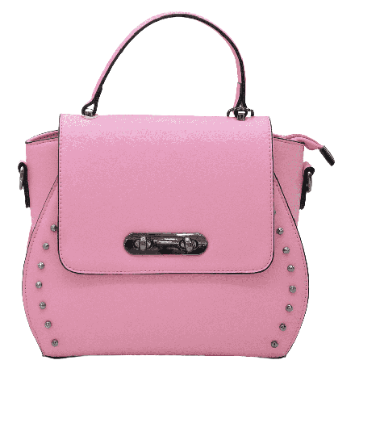

PRODUCT NAME : REOIN

PRODUCT CODE : DG0004

PRICE **: 170000/-**

AFTER DISCOUNTED PRICES

**RS: 119000/-**