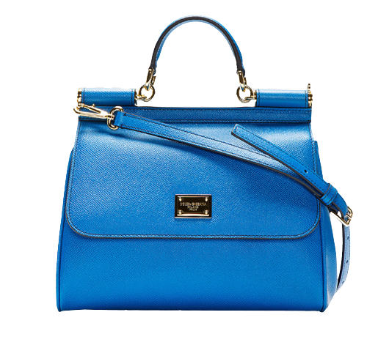

PRODUCT NAME : DEVOTION

PRODUCT CODE : DG0005

PRICE : **180000/-**

AFTER DISCOUNTED PRICES

**RS: 126000/-**