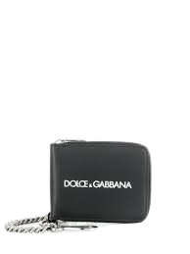

PRODUCT NAME : ALGA

PRODUCT CODE : DG0006

PRICE : **200000/-**

AFTER DISCOUNTED PRICES

**RS: 140000/-**