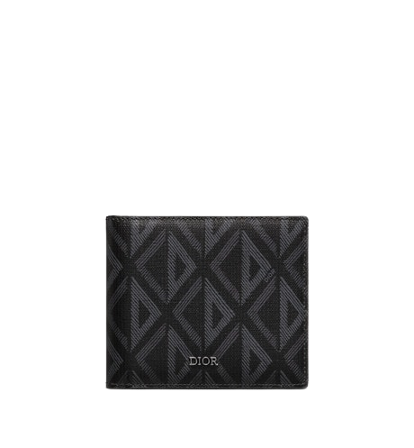

PRODUCT NAME : OBLIQUE

PRODUCT CODE : DI0006

PRICE : **130000/-**

AFTER DISCOUNTED PRICES

**RS:14000/-**