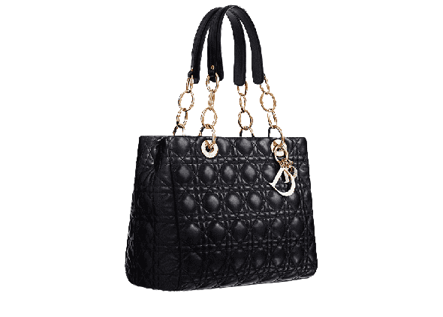

PRODUCT NAME : D-BEE TOTE

PRODUCT CODE : DI0002

PRICE : **80000/-**

AFTER DISCOUNTED PRICES

**RS:56000/-**