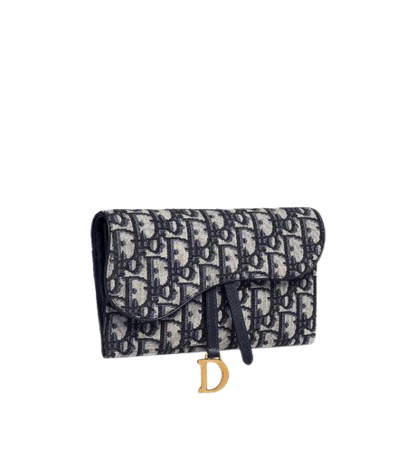

PRODUCT NAME : J’ADIOR

PRODUCT CODE : DI0003

PRICE : **100000/-**

AFTER DISCOUNTED PRICES

**RS:70000/-**