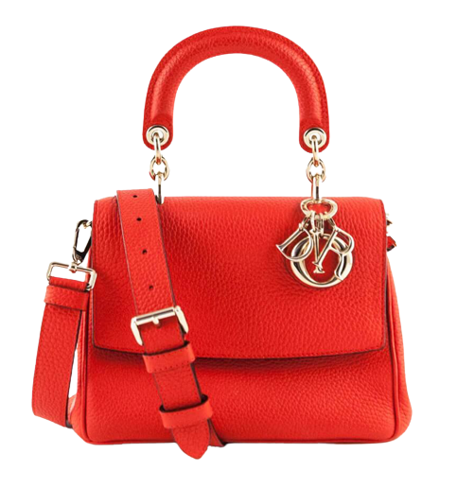

PRODUCT NAME : DIOR 21

PRODUCT CODE : DI0004

PRICE : **140000/-**

AFTER DISCOUNTED PRICES

**RS:98000/-**