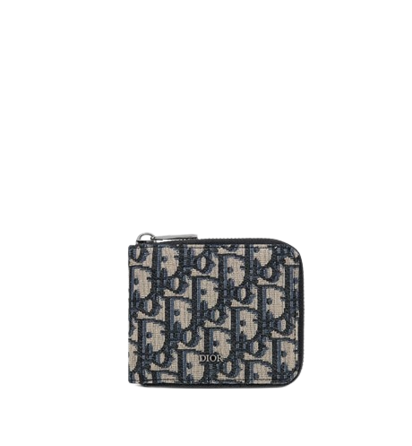

PRODUCT NAME : DIOREVER

PRODUCT CODE : DI0005

PRICE : **170000/-**

AFTER DISCOUNTED PRICES

**RS:119000/-**