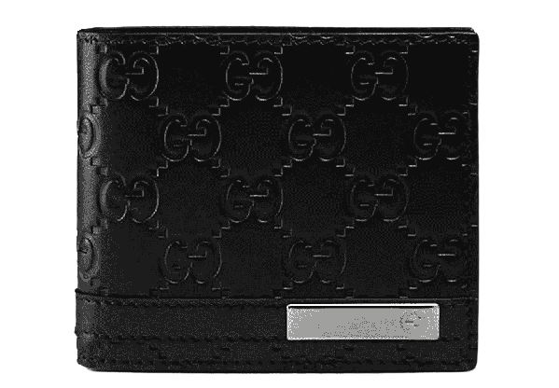

PRODUCT NAME : CANVAS

PRODUCT CODE : GU0001

PRICE : **150000/-**

AFTER DISCOUNTED PRICES

**RS:112500/-**