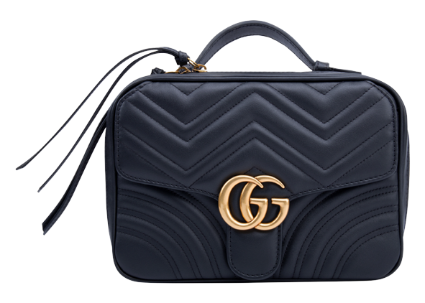

PRODUCT NAME : BANBOU

PRODUCT CODE : GU0002

PRICE : **190000/-**

AFTER DISCOUNTED PRICES

**RS:142500/-**