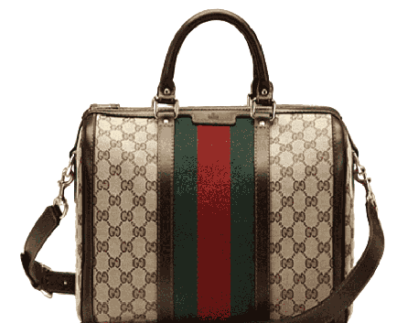

PRODUCT NAME : JACKIE

PRODUCT CODE : GU0004

PRICE : **100000/-**

AFTER DISCOUNTED PRICES

**RS:75000/-**