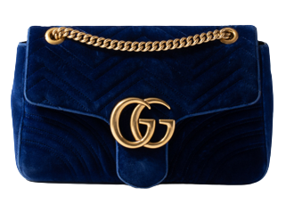

PRODUCT NAME : GUCCISSIUM

PRODUCT CODE : GU0005

PRICE : **180000/-**

AFTER DISCOUNTED PRICES

**RS:135000/-**