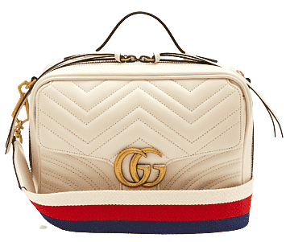

PRODUCT NAME : SOHO DIOCO

PRODUCT CODE : GU0006

PRICE : **70000/-**

AFTER DISCOUNTED PRICES

**RS:52500/-**