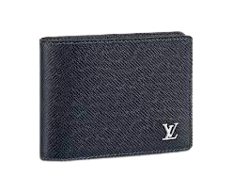

PRODUCT NAME : SAIND CLOUD

PRODUCT CODE : LV0002

PRICE : **120000/-**

AFTER DISCOUNTED PRICES

**RS:90000/-**