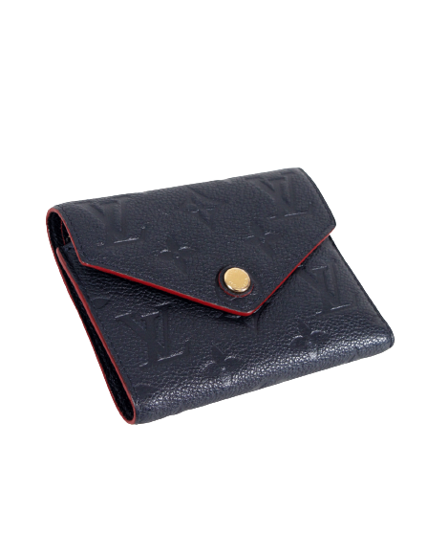

PRODUCT NAME : RIFF

PRODUCT CODE : LV0003

PRICE : **110000/-**

AFTER DISCOUNTED PRICES

**RS:82500/-**