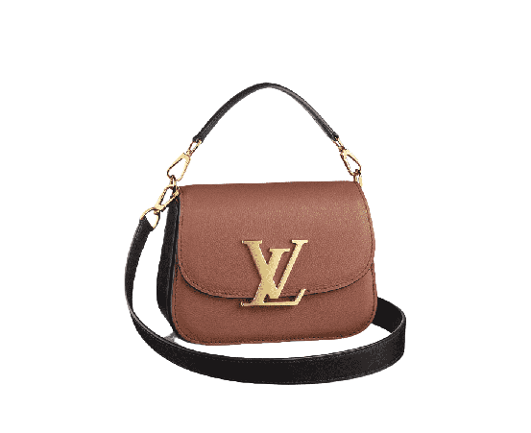

PRODUCT NAME : SAUMER

PRODUCT CODE : LV0004

PRICE : **90000/-**

AFTER DISCOUNTED PRICES

**RS:67500/-**