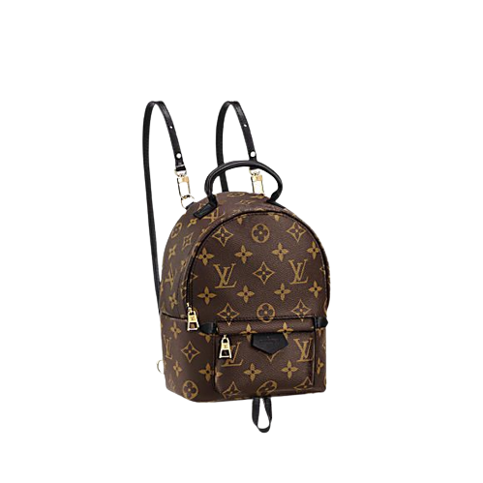

PRODUCT NAME : NILE CROSS

PRODUCT CODE : LV0005

PRICE : **85000/-**

AFTER DISCOUNTED PRICES

**RS:63750/-**