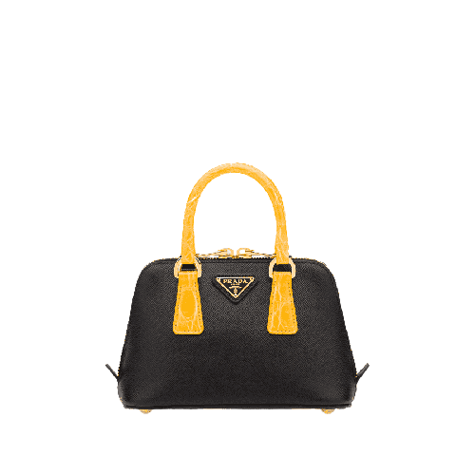

PRODUCT NAME : AFFIANO

PRODUCT CODE : PR0001

PRICE : **100000/-**

AFTER DISCOUNTED PRICES

**RS:80000/-**