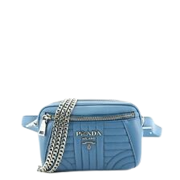

PRODUCT NAME : RAFFIA TOTE

PRODUCT CODE : PR0003

PRICE : **70000/-**

AFTER DISCOUNTED PRICES

**RS:56000/-**