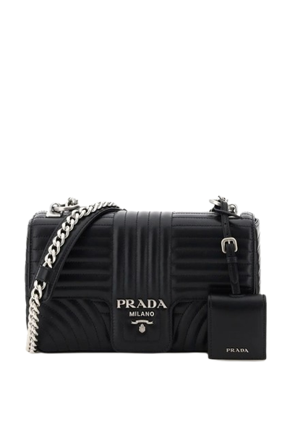

PRODUCT NAME : CLOO

PRODUCT CODE : PR0004

PRICE : **110000/-**

AFTER DISCOUNTED PRICES

**RS:56000**/-