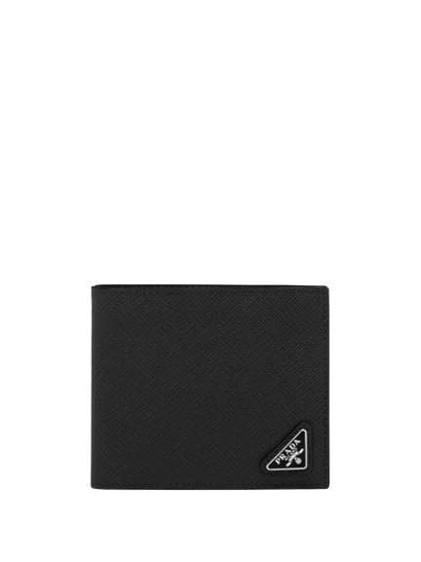

PRODUCT NAME : SYMBOLE

PRODUCT CODE : PR0006

PRICE : **190000/-**

AFTER DISCOUNTED PRICES

**RS:152000/-**