**OUR PRODUCTS ☺**

**PRADA-1**

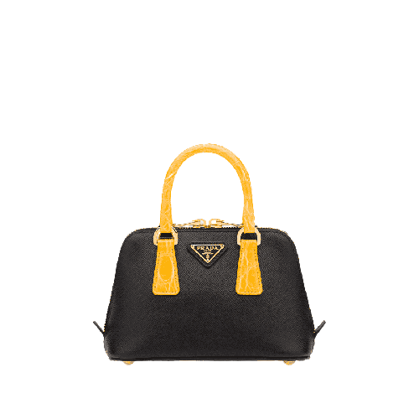

PRODUCT NAME : AFFIANO

PRODUCT CODE : PR0001

PRICE : **100000/-**

AFTER DISCOUNTED PRICES

**RS:80000/-**

**PRADA-2**

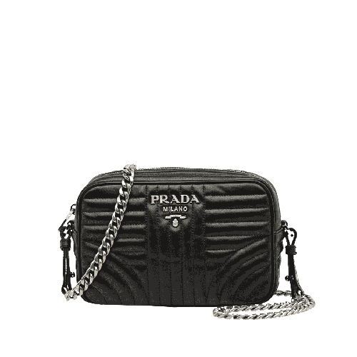

PRODUCT NAME : LANYARD

PRODUCT CODE : PR0002

PRICE : **90000/-**

AFTER DISCOUNTED PRICES

**RS:72000/-**

**PRADA-3**

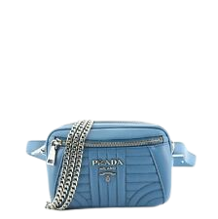

PRODUCT NAME : RAFFIA TOTE

PRODUCT CODE : PR0003

PRICE : **70000/-**

AFTER DISCOUNTED PRICES

**RS:56000/-**

**PRADA-4**

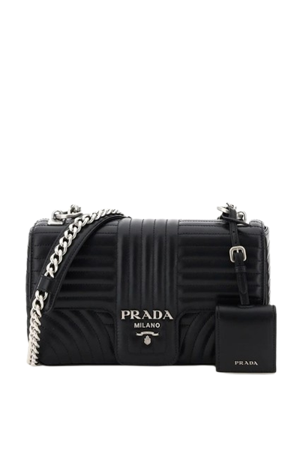

PRODUCT NAME : CLOO

PRODUCT CODE : PR0004

PRICE : **110000/-**

AFTER DISCOUNTED PRICES

**RS:56000**/-

**PRADA-5**

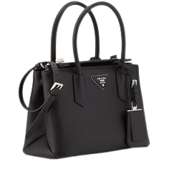

PRODUCT NAME : GALLERIA

PRODUCT CODE : PR0005

PRICE : **170000/-**

AFTER DISCOUNTED PRICES

**RS:136000/-**

**PRADA-6**

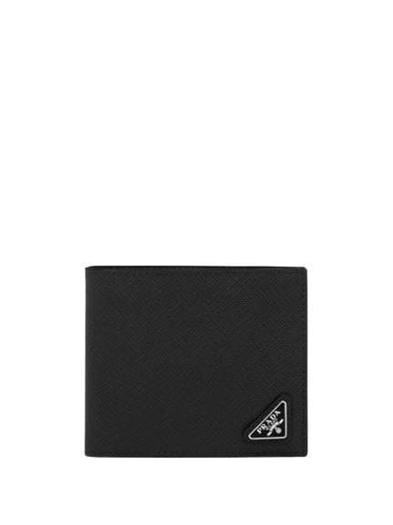

PRODUCT NAME : SYMBOLE

PRODUCT CODE : PR0006

PRICE : **190000/-**

AFTER DISCOUNTED PRICES

**RS:152000/-**

**DOLCE &GABANA-1**

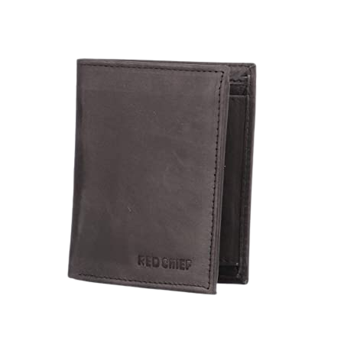

PRODUCT NAME : SATIN DOLCE

PRODUCT CODE : DG0001

PRICE : **180000/-**

AFTER DISCOUNTED PRICES

**RS: 126000/-**

**DOLCE &GABANA-2**

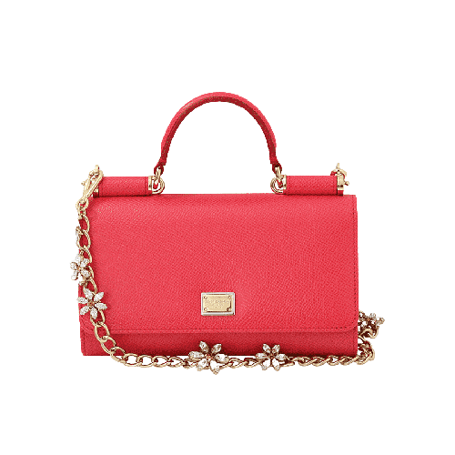

PRODUCT NAME : JACQUARD

PRODUCT CODE : DG0002

PRICE : **150000/-**

AFTER DISCOUNTED PRICES

**RS: 105000/-**

**DOLCE &GABANA-3**

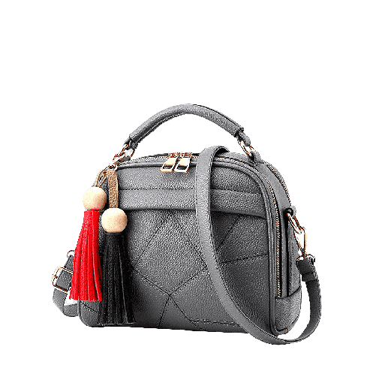

PRODUCT NAME : BROCADE

PRODUCT CODE : DG0003

PRICE : **160000/-**

AFTER DISCOUNTED PRICES

**RS: 112000/-**

**DOLCE &GABANA-4**

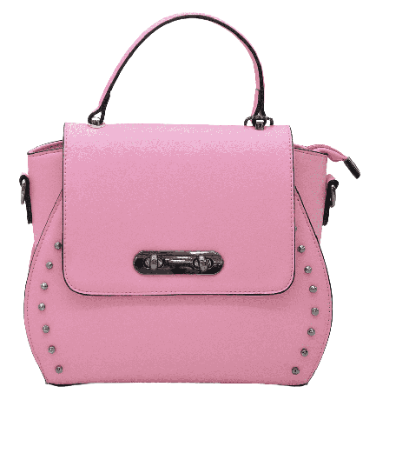

PRODUCT NAME : REOIN

PRODUCT CODE : DG0004

PRICE **: 170000/-**

AFTER DISCOUNTED PRICES

**RS: 119000/-**

**DOLCE &GABANA-5**

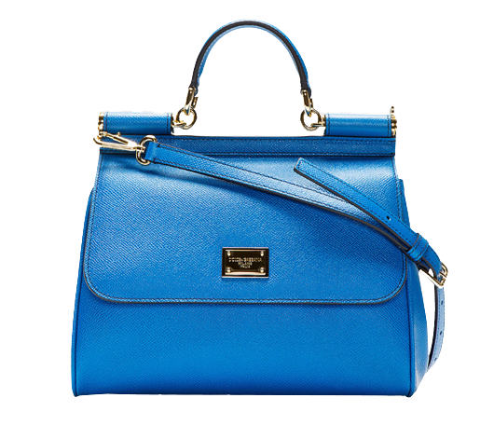

PRODUCT NAME : DEVOTION

PRODUCT CODE : DG0005

PRICE : **180000/-**

AFTER DISCOUNTED PRICES

**RS: 126000/-**

**DOLCE &GABANA-6**

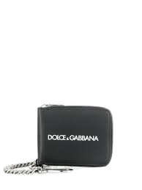

PRODUCT NAME : ALGA

PRODUCT CODE : DG0006

PRICE : **200000/-**

AFTER DISCOUNTED PRICES

**RS: 140000/-**

**LOUIS VUITTON -1**

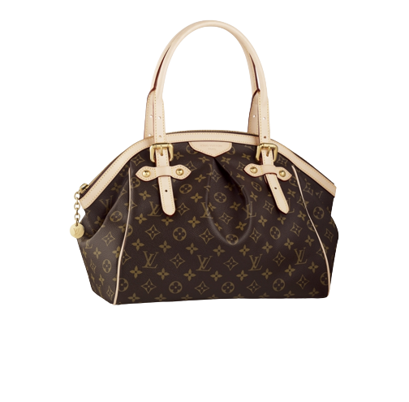

PRODUCT NAME : JAKE MESSENGER

PRODUCT CODE : LV0001

PRICE : **1500000/-**

AFTER DISCOUNTED PRICES

**RS:1125000/-**

**LOUIS VUITTON -2**

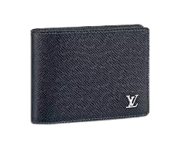

PRODUCT NAME : SAIND CLOUD

PRODUCT CODE : LV0002

PRICE : **120000/-**

AFTER DISCOUNTED PRICES

**RS:90000/-**

**LOUIS VUITTON -3**

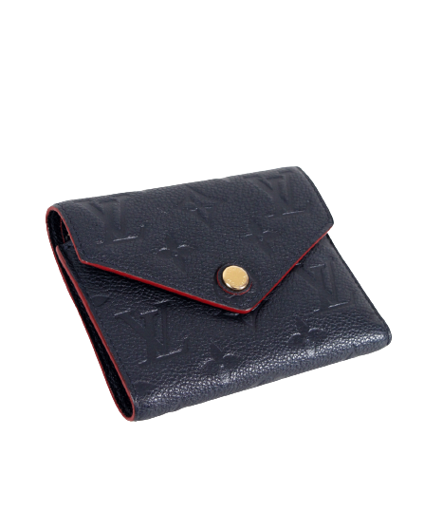

PRODUCT NAME : RIFF

PRODUCT CODE : LV0003

PRICE : **110000/-**

AFTER DISCOUNTED PRICES

**RS:82500/-**

**LOUIS VUITTON -4**

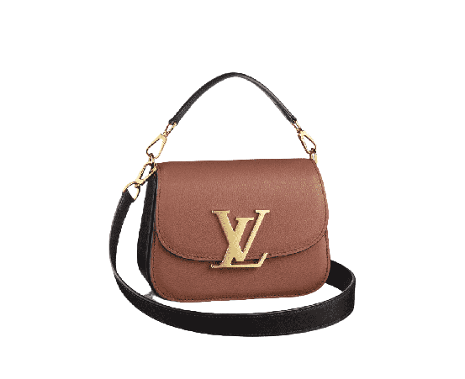

PRODUCT NAME : SAUMER

PRODUCT CODE : LV0004

PRICE : **90000/-**

AFTER DISCOUNTED PRICES

**RS:67500/-**

**LOUIS VUITTON -5**

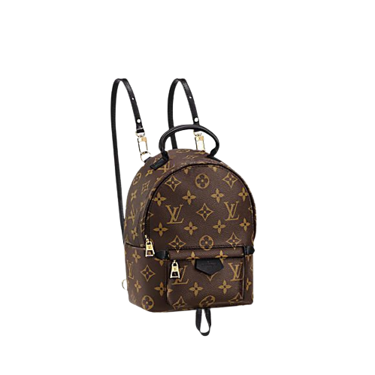

PRODUCT NAME : NILE CROSS

PRODUCT CODE : LV0005

PRICE : **85000/-**

AFTER DISCOUNTED PRICES

**RS:63750/-**

**LOUIS VUITTON -6**

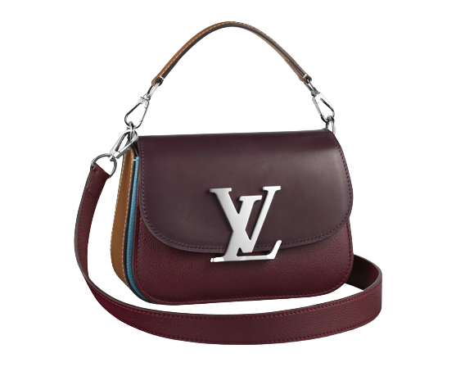

PRODUCT NAME : ODEON

PRODUCT CODE : LV0006

PRICE : **56000/-**

AFTER DISCOUNTED PRICES

**RS:42000/-**

**DIOR-1**

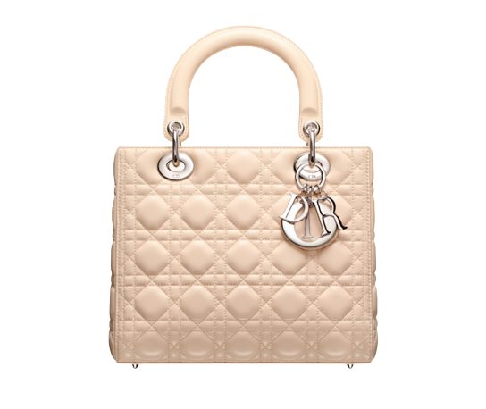

PRODUCT NAME : DIOR PRESUE

PRODUCT CODE : DI0001

PRICE : **20000/-**

AFTER DISCOUNTED PRICES

**RS:14000/-**

**DIOR-2**

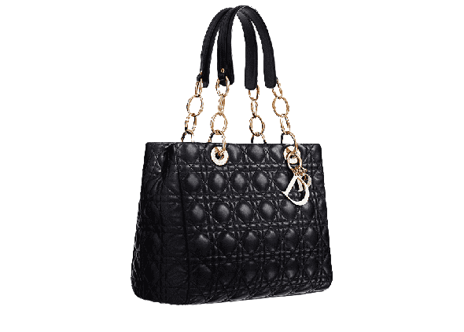

PRODUCT NAME : D-BEE TOTE

PRODUCT CODE : DI0002

PRICE : **80000/-**

AFTER DISCOUNTED PRICES

**RS:56000/-**

**DIOR-3**

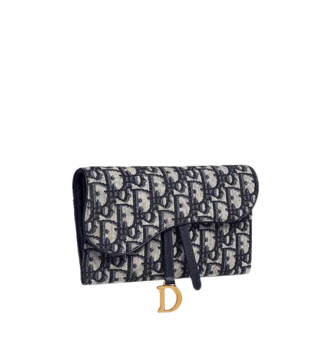

PRODUCT NAME : J’ADIOR

PRODUCT CODE : DI0003

PRICE : **100000/-**

AFTER DISCOUNTED PRICES

**RS:70000/-**

**DIOR-4**

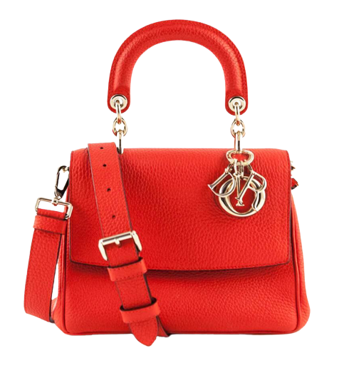

PRODUCT NAME : DIOR 21

PRODUCT CODE : DI0004

PRICE : **140000/-**

AFTER DISCOUNTED PRICES

**RS:98000/-**

**DIOR-5**

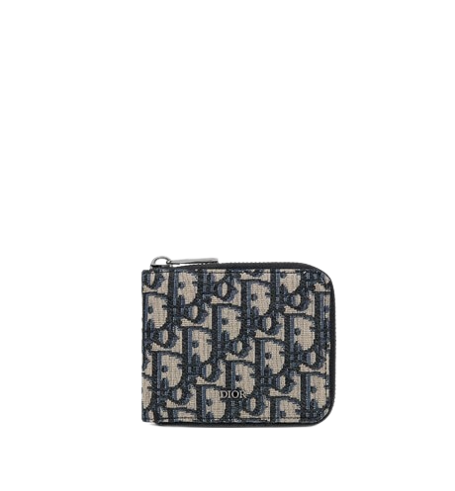

PRODUCT NAME : DIOREVER

PRODUCT CODE : DI0005

PRICE : **170000/-**

AFTER DISCOUNTED PRICES

**RS:119000/-**

**DIOR-6**

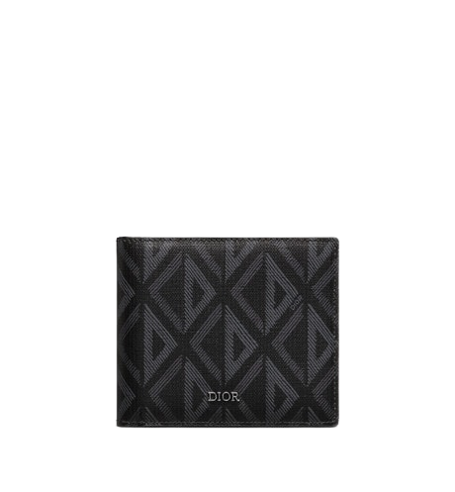

PRODUCT NAME : OBLIQUE

PRODUCT CODE : DI0006

PRICE : **130000/-**

AFTER DISCOUNTED PRICES

**RS:14000/-**

**GUCCI-1**

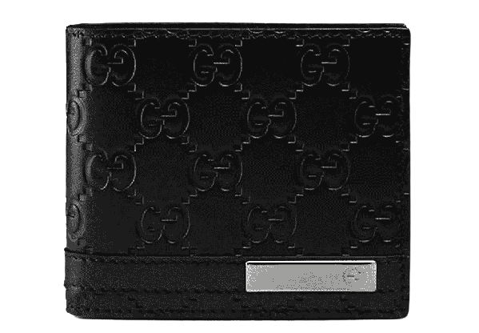

PRODUCT NAME : CANVAS

PRODUCT CODE : GU0001

PRICE : **150000/-**

AFTER DISCOUNTED PRICES

**RS:112500/-**

**GUCCI-2**

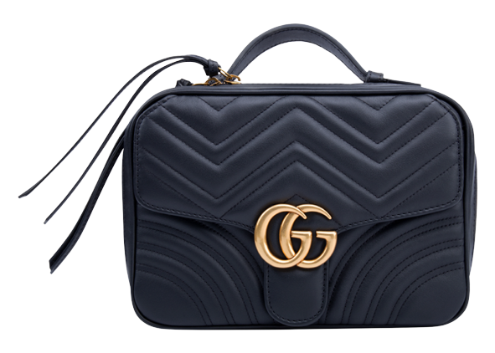

PRODUCT NAME : BANBOU

PRODUCT CODE : GU0002

PRICE : **190000/-**

AFTER DISCOUNTED PRICES

**RS:142500/-**

**GUCCI-3**

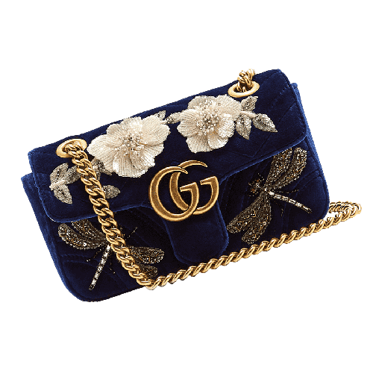

PRODUCT NAME : FLORA

PRODUCT CODE : GU0003

PRICE : **150000/-**

AFTER DISCOUNTED PRICES

**RS:112500/-**

**GUCCI-4**

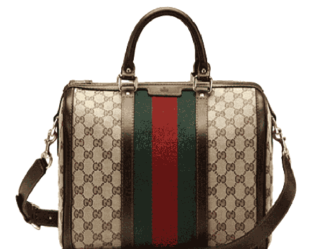

PRODUCT NAME : JACKIE

PRODUCT CODE : GU0004

PRICE : **100000/-**

AFTER DISCOUNTED PRICES

**RS:75000/-**

**GUCCI-5**

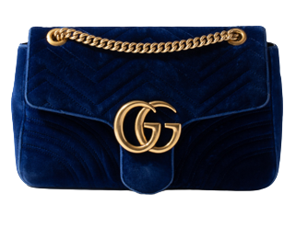

PRODUCT NAME : GUCCISSIUM

PRODUCT CODE : GU0005

PRICE : **180000/-**

AFTER DISCOUNTED PRICES

**RS:135000/-**

**GUCCI-6**

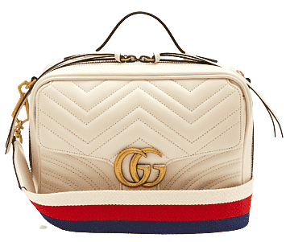

PRODUCT NAME : SOHO DIOCO

PRODUCT CODE : GU0006

PRICE : **70000/-**

AFTER DISCOUNTED PRICES

**RS:52500/-**

**~~THANK YOU~~**