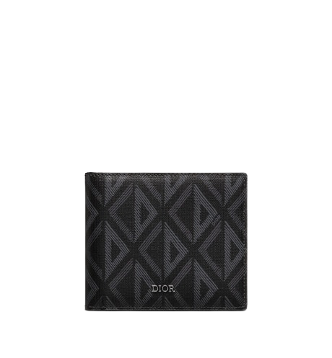

PRODUCT NAME : OBLIQUE

PRODUCT CODE : LV0006

PRICE : **130000/-**

AFTER DISCOUNTED PRICES

**RS:91000/-**