**LECTURE-01 (Saturday 12-April-2025)**

* In November 2015, Google had launched framework “TensorFlow” to provide a powerful, scalable open-source machine learning framework that supports its products and promotes AI innovation globally.
* There are three type of AI applications

1. ANI (Artificial Narrow Intelligence): AI specialized in one task (e.g., voice assistants, image recognition).
2. AGI (Artificial General Intelligence): AI with human-like cognitive abilities across any task.
3. ASI (Artificial Superintelligence) or Singularity: AI that surpasses human intelligence in all aspects. It means machine have more intelligence than human.

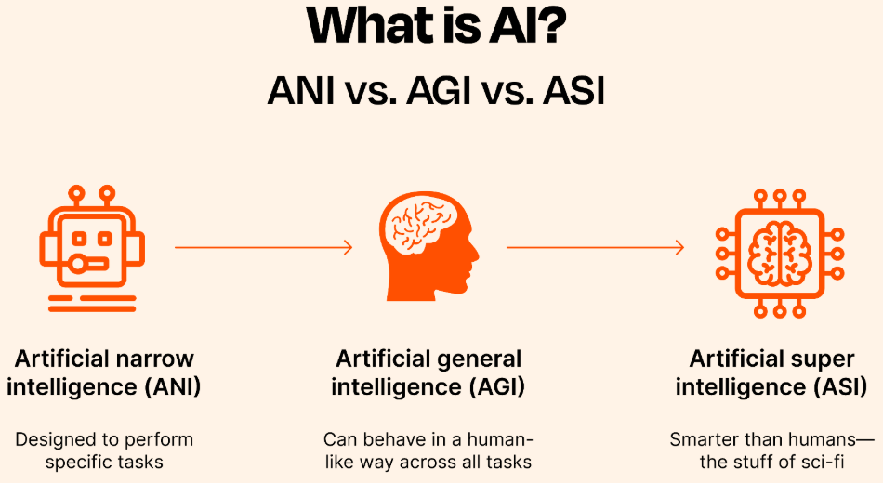

* Till today 12-April-2025, latest version of ChatGPT is “4.5” and its code name is "Orion" which was released on February 27, 2025 by company “OpenAI”.
* Presentation link : <https://docs.google.com/presentation/d/1VNFGsCYMDT1VTe8W1wxFbmAwYsJ1I0Y-6CnTvuCEn98/edit?slide=id.g4dfce81f19_0_45#slide=id.g4dfce81f19_0_45>
* On November 2022, ChatGPT version “3” was launched by company “OpenAI” which had achieved “Level 1” of AGI (Artificial General Intelligence).
* AGI have 5 levels

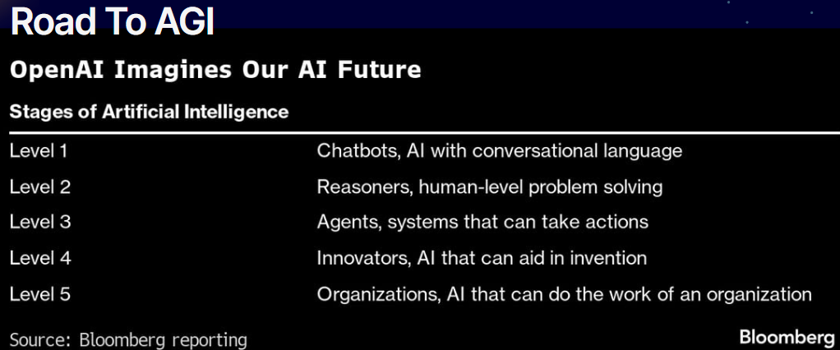

* ChatGPT 3 LLM (Large Language Model) achieved “Level 1” of AGI.
* Current version of ChatGPT LLM achieved “Level 2” of AGI because ChatGPT gives reasons related to its answer. LLM take your query then do research on answer after that provide answer to you.
* ChatGPT LM gives reason in paid version like

Your query?

Reasoned > (by clicking on “>”, it will expand below which contains reason of answer)

Answer.

* We will work on agent creation which is “Level 3” of AGI.
* “Gartner” organization predicted that 2025 is Agentic AI era

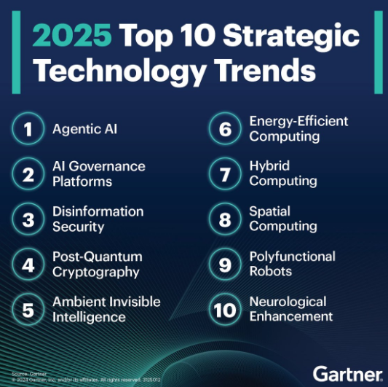

* Agent is considered as human which works autonomously and make decisions.

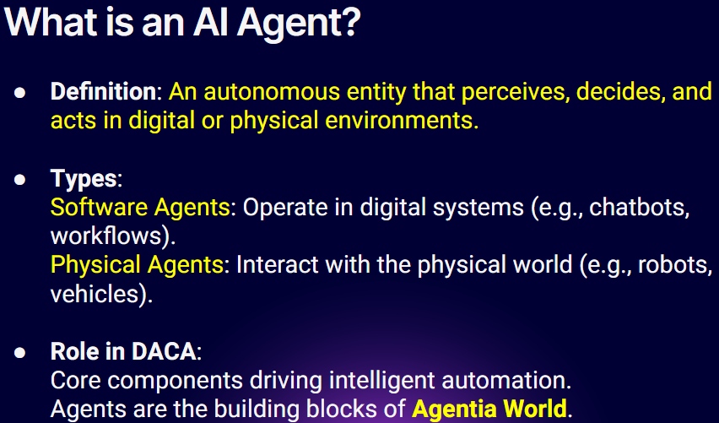

* Examples of Agents : <https://www.figure.ai/>
* ADK (Agent Development Kit) is a framework, released by Google.
* Many technology companies released their frameworks to work on agents.
* We will do NLP (Natural Language Processing/Programming)
* Agentic AI is “Level 3” of AGI.
* A "Unicorn Startup" is a privately held startup company that is valued at $1 billion or more.
* “Airlift” was first unicorn startup in Pakistan.
* In 2022, ChatGPT achieved 1M users in just 5 days.

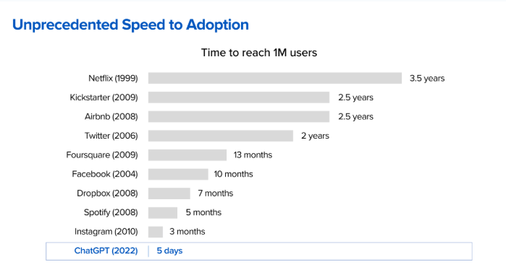

* DACA (Dapr Agentic Cloud Ascent)

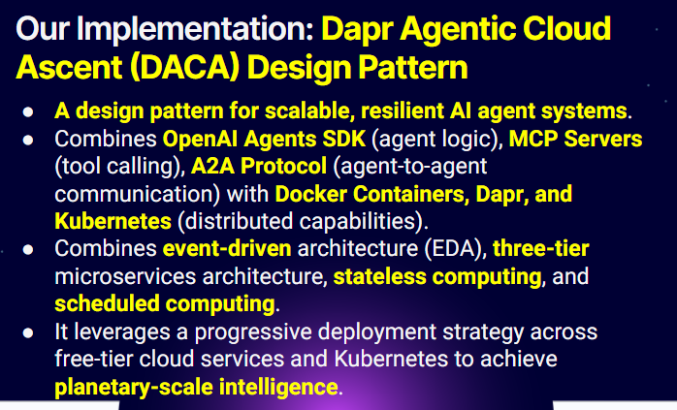

* Prediction

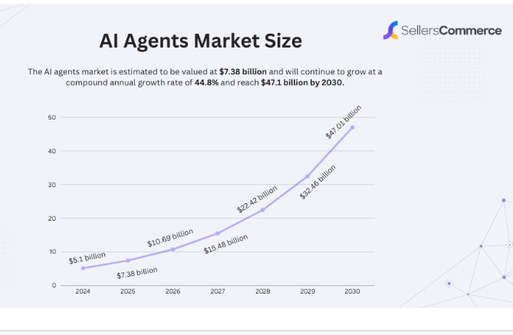

* Agent identify targeted market

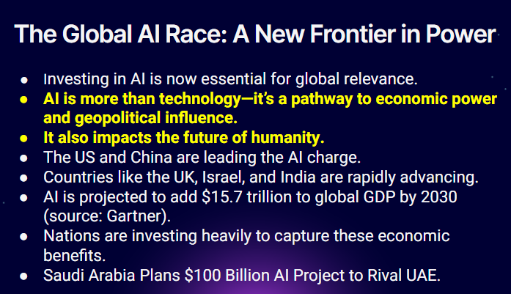

* To use ChatGPT (OpenAI), we have to buy api keys for coding implementation.
* Grok AI (Elon Musk) is greater than ChatGPT.
* To use Grok AI, we have to buy api keys for coding implementation.
* Gemini (Google) provides free api keys. Therefore, we will use Gemini in our course.

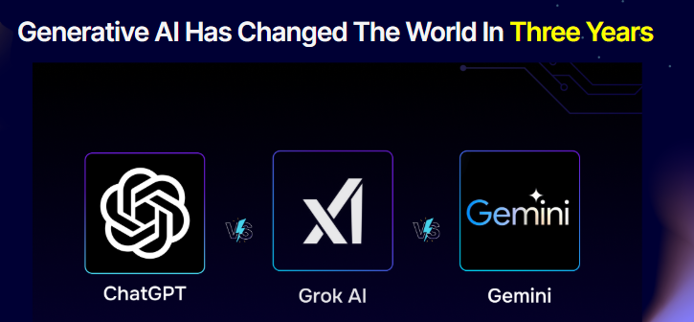

* In April 2025, OpenAI released new models:

1. GPT-4.1
2. o3 and o4-mini

* Arena LLM Leaderboard (<https://lmarena.ai/?leaderboard>) which shows best LLM but ranking changes regularly.

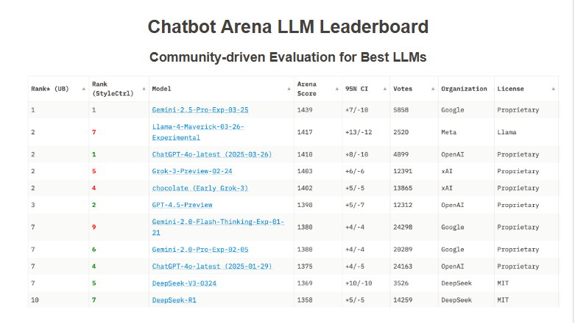

* Three waves of AI

1. Predictive AI in which we train a model then get predicted output from model based on training data.
2. Generative AI in which model create new content from data.
3. Agentic AI in which we provide task and agent will use real world available tools and perform action.

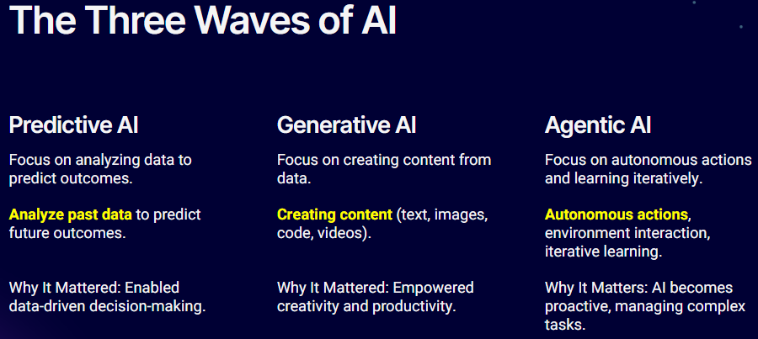

* Agent takes autonomous (without human control) action.

Example 1: Human contact agent then Agent use available tools to give answer to human.

Example 2: Human contact agent then Agent talk to another Agent to give answer to human.

* Google launch “Agent to Agent” (A2A) communication.
* Types of Agents
* Utility – Based Agents (example : bank teller officer)
* Model Based Reflex agents (example : checks ChatGPT output)

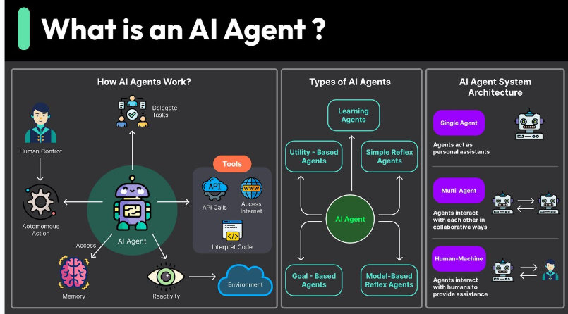

* Many existing applications will be replaced by agents in future
* AI Layer

1. Layer 1: Agentic AI have interface (Agent applications)
2. Layer 2: Open AI Agent SDK (launched in 2025). Langchain is replaced by this SDK and we will use this SDK.
3. Layer 3: we will connect our agent with LLM (Foundation model) which helps decision making
4. Layer 4: our application will be deployed and run at Cloud Computing server (e.g. AWS)
5. Layer 5: Semiconductors (hardware)

* GPU is advanced version of CPU.
* GPU is created by NVIDIA
* GPU performs parallel processing means distribute task while CPU performs sequential processing means dependent tasks.
* Latest laptop have both CPU and GPU.
* “Blackwell” GPU is latest by NVIDIA.
* Semiconductor (commodity) layer required high investment.

We can use agentic orchestration layer but requires high investment.

We will work on application layer (Layer 1).

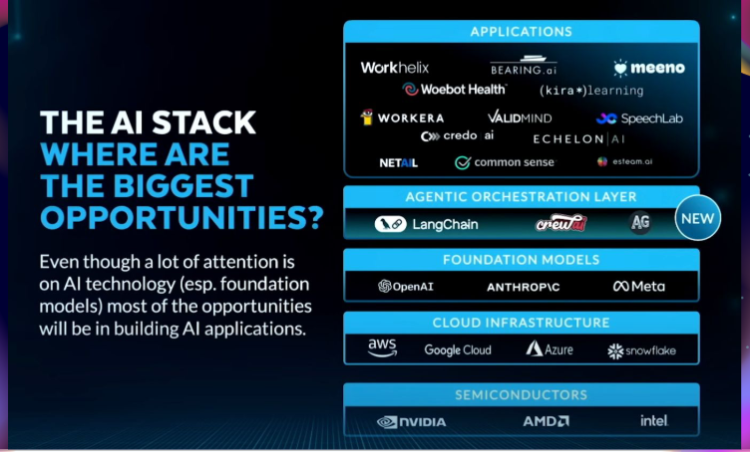

* Python is the top programming language because of AI.
* Javascript is the top programming language of Web.
* LifeCycle or Step of AI model

Step 1 “Training”: In this step, we trained model with data and model stores important features from object.

Step 2 “Inference”: In this step, we ask model to think, reason and share response.

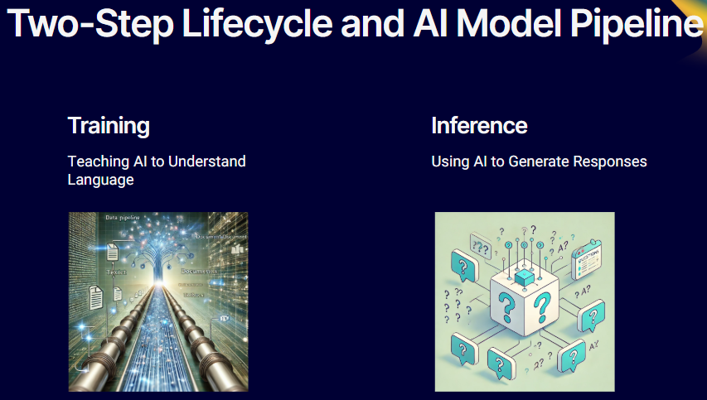

* Training

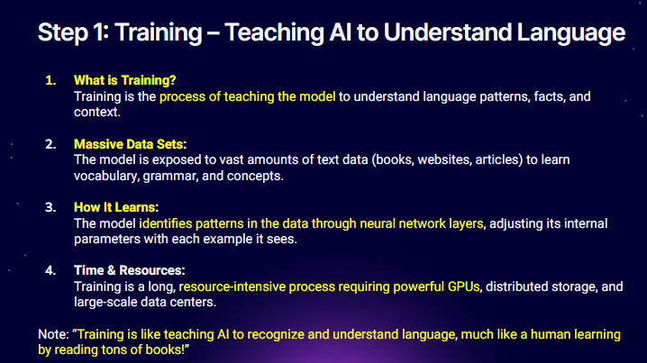

* Inference

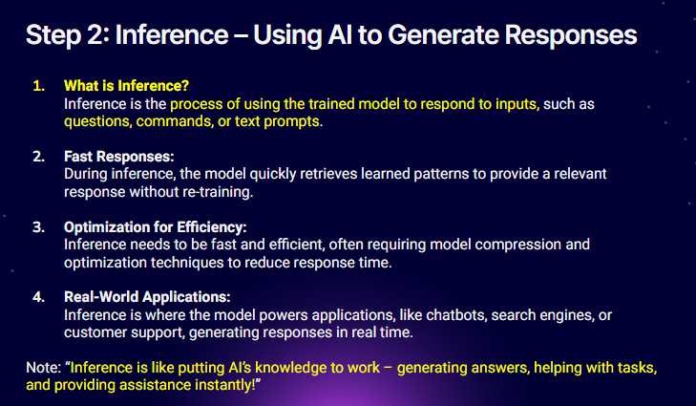

* Due to analysis increased in “o1” model then response time of model is high due to reasoning.

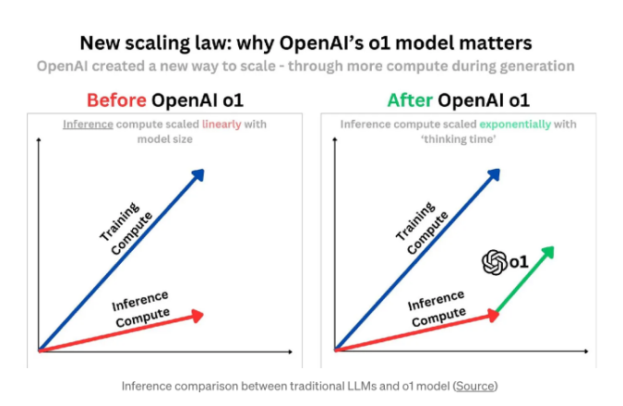

* Coding in Google Colab

1. Open link: <https://colab.research.google.com/>
2. Open new notebook

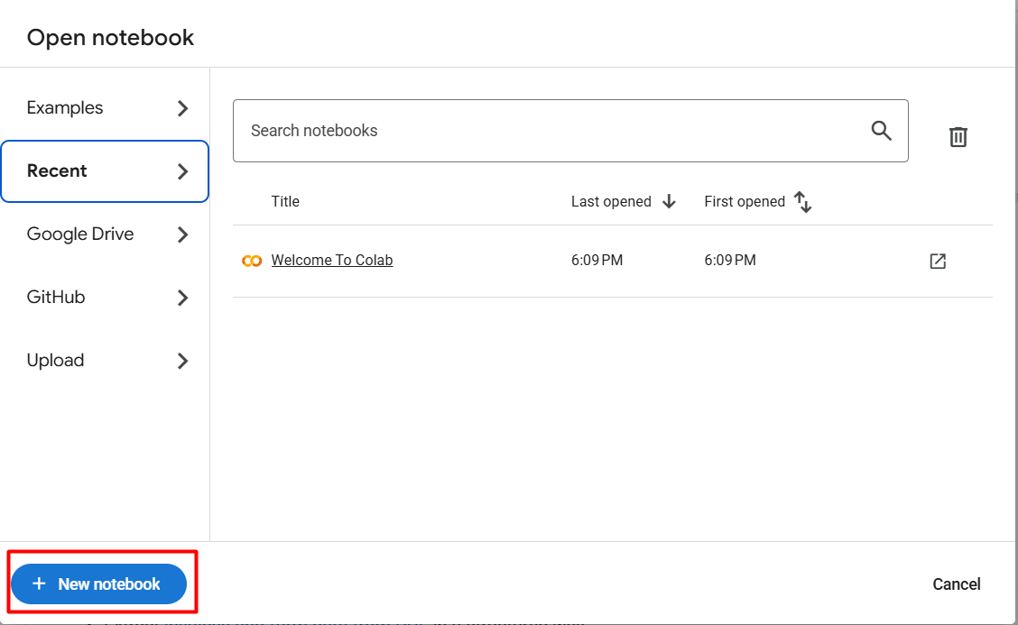

1. write code

print("hello class")

run code and text printed

hello class

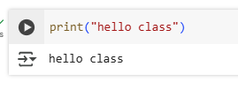

* there are two cells



1. Code : to write code and execute

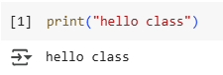

1. Text : to write text/comments/information



* Installing libraries by magic commands using two “!” and “%%”

!pip install PyPI

Here, “pip” is a library used to install another library (e.g “PyPI” library)

* to run all code cells

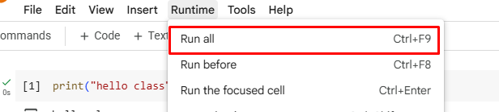

* https://github.com/panaversity/learn-modern-ai-python/blob/main/00_python_colab/01_introduction_to_python/Agentic_AI_Python_Lesson_01_Introduction_to_Python.ipynb
* Programming language is used to communicate human language with machine language.
* Only there are two scripting languages : Python and JavaScript