LECTURE-37 (Saturday 15-November-2025)
- Spec-Kit Repo of Panaversity: https://github.com/panaversity/spec-kit-plus
- Original Repo: https://github.com/github/spec-kit
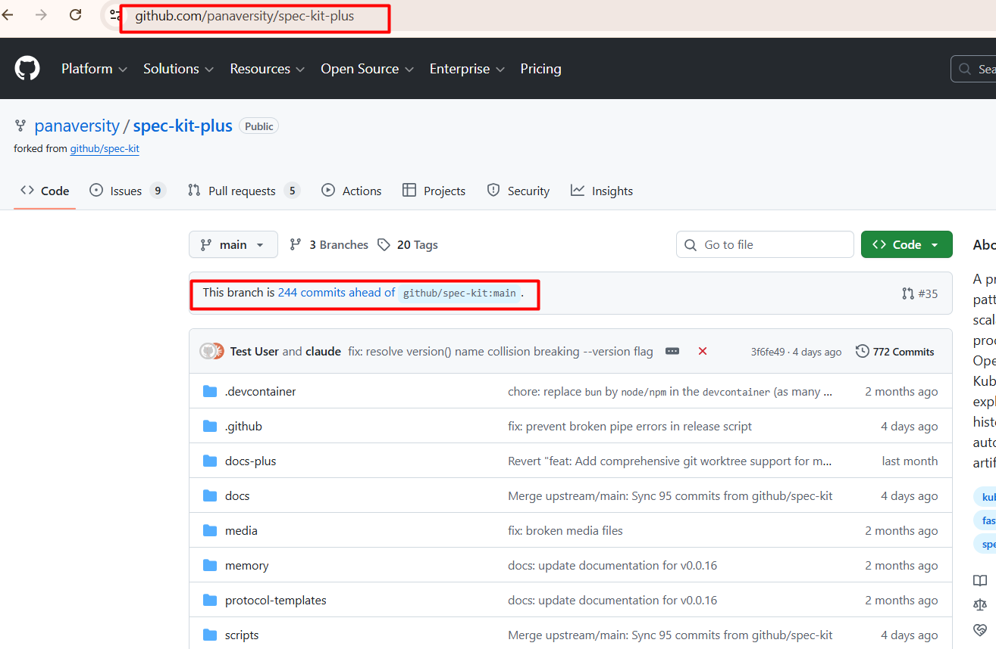
- In “Spec-Driven Development”, we assign small tasks to LLM and we use markdown to provide specs.
- In ”Vibe Coding”, we provide all tasks once to LLM
- https://www.notion.so/Personal-Finance-Tracker-CLI-2aada4c664118005907ce48afdfaba56
- Install NodeJS
- Install Gemini CLI by command: npm install -g @google/gemini-cli
- Confirm Gemini CLI installation by command: gemini –v
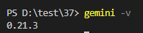
- Run Gemini CLI by command: gemini
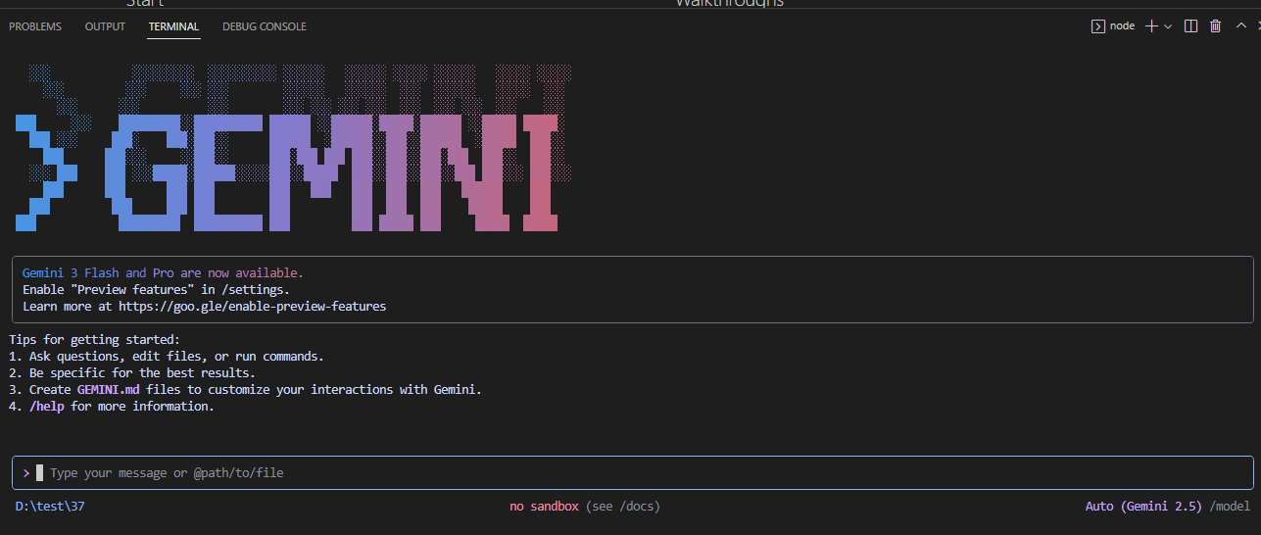
- Test Commands:
- “/help”
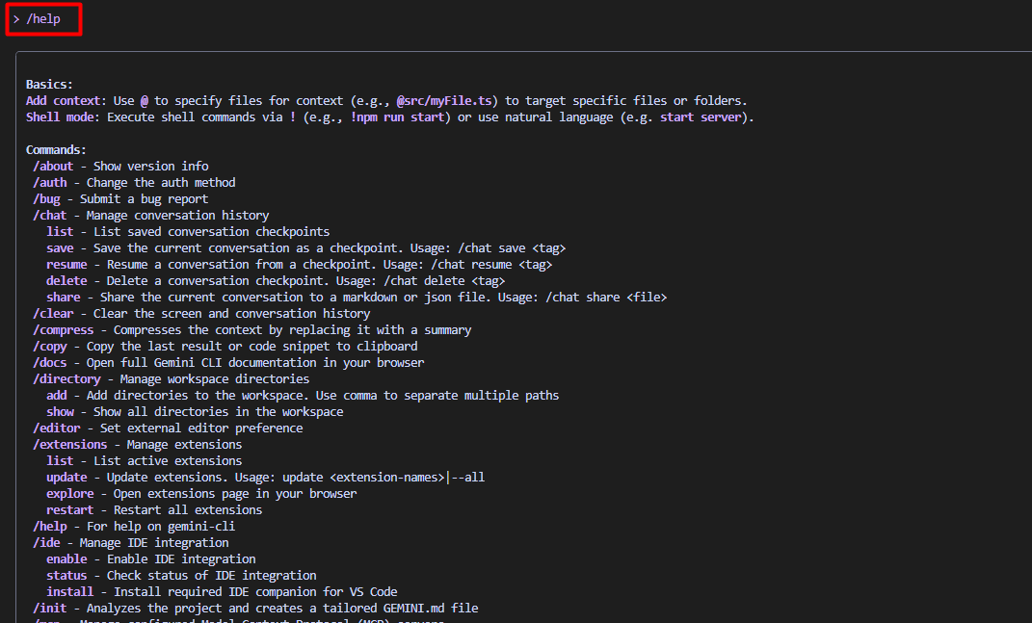
- “/tools”
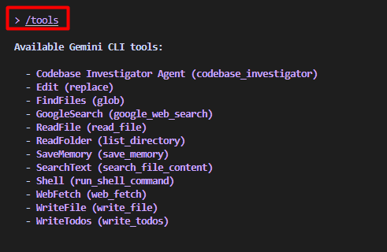
- /memory add <tag>: It is used to store (persist) important context or information so it can be reused later in the same project or workspace.
Example:
Command: /memory add pqr
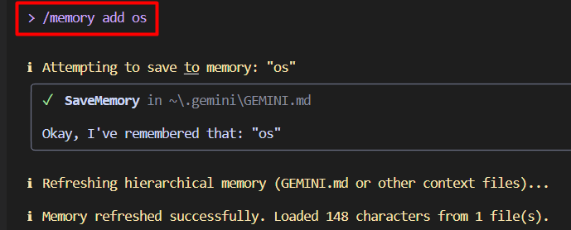
Rules: This project runs on Windows 10 and Windows 11.
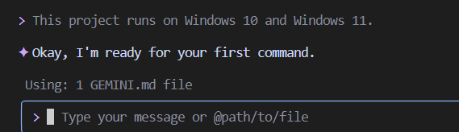
This data is stored in file “GEMINI.md” present at path “C:\Users\abc\.gemini”

- /memory show: It is used to view all memories that are currently stored for your workspace/project.
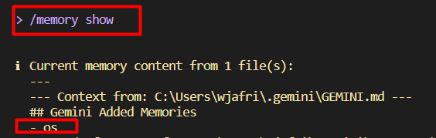
- /memory refresh: It is used to reload or update the memory system, essentially telling Gemini to re-evaluate all stored memories and clear any temporary cache.
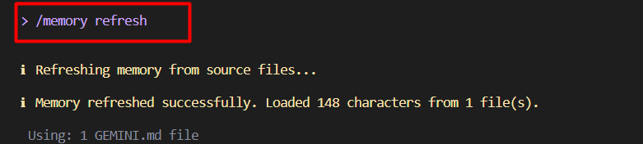
- Run command to set global rules:
/memory add ## 🧭 General Rules
- Follow clear, simple, and maintainable coding practices.
- Provide short explanations unless asked for detailed ones.
- Always ask before making changes that can affect multiple files.
- When unsure about user intent, ask a clarifying question.

---

## 🛠️ Coding Style (Generic)
- Prefer readability over complexity.
- Use descriptive variable, function, and file names.
- Include comments when logic isn’t obvious.
- Keep functions small and modular.
- Follow language-idiomatic conventions (Pythonic, Go-friendly, JS-idiomatic, etc.)
- Create project “finance-tracker”
Setup & Foundation:
- Create project folder: mkdir finance-tracker
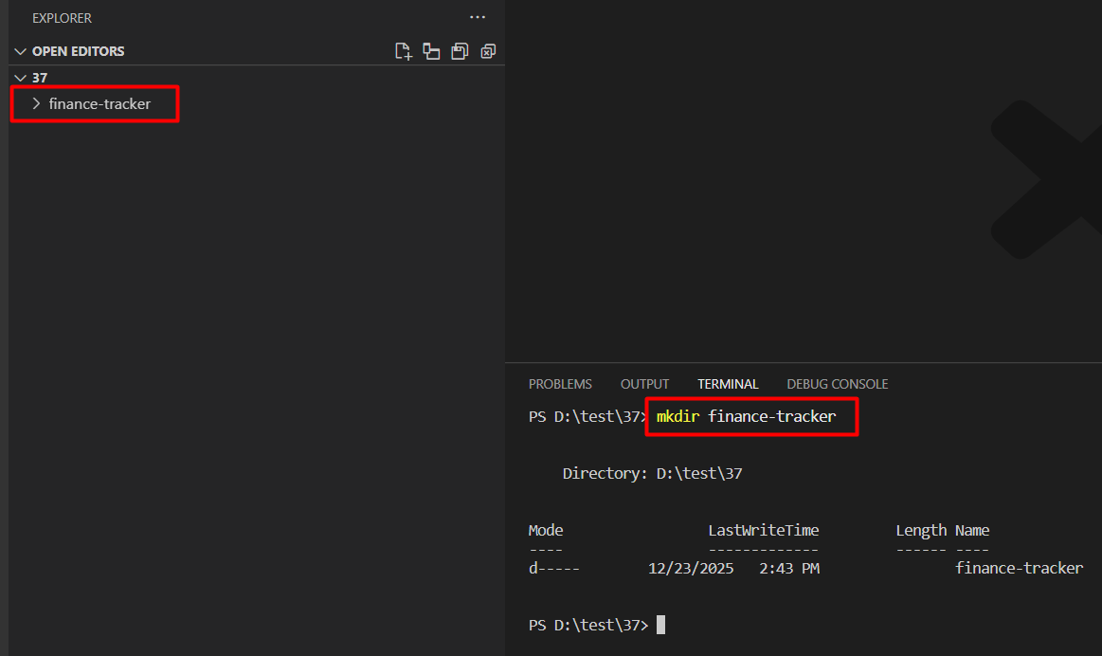
- Go inside created folder by command: cd finance-tracker
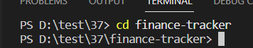
- Install “uv” package by command: pip install uv
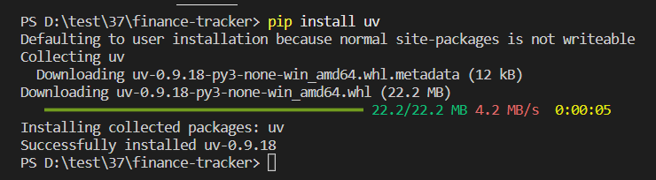
Verify “uv” installation by command: uv --version
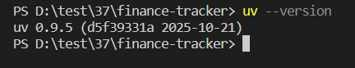
- Create “uv” project by command: uv init
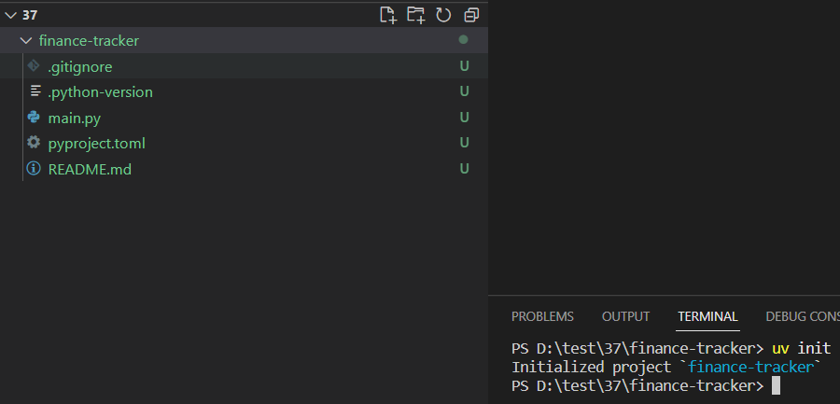
- Create virtual environment by command: uv venv
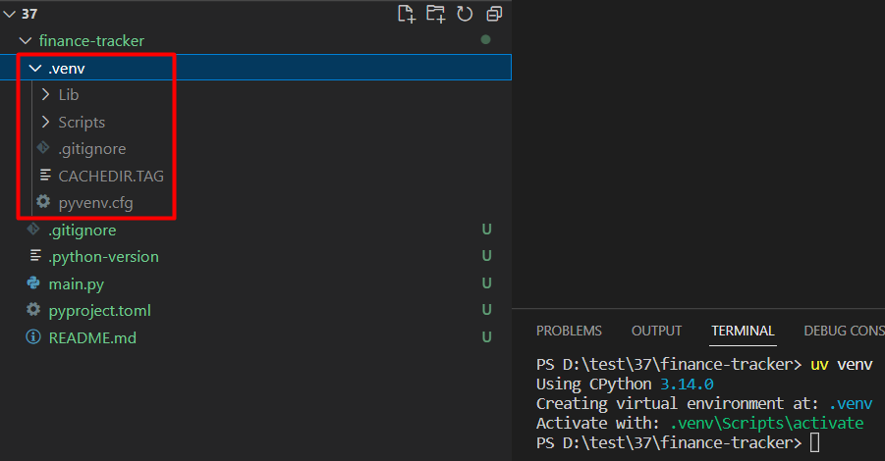
- Activate virtual environment by command: .venv\Scripts\activate
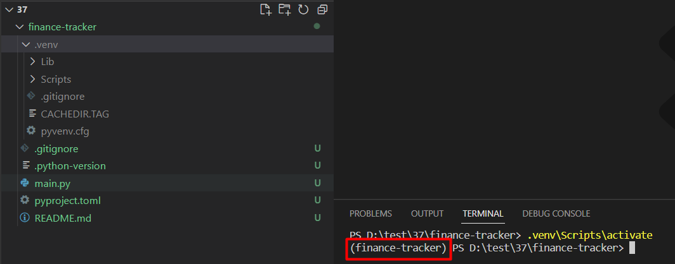
- Add package “questionary” by command: uv add rich questionary
Here,
rich: A Python library for beautiful terminal output like colored text, tables, progress bars, tracebacks, markdown rendering in CLI.
questionary: A Python library for interactive command-line prompts like ask questions, select options (lists, checkboxes), confirmations and text inputs.
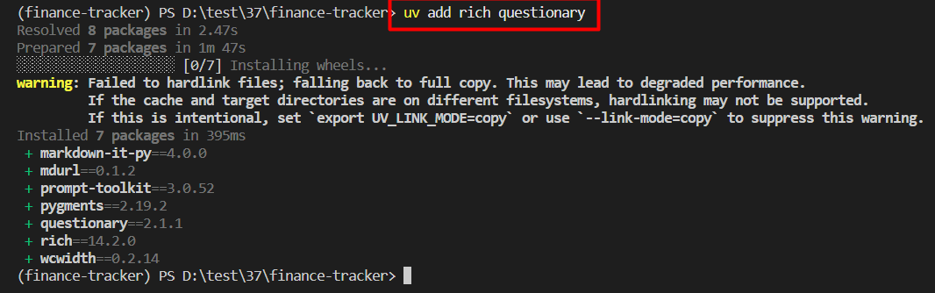
- In project’s root, create “GEMINI.md”
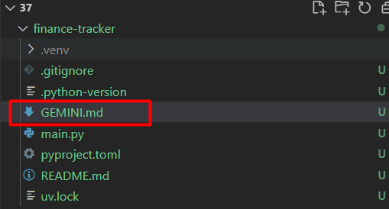
and add below content inside “GEMINI.md”
# Personal Finance Tracker CLI

## Project Overview
Professional CLI application for tracking expenses, income, budgets, and generating financial insights - similar to fintech applications.

## Core Features
- Transaction management (expenses & income)
- Category-based budgeting with alerts
- Financial analytics and health scoring
- Monthly reports and insights
- Data export (CSV/JSON)
- Simple streamlit dashboard

## Tech Stack
- **Language**: Python 3.11+
- **CLI** Framework: Questionary (interactive select lists)
- **UI Library**: Rich (tables, panels, progress bars)
- **Storage**: Plain text files (no database)
- **Package Manager**: UV

## Project Structure
```
finance-tracker/
├── main.py # Entry point with menu loop
├── database/
│ ├── transactions.txt # All transactions
│ └── budgets.txt # Budget allocations
└── features/
├── transactions/
│ ├── GEMINI.md
│ └── transactions.py
├── budgets/
│ ├── GEMINI.md
│ └── budgets.py
└── analytics/
├── GEMINI.md
└── analytics.py
...
```

## Critical Money Handling Rule
**ALWAYS store monetary values as integers (paisa/cents) to avoid floating-point errors.**

```python
# Correct approach:
amount_paisa = 1250 # Store Rs 12.50 as 1250 paisa
display = amount / 100 # Display as Rs 12.50

# Wrong approach:
amount = 12.50 # Never use float for money!
```

## Transaction Categories
**Expenses**: Food, Transport, Shopping, Bills, Entertainment, Health, Other
**Income**: Salary, Freelance, Business, Investment, Gift, Other

# CLI Interaction
This repository uses questionary for dropdown-style selections in the terminal. The UI visual pieces (tables, panels) use Rich.
- Run Gemini CLI by command: gemini

- Prompt: Read all gemini.md and initialize my project and build its structure.
- Prompt: gemini /save features/init
Track Expenses & Income:
- Create “GEMINI.md” at path “features/transactions/” if not present:
# Day 2: Transaction Management

## Goal
Build the core feature - tracking expenses and income transactions.

## Learning Focus
- Working with money in code (avoid float errors!)
- Date handling
- File operations
- Input validation
- Transaction categories

## Fintech Concepts
- **Transaction**: Any money movement (in or out)
- **Debit**: Money going out (expense)
- **Credit**: Money coming in (income)
- **Categories**: Grouping transactions (Food, Transport, Salary, etc.)

## Features to Build

### 1. Add Expense
Flow:
1. Ask amount (validate: must be positive number)
2. Ask category (Food, Transport, Shopping, Bills, Entertainment, Health, Other)
3. Ask description (e.g., "Lunch at restaurant")
4. Ask date (default: today, or allow custom date)
5. Save to transactions.txt

### 2. Add Income
Flow:
1. Ask amount
2. Ask source (Salary, Freelance, Business, Investment, Gift, Other)
3. Ask description
4. Ask date
5. Save to transactions.txt

### 3. List Transactions
Display:
- Show transactions in Rich table
- Columns: Date, Type, Category, Description, Amount
- Color: Red for expenses, Green for income
- Sort by date (newest first)
- Optional filters: last 7 days, only expenses, only income

### 4. Balance Command
Display:
- Total Income (green)
- Total Expenses (red)
- Current Balance (green if positive, red if negative)
- Show for current month

## Success Criteria

✅ Can add expenses with validation
✅ Can add income with validation
✅ Can list all transactions
✅ Can filter transactions by days
✅ Can see current balance
✅ Money calculations are accurate (no float errors)
✅ Beautiful colored output

- Prompt: Read all gemini.md files and build transaction feature
- Prompt: gemini /save features/transactions
- Run project: uv run python main.py
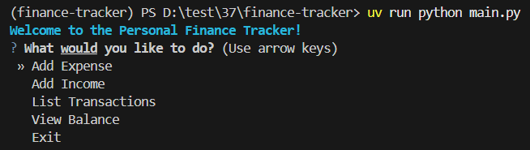
Test “Transaction” implementation using up + down keys:
View Balance
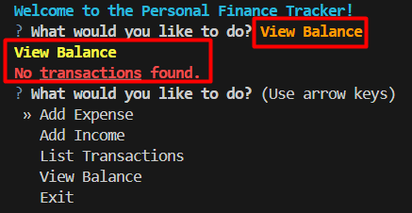
Add Income:
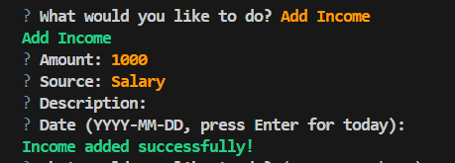
View Balance
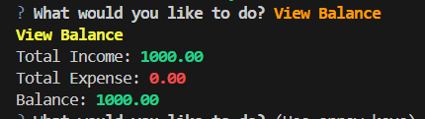
Add Expense
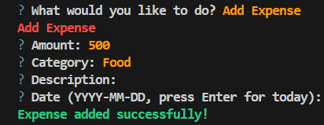
View Balance
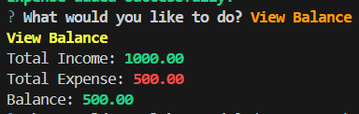
List Transactions
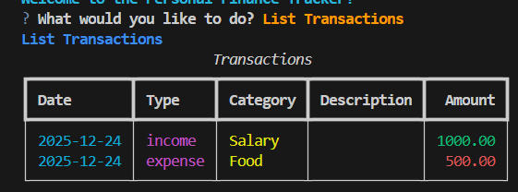
Exit

All transactions data is stored in a file as:
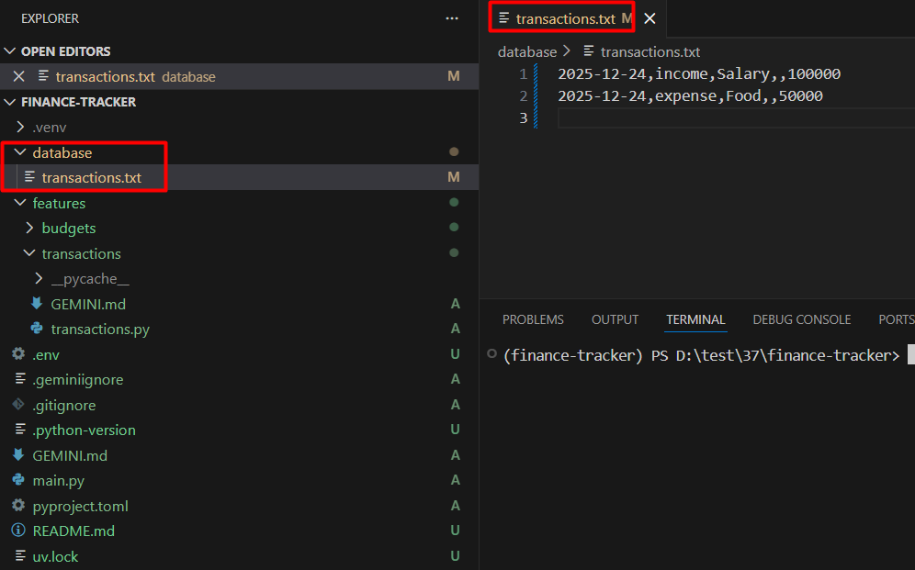
Budget Management:
- Create “GEMINI.md” file at path “features/budgets/” if not present and add below data in file:
# Day 3: Budget Management System

## Today's Goal
Set monthly budgets for categories and track spending against them.

## Learning Focus
- Budget allocation
- Percentage calculations
- Comparison logic
- Warning systems

## Fintech Concepts
- **Budget**: Planned spending limit for a category
- **Budget Utilization**: How much of budget is used (%)
- **Budget Overspending**: When expenses exceed budget
- **Budget Tracking**: Monitoring spending vs planned amount

## Features to Build

Flow:
1. Ask category (Food, Transport, Shopping, Bills, Entertainment, Health)
2. Ask monthly budget amount
3. Save to budgets.txt
4. Show confirmation

Display Rich table:
- Category
- Budget Amount
- Spent (current month)
- Remaining
- Utilization % (with progress bar)
- Status (OK / Warning / Over)

Color coding:
- Green: Under 70% used
- Yellow: 70-100% used
- Red: Over 100% (overspending)

Display:
- Total monthly budget
- Total spent
- Total remaining
- Overall utilization %
- Categories over budget (highlighted)
- Recommendations

## Success Criteria

✅ Can set monthly budgets per category
✅ Can view budget vs actual spending
✅ Shows utilization percentage
✅ Highlights over-budget categories
✅ Shows progress bars
✅ Budget resets each month automatically

- Prompt: Add budget features @features/budget/GEMINI.md
- Prompt: gemini /save features/budgets
- Run project: uv run python main.py
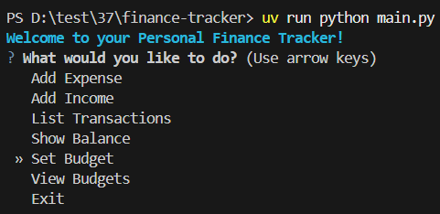
Test “Budget” implementation using up + down keys.
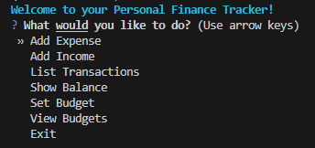
Set Budget
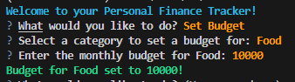
View Budgets
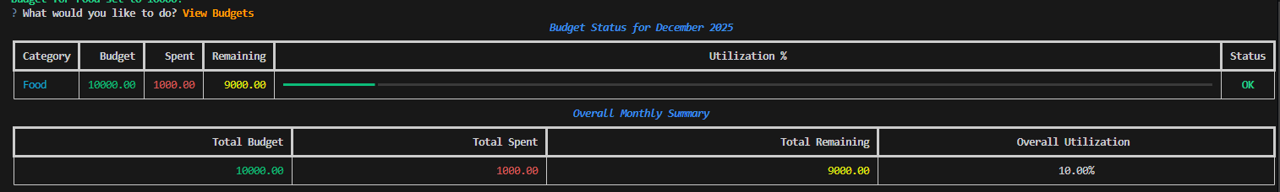
Financial Analytics & Insights:
- Create “GEMINI.md” file at path “features/analytics/” if not present and add below data in file:
# Day 4: Financial Analytics Engine

## Today's Goal
Analyze spending patterns and provide financial insights like real fintech apps.

## Learning Focus
- Data aggregation
- Statistical calculations
- Trend analysis
- Insight generation

## Fintech Concepts
- **Spending Pattern**: How money is distributed across categories
- **Burn Rate**: Average daily spending
- **Savings Rate**: % of income saved
- **Financial Health Score**: Overall financial wellness metric
- **Category Trends**: Which categories increasing/decreasing

## Features to Build

### 1. Spending Analysis

Display:
- Breakdown by category (pie chart in ASCII)
- Top 3 spending categories
- Average daily expense
- Comparison with last month
- Spending trends (up/down)

### 2. Income Analysis

Display:
- Income by source
- Total income this month
- Comparison with last month
- Income stability (regular vs irregular)

### 3. Savings Analysis

Display:
- Monthly savings amount
- Savings rate % (savings/income * 100)
- Savings trend (last 3 months)
- Savings goal progress (if set)

### 4. Financial Health Score

Calculate score (0-100) based on:
- Savings rate (30 points)
- Budget adherence (25 points)
- Income vs expenses (25 points)
- Debt management (20 points)

Display:
- Overall score with interpretation
- Score breakdown by factor
- Recommendations to improve score

Generate comprehensive report:
- Month overview
- Income summary
- Expense summary
- Budget performance
- Savings achieved
- Top transactions
- Trends
- Next month projections

# ASCII Pie Chart Example
```bash
Spending by Category:
Food ████████████ 40%
Transport ██████ 20%
Shopping ████████ 25%
Bills ███ 10%
Other █ 5%
```

## Success Criteria

✅ Shows spending breakdown by category
✅ Calculates burn rate and savings rate
✅ Generates financial health score
✅ Compares current vs last month
✅ Creates comprehensive monthly report
✅ Provides actionable recommendations

- Prompt: Add financial analytics features @features/analytics/GEMINI.md
- Prompt: gemini /save features/analytics
- Run project: uv run python main.py
Test “Financial Analytics” implementation using up + down keys.
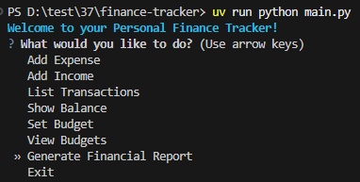
Generate Financial Report
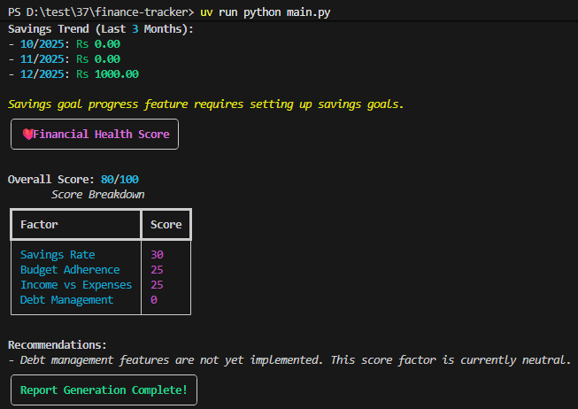
Smart Recommendations & Alerts:
- Create “GEMINI.md” at path “features/smart_assistant/” if not present and add below data:
# Day 5: Smart Financial Assistant

## Today's Goal
Add intelligent recommendations and proactive alerts like modern fintech apps.

## Learning Focus
- Rule-based recommendations
- Alert triggers
- Pattern detection
- Financial advice generation

## Fintech Concepts
- **Smart Alerts**: Proactive notifications about financial events
- **Spending Alerts**: When unusual spending detected
- **Budget Alerts**: When approaching budget limits
- **Savings Opportunities**: Finding ways to save money
- **Financial Tips**: Contextual advice based on behavior

## Features to Build

### 1. Daily Financial Check

Smart analysis showing:
- Today's spending so far
- Remaining daily budget (monthly budget / days)
- Alerts if any
- Quick tip for the day

Example:
📊 Daily Financial Check (Nov 14, 2025)

Today's Spending: Rs 1,250.00
Daily Budget: Rs 2,000.00 ✅
Remaining: Rs 750.00

⚠️ Alerts:
• Transport category at 85% budget (Rs 8,500 / Rs 10,000)
• Large transaction detected: Rs 5,000 (Shopping)

💡 Tip: You're on track! Consider moving Rs 500 to savings.

### 2. Smart Recommendations

Generate recommendations based on:
- Overspending categories → "Reduce Shopping by 20%"
- Low savings → "Try 50/30/20 rule"
- Irregular income → "Build 3-month emergency fund"
- No budget set → "Set budgets for better control"
- Good performance → "Increase savings goal"

### 3. Spending Alerts System

Show active alerts:
- Budget warnings (>80% used)
- Large transaction alerts (>20% of monthly income)
- Unusual spending patterns
- Bill payment reminders
- Savings milestones reached

### 4. Savings Opportunities

Analyze and suggest:
- Categories where spending can be reduced
- Estimate monthly savings potential
- Compare with category averages
- Show "What if" scenarios

### Allow setting goals:
- Emergency fund goal
- Savings target
- Debt payoff

###🎯 Goals Progress:
Emergency Fund
[████████░░] 80% (Rs 80,000 / Rs 100,000)
Expected: Dec 2025
Vacation Savings
[████░░░░░░] 40% (Rs 20,000 / Rs 50,000)
Expected: Mar 2026

## Success Criteria

✅ Daily financial check shows relevant info
✅ Smart recommendations based on actual behavior
✅ Proactive alerts for important events
✅ Savings opportunities identified
✅ Financial goals can be set and tracked
✅ All recommendations are actionable

- Prompt: Add intelligent recommendations to finance tracker. Read @features/smart_assistant/GEMINI.md
- Prompt: gemini /save features/smart_assistant
Test “Smart Recommendations & Alerts”.
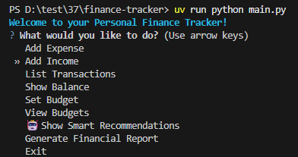
Show Smart Recommendations
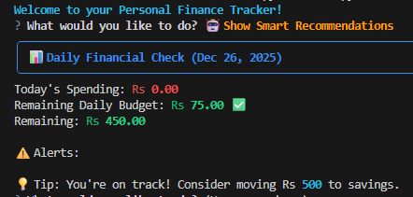
Export & Data Management:
- Create file “GEMINI.md” at path “features/data_management/” if not present and add below content:

# Day 6: Data Management & Export

## Today's Goal
Professional data export, import, and backup features.

## Learning Focus
- Data export formats (CSV, JSON)
- Data import and validation
- Backup and restore
- Data integrity

## Fintech Concepts
- **Data Export**: Download financial data for external use
- **Data Portability**: Moving data between systems
- **Audit Trail**: Complete transaction history
- **Data Backup**: Protecting financial information

## Features to Build

### 1. Export Transactions

Export formats:
- CSV (for Excel/Sheets)
- JSON (for developers)
- PDF (coming later)

### 3. Export Monthly Report
Comprehensive JSON export with:
- All transactions
- Budget summary
- Analytics
- Health score
- Recommendations
### 3. Export Monthly Report
Comprehensive JSON export with:
- All transactions
- Budget summary
- Analytics
- Health score
- Recommendations

### 3. Export Monthly Report
Comprehensive JSON export with:
- All transactions
- Budget summary
- Analytics
- Health score
- Recommendations

### 4. Import Transactions

Features:
- Validate CSV format
- Check for duplicates
- Confirm before importing
- Show import summary

### 5. Backup System

Features:
- Create timestamped backup
- Compress files
- Store in backups/ folder
- Auto-cleanup old backups (keep last 10)

### 6. Data Validation

Check data integrity:
- Find corrupt entries
- Check for missing data
- Verify calculations
- Fix common issues

## Success Criteria

✅ Can export transactions to CSV
✅ Can export budgets
✅ Can export complete monthly reports
✅ Can import transactions from CSV
✅ Backup creates timestamped archive
✅ Restore works correctly
✅ Data validation finds issues
- Prompt: Add data management features. Read @features/data_management/GEMINI.md
- Prompt: gemini /save features/data_management
Test “Export & Data Management”.
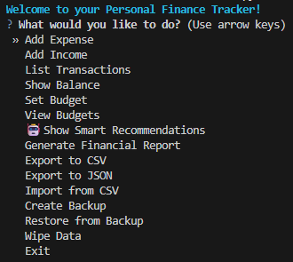
Export to CSV
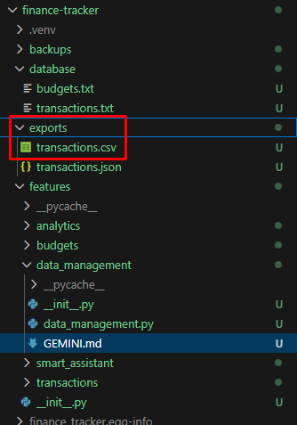
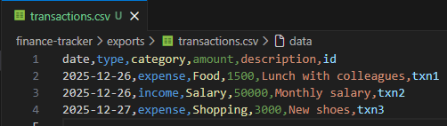
Export to JSON
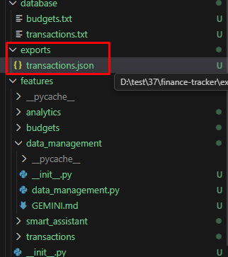
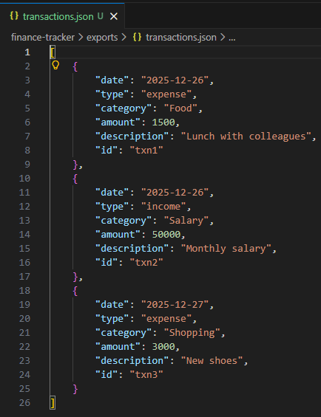
Select “Generate Financial Report” to check all data.
Wipe Data
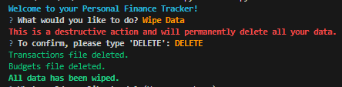
Select “Generate Financial Report” to check all data removed.
Import from CSV
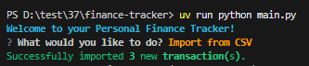
Select “Generate Financial Report” to check exported data imported successfully.
Create Backup
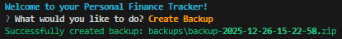
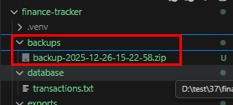
Select “Generate Financial Report” to check all data.
Wipe Data
Select “Generate Financial Report” to check all data removed.
Restore from Backup
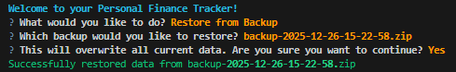
Select “Generate Financial Report” to check all data recovered from created backup.
Website:
- Create file “GEMINI.md” at path ““features/website/” if not present and add below content:

# Day 7: Web Dashboard & Final Polish

## Today's Objective
Create a simple web interface to view your finance data and polish the CLI application.

---

## Part A: Simple Web Dashboard

### What You'll Build
A single-page web dashboard that displays:
- Current balance with income and expenses
- Budget progress bars (color-coded)
- Recent transactions in a table
- Clean, professional design

### Tech Stack to Use
- **Streamlit** - Python web framework

**What to Display:**

#### Balance Section
- Large centered balance amount
- Income and expenses side by side
- Use green for income, red for expenses

#### Budget Status Section
- List each budget category
- Show: Budget amount, Spent amount, Percentage
- Progress bars with colors:
- Green: under 70% used
- Yellow: 70-99% used
- Red: 100%+ used (over budget)

#### Recent Transactions Table
- Show last 10 transactions
- Columns: Date, Type, Category, Description, Amount
- Color-code by type (income=green, expense=red)

### Styling Guidelines
- Use card-based design (white boxes with shadows)
- Maximum width: 1200px, centered
- Clean fonts (Arial or similar)
- Plenty of white space
- Mobile-friendly (responsive)

- Prompt: Add website features. Read @features/website/GEMINI.md
- Run command: uv sync
Or
pip install -e .
- Run project: uv run python main.py
Test “Website”
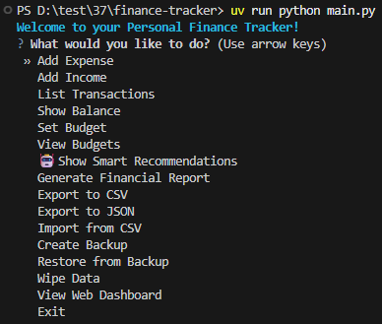
View Web Dashboard
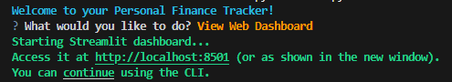
http://localhost:8502/
