LECTURE-14 (Saturday 20-September-2025)
- Prompt Driven Development (PDD): https://github.com/panaversity/learn-agentic-ai/tree/main/06_prompt_driven_development
- https://cursor.com/: Cursor is an AI-powered code editor. The cost of cursor license is 20$ monthly.
- The cost of ChatGPT license is 20$ monthly.
- The latest version ChatGPT is “GPT-5”.
- GPT-5 Codex is a specialized version of OpenAI’s GPT-5 model, tuned especially for agentic coding and software engineering tasks.
- Best combination to work : Cursor (Licensed) + VSCode + ChatGPT (Licensed) + GPT-5 CodeX
- Use 5 best LLMs:
- ChatGPT
- Google Gemini
- Grok
- Claude
- DeepSeek
- Prompt-Driven Development (PDD): It is a modern software development style, has emerged with AI coding assistants like ChatGPT, Codex, and Cursor. In Prompt-Driven Development, the primary “programming interface” is the prompt. Instead of manually coding everything, you write prompts (instructions, requirements, or natural-language descriptions) that guide the AI to generate, refactor, or explain code. The quality of the prompt directly affects the quality of the generated output (similar to how requirements shape traditional coding).
- Text-Driven Development (TDD): It is a newer software development approach. Instead of writing low-level code first, you start by describing in plain language (text) what you want the software/system to do. An AI coding assistant (like GPT-5 Codex, Cursor, Copilot, etc.) then translates that text into code, tests, or even full implementations. The developer iterates by refining the natural-language specification, reviewing the generated code, and adjusting as needed.
- Design Thinking: It is a problem-solving and innovation approach, focuses on understanding users, challenging assumptions, and creating effective solutions through creativity and iteration. It is widely used in product design, business strategy, and even education because it emphasizes human-centered design.
Key Stages of Design Thinking:
- Empathize: understand user’s needs, experiences, and challenges through research, observation, and interaction.
- Define: clearly articulate the problem by synthesizing insights into a problem statement.
- Ideate: brainstorm a wide range of creative solutions without judgment.
- Prototype: build simple, low-cost versions (mockups, models, and wireframes) of the best ideas to explore solutions.
- Test: try the prototypes with users, gather feedback and refine the solutions.
- Prompt Engineering Exam will be conducted after 2 or 3 weeks and exam contains 150 questions. After that, we have “OpenAI SDK Agent” test and then we have “MCP” test.
- PIAIC is working on two more projects “Prompt Project” and “Startup Project”
- https://github.com/panaversity/learn-agentic-ai/tree/main
- https://github.com/panaversity/learn-agentic-ai/tree/main/-01_lets_get_started
- https://github.com/panaversity/learn-agentic-ai/tree/main/01_ai_agents_first
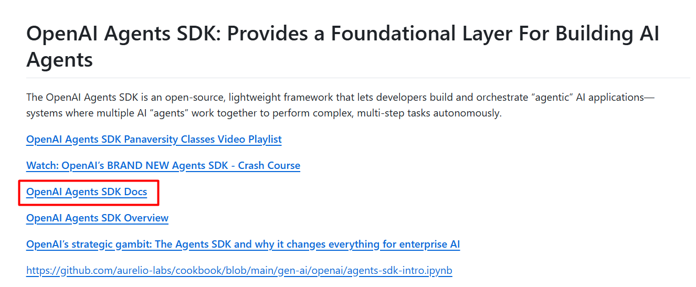
- https://openai.github.io/openai-agents-python/
- OpenAI Agents SDK: It enables you to build agentic AI applications in a lightweight, easy-to-use package with very few abstractions. It is a production-ready upgrade of our previous experimentation for agents, Swarm. The Agents SDK has a very small set of primitives (default):
- Agents: They are LLMs equipped with instructions and tools.
- Handoffs: It allow agents to delegate to other agents for specific tasks.
- Guardrails: It enables validation of agent inputs and outputs
- Sessions: It automatically maintains conversation history across agent runs.
- https://github.com/panaversity/learn-agentic-ai/blob/main/01_ai_agents_first/05_model_configuration/Global%2C_Run_and_Agent_Level_Agents_SDK_Config.ipynb
- Create “UV” project “Hello World”:
- Open VSCode
- Create project “test1”
- Add file “main.py”
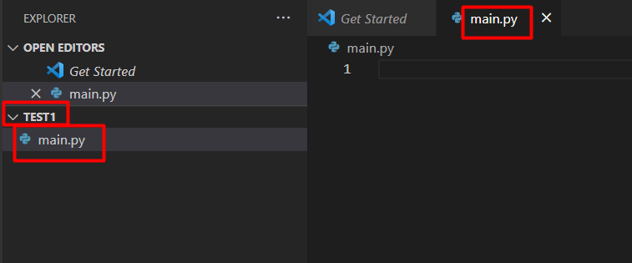
- Execute file
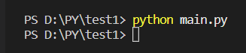
- Install OpenAI Agents SDK by command: pip install -Uq openai-agents
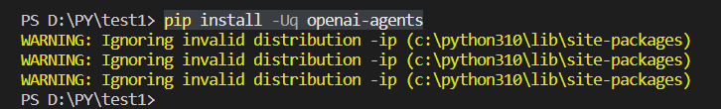
- Google offers a free API key that we can create in Google AI Studio for development and testing purpose.
- https://aistudio.google.com
- Click at “Get started”
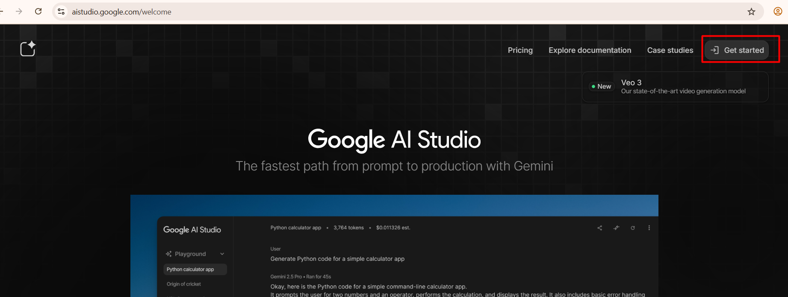
- Sign-in with your gmail account.
- Click at “Get API key”
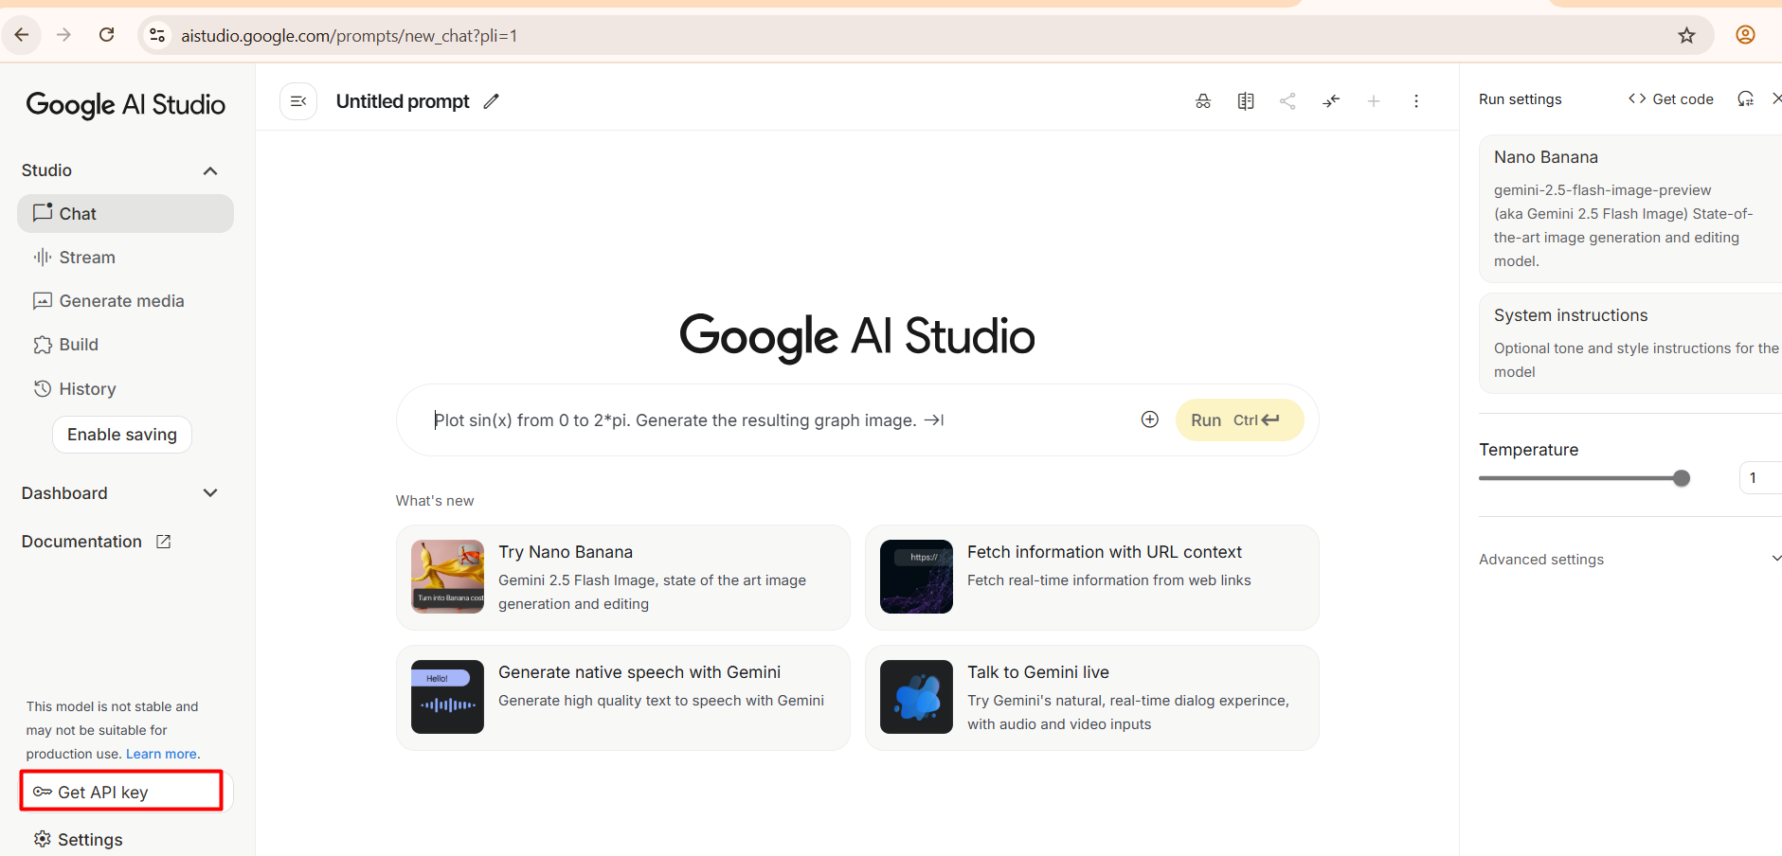
- Click at “Create API key”
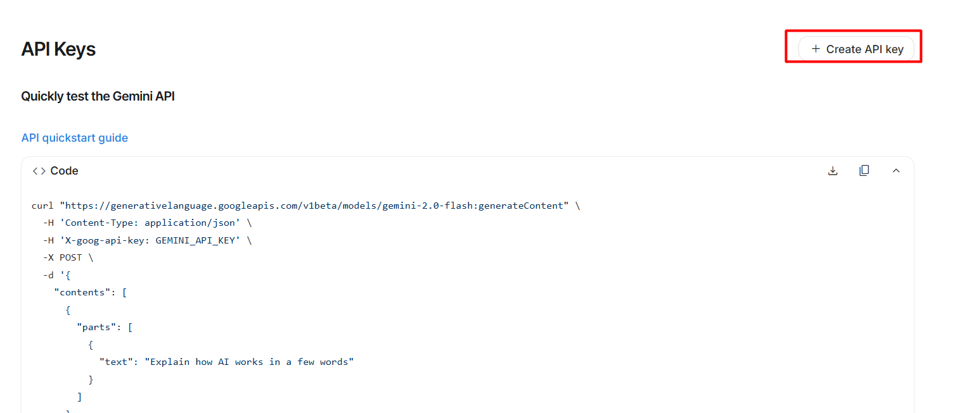
- Select “Gemini API”
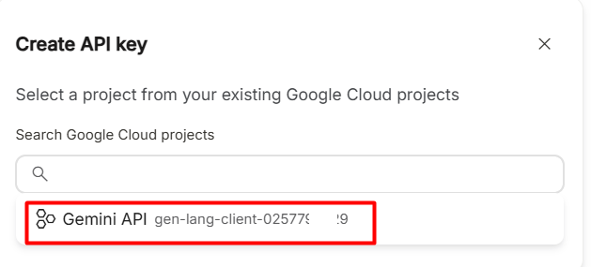
- Then
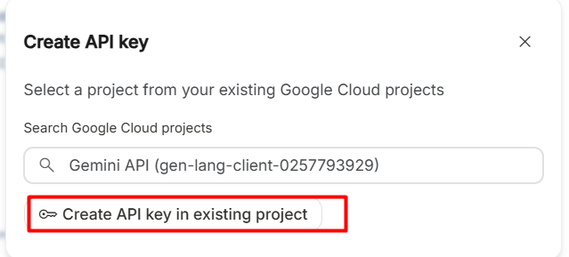
- You get Google Gemini API key
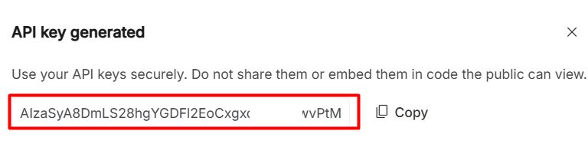
- Now copy code and replace highlighted “gemini_api_key” field by above key:
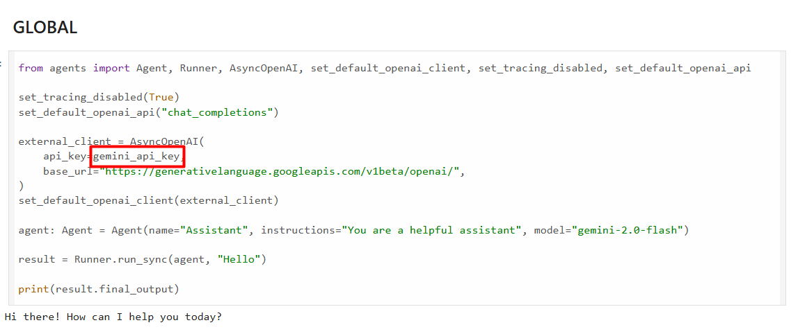
- So, code in “main.py”:
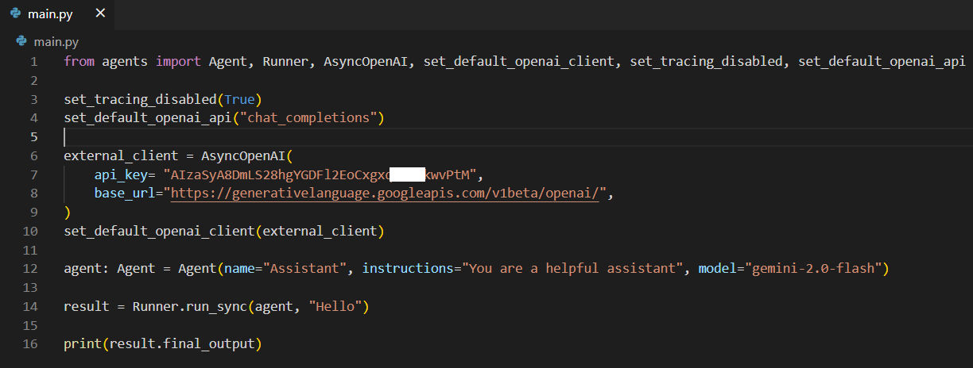
Here,
result = Runner.run_sync(agent, "Hello"): “Hello” is prompt. What we write for LLM is called “intern”. We used sync method to call “@function” tool.
- On code execution, we get response from LLM
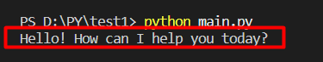
Now, doing same thing but keeping Google Gemini key in environment variable file:
- Open VSCode
- Create project “test2”
- Add file “main.ipynb” (Jupyter Notebook)
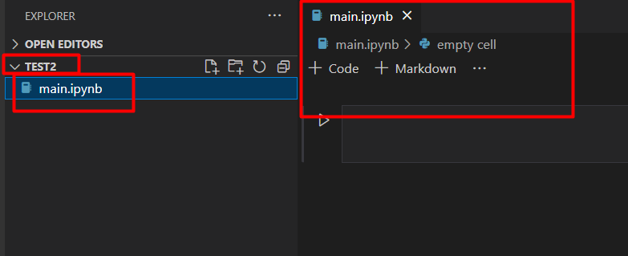
- Execute file
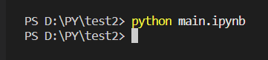
- In a “Code” cell, Install OpenAI Agents SDK by command: !pip install -Uq openai-agents
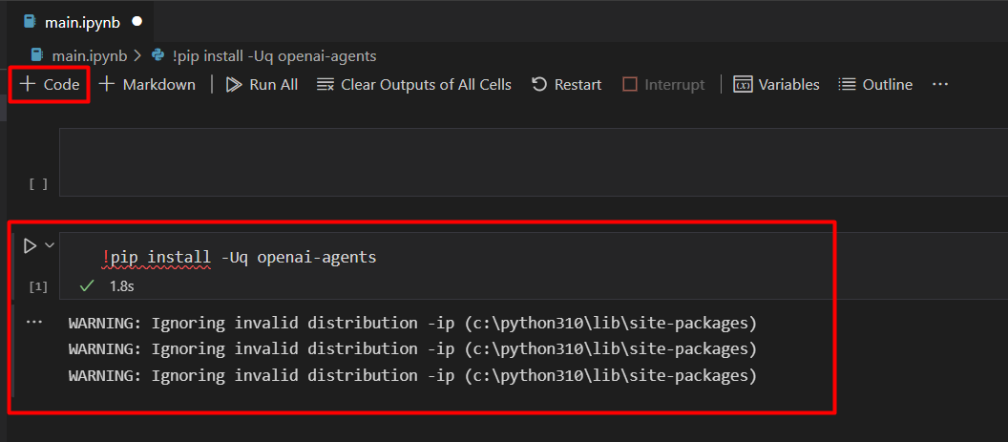
- To make your Jupyter Notebook capable of running asynchronous functions, use below code:
import nest_asyncio
nest_asyncio.apply()
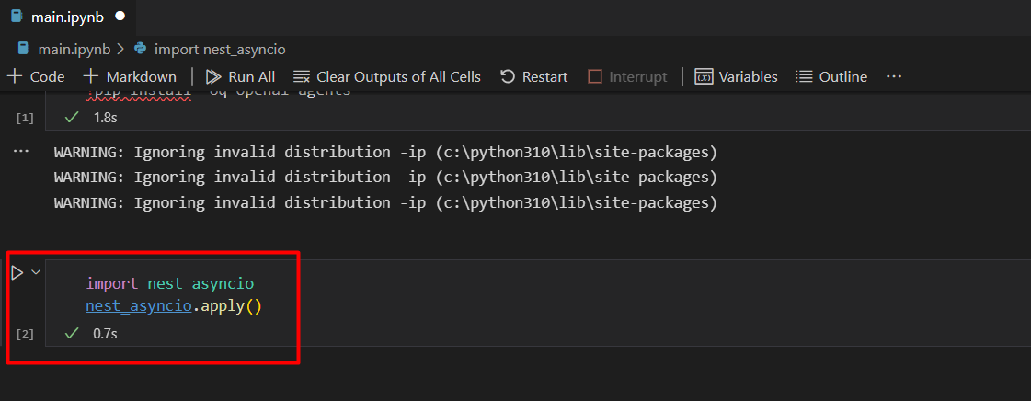
- To import Google Gemini API key from environment variables, create a file with name “.env” and keep your Google Gemini API key in environment variable file:
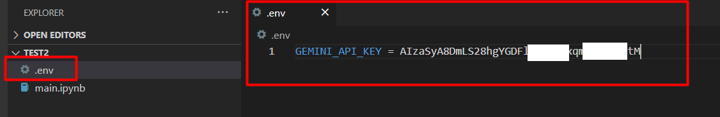
- Execute below code and you get gemini_api_key:
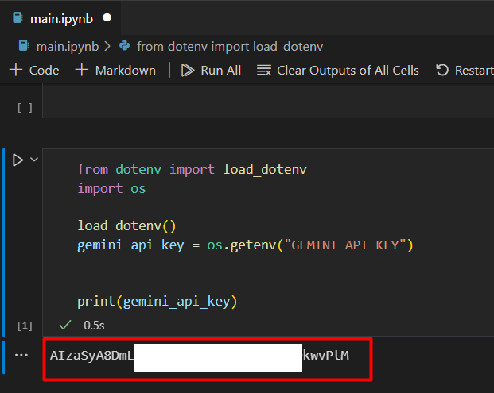
Here,
os.getenv(): returns environment variables
- Now copy code:
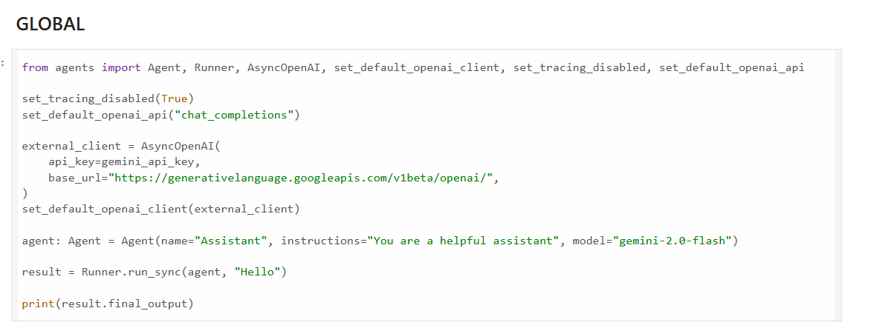
- On code execution, we get response from LLM
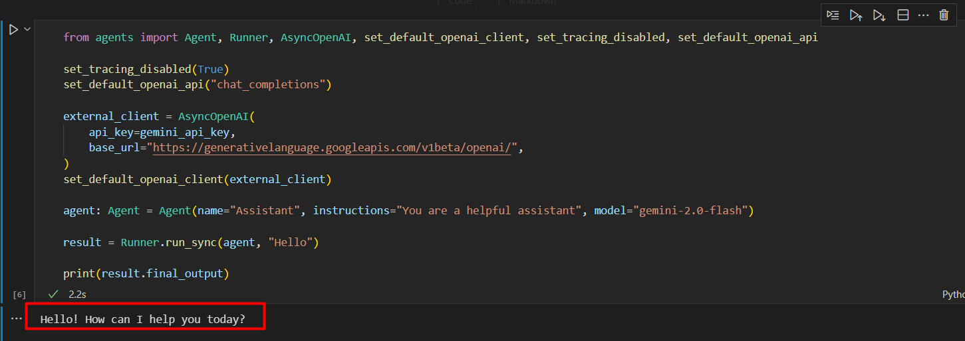
- There are three main APIs offered to interact with a LLM.
- Chat Completion API: Lets you send structured messages (role: system, user, assistant) in request and get conversational responses. It is best for chatbots, agents, assistants, interactive apps. It is stateless API.
- Text Completion API: You send a prompt string in request and the model continues it with the most likely text. It is best for content generation, text expansion, code completion, writing help. It is more "raw" than chat but no role separation.
- Embedding API: It converts text into high-dimensional vectors (embeddings). It is best for semantic search, recommendation, clustering, retrieval-augmented generation (RAG) and similarity matching.
Some providers also count fine-tuning APIs or moderation APIs as separate categories, but the above three are the core.

