LECTURE-02 (Wednesday 20-August-2025) (Online Class 1)
- Youtube live class: https://www.youtube.com/live/2AW4Ooki2O8?si=PVs1zZSYUGchsJMe
- https://github.com/panaversity/learn-low-code-agentic-ai
- n8n: Visual programming
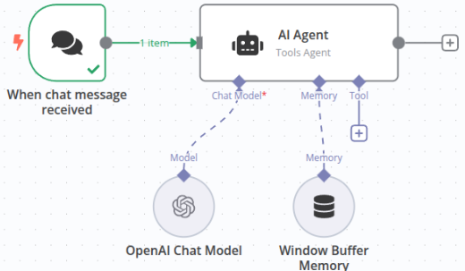
In above image, we created an “AI Agent” and connect “AI Agent” with “OpenAI Chat Model”.
- n8n (pronounced “n-eight-n”) is an open‑source workflow automation, Agentic AI, and orchestration platform. It lets you build AI Agents and connect APIs, databases, and services with a visual, node‑based editor, while still giving you the power to drop into code when you need it. For agentic AI, that combination—no‑code orchestration with just‑enough code—makes n8n an ideal control plane for prototyping and building systems that can perceive, plan, and act across tools.
Here,
Open Source: n8n code is available at internet.
Workflow: Tasks in sequence (Task 1 performed then Task 2 performed then Task 3 performed)
Orchestration: It decides which item will perform which action. AI will decide to use which channel to perform which operation.
- 3 waves of AI
- Before November 2022, Predictive AI: It predicted results based on statistics.
- In November 2022, Generative AI started by the introduction of ChatGPT introduced: LLM generate results
- Now, Agentic AI: It generate results but also, can take actions based on reasoning.
- AI Agent: It is a system that does not just answer a prompt but also perceives, decides and acts toward a goal, often over multiple steps and with tools.
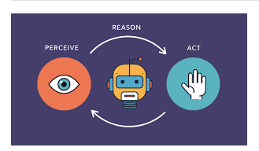
Gartner’s Top 10 Tech Trends Of 2025: Agentic AI and Beyond : https://www.productiveedge.com/blog/gartners-top-10-tech-trends-of-2025-agentic-ai-and-beyond
Agentic AI is at top trend.
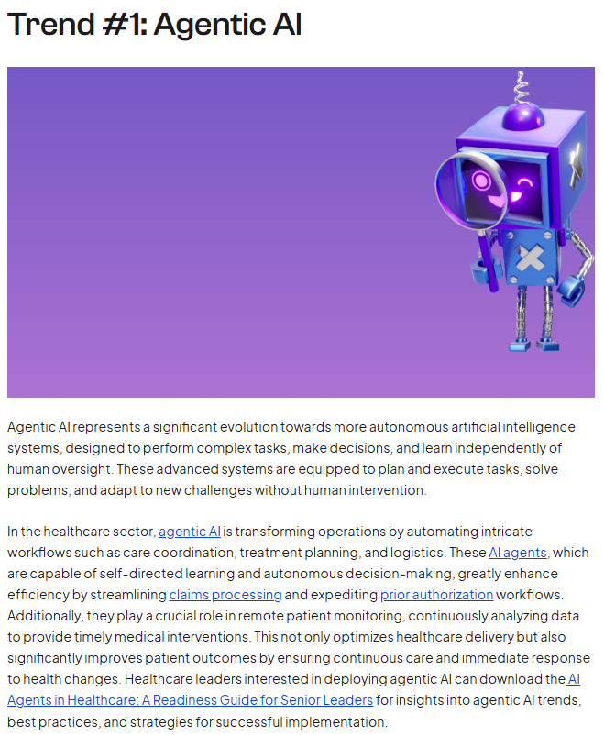
- IDEA: LLM (the brain) + tools/APIs (hands) + memory (long-term context) + goals (what to achieve) + a loop (to try, check, and try again).
- Agent is different from a simple Chatbot as Chatbot is a single-turn Q&A while Agent is a multi-step workflow as Agent can browse data, call APIs, write files, plan next steps and keep going until a goal condition is met.
- Core parts of Agent:
- Planner/Reasoner: figures out next best action.
- Tools/Actuators: code functions, APIs (email, DB, calendar, web, shell, etc.).
- Memory/State: keeps track of what’s done, results, and constraints.
- Critic/Verifier (optional): checks outputs, retries or switches strategy.
- Examples of Agent:
- Inbox triage agent: reads emails, classifies, drafts replies, schedules meetings.
- Data analyst agent: pulls Xero/DB data, cleans it, runs queries, builds a CSV/visual, summarizes findings.
- DevOps agent: watches logs, files incidents, rolls back or scales services based on rules.
- Agent usage:
- You need automation across several steps or systems.
- The task benefits from planning and feedback (retrying, verifying).
- You want hands-off (giving control to another) workflows with occasional human approval.
- Trade-offs (Advantages/Disadvantages):
Pros: autonomy (nothing to do for user), speed, integrates many tools, handles long workflows.
Cons: time taking, harder to control/trace, needs guardrails and evals, can incur cost and require careful permissions.
- Now, we can generate Agents of three types:
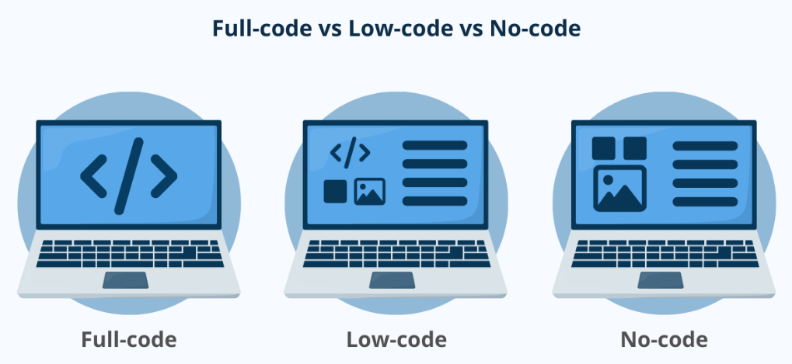
- Low-Code is concept like Scripting and Visuals.
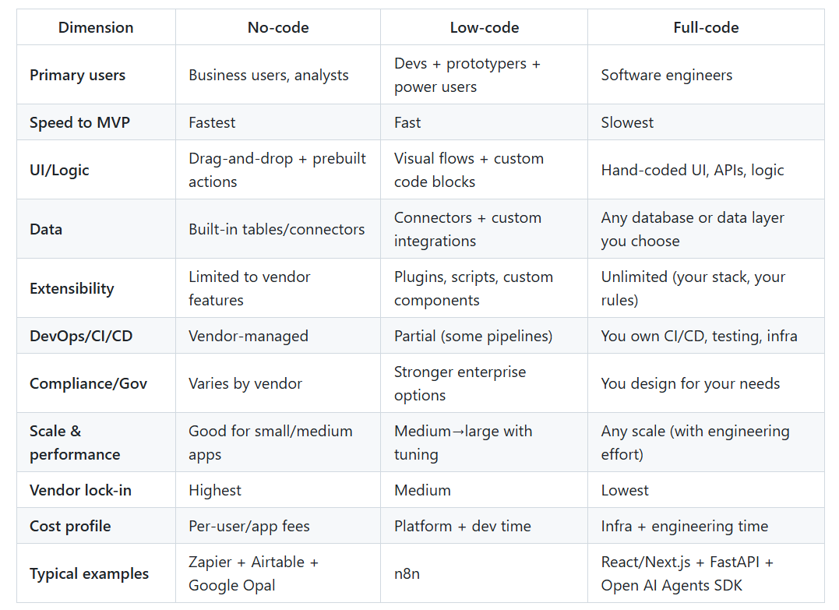
- n8n is low-code.
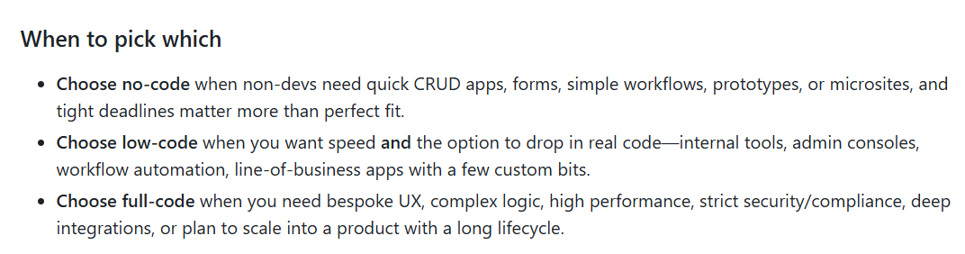
- Types of development:
- Enterprise/Companies
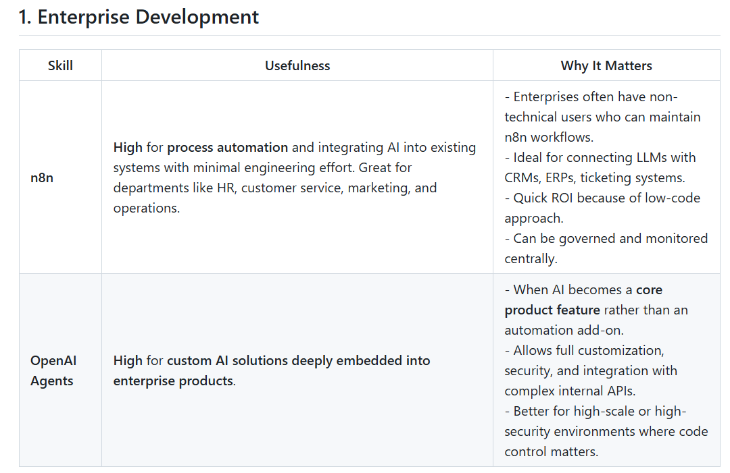
- Startups
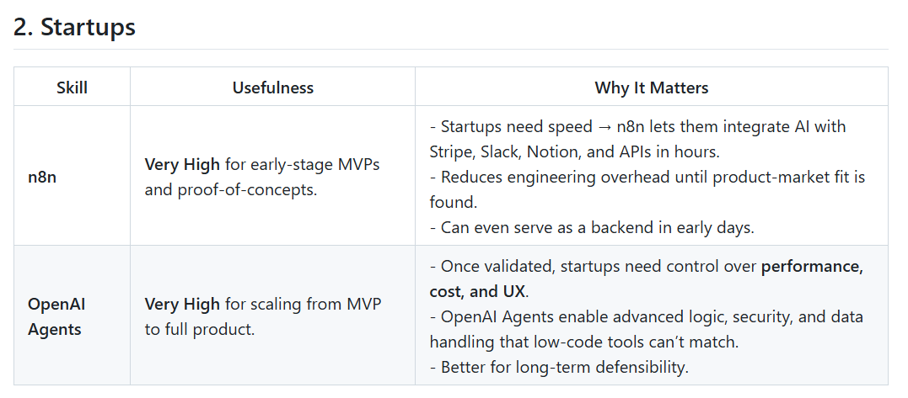
- Freelancing
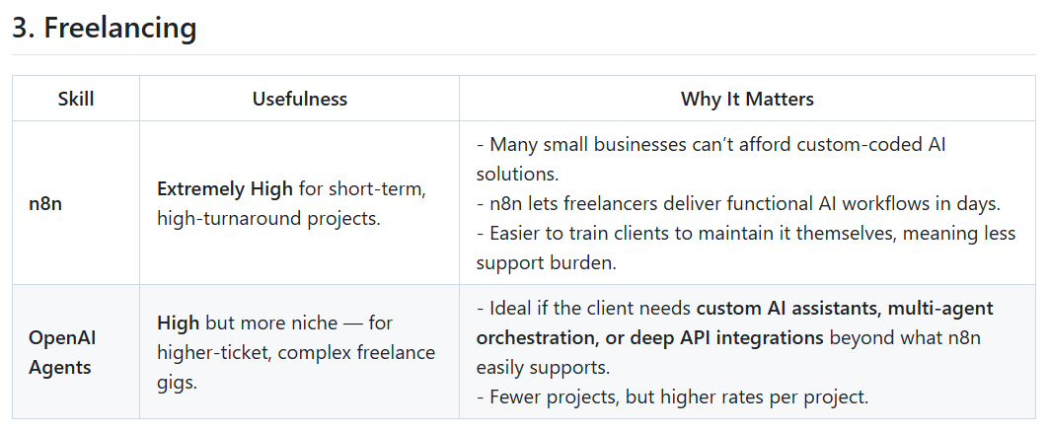
Overall:
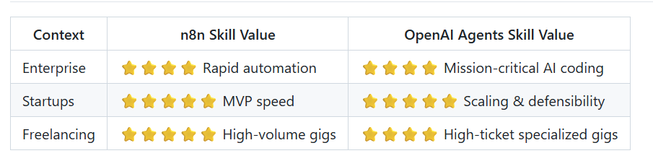
- Goto https://n8n.io/
- Sart free 14-day trial
- Click at “Start from scratch”
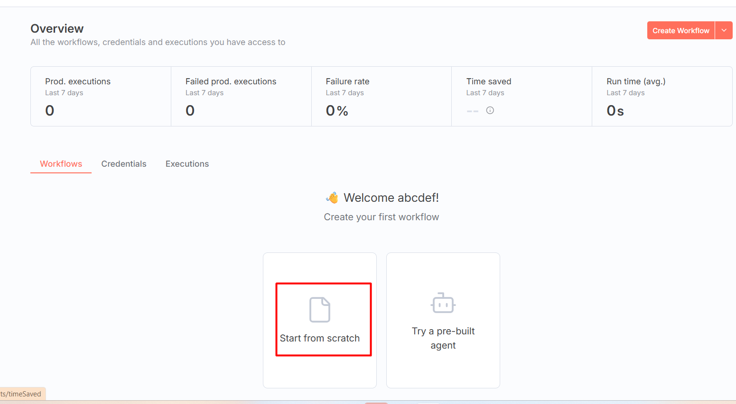
- Click at “+”
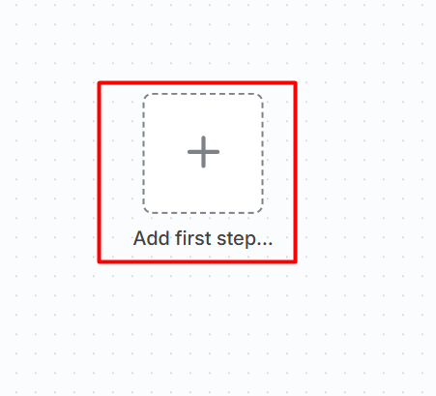
- Select “On chat message”
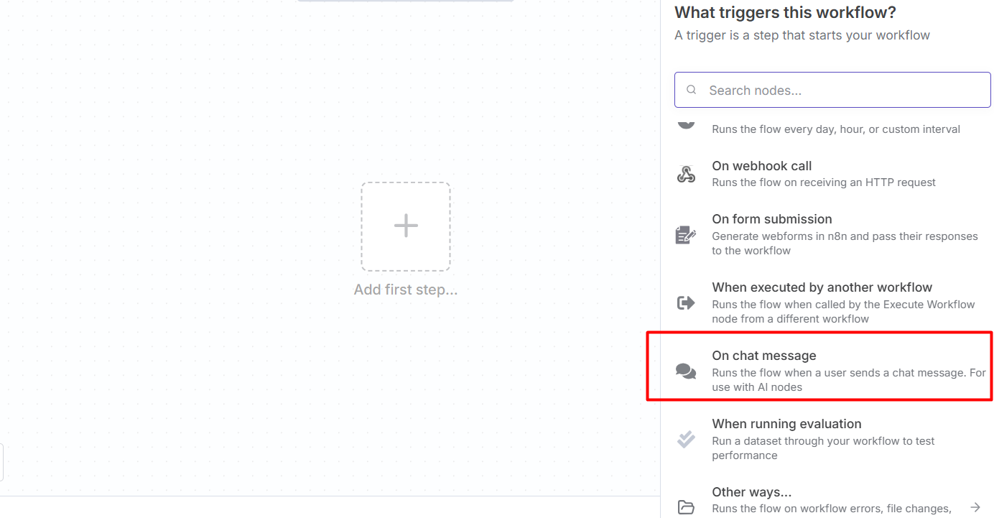
- Below window open
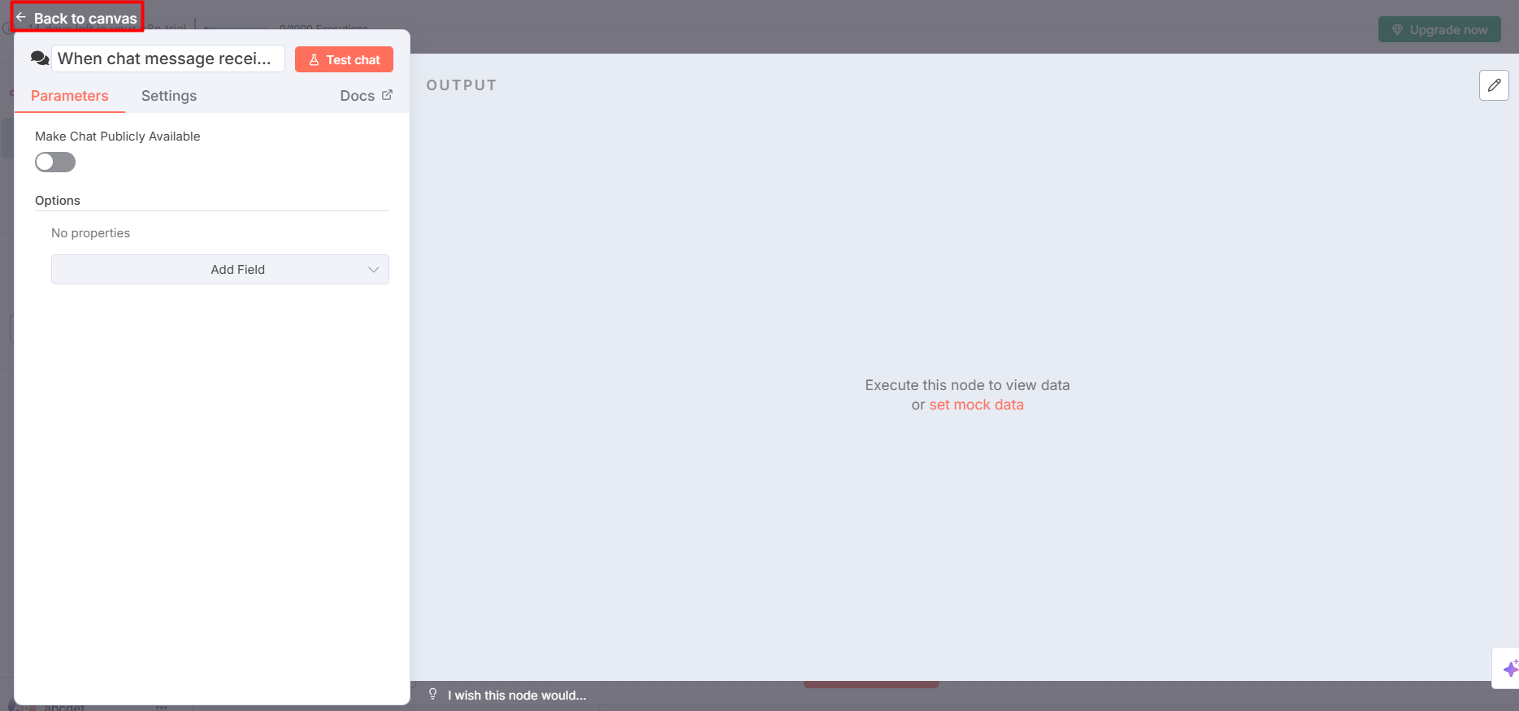
- Click at “Back to canvas” or press “Esc” key
- Click at “+”
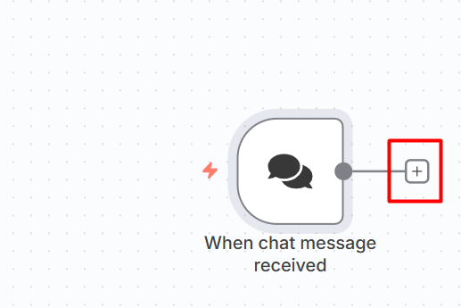
- Select “AI Agent”
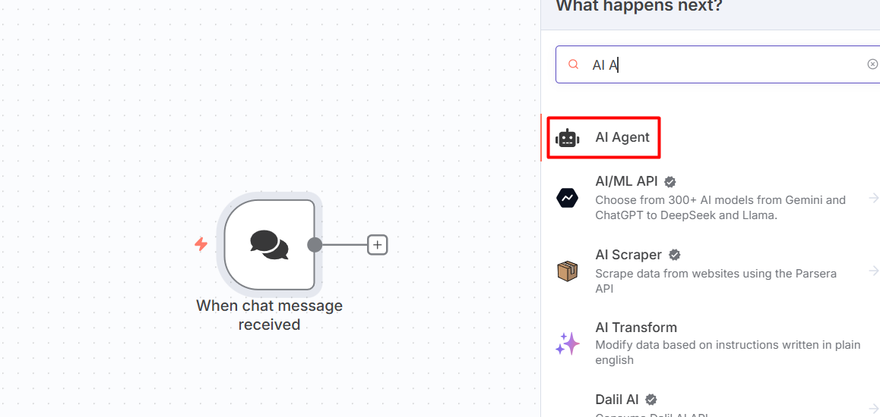
- Below window open
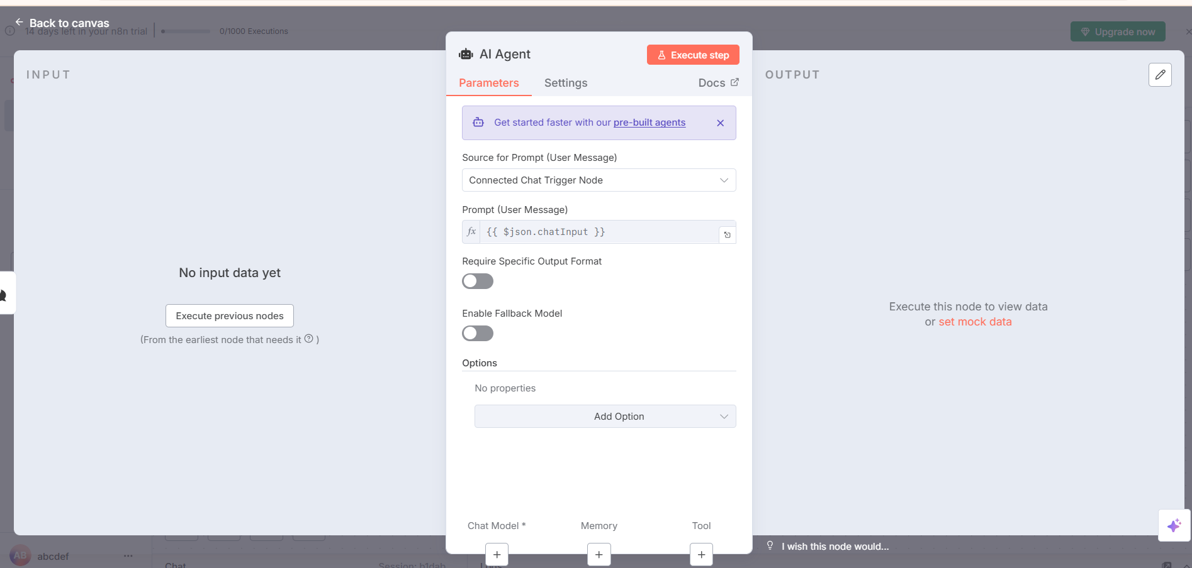
- Every “AI Agent” has an LLM and LLM is called from API
- Google provides free API which can be used by API key. To get API key, goto https://aistudio.google.com/prompts/new_chat
- Click at “Get API key”
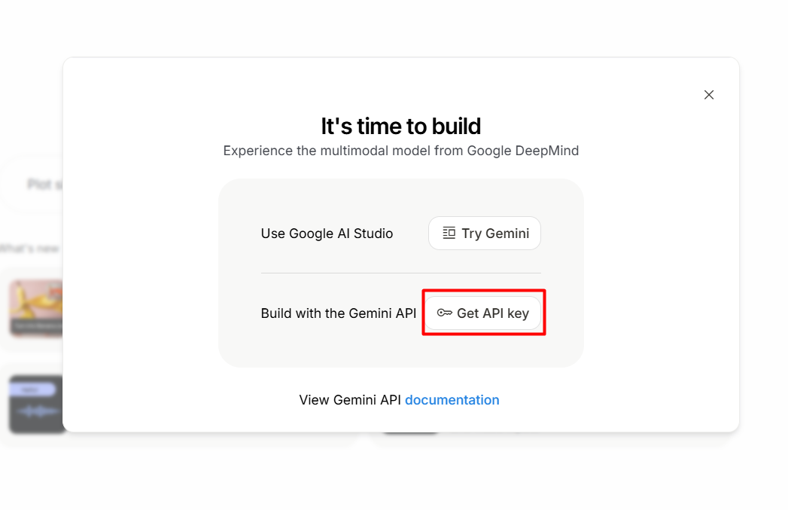
- Accept license
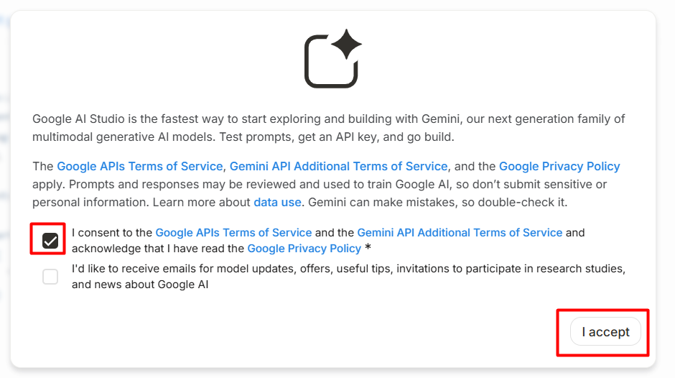
- Click at “Create API key”
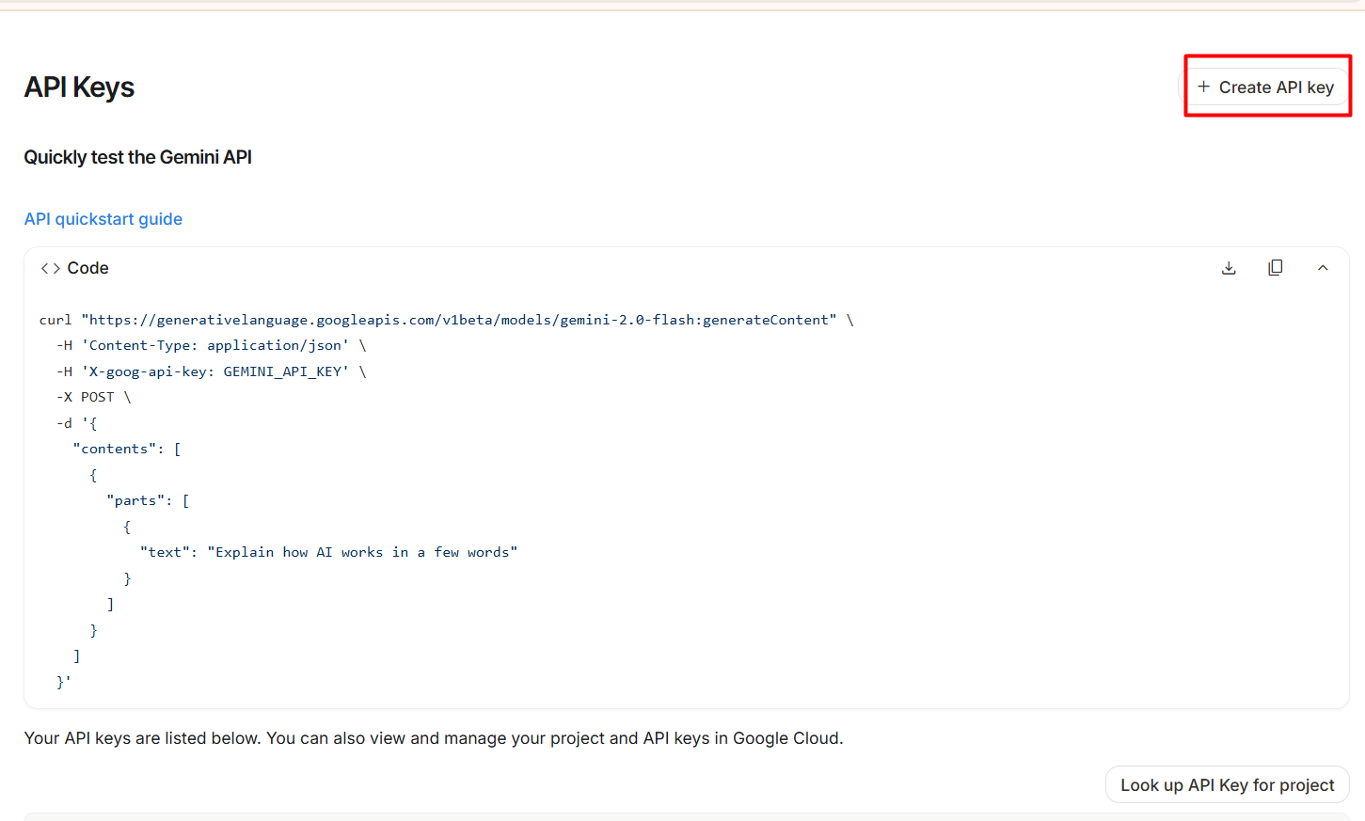
- Copy created API key
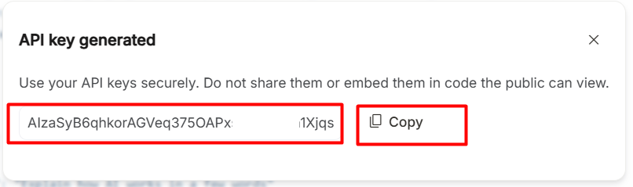ss
- Click at “+” of “Chat Model”
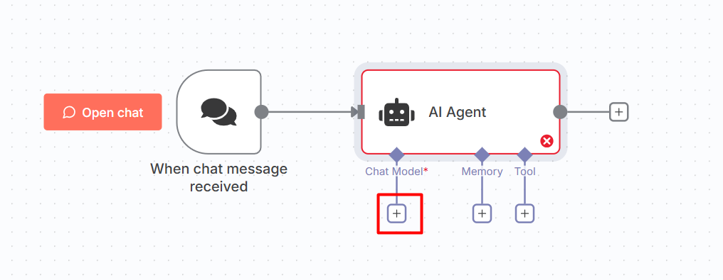
- Select “Google Gemini Chat Model”
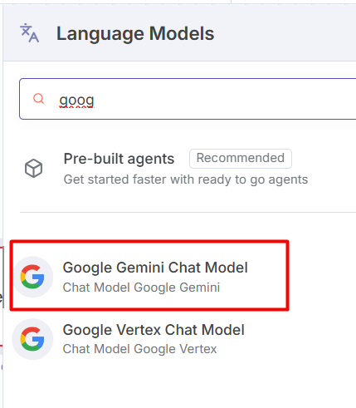
- Click at “+ Create new credential”
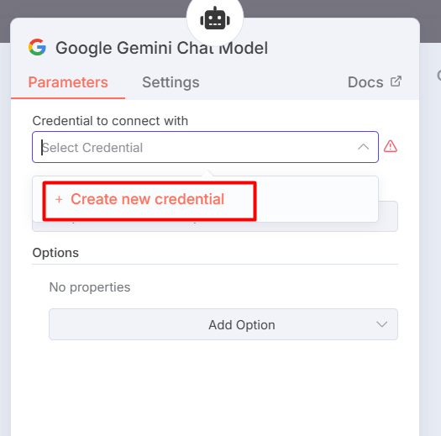
- Paste created API key and “Save”

- Chatbot ready
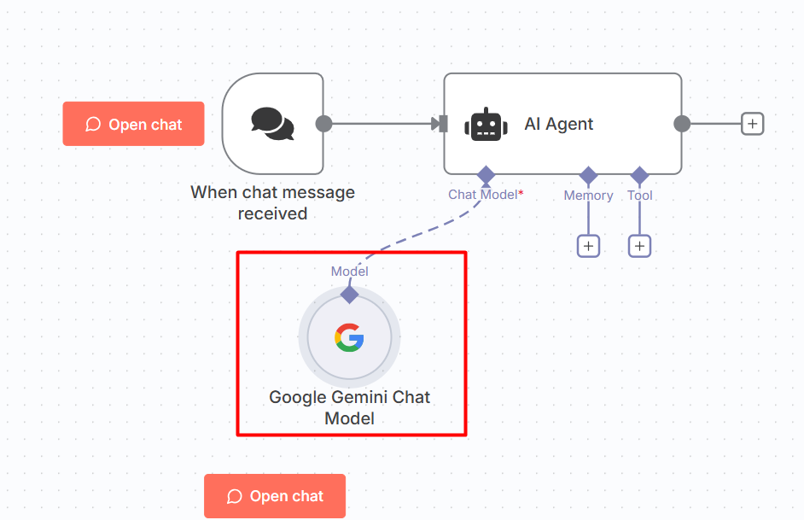
- Click at “Open chat”
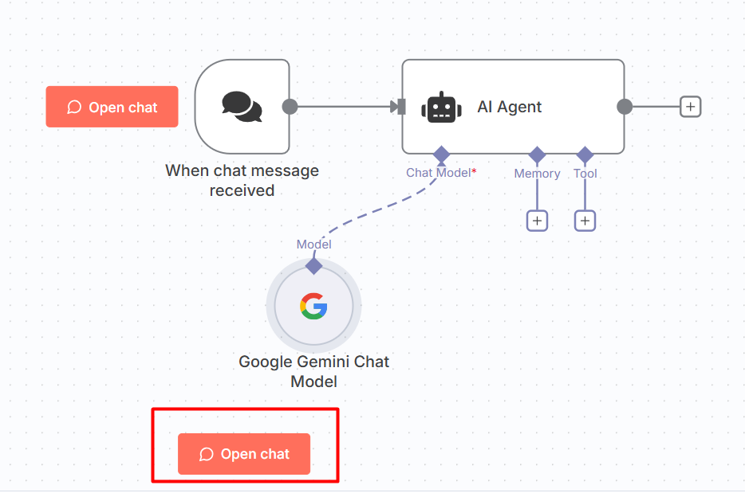
- Chatbot window appear
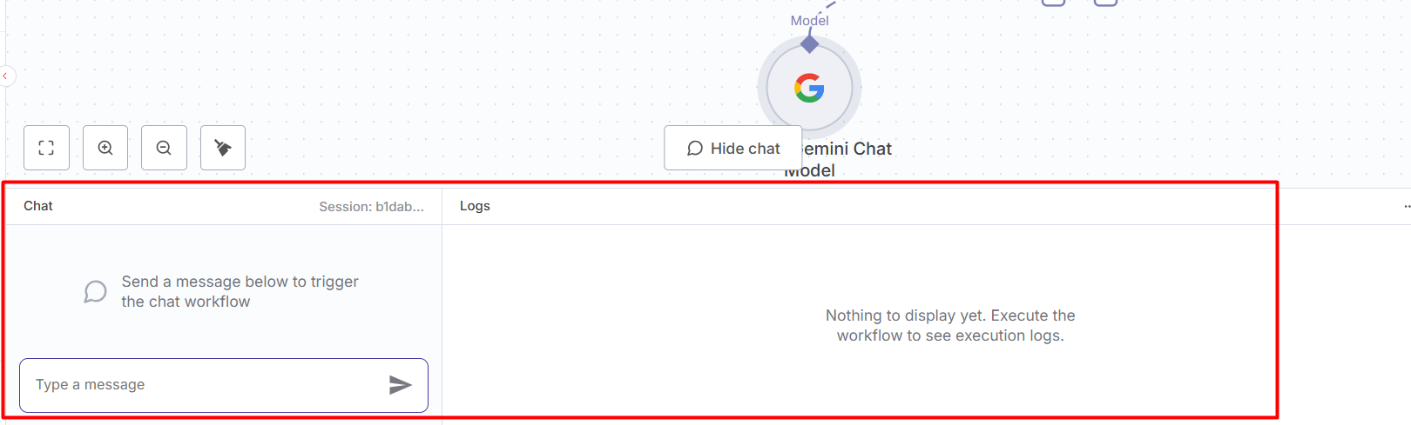
- Send message in chat “What is my name?” then we can see output highlighted in below image:
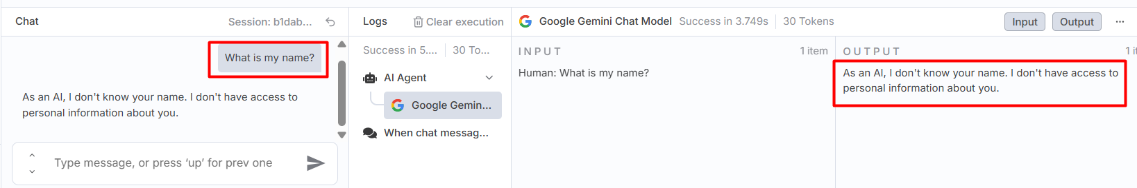
- Send message in chat “My name is PQR.” then we can see output highlighted in below image and also, same reply in chat:
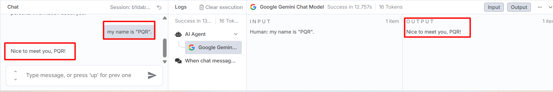
- Now again send message in chat “What is my name?” then we can see output highlighted in below image. LLM forgot previously provided data (name: PQR) because LLM follows stateless protocol by default. Stateless means each prompt (input) we send to the LLM is treated as a separate and independent request. The model does not keep track of previous conversations or sessions on its own. If we want to LLM to remember conversation then we need to save conversation separately.
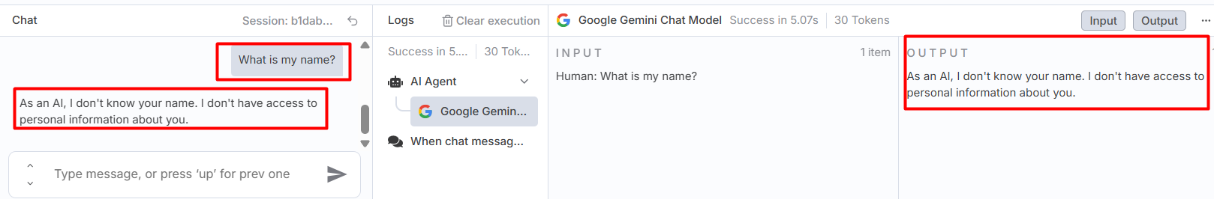
- Below is the option to store conversation with LLM
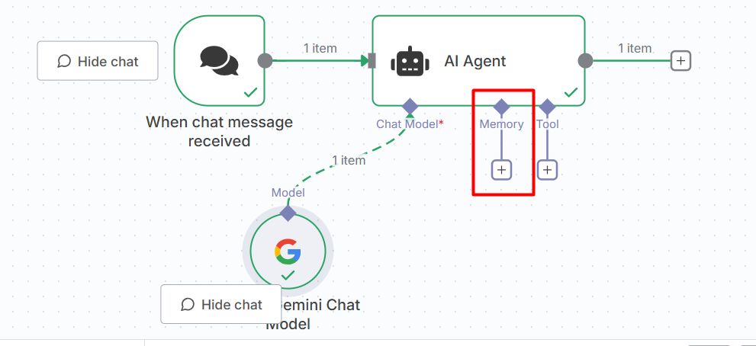
- Add “Simple Memory” by clicking “+”
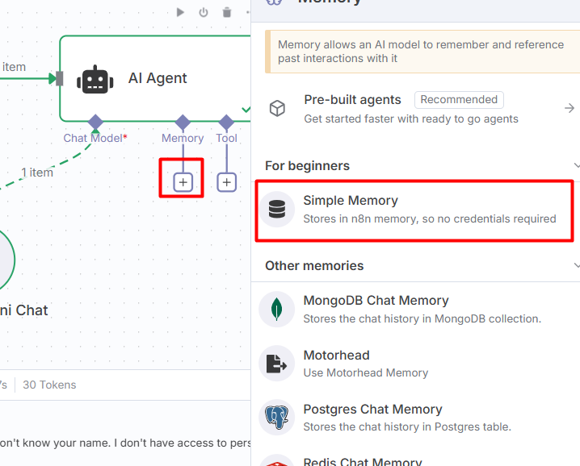
- “Simple Memory” window open
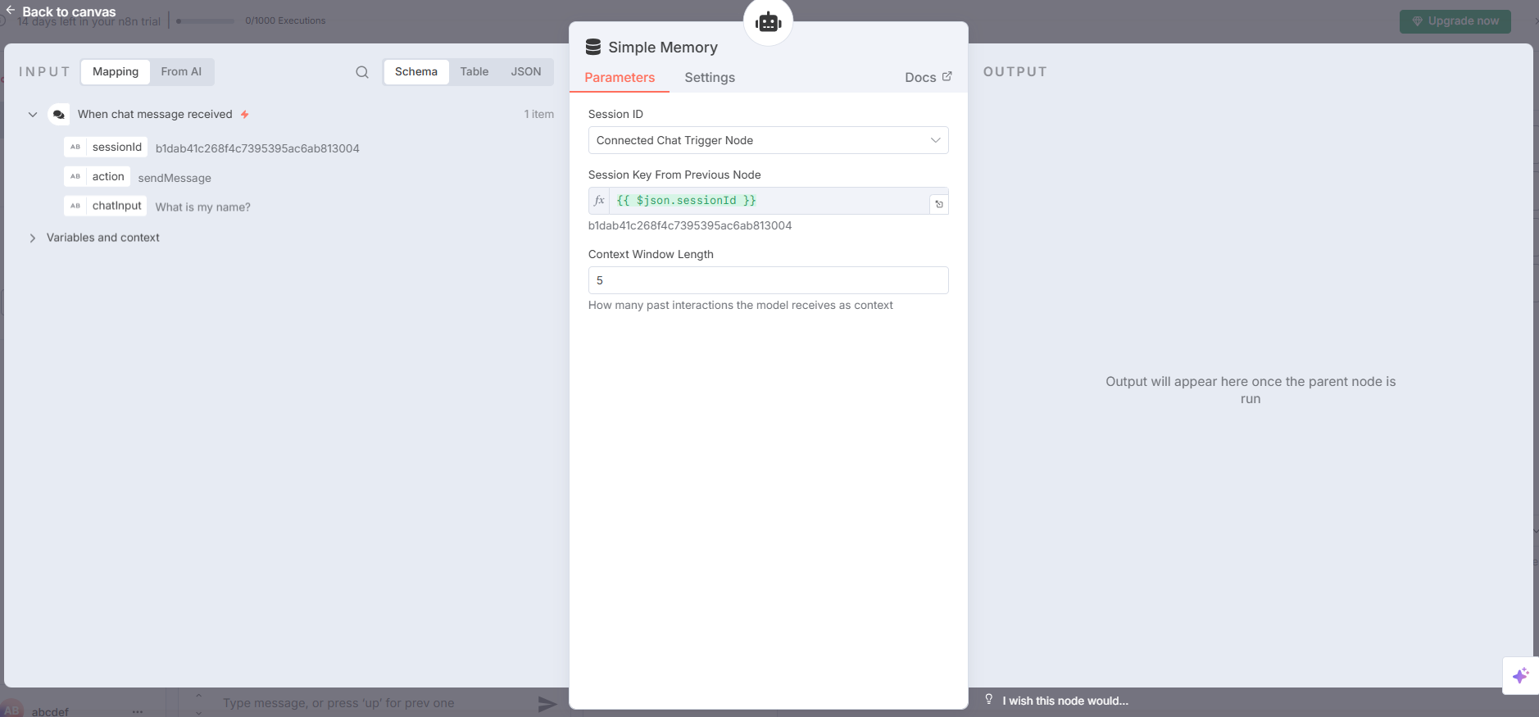
- Now again send message in chat “My name is DEF.” then we can see output highlighted in below image:
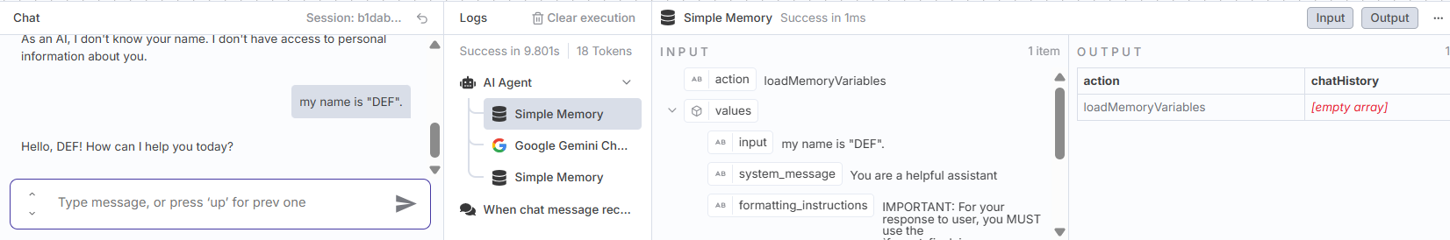
- Now again send message in chat “What is my name?” then we can see output highlighted in below image. Now, LLM remembers chat history.
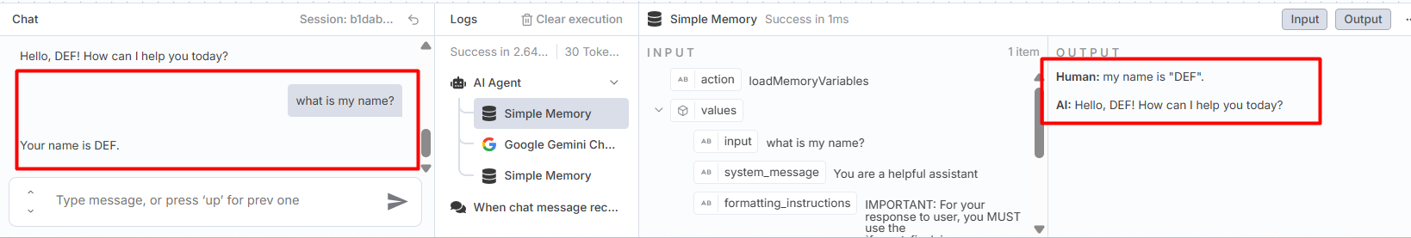
- https://github.com/panaversity/learn-low-code-agentic-ai/tree/main/02_beginner_tutorial
- https://n8n.io/ : It is a cloud environment.
- We can run n8n locally using NodeJS or Docker.
- To install “n8n” using npm, goto:
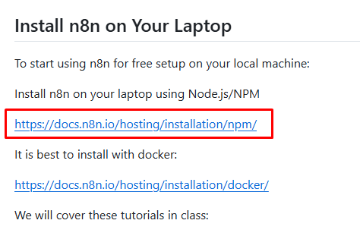
- https://docs.n8n.io/hosting/installation/npm/
- First download and install NodeJS from https://nodejs.org/en/download
- After installation, confirm that NodeJS installed successfully, open cmd at any path and run command : node –v
- You get NodeJS version installed in our system
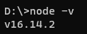
- Check installed Node Package Manager version by command : npm –v
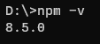
- To install “n8n” globally (means in operating system), use command: npm install n8n -g
- To install or update to a specific version of “n8n” use command like: npm install -g n8n@0.126.1
- To update “n8n” to the latest version, use command: npm update -g n8n
- To install the next version, use command: npm install -g n8n@next
- Check installed “n8n” version by command : n8n –v
- n8n package which we have installed:
