LECTURE-10 (Wednesday 10-September-2025) (Online)
- https://github.com/panaversity/learn-low-code-agentic-ai/tree/main/00_prompt_engineering/image_generation
- It is tutorial of Prompt Engineering for Nano Banana
- Artistic Style


- Corporate Style

- High Fiction Style

- https://github.com/panaversity/learn-low-code-agentic-ai/tree/main/00_prompt_engineering
- 4 aspects of Prompt Engineering
- One major aspect is that user writing prompt without tool calling and get text in LLM response but it will no longer work because MCP server will become common in future.
- Second major aspect is that user writing prompt with tool calling and get text in LLM response.
- Third aspect is that user writing prompt and get image in LLM response.
- Fourth aspect is that user writing prompt and get video in LLM response.
- MCP (Model Context Protocol) is like USB for Prompt Engineering which contains data. Similarly, in future, we will have chance to set MCP server link in ChatGPT or in other applications for tool calling.
- LLM response is multi modal as response contains text, image and video, so in future, all above four aspects will become one.
- Mixture of Experts (MoE): Different model (field) experts are connected with LLM through MoE.
- OpenAI just released “multi-model real-time API”. In future, LLM camera and mic can be used live. In future, you can communicate with Avatar and through MCP server, at the same time, you can give instructions to Robot which is present at your home.
- https://github.com/panaversity/learn-low-code-agentic-ai/tree/main/00_prompt_engineering
- readme.md
- Fundamental Prompting Techniques
- Zero-Shot Prompting: It is the simplest approach in which we just ask question from LLM directly without examples.
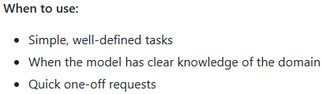
Output using Google AI Studio Chatbot:
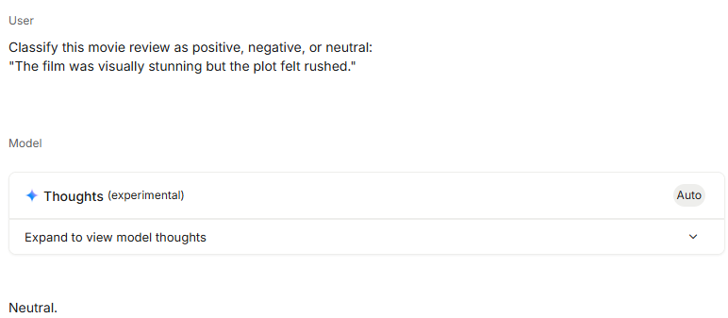
- One-Shot Prompting: In this approach, we provide a single example in prompt to guide LLM the format of response.
Output using Google AI Studio Chatbot:
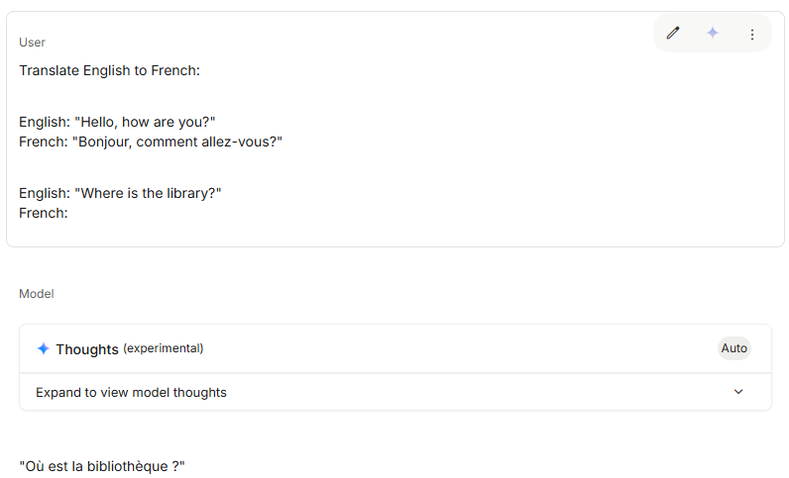
- Few-Shot Prompting: If we use one-shot prompting then there is one disadvantage that next time when we asked any other relative question without example then LLM will consider same example of our first one-shot prompt and will provide response according to first one prompt example for future prompts. To overcome this issue, we can use “Few-Shot Prompting” approach. In this approach, we provide multiple different examples to establish a clear pattern.
Output using Google AI Studio Chatbot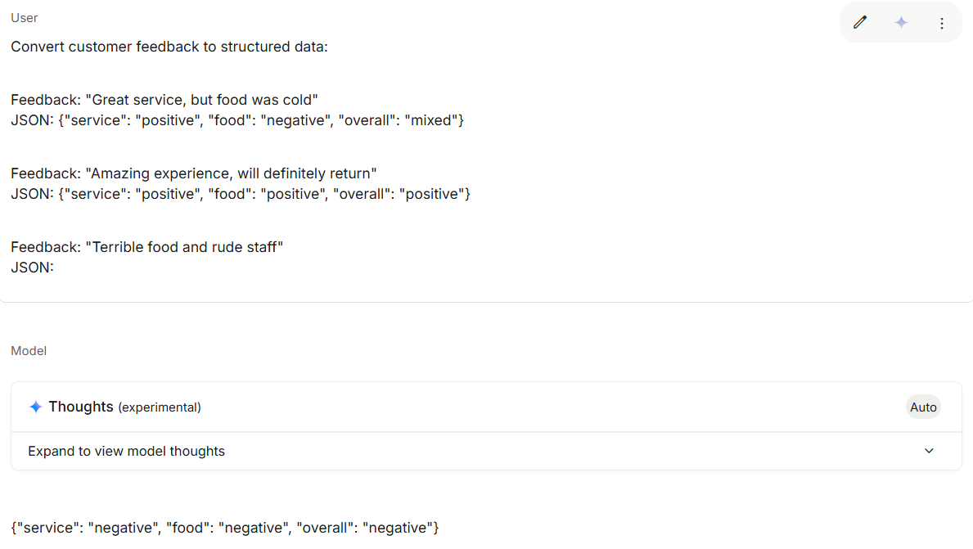
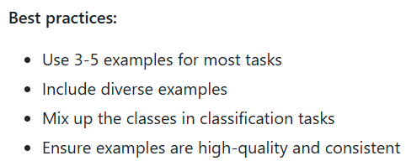
- System Prompting: In this approach, we set overall context, rules and behavior guidelines.
Example:
We have provided below highlighted prompt as System Prompt and we have received response from LLM that it will represent our mentioned role (travel guide) and will share response based on our shared points.
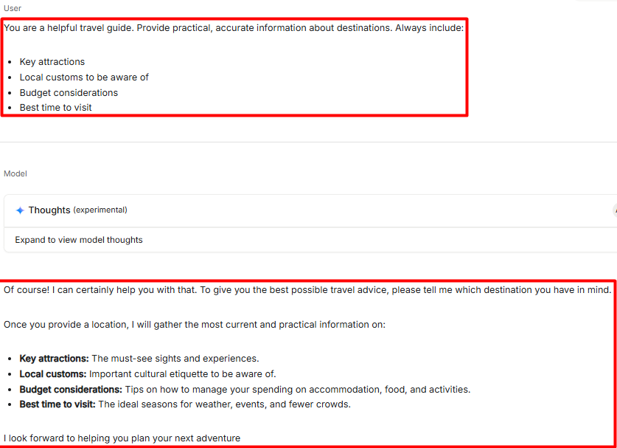
We provided highlighted prompt and based on our pre-defined System Prompt, LLM responded:
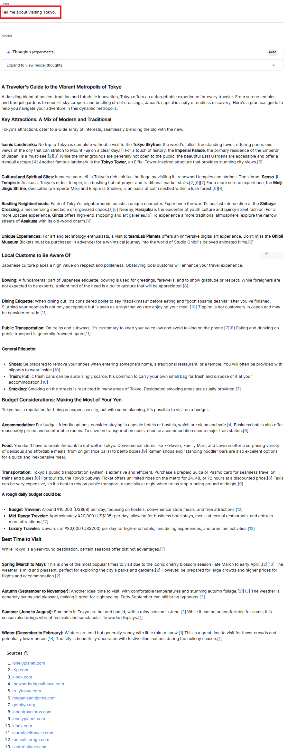
In addition, actual location to set System Prompt is:
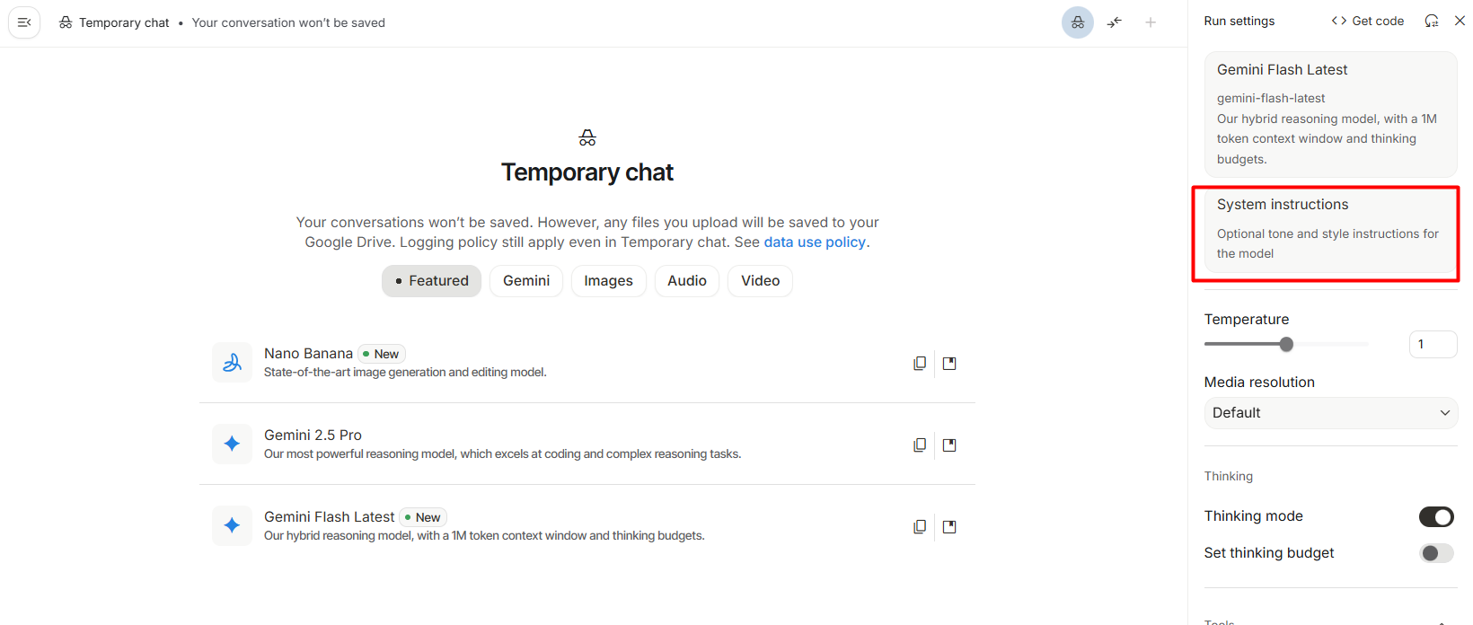
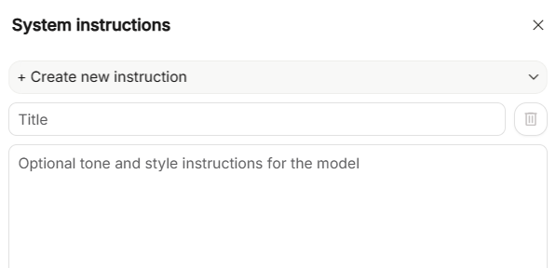

Example:
We set below prompt in “System instructions” with title “Doctor”
Prompt: You are a helpful doctor. Whenever information related to any medicine is asked, always include:
- Formula of medicine
- Company name which is producing mentioned medicine
- Other medicine name having same formula together with their company names
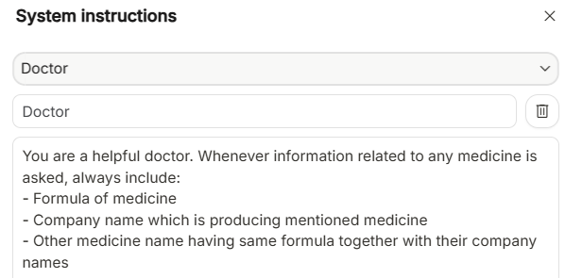

User prompt: Please share information related to medicine "Fexet D"?
Output by LLM:
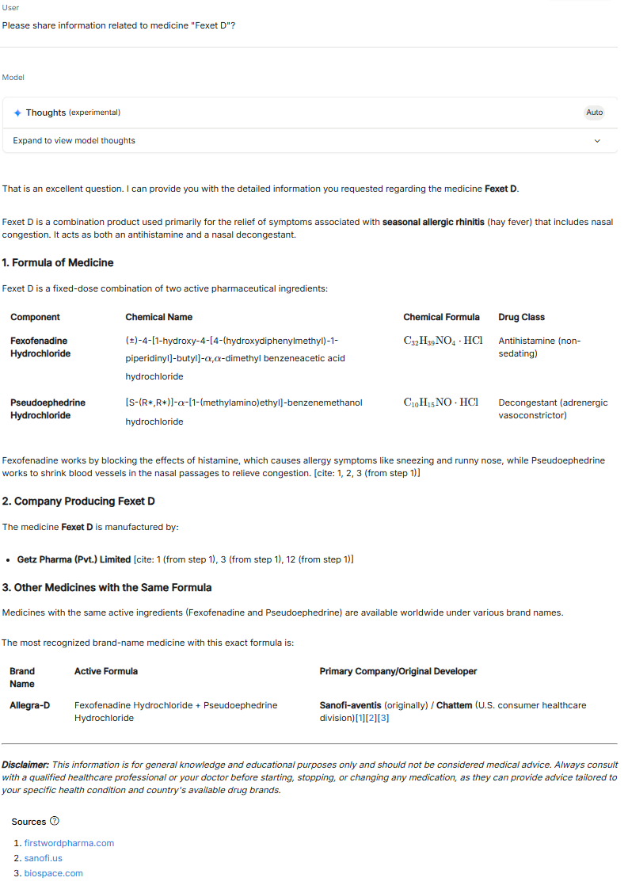
- Role Prompting: In this approach, we assign a specific character or role or expertise to the AI.
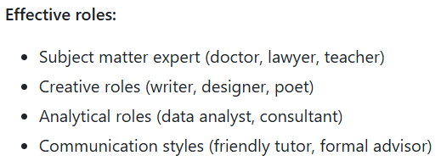
Example:
Prompt: Act as an experienced software architect. I need help designing a scalable web application for 1 million users. What architecture patterns should I consider?
Output by LLM:
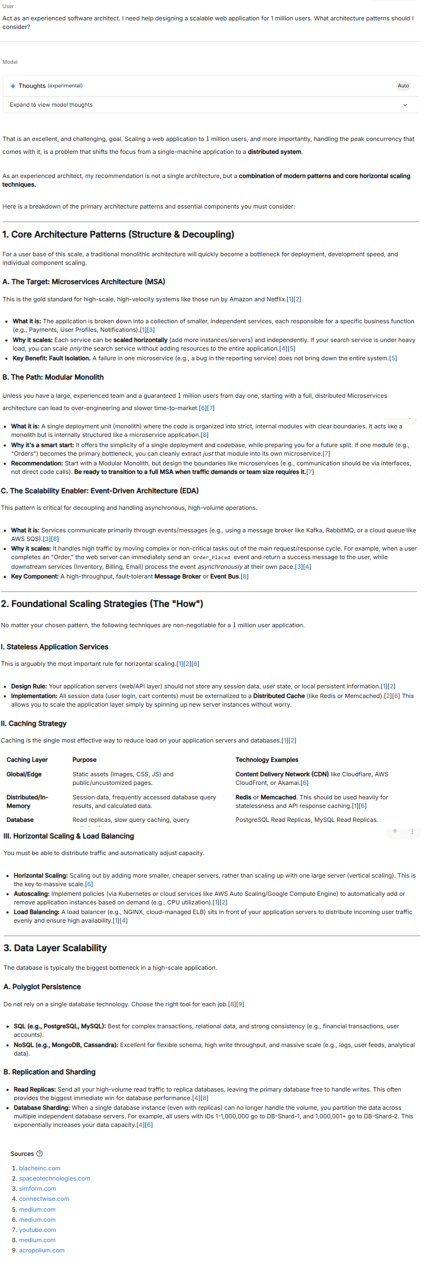
- Contextual Prompting: In this approach, we provide specific background information relevant to the task OR we provide context based on which LLM provide its response.
Example: Context: You're writing for a tech blog aimed at beginners who have never coded before.
Write a 200-word explanation of what an API is, using simple language and practical examples.
Output by LLM:
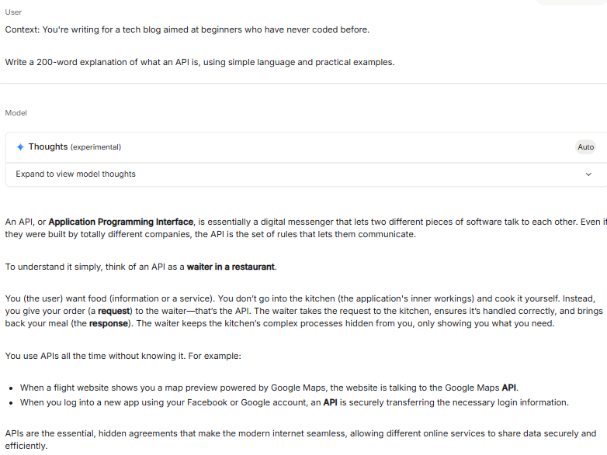
- Thinking Mode: It is a feature in Google AI Studio Chatbot. This feature is available only in “Gemini Flash” version. If “Thinking mode” enabled then AI will use external tools to finalize output of our query. If “Thinking mode” disabled then AI will use its internal reasoning and knowledge base to finalize output.
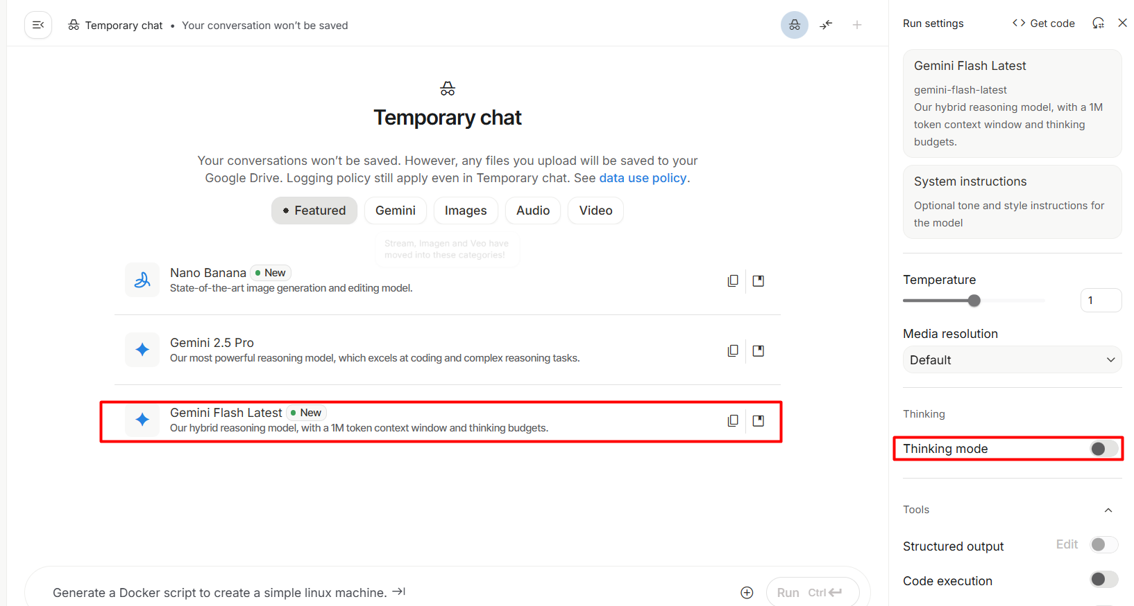
- Advanced Prompting Strategies:
- Chain of Thought (CoT) Prompting: In this approach, we encourage step-by-step reasoning for complex problems.
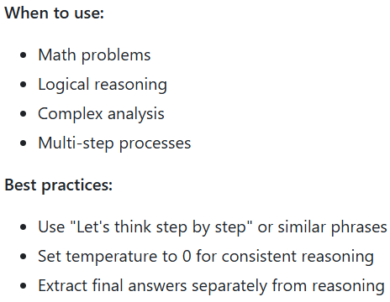
Temperature “0” same answer for same prompt each time.
Example:
Prompt: Solve this step by step:
If I was 6 when my sister was half my age, how old is my sister when I'm 40?
Let me think through this step by step:
Output by LLM:
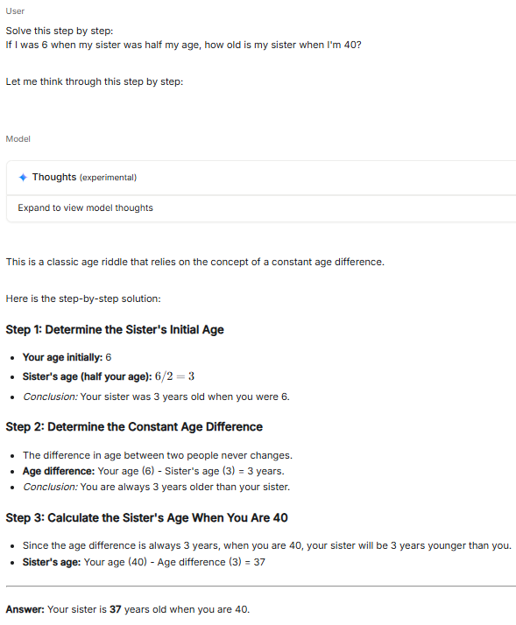

- Self-Consistency: In this approach, we generate multiple reasoning paths and select the most common answer OR we provide 4 or 5 prompts to LLM and choose the common answer present from LLM responses.
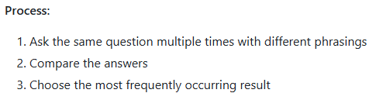
Example:
Prompt: If a store offers a 20% discount on a $50 item, what is the final price?
Generate 3 different reasoning paths for this question and select the most consistent answer.
Output by LLM:

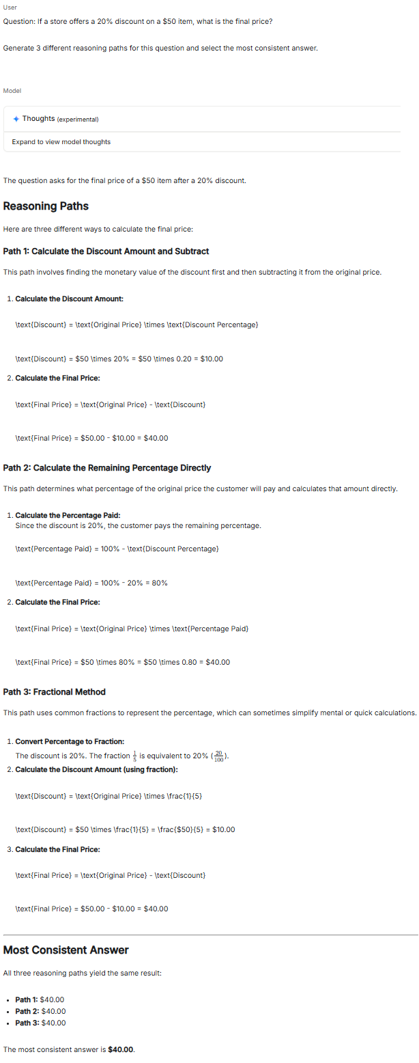
- Step-Back Prompting: In this approach, first we ask a more general question then use that context for the specific question.
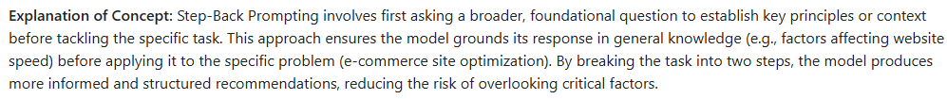
Example 1:
Prompt: what are the key principles of good user interface design?
Output of LLM:
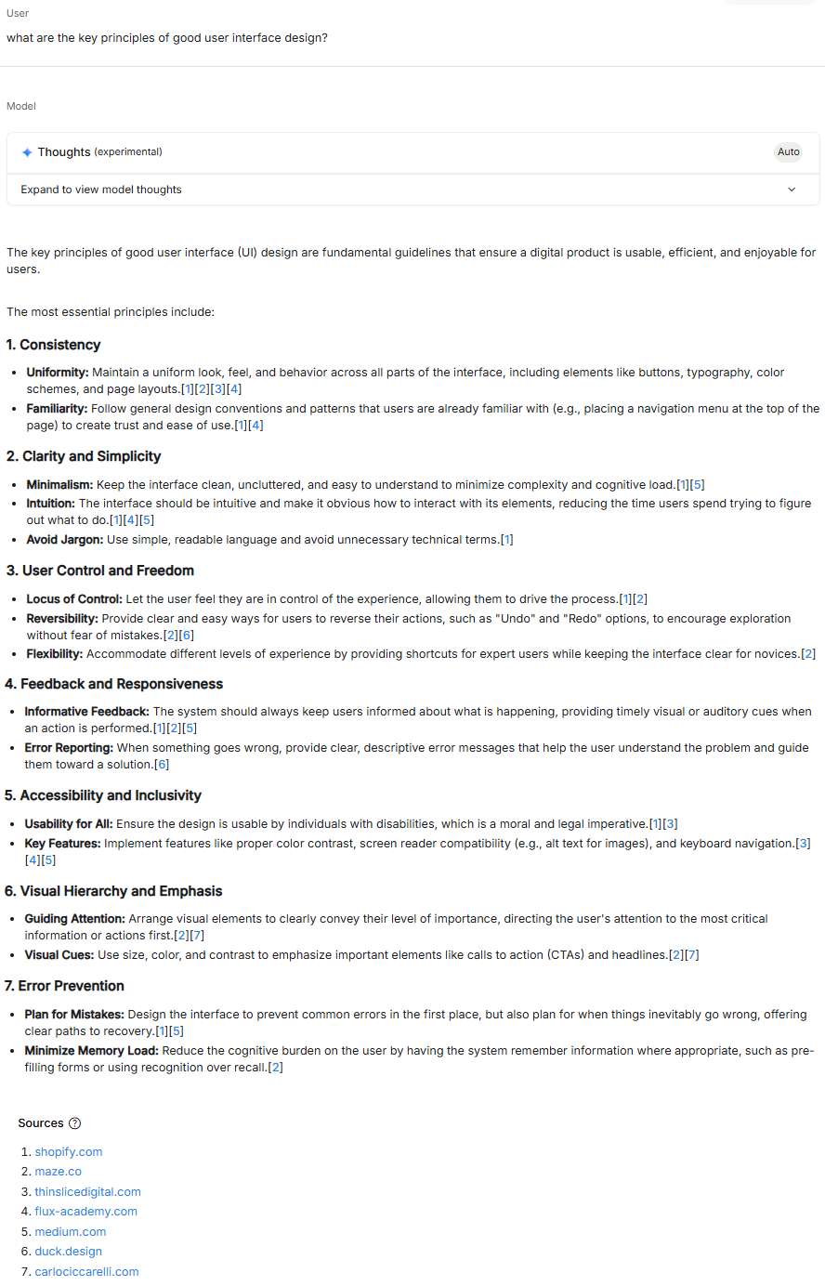
Now, use prompt based on above response: Now, using those principles, redesign a basic mobile app's login screen
Output of LLM:
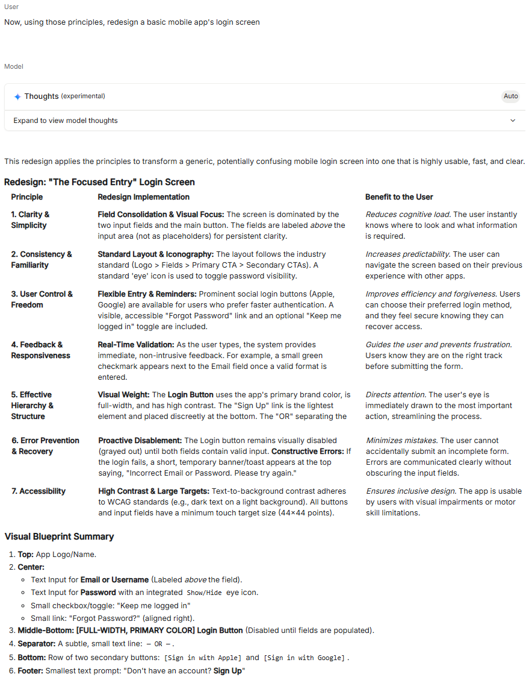
Example 2:
Prompt: what are the key factors that generally affect website loading speed?
Output of LLM:
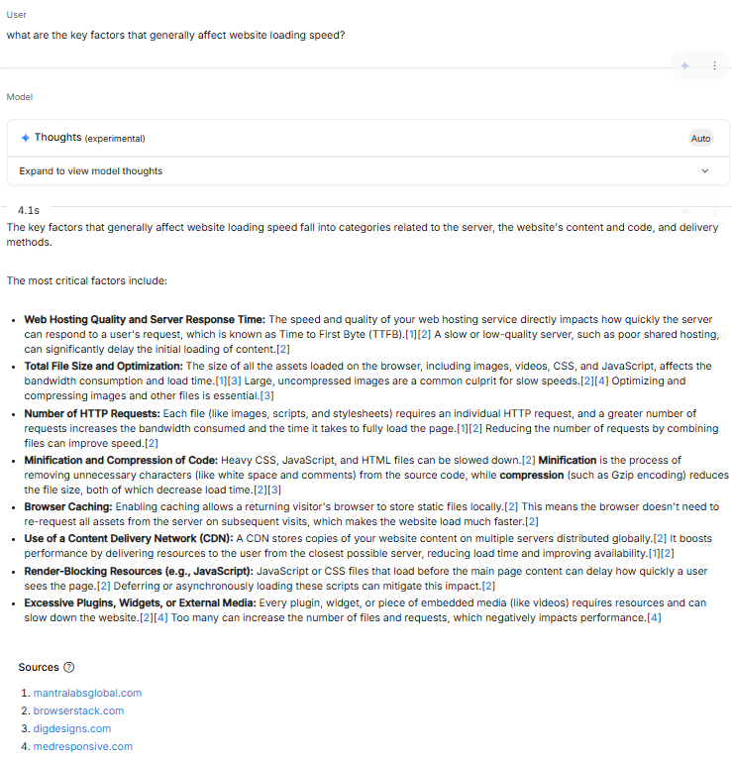

Now, use prompt based on above response: using these factors, provide specific recommendations to optimize the loading speed of an e-commerce website with heavy product images and multiple third-party plugins.
Output of LLM:
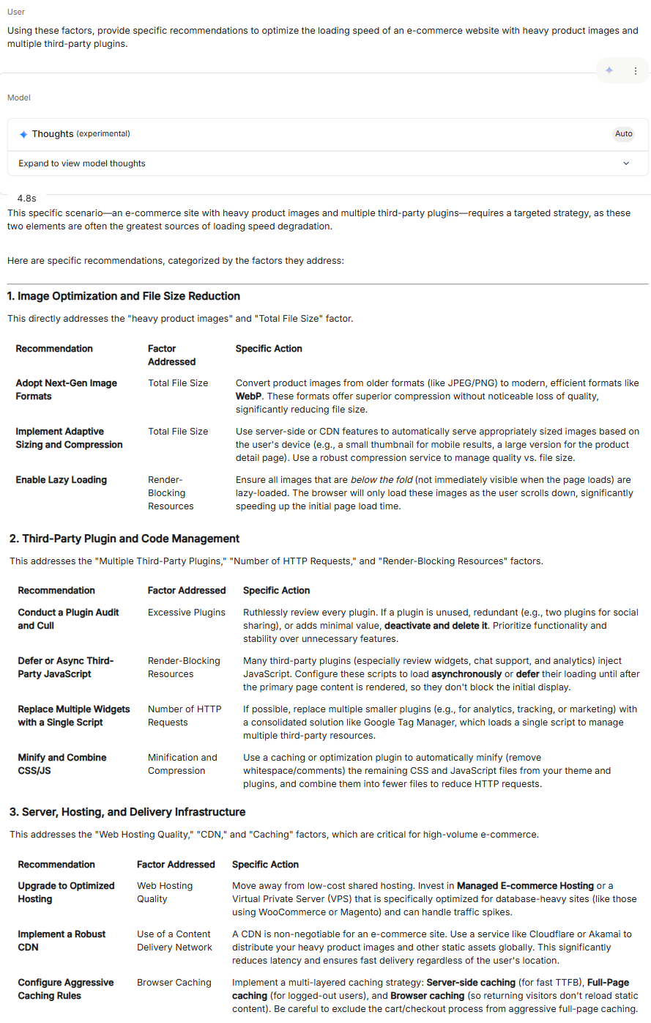

- ReAct (Reasoning/Thoughts + Acting): In this approach, we combine reasoning/thoughts with tool use or actions. It means that we do iterative/loop prompting to finalize answer because prompt depends on the answer of LLM.
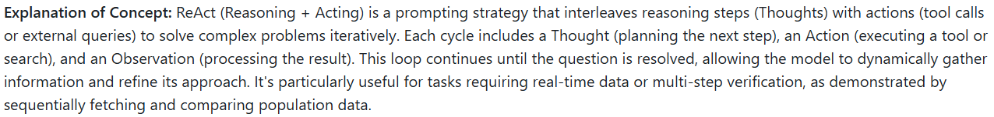
Example 1:
Question) I need to find out how many children the members of Metallica have in total.
Thought: I need to find information about each band member and their children.
Action Prompt: Search for "Metallica band members"
Observation: LLM result
Thought: Now I need to search for each member individually...

Example 2:
Question: What is the current population of Tokyo, and how does it compare to New York City?

Thought: I need to find the current population of Tokyo and New York City to compare them. I should start by searching for the latest population data for Tokyo.
Action Prompt: what is the current population of Tokyo
LLM response : current population of Tokyo 2025
Observation: [Assume tool response: According to recent estimates, Tokyo's population in 2025 is approximately 37.4 million in the metropolitan area.]
Thought: Now I have Tokyo's population. Next, I need the population for New York City.
Action Prompt: what is the current population of New York City
LLM response : current population of New York City 2025
Observation: [Assume tool response: New York City's metropolitan area population in 2025 is estimated at about 23.6 million.]
Thought: With both figures, I can compare them. Tokyo has a larger population than New York City by about 13.8 million people.
Final Answer: Tokyo's population is approximately 37.4 million, compared to New York City's 23.6 million, making Tokyo significantly larger.

- Tree of Thoughts (ToT): In this approach, we explore multiple reasoning branches simultaneously for complex problems. It means that we observe reasons of LLM responses, take useful part from each LLM response and combine them to finalize answer.
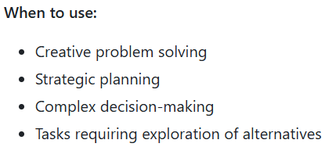

Example:
Question: What is the best marketing strategy for launching a new eco-friendly clothing brand targeting young adults?

Task: Explore multiple strategic approaches, evaluate them, and select the best one.

Branch 1: Social Media Campaign Thought: Young adults are active on platforms like Instagram and TikTok. A campaign using influencers could build brand awareness.
Exploration:
Pros: High engagement, visually appealing for clothing, cost-effective with micro-influencers.
Cons: Risk of inauthentic partnerships, oversaturation in influencer marketing. Evaluation: Strong for visibility but needs unique content to stand out.
Score:8/10

Branch 2: Sustainable Pop-Up Events Thought: Hosting pop-up shops at eco-conscious festivals or college campuses could create direct engagement.
Exploration:
Pros: Hands-on experience with products, builds community, aligns with eco-friendly values.
Cons: High logistical costs, limited geographic reach. Evaluation: Great for brand authenticity but resource-intensive.
Score: 7/10.

Branch 3: Collaborative Partnerships Thought: Partnering with eco-friendly brands (e.g., sustainable accessories) could cross-promote to aligned audiences.
Exploration:
Pros: Expands reach via partner networks, reinforces eco-mission.
Cons: Complex coordination, potential brand dilution. Evaluation: Effective for niche targeting but requires careful partner selection.
Score: 7.5/10.

Synthesis: Combine a social media campaign (Branch 1) with selective pop-up events (Branch 2) for maximum impact. Use partnerships (Branch 3) to amplify reach at events.

Final Strategy: Launch with a TikTok influencer campaign showcasing eco-friendly clothing, paired with pop-up shops at green festivals to engage young adults directly. Collaborate with a sustainable accessory brand to co-promote at events.
- Best Practices for Effective Prompts:
- Be Specific and Clear:
Bad: Write about dogs.
Good: Write a 300-word informative article about the health benefits of owning a dog, focusing on mental health, physical activity, and social connections. Use a friendly, accessible tone for general readers.
- Use Action Verbs: Be explicit about what you want the AI to do:
- Analyze, Compare, Create, Describe, Evaluate
- Extract, Generate, List, Rank, Summarize
- Translate, Write, Explain, Classify
- Provide Examples When Possible: Examples are the most powerful way to communicate your expectations.
- Structure Your Prompts: use clear formatting:
Task: [What you want done]
Context: [Background information]
Format: [How you want the output structured]
Example: [Sample of desired output]
- Use Instructions Over Constraints
Better: Write a professional email summarizing the key points from our meeting.
Avoid: Write an email but don't make it too long or too informal or too detailed.
- Control Output Format: specify exactly how you want the response structured:
Example:
Prompt: return your answer as a JSON object with the following structure:
{
"main_idea": "string",
"supporting_points": ["string", "string"],
"confidence_level": "high/medium/low"
}
- Use Variables for Reusability:
Example:
Prompt:
Role: You are a {expertise} expert
Task: Analyze the {document_type} and provide recommendations for {target_audience}
Context: This is for a {industry} company with {company_size} employees
- Iterate and Document:
- Keep track of what works and what doesn't
- Document your successful prompts
- Test variations to improve performance

