LECTURE-03 (Thursday 21-August-2025) (Online Class 2)
- YouTube link: https://www.youtube.com/live/L1VeDki57H4?si=EL999idmBUdEbswZ
- In n8n, “AI Agent” node is called clustered node because this node can have multiple connections:
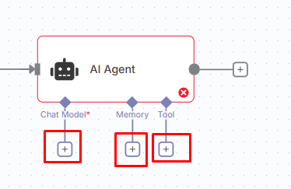
- Below highlighted arrow indicates flow as well as indicates that output of previous node is passed to arrow connected node and considered as input for arrow connected node.
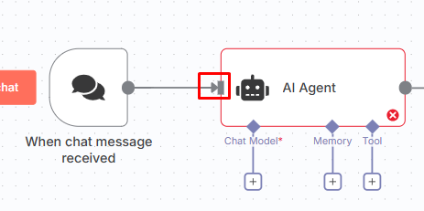
- Inactive: If we add scheduled node then it cannot be automatically executed and we need to execute scheduled node manually if workflow is set to “inactive”. If we set workflow to “active” then scheduled node executed automatically at scheduled time.
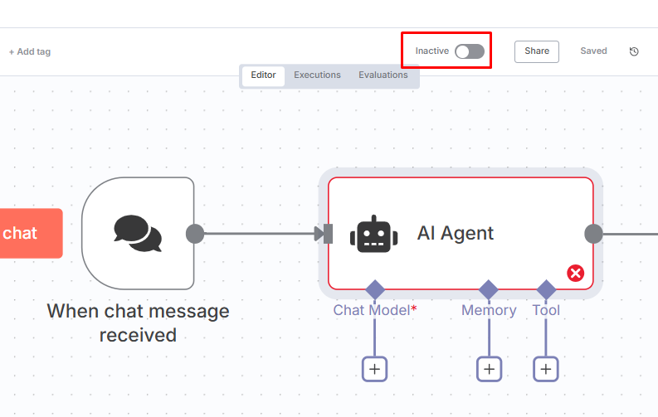
- If we open “AI Agent” node, at left side “INPUT” window is present while “OUTPUT” window is present at right side.
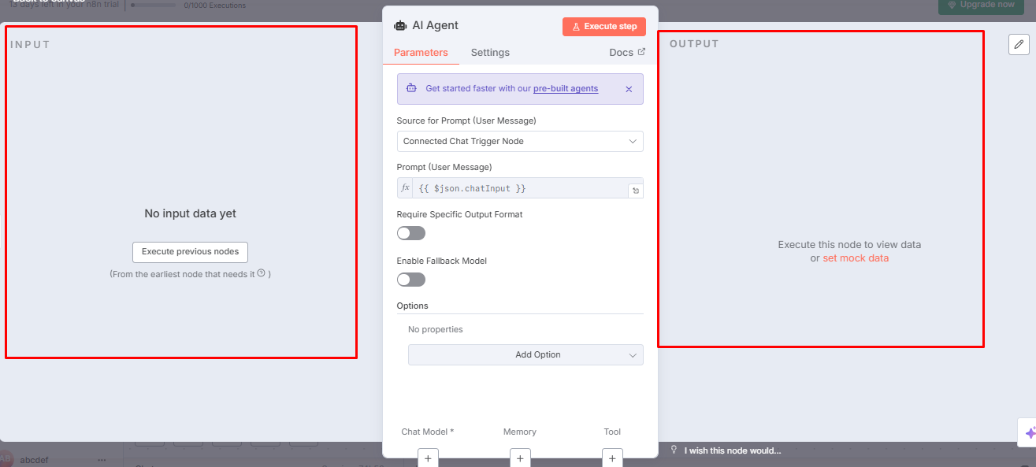
- Expressions: It is output data encoded in curly brackets of one node, passed as input parameters to next node.
- https://github.com/panaversity/learn-low-code-agentic-ai
- Lecture-01 Repetition
- Workflow always starts with Trigger node.

