LECTURE-07 (Saturday 31-January-2026)
- https://agentfactory.panaversity.org/docs/General-Agents-Foundations/markdown-writing-instructions
- Chapter 2 : Markdown
- Markdown language is understandable for both LLM and human.
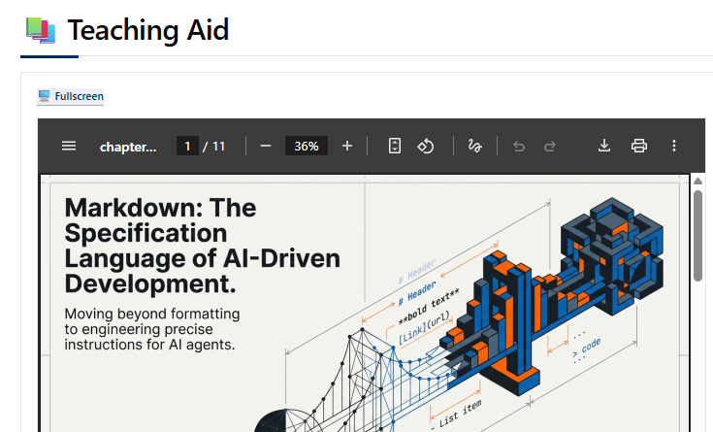
- https://pub-80f166e40b854371ac7b05053b435162.r2.dev/books/ai-native-dev/static/slides/part-1/chapter-02/chapter-02-slides.pdf
- LLM output format is by default “Markdown” since start.
- OpenAI trained its model on the basis of Markdown language.
- 3 layers of AIDD (Architecture AI Driven Development)
- Intent : what human wants
- Decision making
- Performing action
- Speckit and Github both belongs to Microsoft.
- Online Markdown language preview : https://markdownlivepreview.com/
- Heading defines scope and hierarchy.
- In a markdown file, “#” (hash) used only once and at the top of file and space required after “#”
- Do not skip any step/level, which means after single hash, double hash will come, do not use triple hash.
- Unordered list means instructing LLM to perform action in parallel. For it, we can use bullets.
- Ordered list means dependency as step 2 depends on completion of step 1. We need to use numbering.
- Three back tick (```) used for block of code, also mention language in which code is written. Ending of code is also required with 3 bac kticks.
Example:
```python
def greet(name)
return "HELLO"
```

Output:
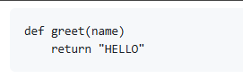
- First, LLM contains big data then comes MOE (mixture of experts)
- If we do not mention language then tokens usage increased as LLM first looks for expert.
- Bold or capitalize letters means required.
- Italic means good to be.
- Bold and italic means critical system requirement
- Hyperlink or Anchoring or Alt is defined as “[Alt/Anchoring Text](Alt/Anchoring text link)
Example:
[Visit Google](https://www.google.com)

Output:

It is good to give alt text for image.
- Spec Driven Development determines flow.
- AIDD (AI Driven Development) determines flow of doing something.
- “.md” is the extension of markdown file.
- https://agentfactory.panaversity.org/docs/General-Agents-Foundations/markdown-writing-instructions/introduction
Input:
# Heading One

## Heading Two

### Heading Three

#### Heading Four

##### Heading Five

###### Heading Six

Normal

**Bold**

*Italic*

***Bold Italic***

**Not Bold**

Output:
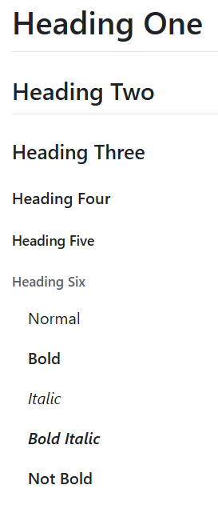

Input:
# Science

## Animals
- Mamals
- Birds
- Insects

## Plants
78. Trees
2. Herbs
3. Shurbs

Output:
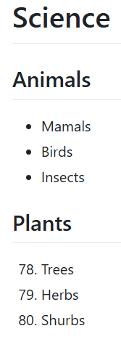
- Numbers always synced automatically
Input:
## Animals
- Mamals
* Birds
+ Insects

Output:
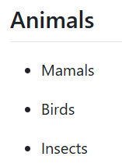

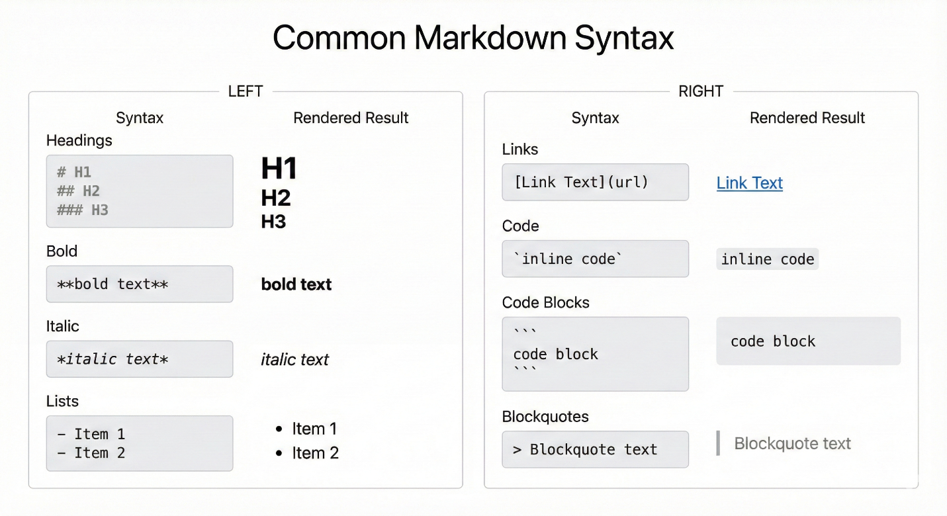

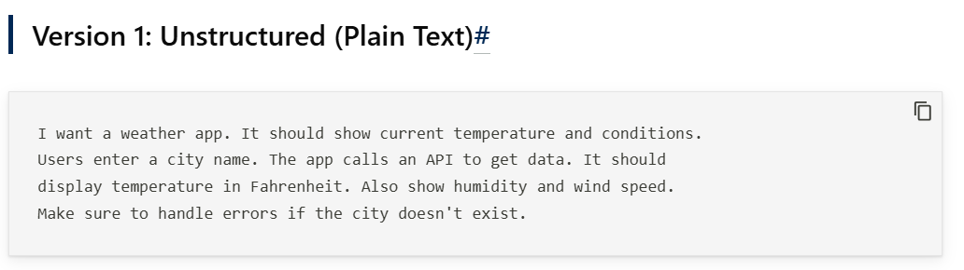
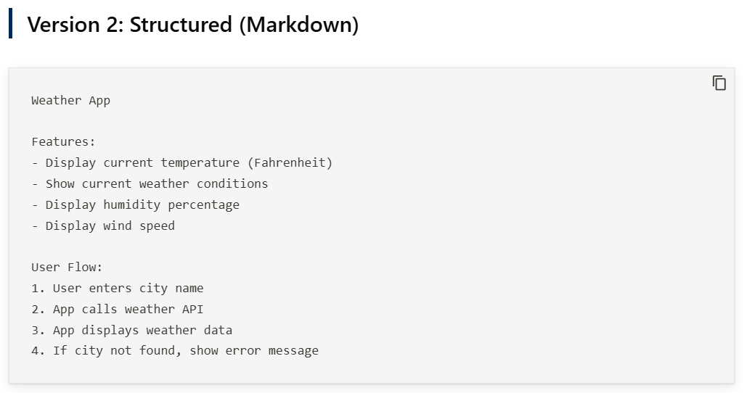
- https://agentfactory.panaversity.org/docs/General-Agents-Foundations/markdown-writing-instructions/headings
- Chapter 14
- https://agentfactory.panaversity.org/docs/General-Agents-Foundations/general-agents
- https://agentfactory.panaversity.org/docs/General-Agents-Foundations/general-agents/claude-md-context-files
- Command to initialize Claude Code file: claude init .
Press Enter
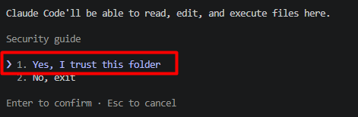
Select “1”
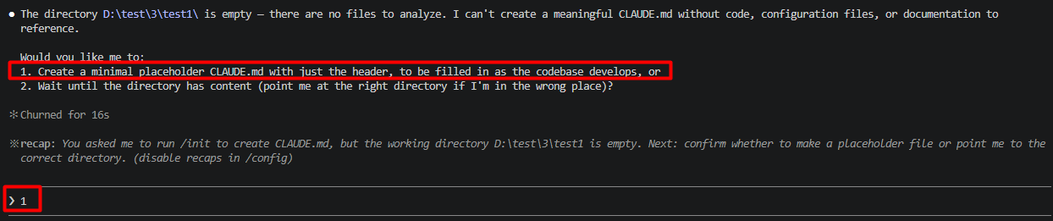
Select “1”
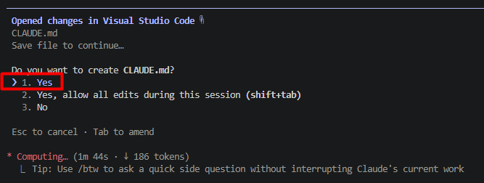
“CLAUDE.md” file created.
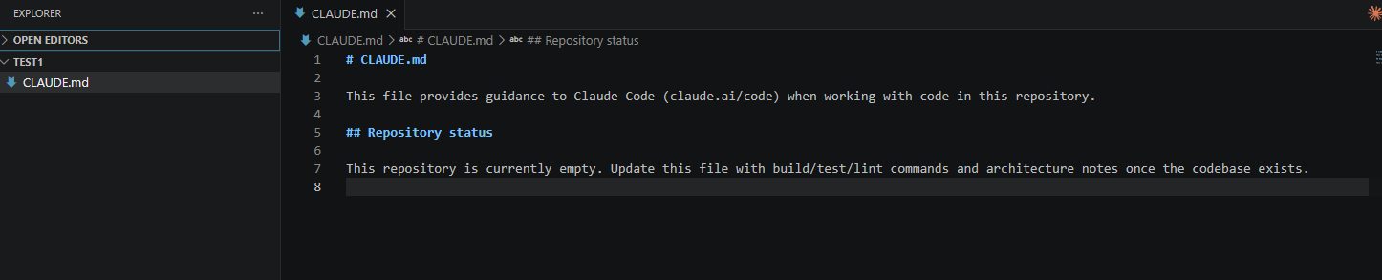
- Prompt to show path where we are present: pwd
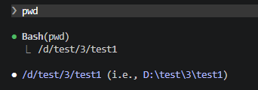
- https://agentfactory.panaversity.org/docs/General-Agents-Foundations/general-agents/agent-skills
- Recommended path structure for skill file : ProjectRootFolder/.claude/skills/meeting-notes/meeting.md
- ProjectRootFolder/.claude/skills.md: This skill is considered as skill for whole project.
- Always mention when skill needs to be executed.
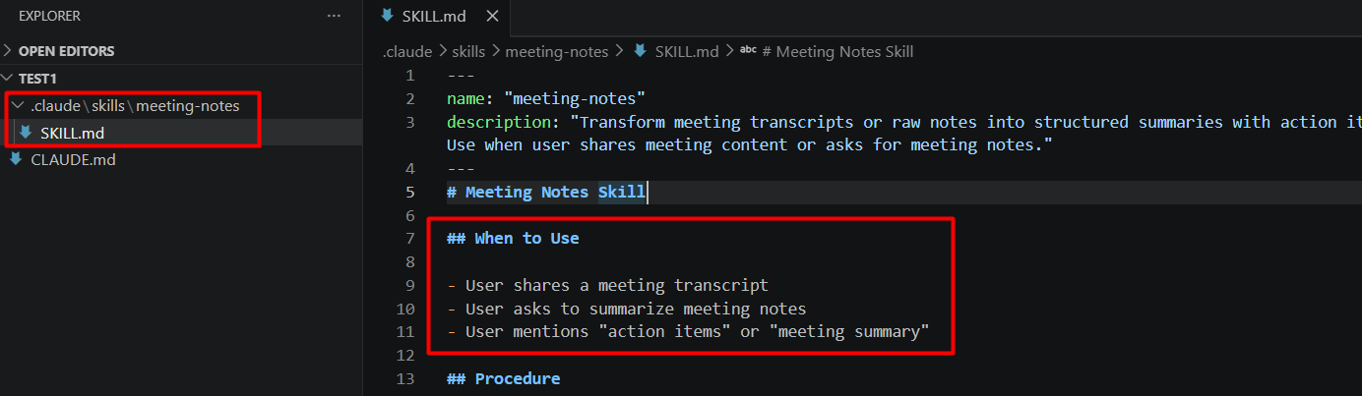
- “/skills” returns skills.
