LECTURE-01 (Sunday 18-October-2026)
- Every Claude’s chat bot session have a separate virtual machine at backend.
- LLM is stateless, AI thinks (inference) and AI provides output.
- AI agentic creates a framework to communicate with LLM.
- Harness: all working around LLM called Harness.
- LLM capabilities and harness (send request and get response from LLM), two things on which AI companies focused or having competition.
- OpenAI SDK (harness) : send request and get response from LLM
- Oct 2025, Boris Cherny (founder of Claude Code) connected CLI from Chatbot (Claude CLI)
- Claude Cowork by Anthropic: it gives an AI assistant a workspace where it can help carry out multi-step tasks involving files, documents, and other work.
- Cowork is like delegating a job to an AI assistant, rather than simply asking it a question.
- Difference between Cowork and OpenClaw:
Anthropic's Cowork is a ready-made AI coworker for getting work done. It is best for delegating everyday professional work without building your own AI system.
OpenClaw is an open-source platform for building and running your own AI assistant. It is best for building a customizable assistant that can connect to your messaging apps and devices.
Recommendation: If you are a non-technical user who wants to get productive immediately, start with Cowork but if you are comfortable with technical setup and want to build a highly customized assistant that can communicate through WhatsApp or Telegram and automate your own workflows, start with OpenClaw.
- If harness needs processed in local computer then for this purpose, system needs turned on and cannot shut down. To overcome this issue, harness will run at cloud servers.
- Every session connected to cloud server.
- To avoid sensitive data leakage during session, every session have a separate virtual machine.
- 4 certifications: https://agentfactory.panaversity.org/docs/certifications

- Exam: https://agentfactory.panaversity.org/docs/certifications/pcao-f
- We need email id of Claude Partner for Claude Certification
- Fees of Claude Associate Exam is “99$”.
- To get email id, we need to give Mock Test and Viva.
- Previously, company go to consultant for their issue, consultant share presentation related to issue and then MOU signed between consultant and company then team of consultant come and fix issue.
- FDE (Forward Deploy Engineer) is an AI consultant who comes to company and fix issue at company by sitting in company together with domain expert of company.
- If company hired FDE then FDE becomes “AI Solution Architect”
- Plugins will be considered as “Product” by which we can earn “10$”.
- For associate certification, we have to study 10 crash courses : https://agentfactory.panaversity.org/docs/foundations
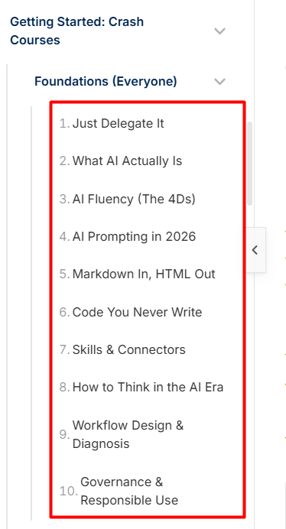

- If you weak in English then identify difficult English vocabulary first, understand it in simple language and create a cheat sheet to make future reading easier.
- First target, mock test : https://agentfactory.panaversity.org/docs/certifications/pcao-f
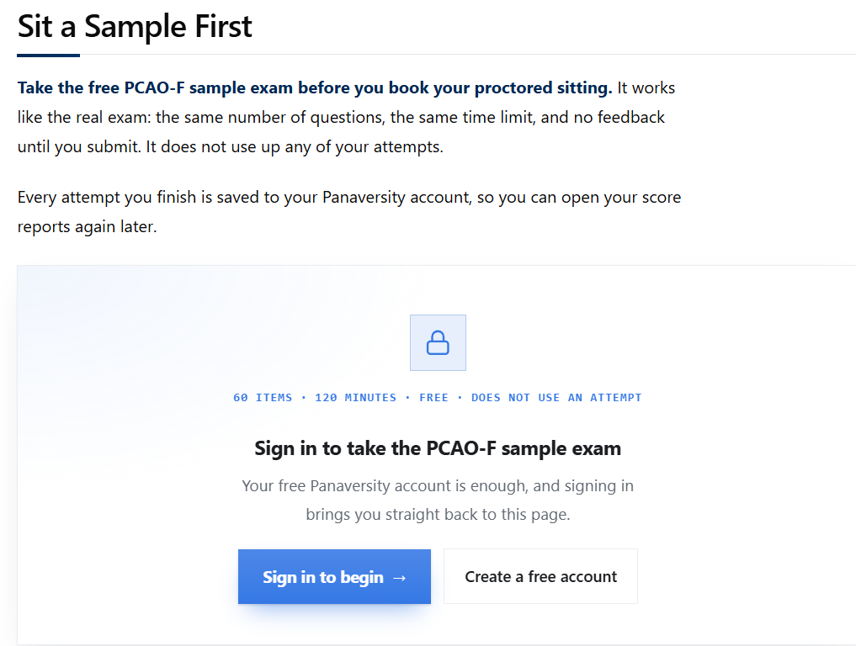

- Every crash course have test questions in then end “Flash Cards”.
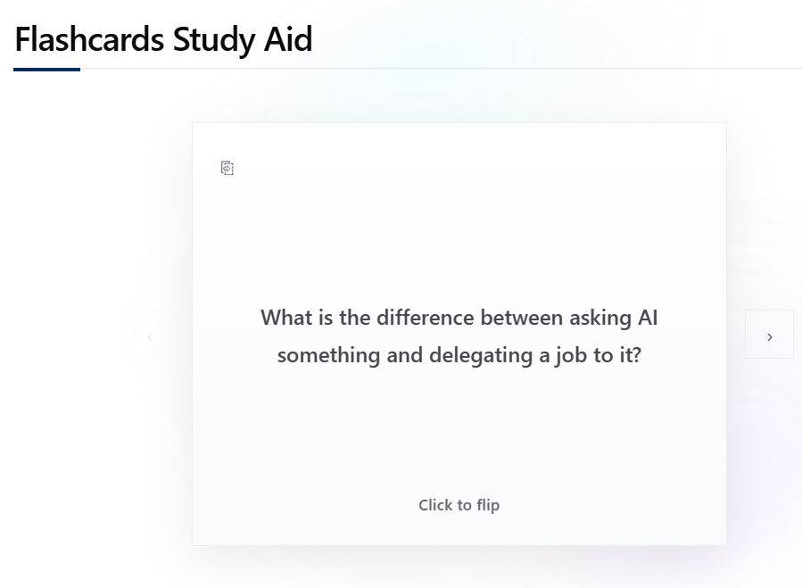
- Mock test: 60 questions in 120 minutes
https://agentfactory.panaversity.org/docs/certifications/pcao-f
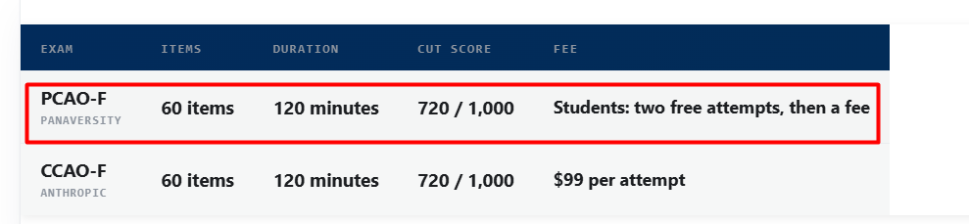
- Depending on questions complexity, marks of question varies.
- Do not memorize but clear the concept.
- PIAIC mock test is harder than Claude certification test.
- We have to secure “720” out of “1000”.
- https://agentfactory.panaversity.org/docs/certifications/pcao-f
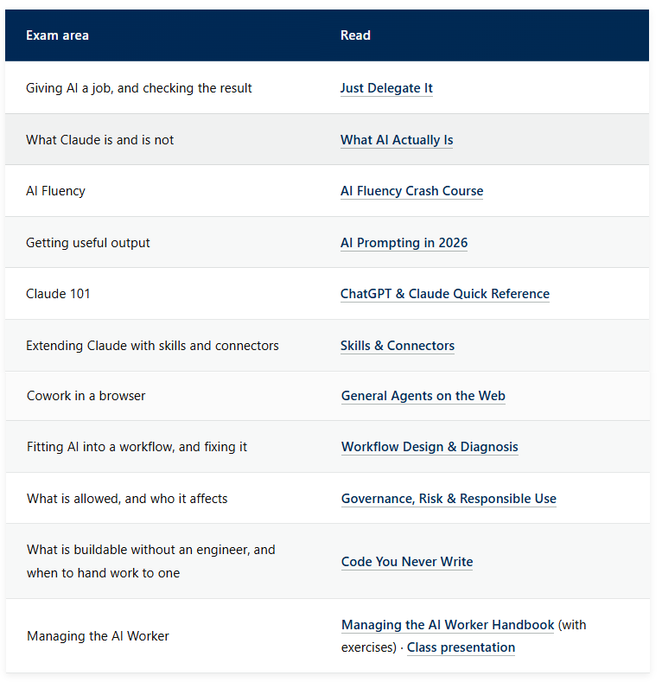

- https://agentfactory.panaversity.org/docs/ai-fluency-crash-course
- AI fluency means we need to know what to give AI, how to guide AI, how to judge AI’s work and when not to use AI.
- AI Fluency Framework, created by Professor Rick Dakan and Professor Joseph Feller in courses produced with Anthropic. It has four human competencies, called the 4Ds:
- Delegation: decide what AI should do.
- Description: explain what you need.
- Discernment: judge what AI gives you.
- Diligence: use AI responsibly and own the outcome.

- Presentation (AI Fluency_ the 4Ds Slide Deck): https://docs.google.com/presentation/d/14WYBY7bFYde5GNONaqI1QBtFf5KZFC5q9Odbj6HbTGQ/edit?pli=1
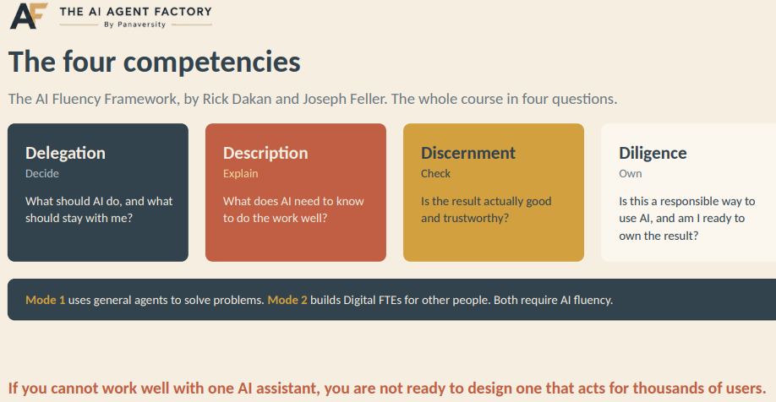
- https://agentfactory.panaversity.org/docs/foundations

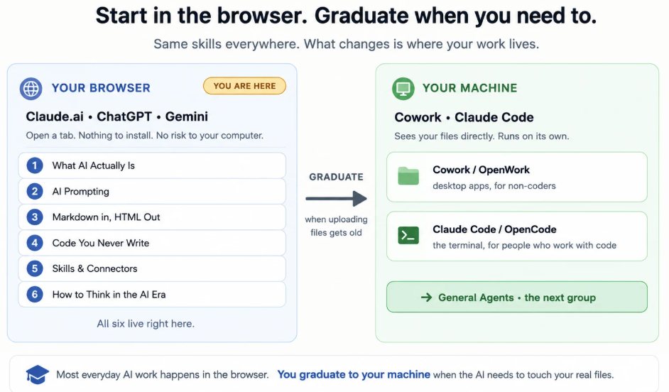

- AI can change output every time and to overcome this issue, we use Skills, which makes AI deterministic.
- Connectors: We can connect all applications with Claude using MCP (Model Context Protocol) server. For example:
We have to keep code at GitHub so we connect GitHub with Claude
Or
We need to keep data in database PostgreSQL then we connect Claude with PostgreSQL
- Coding agent used only for coding while General agent used for general purpose. Claude is a general agent.
- Context Engineering: It means when and what to provide LLM. It is a part of Prompt Engineering.
- All below ten points related to Prompt and Context engineering.
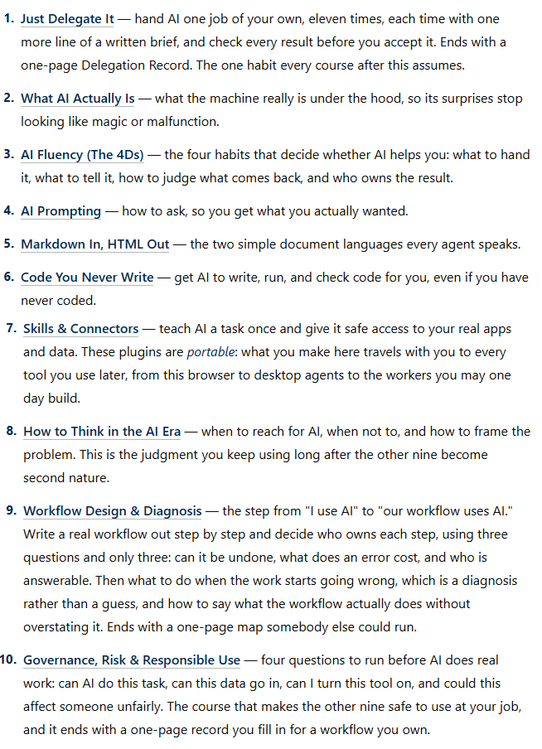
- Delegate: set role of agent or define work for AI. We should have knowledge that what should we delegate to AI.
- What AI is? AI is not a search engine but is Generative AI that predicts new token.
- AI fluency 4 Ds: Analyze whether AI will work for us or not.
- When you want to replace AI from system then provide 5 expected results then ask your question from AI and analyze AI response then decide if AI works for your system.
- AI knows markdown language well.
- Coding is universal language
- AI Connectors (MCP) indicates how AI agents communicates.
- One agent can have knowledge how another agent works and this knowledge can obtained by calling list of tools called Tool Calling. Two people open the same AI tool and provide two difference paths but output AI tool picture for both is same.
- If some task, you can do without AI then do not assign those tasks to AI as AI working will cost.
- Like we organize our company with three categories:
- Green data like public data
- White data like internal organization documents
- Red data which cannot be shared with AI like environment variables
Techniques to hide data from AI:
- Reduction: remove sensitive data
- Pseudonymization: add fake mapping for sensitive data
- Anonymization: encrypt sensitive data in one type which cannot be decrypted

