Instructions:
Complete this Functional Areas Digital Representation Worksheet using the instruction descriptions for submission. When you have completed all parts, submit your completed worksheet in the “Assignment and grades” tab in your course menu and then return to Module 4 for a module wrap-up.

Step 1: Using freely available digital tools, create a chart, graph, infographic, or other visual representation of the interrelated nature of the functional areas of a business (it is recommended that you use the business for your final project).

Step 2: Incorporate all of the various functional areas discussed in this module into your representation, including human resources, marketing and sales, IT, finance, and production.

Step 3: Include detailed descriptions of each functional area within your digital representation and visually demonstrate how each of the areas are interrelated.

A few images to get you started:
Major Functional Area Fishbone Concept Map
Functional Areas with Explanation
Organizational Chart
Pie Chart

Please proceed to the next page to work on your Functional Areas Digital Representation

Step 1: Using freely available digital tools, create a chart, graph, infographic, or other visual representation of the interrelated nature of the functional areas of a business (it is recommended that you use the business for your final project). You can use the templates in MS Office too.

Answer the following questions:

- What tool did you use? The tool used was Canva.
- Would you recommend this tool to others:

I personally recommend this because it has varieties of preset art you can use to present your ideas in a graphic form. The options provided will enable you to streamline in a form that will best suit your project. It works just like a template. All that is required is just to fine tune the art to your taste without having to start from scratch.

Step 2: Incorporate all of the various functional areas discussed in this module into your representation, including human resources, marketing and sales, IT, finance, and production.

Step 3: Include detailed descriptions of each functional area within your digital representation and visually demonstrate how each of the areas are interrelated.

- Write 1-2 paragraphs total for this section explaining how each area is interrelated.

Interrelation between the functional areas of the amazon company goes beyond just working together. A better and more efficient way is collaboration which involves sharing the vision and objective of a company which will lead to shared ideas and its execution. Pogue (2022).

The functional areas that are interrelated are
- Sales, Marketing and Product functional areas work together to drive revenue growth.
- Technology functional area forms a support system to all other functional areas in the area of development of e-commerce platforms and all backend processes
- Finance gives a financial report which will guide all other functional areas
- Human Resources and Finance also supports business operations
- Operations and Customer Service collaborate to deliver quality products and services to the customers.
- Admin area works with all the functional areas for the smooth running of the company by managing all the areas through monitoring the business performances internally and externally.
(Gerlacher, 2024; Kaerankin, 2013; Pogue, 2022)

- Include your digital representation in the space below:

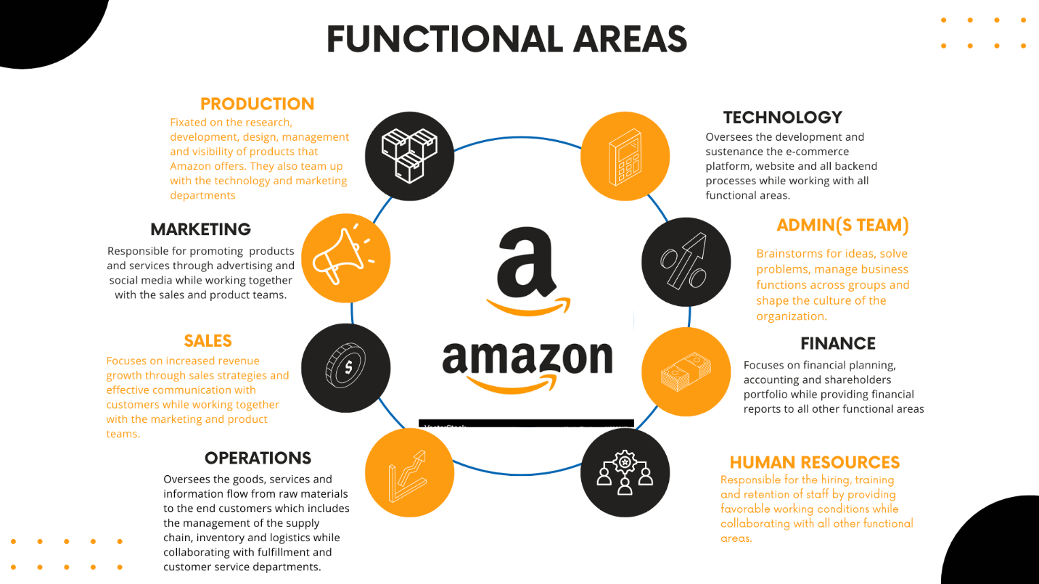

References
Om (2024). Amazon logo and favicon vector image. Vectorstock. https://www.vectorstock.com/royalty-free-vector/amazon-logo-and-favicon-vector-46860110

Gerlacher, C. (2024, July). 6 Major Functional Areas in Business Enterprises Flashcards. Brainscape.https://www.brainscape.com/flashcards/6-major-functional-areas-in-business-ent-2843752/packs/4727643

Kaerankin (2013, February 13). Functional Areas of a Business. Slideshare. https://www.slideshare.net/slideshow/functional-areas-of-a-business/16384864

Pogue, S. (2022, April 6). 11 Ways to Improve Collaboration Between Departments. Workzone. https://www.workzone.com/blog/9-ways-to-improve-collaboration-between-departments/

