**2D CAD Guide**

**Step 0: Set up the CST file.**

Remember to set length to units of ‘mm’ and frequency to units of ‘MHz’.

**SECTION 1: MICROSTRIP CAD**

**Step 1: Enter parameters as shown below.**

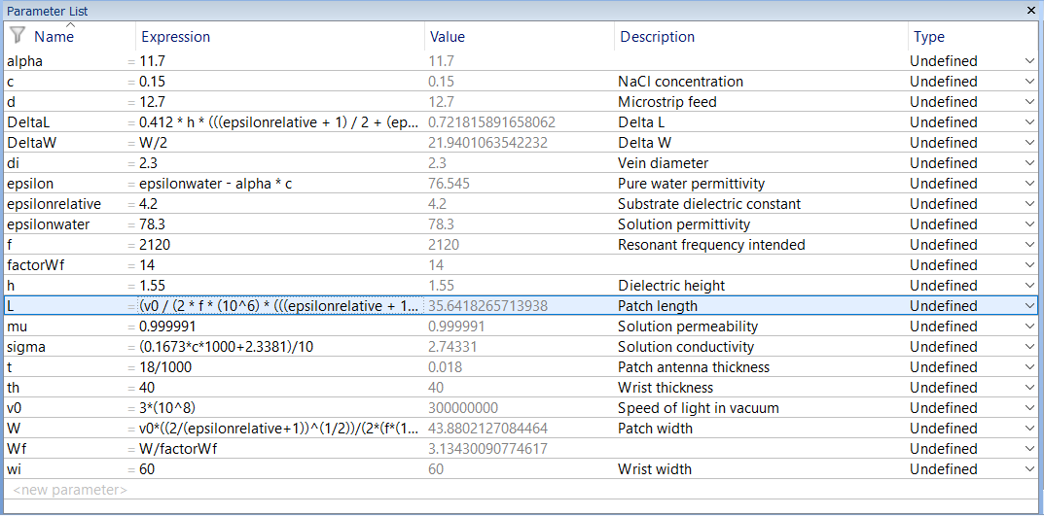

**For your experiment, the value for f is different, please take note!**

The very long expression for DeltaL is

|  |
| --- |
| 0.412 * h * (((epsilonrelative + 1) / 2 + (epsilonrelative - 1) * ((1 + 12 * h / W) ^ (-1 / 2)) / 2 + 0.3) * (W / h + 0.264)) / (((epsilonrelative + 1) / 2 + (epsilonrelative - 1) * ((1 + 12 * h / W) ^ (-1 / 2)) / 2 - 0.258) * (W / h + 0.8)) |

The very long expression for L is

|  |
| --- |
| (v0 / (2 * f * (10^6) * (((epsilonrelative + 1) / 2 + (epsilonrelative - 1) * ((1 + 12 * h / W) ^ (-1 / 2)) / 2) ^ (1 / 2))))*1000 |

The very long expression for W is

|  |
| --- |
| v0*((2/(epsilonrelative+1))^(1/2))/(2*(f*(10^6)))*1000 |

**Step 2: Create the substrate**

Create a brick called ‘SUBSTRATE’ with the following parameters:

|  |  |  |  |
| --- | --- | --- | --- |
| Xmin: | -(W+2*DeltaW)/2 | Xmax: | (W+2*DeltaW)/2 |
| Ymin: | -h/2 | Ymax: | h/2 |
| Zmin: | -(L+2*DeltaL)/2 | Zmax: | (L+2*DeltaL)/2 |

Use a new material (created by you), called ‘FR4’ with the following properties:

*General*

|  |  |
| --- | --- |
| Epsilon | epsilonrelative |
| RGB | 240, 209, 194 |

*Conductivity: Only change tangent delta el. and at frequency as shown below. Do not change the rest.*

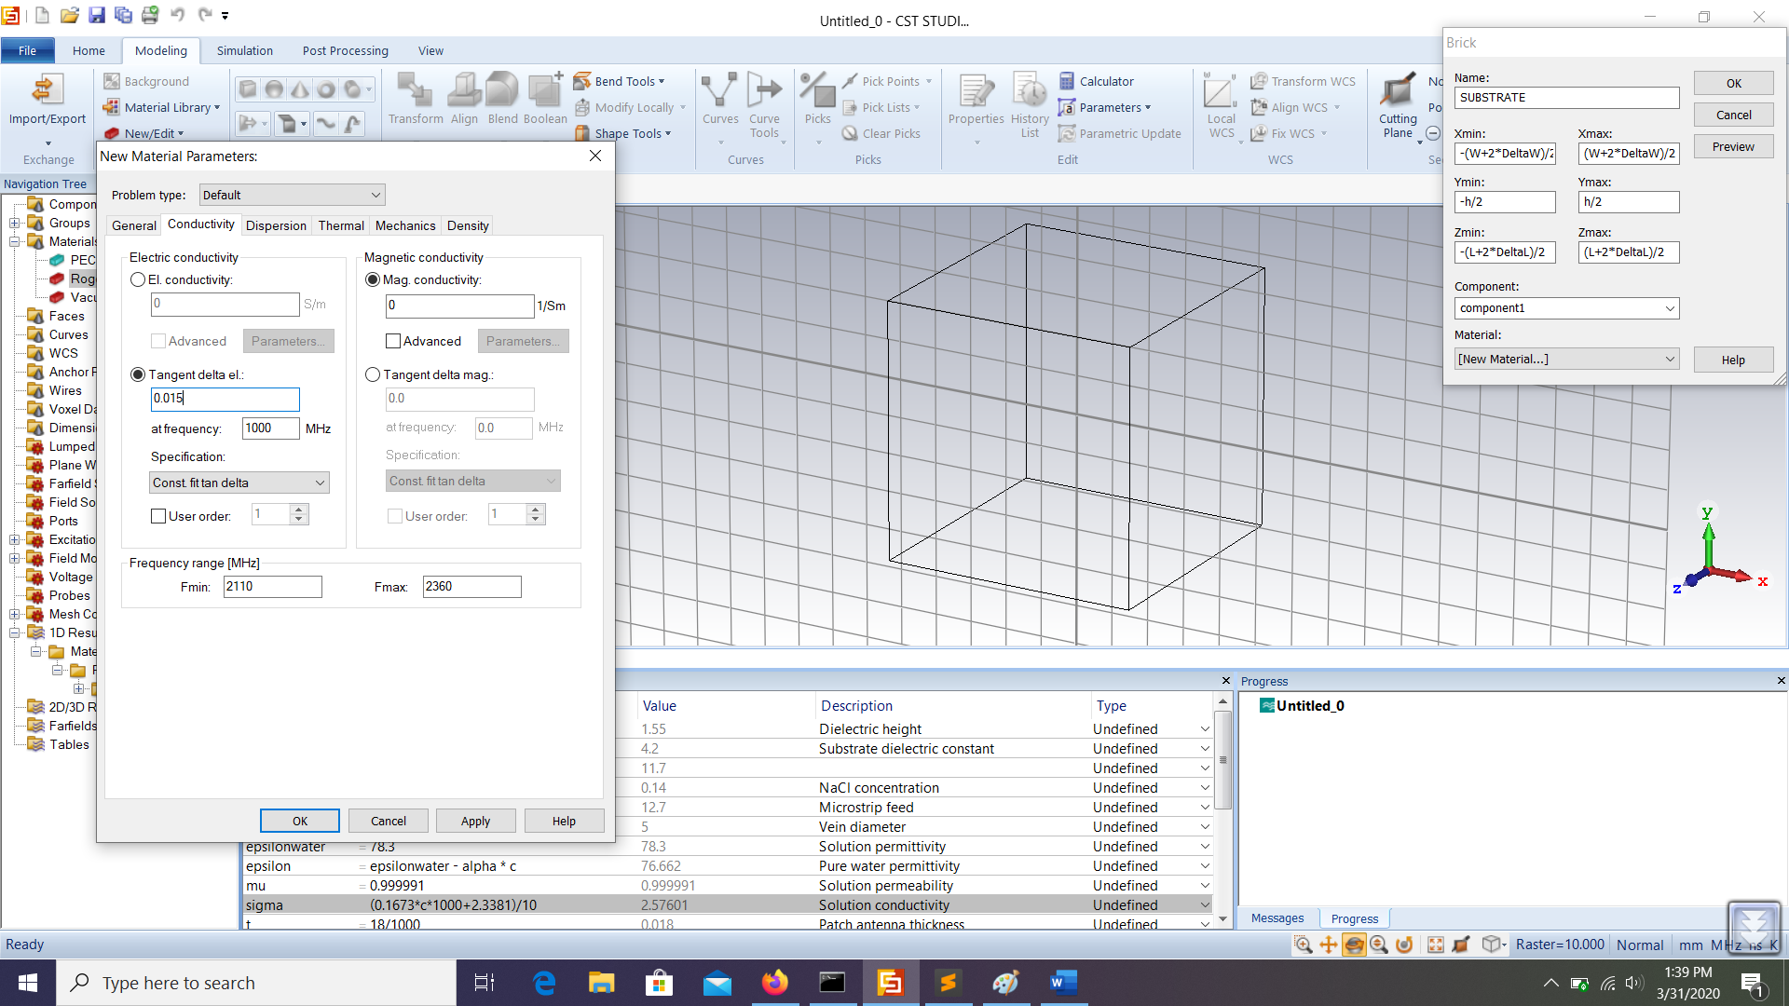

**Step 3: Create the ground plane**

Click on either side of the substrate and extrude annealed copper at a height of t.

**Step 4: Create the antenna**

Pick the face of the other side (the side that was not involved in Step 3).

Align the WCS plane on the face picked.

Create the patch antenna (called ‘PATCH ANTENNA’) made of annealed copper with the following parameters:

|  |  |  |  |
| --- | --- | --- | --- |
| Umin: | -W/2 | Umax: | W/2 |
| Vmin | -L/2 | Vmax: | L/2 |
| Wmin: | 0 | Wmax: | t |

**Step 5: Create the microstrip feed**

Do not realign the WCS plane from the previous step.

Using the previous WCS plane, make the microstrip feed (called ‘MICROSTRIP FEED’) using annealed copper with the following parameters:

|  |  |  |  |
| --- | --- | --- | --- |
| Umin: | -Wf/2 | Umax: | Wf/2 |
| Vmin | -L/2-DeltaL | Vmax: | -L/2 |
| Wmin: | 0 | Wmax: | t |

**Step 6: Add the microstrip feed and the patch antenna.**

**Step 7: Create a waveguide port**

Pick the cross section of the microstrip feed.

Create a waveguide port, with the change the entry on Ymin from 0 to t + h.

**SECTION 2: DUPLICATING THE MICROSTRIP CAD**

You are recommended to save the work in Section 1, then use the ‘Save As’ option to save the work done in this section in a separate file.

On ‘Navigation Tree’ on your left, expand the ‘Components’ tab until it is fully expanded.

You would see ‘SUBSTRATE’, ‘GROUND PLANE’, ‘PATCH ANTENNA’. Do the following steps:

|  |  |
| --- | --- |
| Component | Steps |
| PATCH ANTENNA | 1. Click on the component on the Navigation Tree 2. Hit CTRL + T on your keyboard 3. Ensure that ‘Copy’ is checked, and translate by W = **th + t**. |
| SUBSTRATE | 1. Click on the component on the Navigation Tree 2. Hit CTRL + T on your keyboard 3. Ensure that ‘Copy’ is checked, and translate by W = **th + 2 * t + h**. |
| GROUND PLANE | 1. Click on the component on the Navigation Tree 2. Hit CTRL + T on your keyboard 3. Ensure that ‘Copy’ is checked, and translate by W = **th + 3 * t + 2 * h**. |

Create a waveguide port for this duplicated microstrip as you’ve done previously in Section 1.

**SECTION 3: BLOOD CAD**

Create a brick called ‘BLOOD’ with the following parameters:

|  |  |  |  |
| --- | --- | --- | --- |
| Umin: | -wi/2 | Umax: | wi/2 |
| Vmin | -L/2-DeltaL | Vmax: | L/2+DeltaL |
| Wmin: | th/2-di/2 | Wmax: | th/2+di/2 |

Use a custom material made by you called ‘BLOOD’ that has the following properties:

|  |  |
| --- | --- |
| Epsilon | epsilon |
| Mue | mu |
| Conductivity | sigma |
| Color | Red |

**SECTION 4: RUN SIMULATIONS**

Go ahead and run the simulation. If your desired resonance frequency changes, you would just have to change the value of f in the parameter list, update parameters and CST will do everything for you. Have fun! (THERE IS ADDITIONAL GUIDE ON HOW TO EXPORT YOUR RESULTS)

**BONUS: EXPORT RESULTS**

View an S-parameter (you should know how to do this).

Go to ‘Post Processing’ and click ‘Import/Export’, ‘Plot Data (ASCII)’.

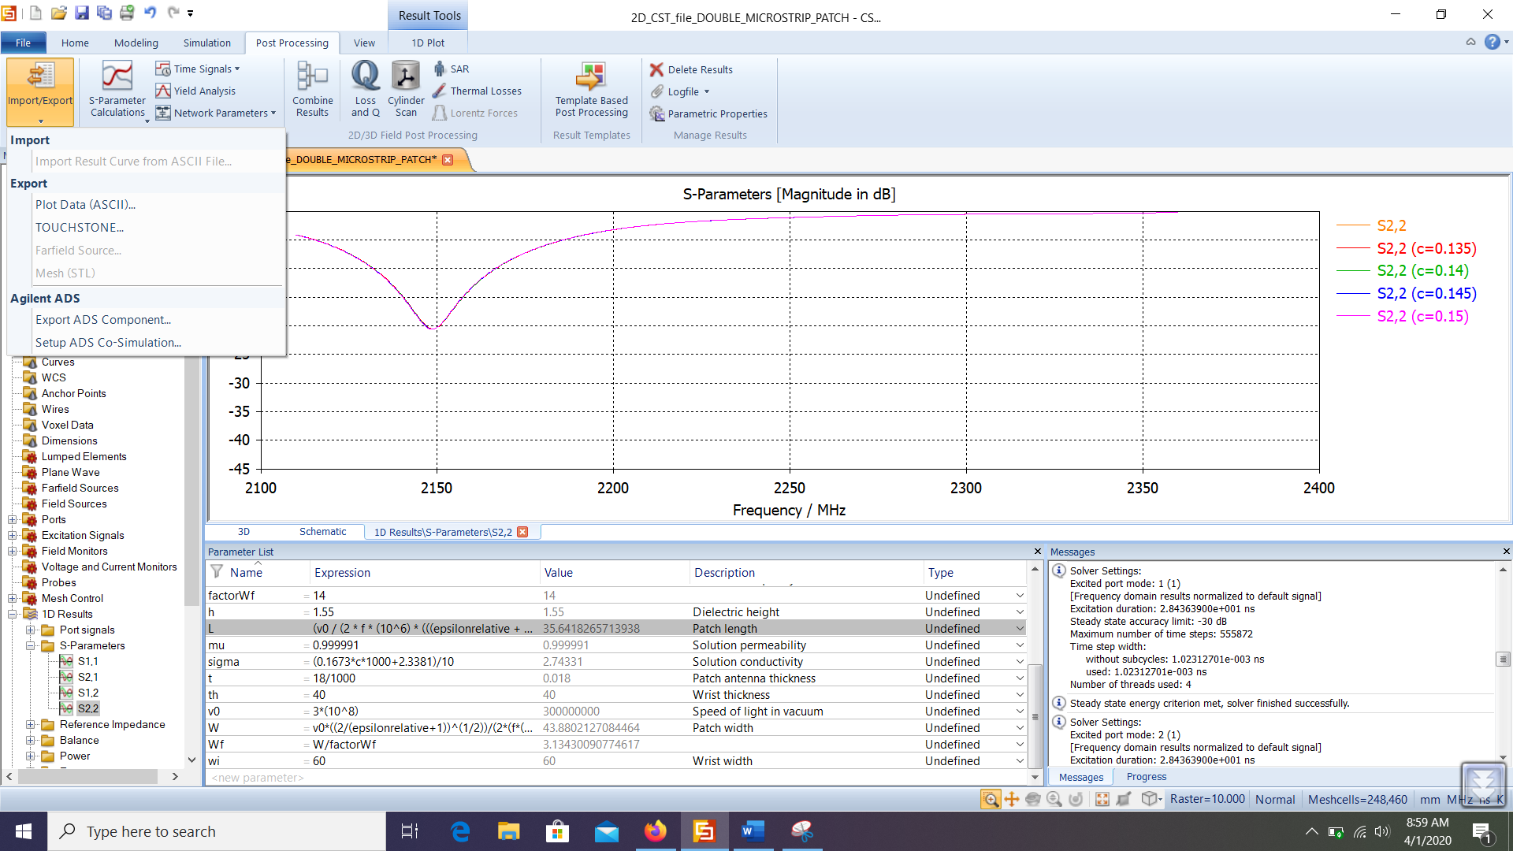

Save the file in .txt format.

Note: You would have to save a .txt file for each S-parameter. Do the above for each parameter (view each, S11, S12, S21 and S22 and save them into different filenames).