Cairo University  
Faculty of Computers and Information



**CS251**

**Software Engineering I**

Lost/Found

Software Requirements Specifications

Reem Tarek, Alaa Elmenshawy &Engy Ayman

December 2018

Contents

Instructions [To be removed] 3

Team 3

Document Purpose and Audience 3

System Models 3

I. Class diagrams 3

Important Algorithm 5

II. Sequence diagrams 5

Class - Sequence Usage Table 7

Ownership Report 8

Policy Regarding Plagiarism: 8

References 8

Authors 8

# Team

|  |  |  |  |
| --- | --- | --- | --- |
| **ID** | **Name** | **Email** | **Mobile** |
| 20160104 | Reem Tarek Selim | reemtarematr97@gmail.com | 01155592915 |
| 20160060 | Alaa Elmenshawy AbdelFattah | princesslole@yahoo.com | 01100256631 |
| 20160068 | Engy Ayman Rafael | Engyayman175@gmail.com | 01278270385 |

# Document Purpose

• This Document is made to show the Software Design of lost and found Website with details this Document is providing System in the easiest way with several views of System Designs.

• It will contain Specific Information about the interaction between Users and System with clarify the use case and the sequence diagram of the idea of the project and show how the flow of events are being undertaken inside the application.

# Document Audience

* + Our audience are developers, Technical, Software Engineers , company and designers.

# System Models

## I. Class diagrams

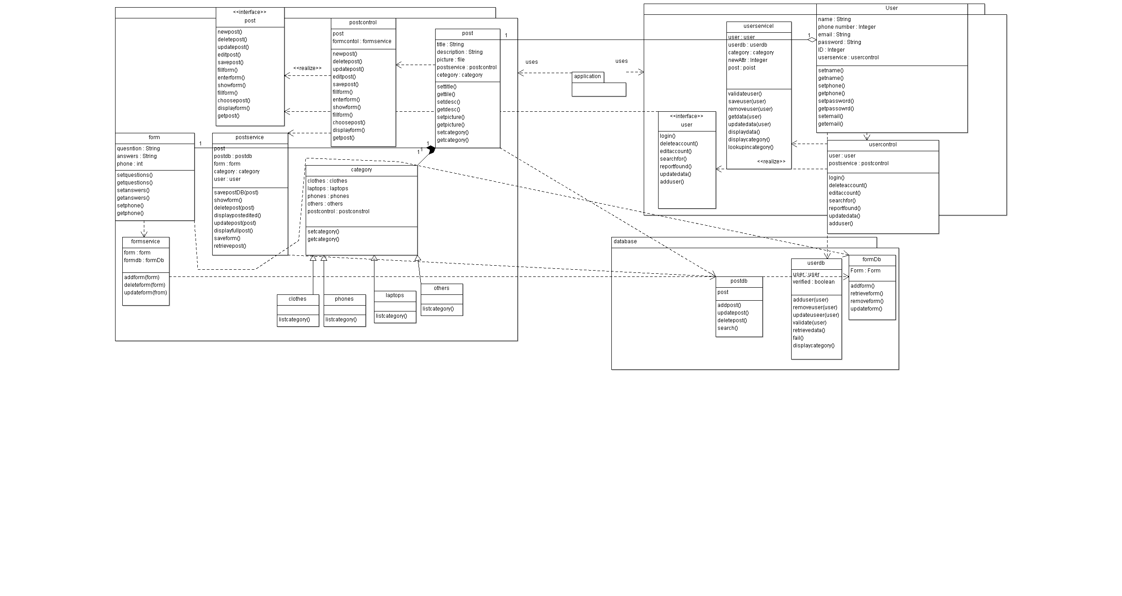

**List down your classes and describe them**

| **Class ID** | **Class Name** | **Description & Responsibility** |
| --- | --- | --- |
| 1 | User | Is a person who found or lost thing who should have an account with (name, phone number, password, and e-mail, picture) then put it in database with ID.  And this person can post and fill form(questions) if he find any lost thing |
| 2 | User interface | Is an interface class to user who use system to update data in his account or delete his account or search in posts in any category to find his lost thing and when he finds the post he must fill the form with answers to ensure that thing belong to him |
| 3 | Userservice | Is a link class between class user and interface class of user which has a lot of functions like login, delete account, edit account, search for, update data |
| 4 | User control | Is a link class between class user and database of the system who can save, remove, update and display data of the user in the system. |
| 5 | userdb | Is a database class contains all data of the users of the system and verify the data of the users account before save in data to prevent similar data of two users. |
| 6 | Postdb | Is a database class contains all posts and the owner of the post can edit, delete posts and add new post. |
| 7 | Postservice | Is a link class between class user and interface class of post to new post ,delete post or edit post |
| 8 | categoryDb | Is a database class divides all posts to different categories to facilitate the search to user. |
| 9 | Post | Is class to set and get posts and ensure that the post with picture and form of questions to add and save the post to system |
| 10 | Post interface | Is an interface class to show all posts in specific category to user. |
| 12 | form | Is a class with questions about lost thing and when user found his post he should first answer the questions and communicate with owner of the post with his phone number in the form to insure from his answers. |
| 13 | Postcontrol | Is a link class between class post and database to add the post in specific category and when the user search for something he should first choose category and then the system show all posts with details. |
| 14 | category | Is class of a lot of categories (types) of things to divide lost things to specific category and facilitate the search to user. |

## 

## II. Sequence diagrams

1. **Signup()**

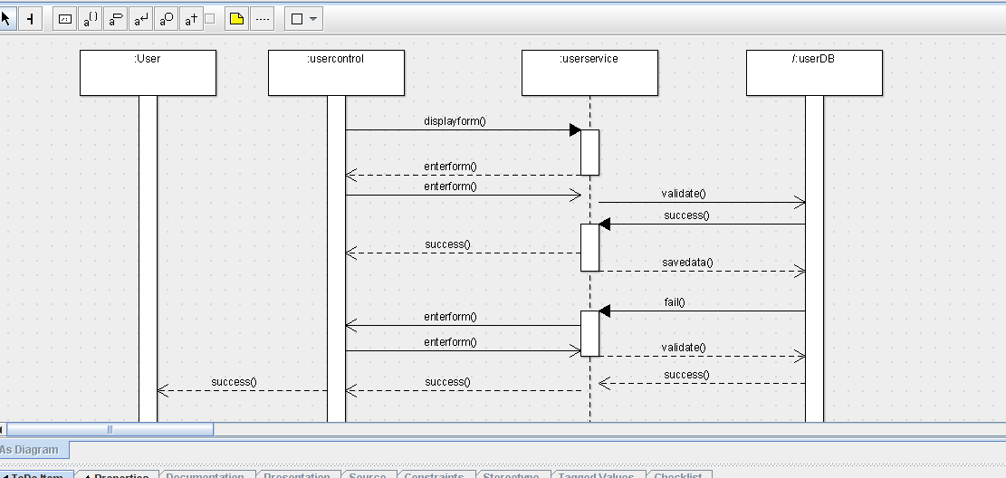

1. Login()

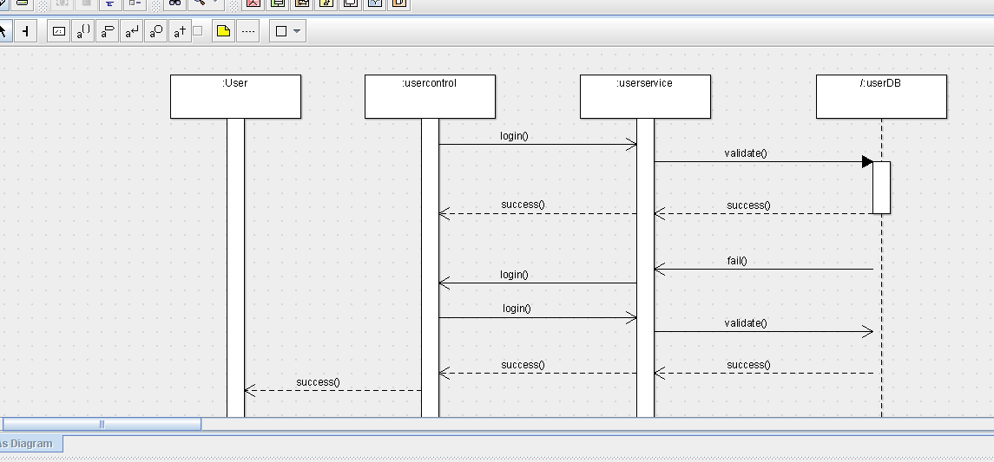

1. Addpost()

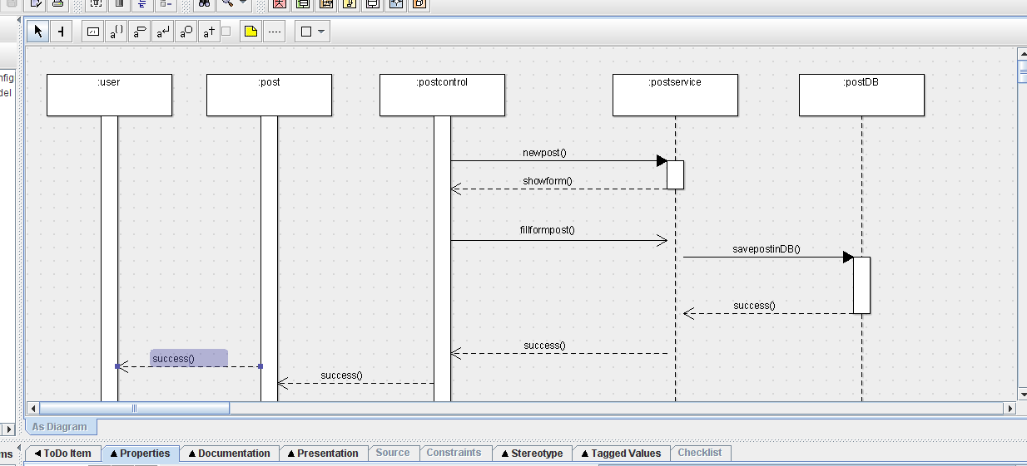

1. Editpost()

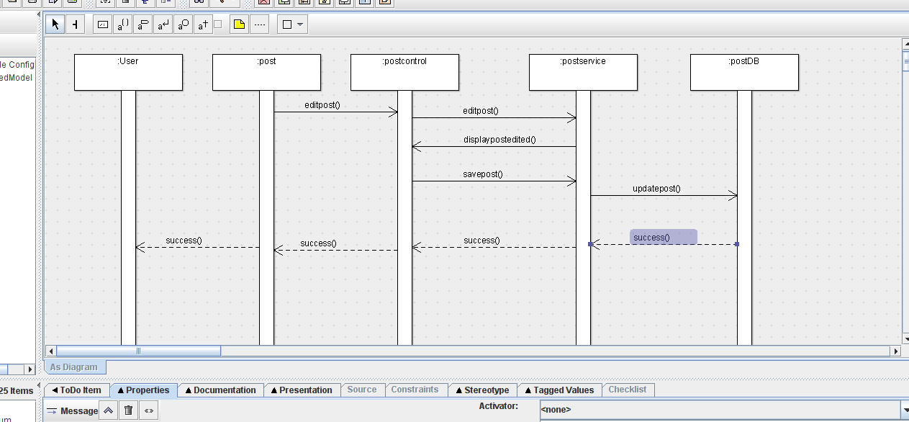

1. Deletepost()

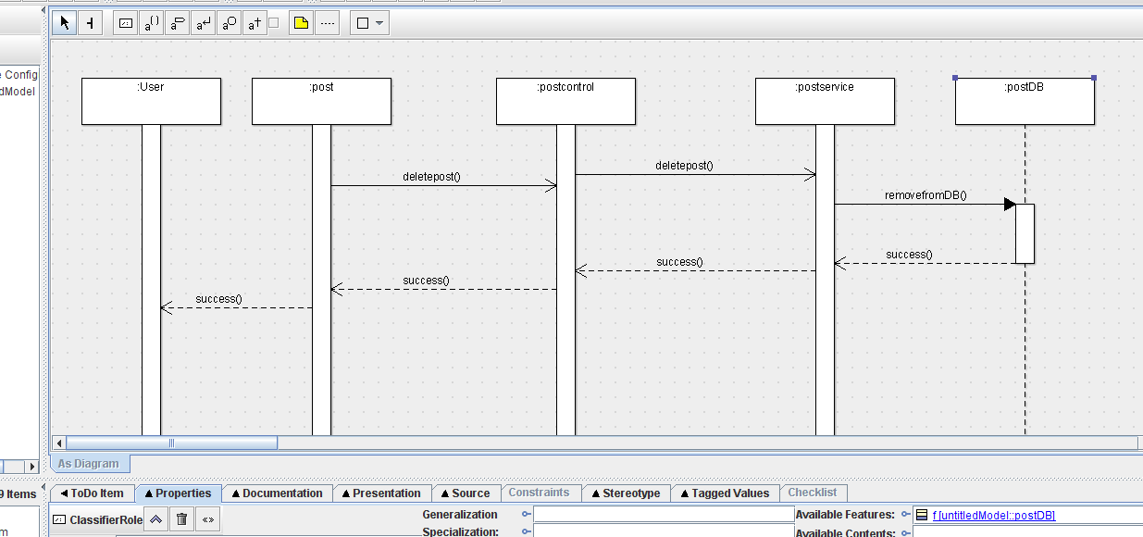

1. Editaccount ()

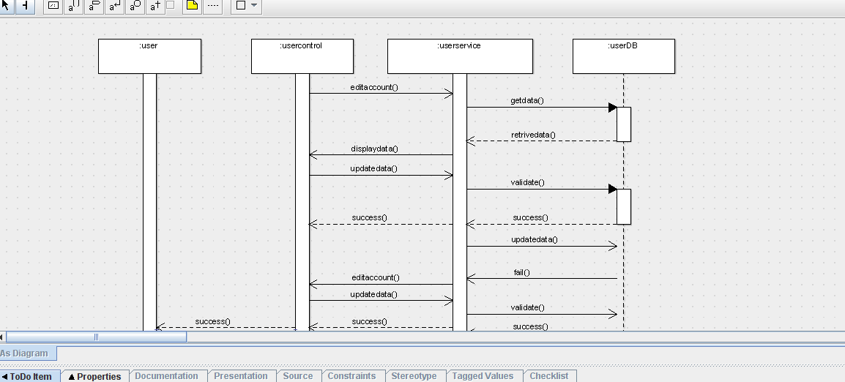

7- Deleteaccount ()

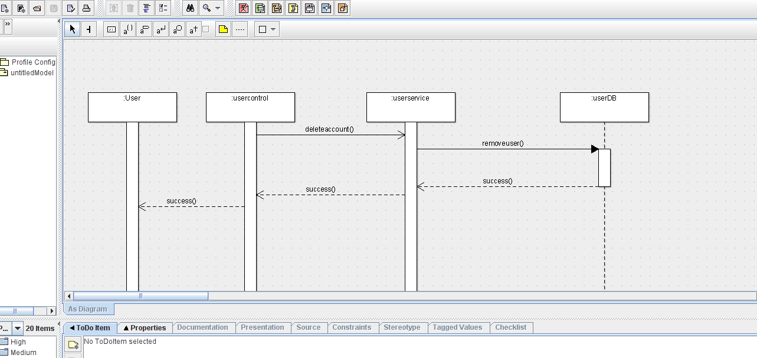

8- Search()

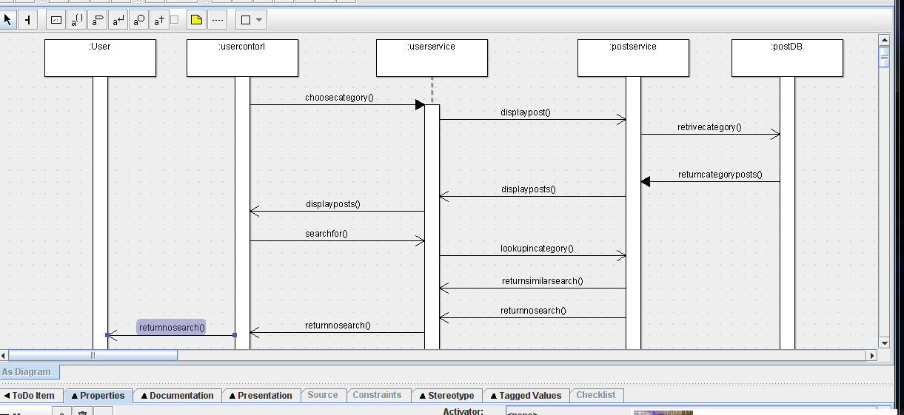

9- Reportfoundthing()

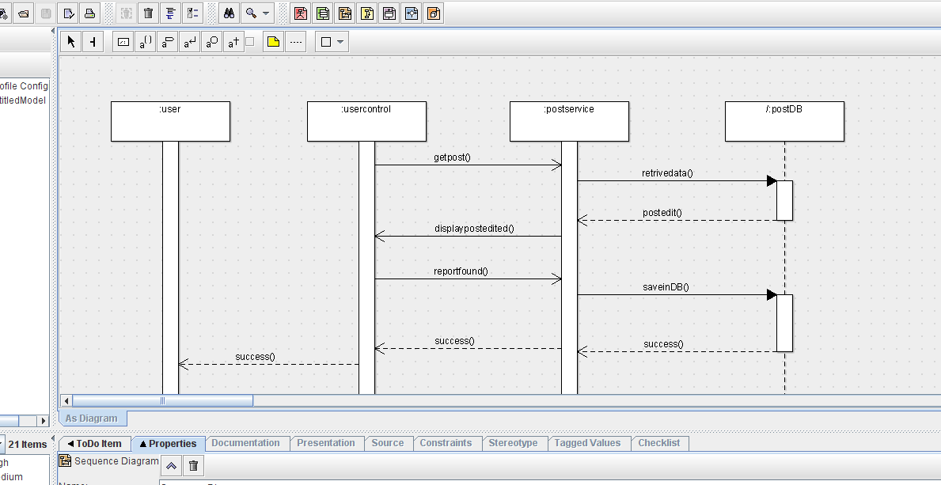

10- Verifyownership()

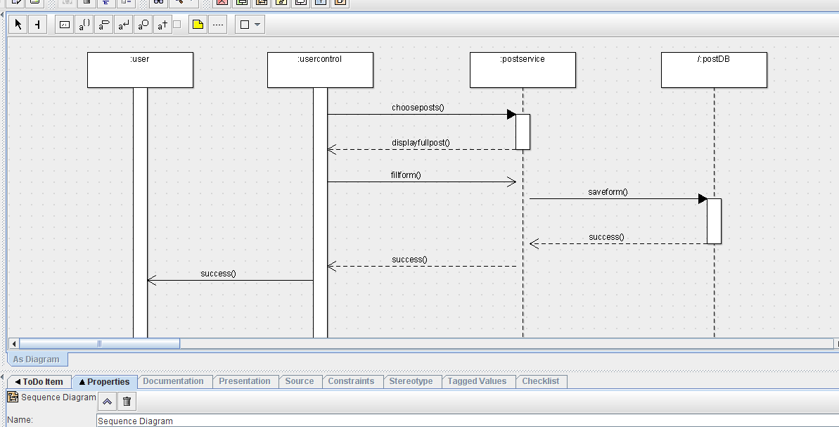

### Class - Sequence Usage Table

| **Class Name** | **Sequence Diagrams** | **Overall used methods** |
| --- | --- | --- |
| User | 1,2,3,4,5,6,7,8,9,10 |  |
| UserControl | 1,2,6,7,8,9,10 | Displayform, editaccount, enterform, updatedata, choosecategory, login , searchfor , deleteaccount, fillform, getpost, reportform,chooseposts |

|  |  |  |
| --- | --- | --- |
| UserService | 1,2,6,7,8 | Validate , savedata, getdata, lookupincataegory,displaydata,editaccount, displayposts,updatedata, removeuser |
| UserDB | 1,2,6,7 | Success, fail, retrievedata |
| Post | 3,4,5 | Editpost, deletepost |
| PostControl | 3,4,5 | Newpost, fillformpost, editpost, savepost,deletepost |
| PostService | 3,4,5,8,9,10 | SavepostinDB,showform, diplaypostedited , updatepost, removefromDB , retrievecategory, displayposts, returnsimilarsearch, retrievedata, saveinDB,saveform, displayfullpost |
| PostDB | 3,4,5,8,9,10 | returncateoryposts, postedited, success |

# Ownership Report

|  |  |
| --- | --- |
| **Item** | **Owners** |
| Class diagrams | *Reem Tarek* |
| Document Purpose, Document audience, description of classes and Sequence Usage Table | *Engy Ayman* |
| Sequence diagrams | *Alaa Elmenshawy* |