**Faculty of Computer and Information**

**Cairo University**

**Fundamentals of IS- IS231**

**Information Systems- Case Study Assignment**

***Business name: Spectra restaurant***

|  |  |  |
| --- | --- | --- |
| **Name** | **ID** | **Group** |
| Alaa Elmenshawy | 20160060 | CS 2 |
| Reem Tarek | 20160104 | CS 2 |
| Engy Ayman | 20160068 | CS 2 |

**Dr: Hatem**

**TA: Hala Magdy**

**Step 1:**

restaurant(Spectra)

Reason: we searched for many agencies and we found this company is one of good choices to make a business in Egypt

especially it is highly demanded

**Step 2:**

Business description:

Serving meals (fast food, fine cuisine, gourmet) and drinks, preparing and organizing parties, deliver food

Location of the business: Giza, Mohnadseen, fifth settlemnt

**Step 3:**

Size of the business:

1-30 employee per branch and they are divided into two shifts as in following pie chart:

2-70 customers per day for each restaurant branch on average and increases into 100 customers on occasion.

Here is a graph for estimation of people attending restaurant:

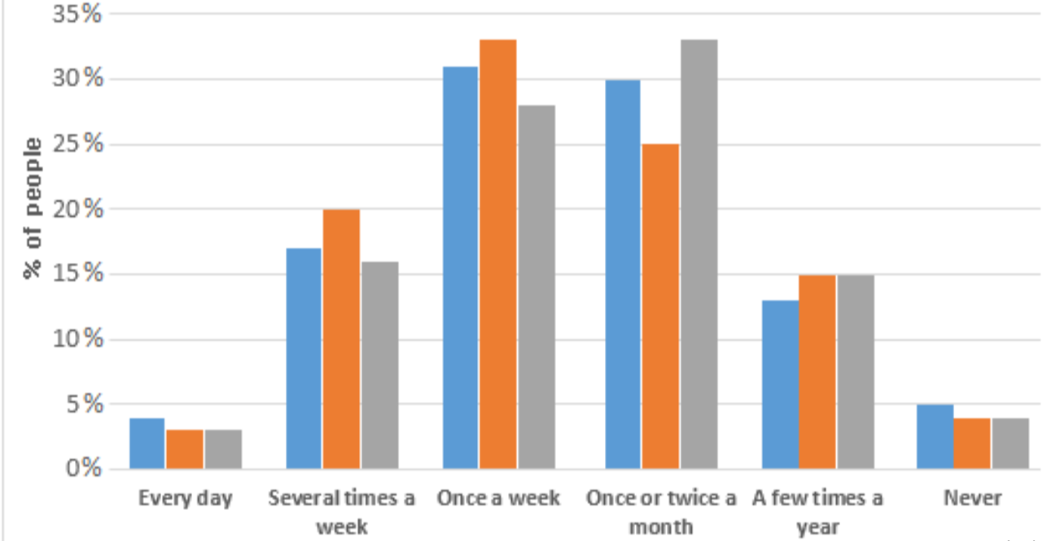

3-Average purchase per customer: 150 IE per full meal but here another graph explains average demand on meals, beverages, desserts

**Step 4:**

Main departments within the organization structure:

1-Food and drink

2-Accounting

3-human resources

4-Training and development

5-adminstration

6-marketing and sales

7-after sales communication and telecommunication

8-booking

**Step 5:**

Main work cycles:

1-achieving human resource system

2-managing daily budget and cost

3-managing bank accounts

4-Create schedule for shifts for staff

5-checking the food and beverage supply

6-order food supply

7-making a plan for menu

8-prepare meals

9-prepare restaurant to open for guests (check tables, seats, serving customers, decorations)

10-receiving customers’ bookings

11-preparing to get customers served

12-preparing delivering food for telephoned orders

13-analyze sales

**Step 6:**

Group of factors to prioritize the work cycles:

1-Time necessary to serve customer

2-The customer queue length

3-Number of staff personnel involved

4-Cost of operation

**Step 7:**

Prioritize step5 according to step6:

1. Prepare new mails.
2. Receive customer orders.
3. Send order to prepare/execute.
4. Deliver order to customer.
5. Registering the customers purchased goods.
6. Making offers.
7. Managing banks accounts.

**Step 8:**

selected functions:

1-getting orders

2-preparing orders

3-delivering and serving orders

**Step 9:**

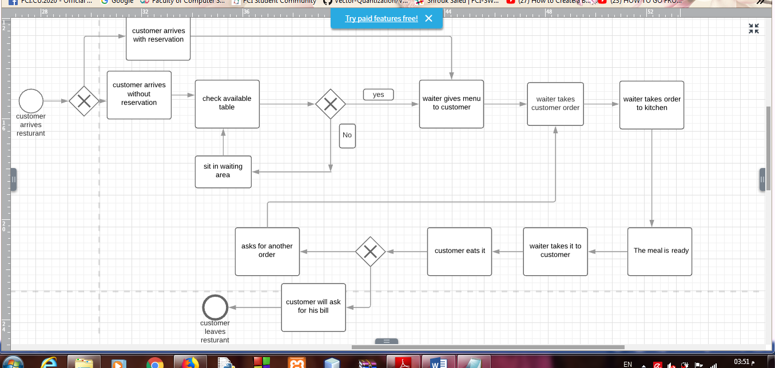

**Step 10:**

1-when the number of customer who arrive is greater than number of tables in restaurant.

Solution: let the customer sit in waiting area.

2- when resources expired suddenly.

Solution: tell the manager immediately and delete it from menu temporarily.

3- when the number of customers who want to make order in restaurant is greater than the number of waiters.

Solution: can get extra waiters in days at which the restaurant is completed by customers.

**Step 11:**

Problem: several people don't know my restaurant or know my restaurant name but don't know my restaurant 's location so I can make a website for my restaurant and set information about restaurant's location and menus.

Problem: when resources expired suddenly so I must tell the manager immediately and delete it from menu temporarily.

Problem: when the number of customer who arrive is greater than number of tables in restaurant so I can let the customer sit in waiting area.

**Step 12:**

|  |  |  |
| --- | --- | --- |
| **Technique** | **Pros** | **Cons** |
| **Host locally** | 1-control over own infrastructure hardware as you have the control your own resources.  2-can be customized as business grows. | 1-everything should be handled by yourself, the more the company grows, the more it can be complicated .  2-long time processing. |
| **Co -location hosting** | 1-Greater amount of bandwidth at considerably lower cost.  2-Colocation hosting is flexible, efficient and secure.  3- You own the server machinery and are free to upgrade it anytime you wish | 1-Co-location hosting needs higher start-up cost.  2- Restrictions on maintenance with regards to time or resources |
| **Host rented virtual server at a cloud service** | 1-It is flexible, usable and enhanced scalability because it contains a great bandwidth  2- you are also only billed for the resources you actually using (reduce cost).  3- it is also good for security reasons, particularly DDoS attacks. | 1-Automatic updates enforce change.  2- Cost savings are reduced as user demand grows.  3- government can access all of your data with the appropriate warrant. |
| **ERP & local installation** | 1-greater ability to customize  2-organization has more control over implementation process.  3-reduce initial price of system. | 1-customization can delay implementation time.  2-implementation process can take significantly longer. |

Choice → Host rented virtual server at a cloud service because:

1. It will protect the restaurant database from attacks.
2. Highly protection with lower cost.
3. it lets me deal with server that can let any customer in any country contact with us.

**Step 13:**

cloud computing configuration:

-using routers

-ADSLs

-its speed will be estimated to be in range of: 500.00 mbps for website

and in cloud .15 mbps for user

-expected traffic:

we don't expect high traffic or congestion in our website as the restaurant will target specific customers for fine dining

also cloud service will be able to reduce traffic as it can carry large number of users

-the website will be available 24hours/7days but for seeing menu but for ordering will be available from 9:00 AM to 12:00 AM

-it will be used across WLAN

**Step 14:**

|  |  |  |
| --- | --- | --- |
| **Approach** | **Pros** | **Cons** |
| **We can Customize the entire application and then apply it all at once and stop the manual system** | can be done at fast time | can be kind of complex as there may be modules are depending on others to be made  also there may be some modules will not work properly  stopping manual system can affect later on if there is something wrong happened within application |
| **Implement one module at a time** | the application will be more accurate and face less error | it will take very long time developing especially if there are many modules |
| **Implement ALL modules in parallel with the existing manual system** | will save time  will be accurate  existing manual system will help in implementing modules | some modules can depend on others so it can be complex |
| **We can implement ALL modules in a part of the operation and compare results with the existing manual system before full implementation** | very accurate in making the application  also comparison helps the development in application better | developing can be very slowly due to need of feedback as comparing results to the manual system  also some manual system operations cannot be implemented in application |

-We decided on We can implement ALL modules in a part of the operation and compare results with the existing manual system before full implementation however it can take long time in development as it is best to make our business accurate

**Step 15:**

|  |  |  |
| --- | --- | --- |
| **Training technique** | **Pros** | **Cons** |
| **Train the personnel at once** | 1- focus on one person so the training will be perfect | 1-more salaries for the extra working hours.  2-higher cost |
| **Train them a group at a time** | 1-it won't need extra working hours.  2-lower cost | 1-the training won't be so perfect like first option. |
| **Training of trainers TOT** | 1-the lowest cost and working hours. | 1-it is not good because the one who train them won't have any experience in this work so it will make training in this case so bad. |