Dareen Housam Eldin Alaa Eldin Elgendy | 2022170141
Shahd Sameh Abdulaziz Alsayed | 2022170206
Rahma Ahmed Ahmed Ezzat | 2022170148
Rasha Abd El khalik Abd El Hamid Abo Khalifa | 2022170151
Fatma El Zahraa Atef Mahmoud Ahmed | 2022170302
Engy Abdelmalak Khillah Boules | 2022170078
SC Department

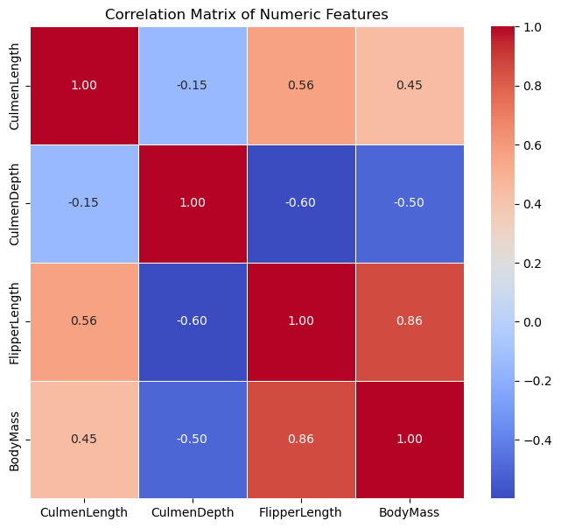
- Very Strong Positive Correlation: FlipperLength and BodyMass have a very strong positive correlation 0.86. Features with strong correlations are generally effective at discriminating between species, but might be redundant if used together.
- Moderate Positive Correlation: CulmenLength shows a moderate positive correlation with FlipperLength 0.56 and BodyMass 0.45.
- Moderate Negative Correlation: CulmenDepth has a moderate negative correlation with FlipperLength -0.60 and BodyMass -0.50.
- Weak Correlation: The correlation between CulmenLength and CulmenDepth is weak -0.15

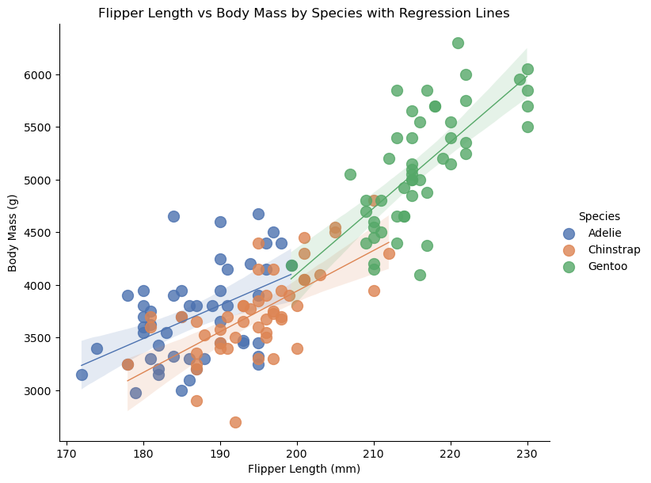
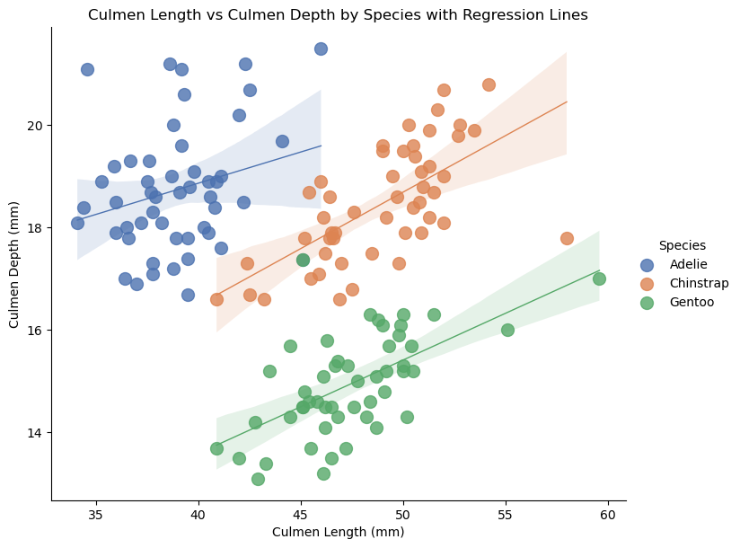

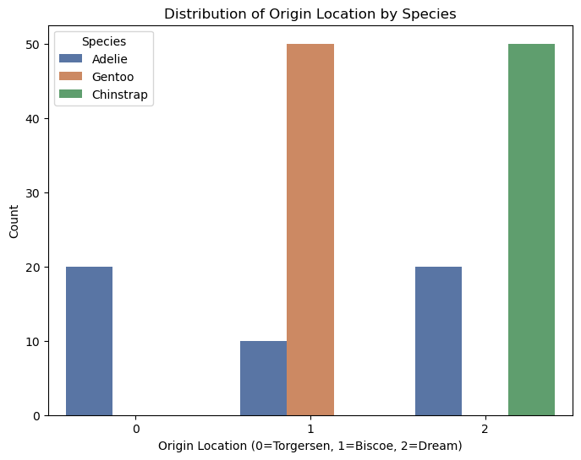

Adaline Experiments
With eta=0.1, epochs=200, mse_threshold=1e-6 and bias

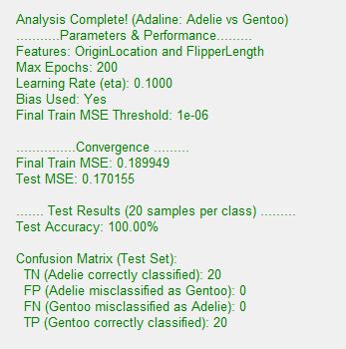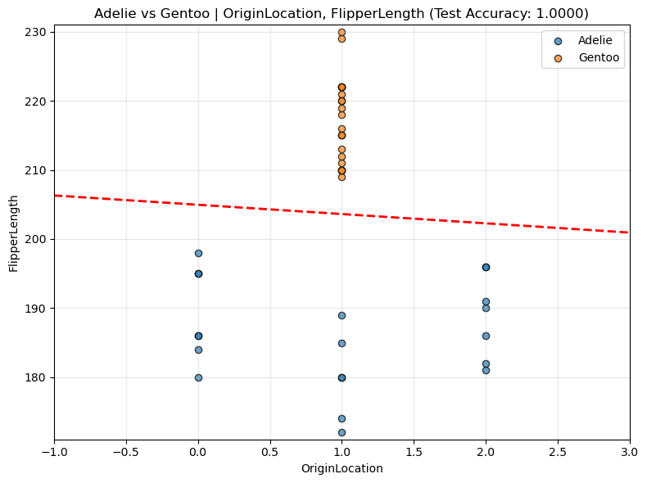

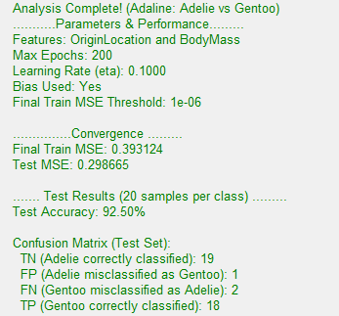
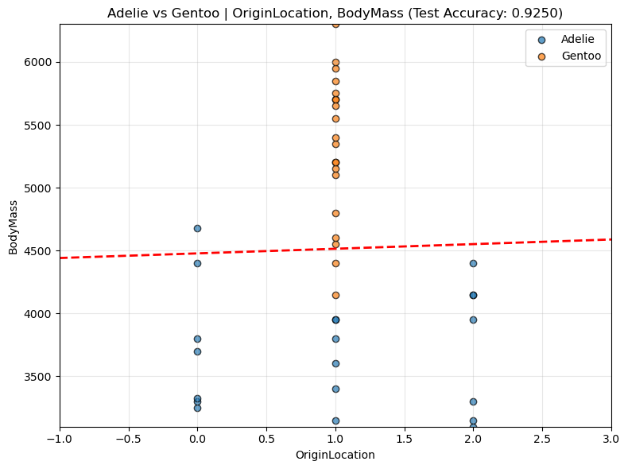

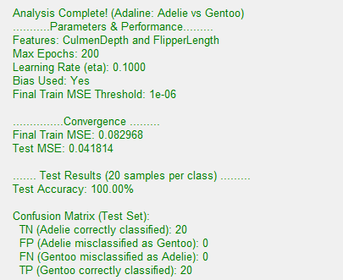
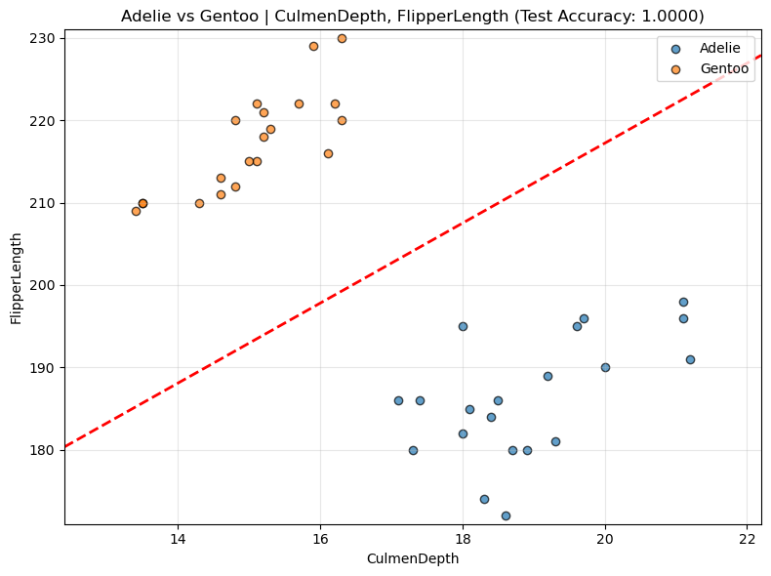

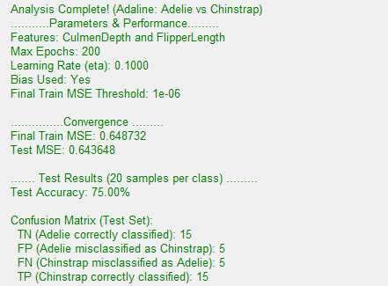
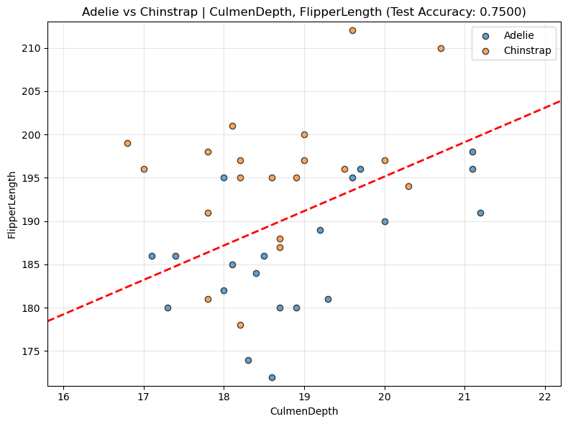

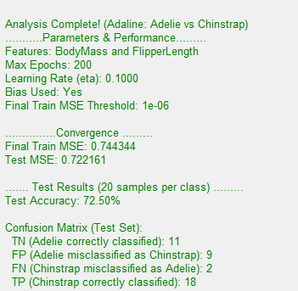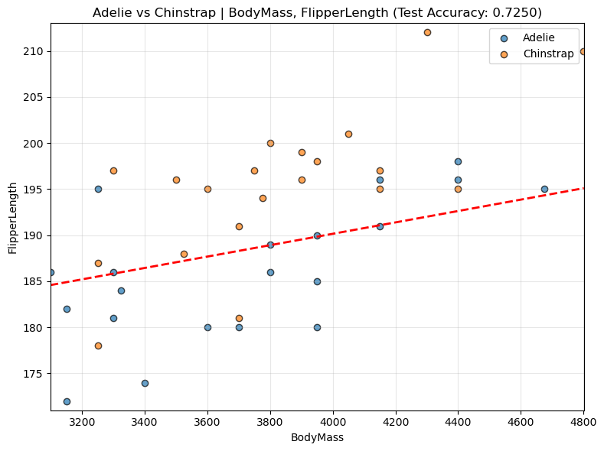

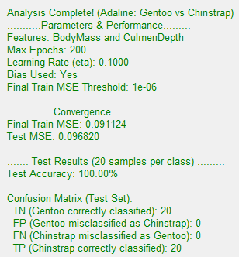
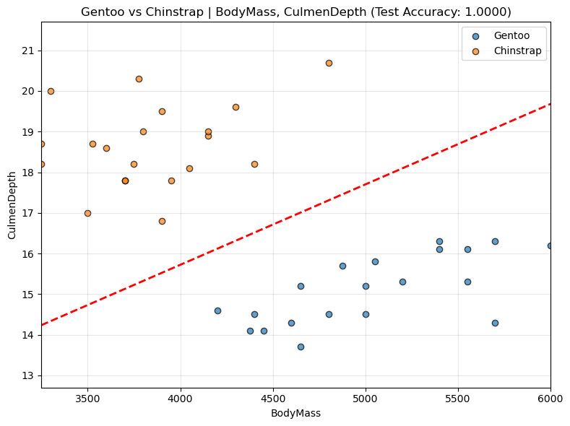

Run | Classes | Features | Test Acc. | Analysis of Class Discrimination & Feature Effectiveness
1 | Adelie vs Gentoo | OriginLocation, FlipperLength | 100% | Discrimination Quality: Excellent. A perfect 100.00% accuracy was achieved. Separability: The classes are perfectly linearly separable.
2 | Adelie vs Gentoo | OriginLocation, BodyMass | 92.50% | Discrimination Quality: Moderate-Good. Accuracy is high, but 3 samples were misclassified (FP=1, FN=2). Separability: The classes are mostly linearly separable, but the features cause slight overlap.
3 | Adelie vs Gentoo | CulmenDepth, FlipperLength | 100% | Discrimination Quality: Excellent. A perfect 100.00% accuracy was achieved. Separability: The classes are perfectly linearly separable.
4 | Adelie vs Chinstrap | CulmenDepth, FlipperLength | 75.00% | Discrimination Quality: Poor. Accuracy is low, with 10 samples misclassified (FP=5, FN=5). Separability: The classes are not linearly separable; there is significant overlap.
5 | Adelie vs Chinstrap | BodyMass, FlipperLength | 72.50% | Discrimination Quality: Very Poor. This is the lowest accuracy, with 11 misclassifications (FP=9, FN=2). Separability: The classes are not linearly separable; the highly correlated features provide poor distinction for this pair.
6 | Gentoo vs Chinstrap | BodyMass, CulmenDepth | 100% | Discrimination Quality: Excellent. A perfect 100.00% accuracy was achieved. Separability: The classes are perfectly linearly separable.

With eta=0.01, epochs=300, mse_threshold=1e-4 and without bias
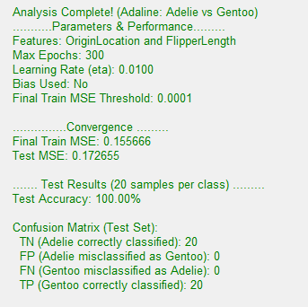
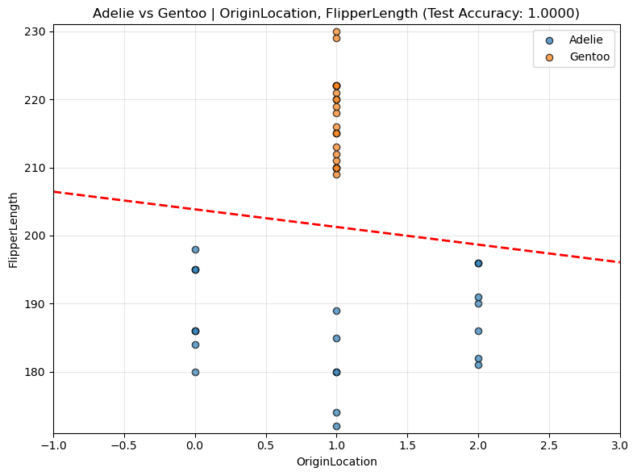
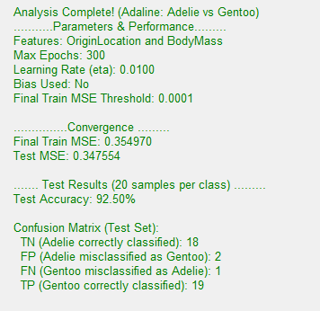
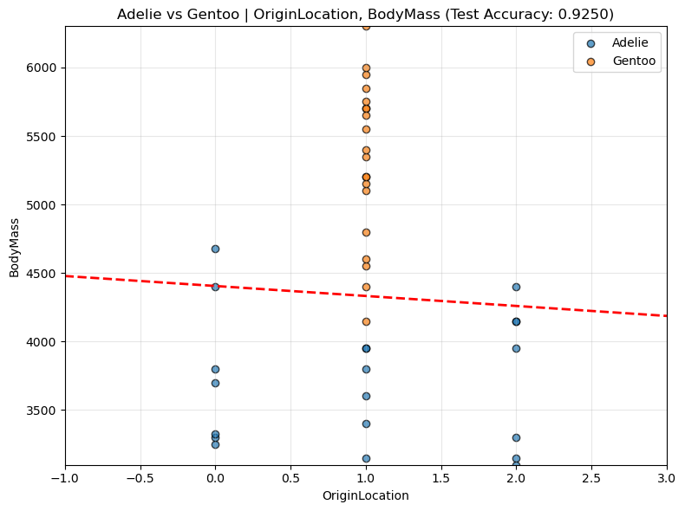

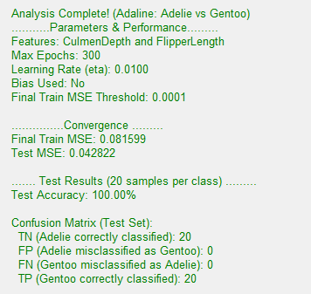
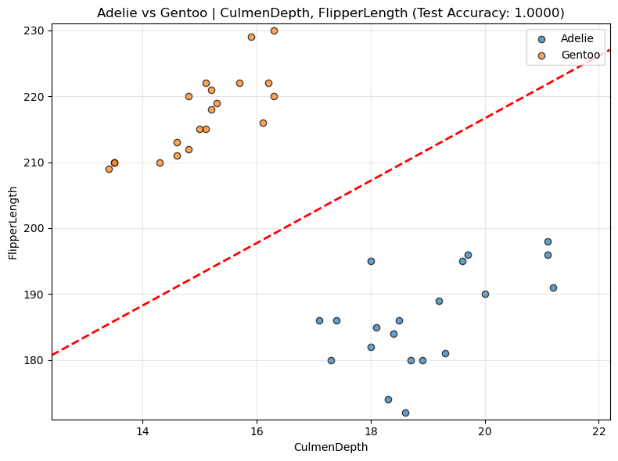

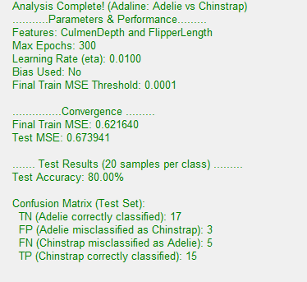
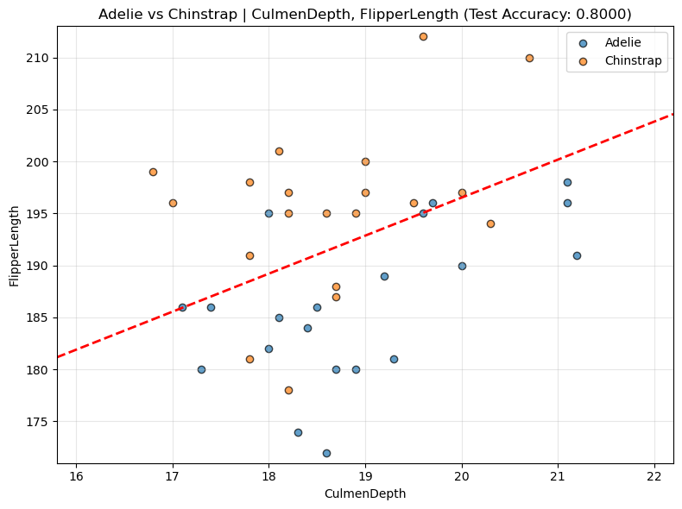

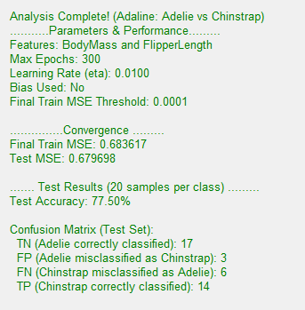
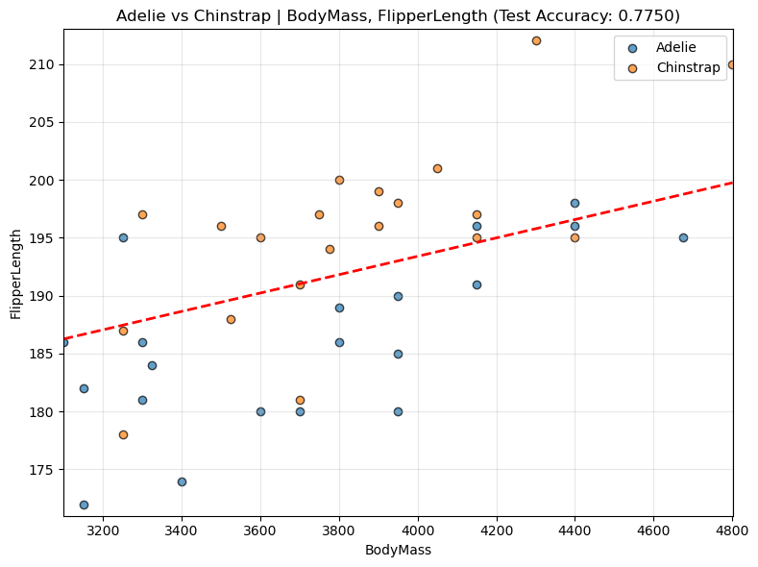

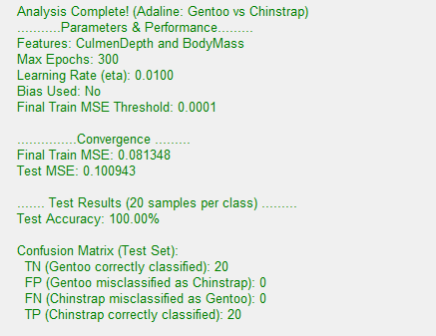
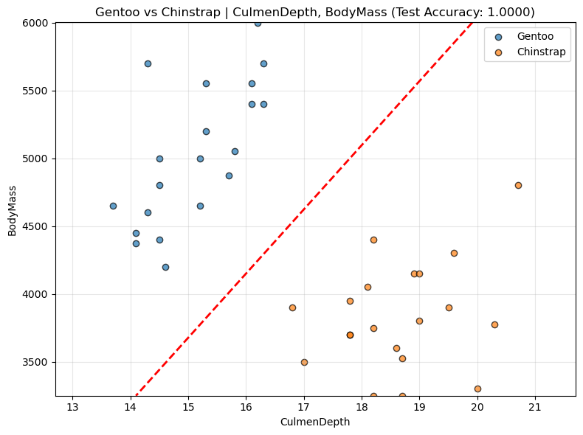

Run | Classes | Features | Test Acc | Analysis of Class Discrimination & Feature Effectiveness
7 | Adelie vs Gentoo | OriginLocation, FlipperLength | 100% | Discrimination Quality: Excellent. A perfect 100.00% accuracy was achieved. Separability: The classes are perfectly linearly separable.
8 | Adelie vs Gentoo | OriginLocation, BodyMass | 92.50% | Discrimination Quality: Moderate-Good. Accuracy is high, but 3 samples were misclassified (FP=2, FN=1). Separability: The classes are mostly linearly separable, showing consistent results with the previous parameter set.
9 | Adelie vs Gentoo | CulmenDepth, FlipperLength | 100% | Discrimination Quality: Excellent. A perfect 100.00% accuracy was achieved. Separability: The classes are perfectly linearly separable.
10 | Adelie vs Chinstrap | CulmenDepth, FlipperLength | 80.00% | Discrimination Quality: Poor. Accuracy is low, with 8 samples misclassified (FP=3, FN=5). Separability: The classes are not linearly separable, although performance improved slightly from Run 4.
11 | Adelie vs Chinstrap | BodyMass, FlipperLength | 77.50% | Discrimination Quality: Poor. Accuracy is low, with 9 misclassifications (FP=3, FN=6). Separability: The classes are not linearly separable; this pair is consistently difficult.
12 | Gentoo vs Chinstrap | CulmenDepth, BodyMass | 100% | Discrimination Quality: Excellent. A perfect 100.00% accuracy was achieved. Separability: The classes are perfectly linearly separable.

Best Combination: ('Adelie', 'Gentoo', 'CulmenDepth', 'FlipperLength')

Perceptron
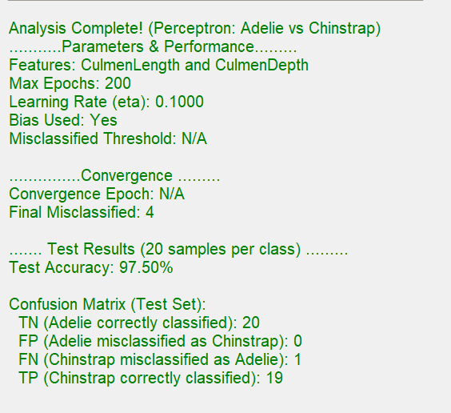

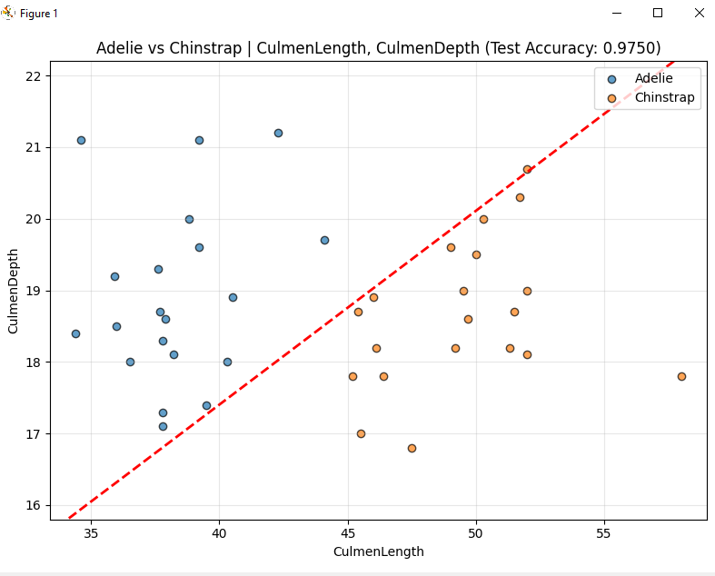

Analysis of Class Discrimination & Feature Effectiveness:
Discrimination Quality: Good. The combination achieves high accuracy 97.50%, confirming that these two morphological features are strong discriminators between Adelie and Chinstrap penguins.
Separability: The classes are nearly linearly separable. The Perceptron found a boundary that correctly classified all but one Chinstrap sample on the test set FN=1.

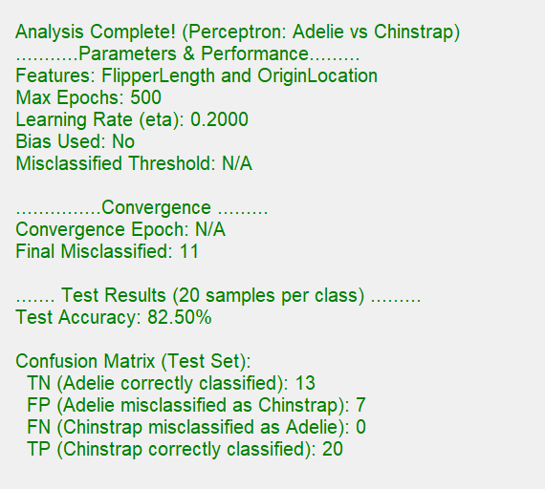

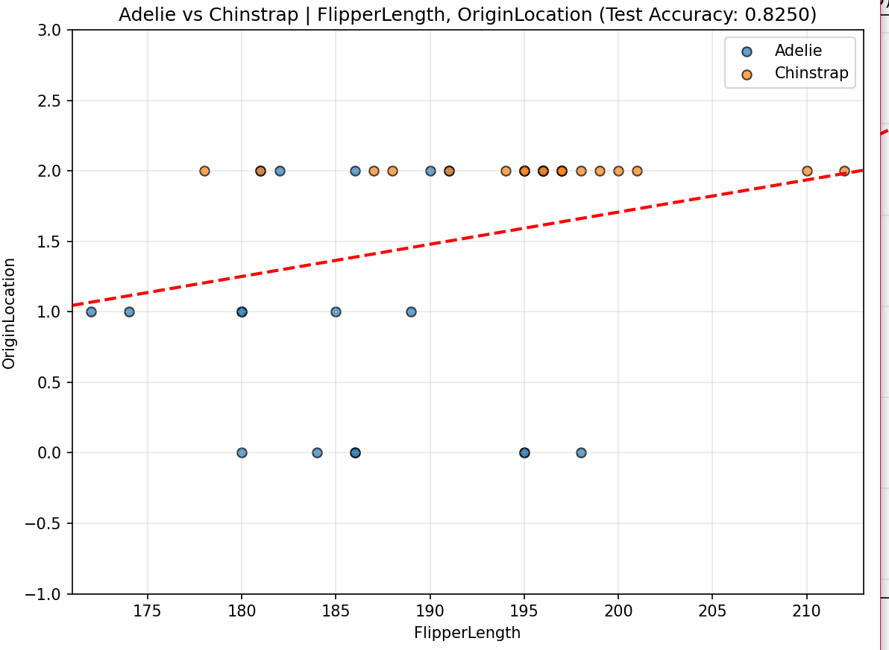

Analysis of Class Discrimination & Feature Effectiveness:
Discrimination Quality: Poor/Medium. The accuracy is 82.50%, which is significantly lower than the other combinations, indicating weaker linear separability.
Separability: The classes show substantial overlap, particularly at OriginLocation1 OriginLocation 2, where samples from both species are mixed. The boundary fails to effectively separate the groups, resulting in 7 false positives (Adelie misclassified as Chinstrap).

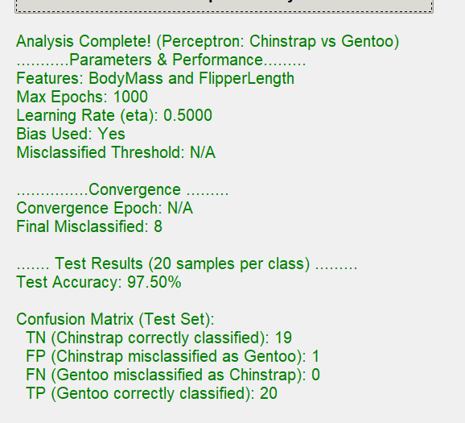

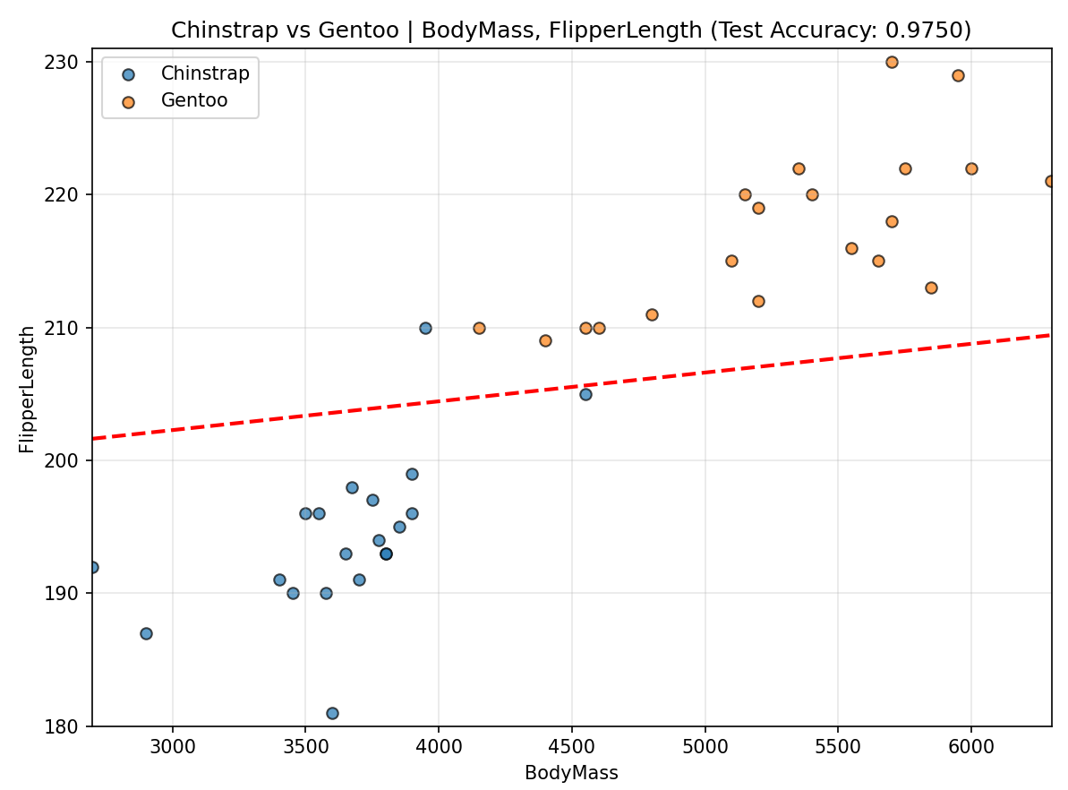
Analysis of Class Discrimination & Feature Effectiveness:
Discrimination Quality: Good. The 97.50% accuracy indicates strong performance.
Separability: The two species are almost perfectly linearly separable. The boundary successfully isolates the two clusters, resulting in only one false positive (Chinstrap misclassified as Gentoo, FP=1

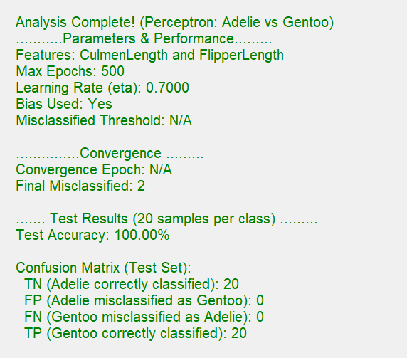

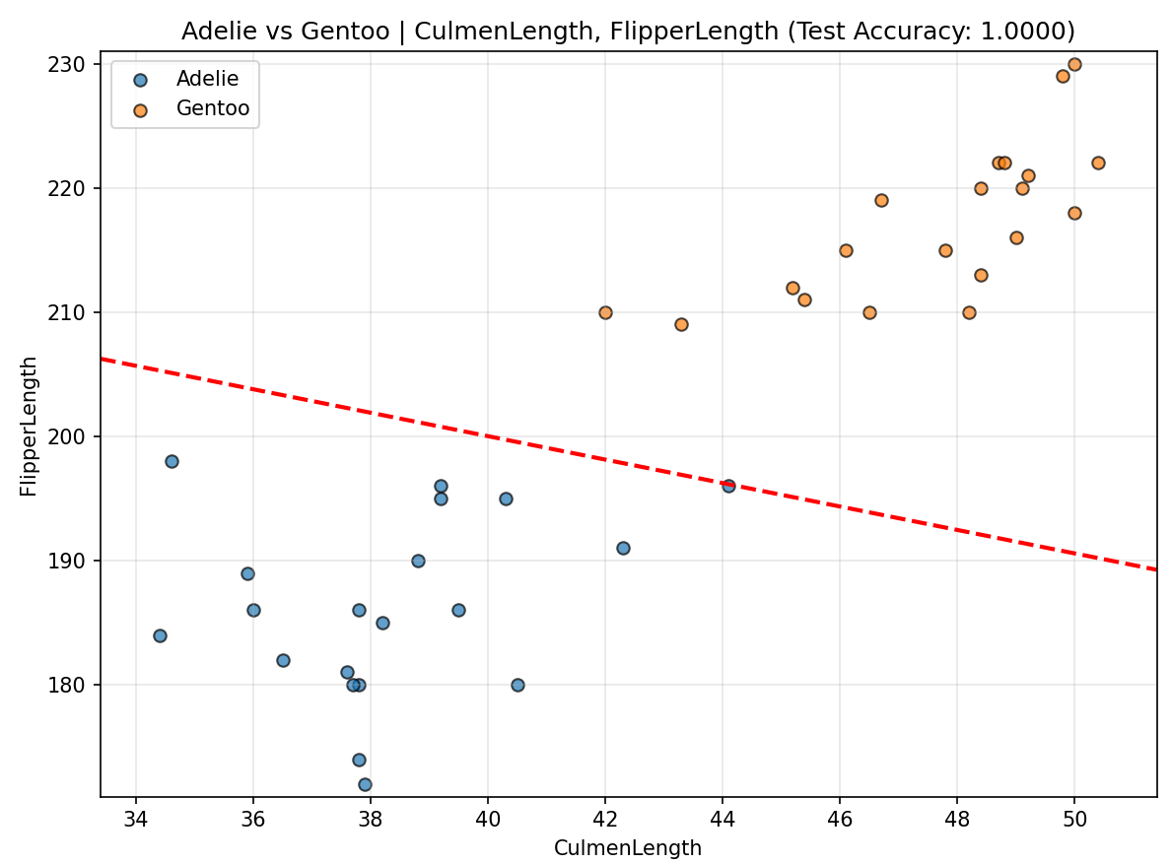
Analysis of Class Discrimination & Feature Effectiveness:
Discrimination Quality: Excellent. A perfect 100.00% accuracy was achieved on the test set.
Separability: The classes are perfectly linearly separable with respect to these two features. Although the Perceptron did not converge to zero misclassified on the training set Final Misclassified=2, the learned boundary generalized perfectly to the test set, achieving 0 false positives and 0 false negatives.

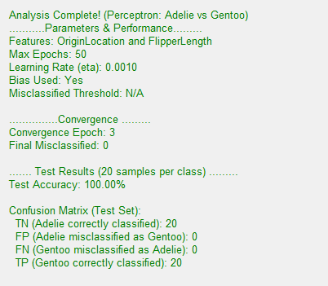

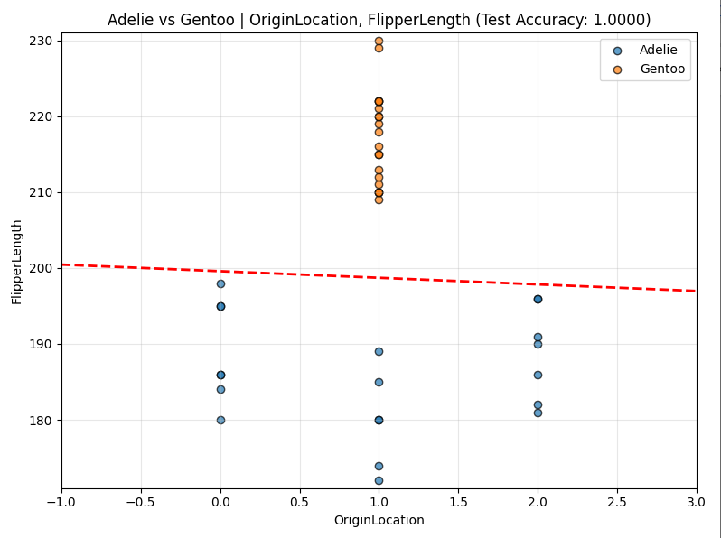

Analysis of Class Discrimination & Feature Effectiveness:
Discrimination Quality: Excellent. Perfect 100.00% accuracy and full convergence textFinal Misclassified=0Convergence Epoch=3.
Separability: The classes are perfectly linearly separable. The Perceptron converged quickly, indicating the separation is robust. The boundary is drawn horizontally at a FlipperLength value that splits the Adelie and Gentoo clusters at OriginLocation=1 and ignores the Adelie points at OriginLocation=0 and OriginLocation=2 because Gentoo is absent there.

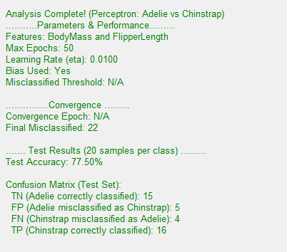

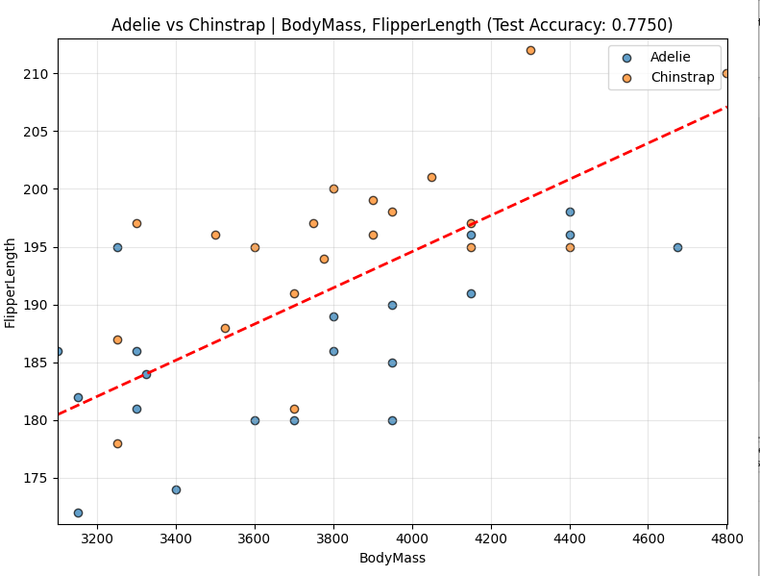
Analysis of Class Discrimination & Feature Effectiveness:
Discrimination Quality: Poor. The accuracy of 77.50% is the lowest observed, and the high Final Misclassified=22 confirms the Perceptron struggled to find a good solution.
Separability: The classes are not linearly separable boundary settled in a position that failed to properly isolate the clusters, leading to 5 false positives and 4 false negatives.

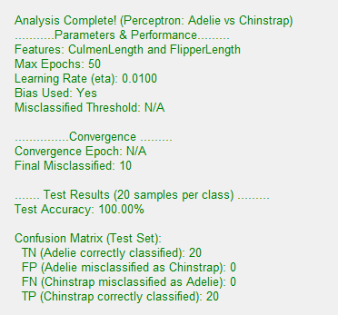

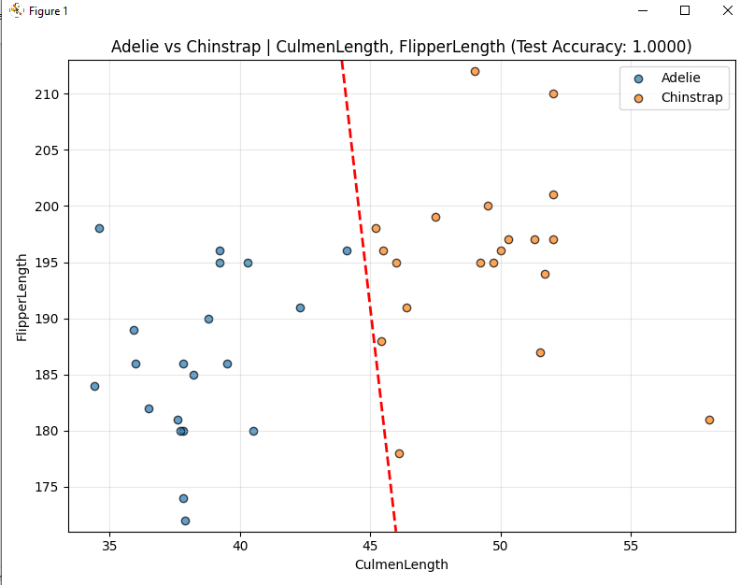
Analysis of Class Discrimination & Feature Effectiveness:
Discrimination Quality: Excellent. A perfect 100.00% accuracy was achieved, and the Perceptron converged very quickly Convergence Epoch=2.
Separability: The classes are perfectly linearly separable

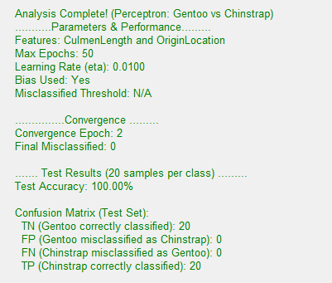
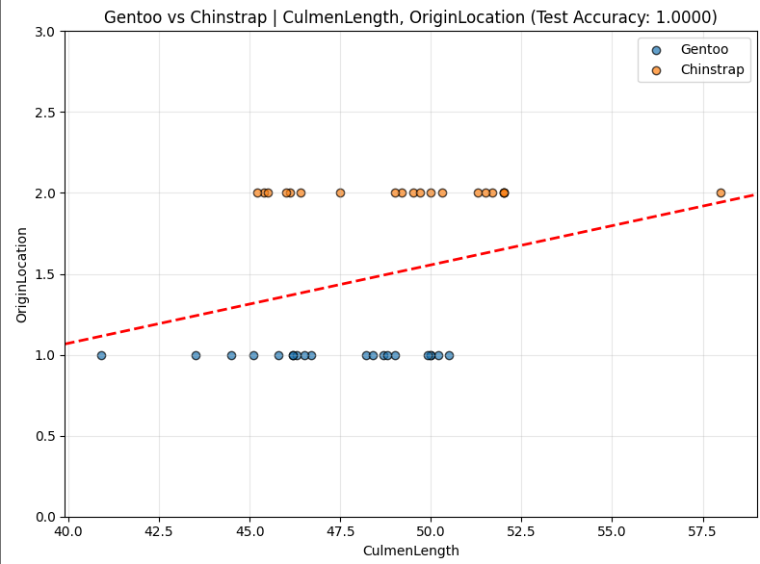

Features achieved highest accuracy:
Adelie VS Chinstrap
- Culmen length & Flipper length (Acc:100%)
- Culmen length & Culmen depth (Acc: 0.97)

Chinstrap VS Gentoo
- Original location & Culmen length (Acc:100%)
- Body mass & Flipper length (Acc: 0.97)

Adelie VS Gentoo
- Culmen length & Flipper length (Acc:100%)
- Original location & Flipper length (Acc:100%)

