Measurement of Angles

Lesson 1

Use your angle-measuring tool to measure the angle given by the starred location on the Ferris wheel. Assume that the starting position is the bottommost point of the Ferris wheel and that the Ferris wheel rotates counterclockwise. Write the number of wedges under each Ferris wheel.

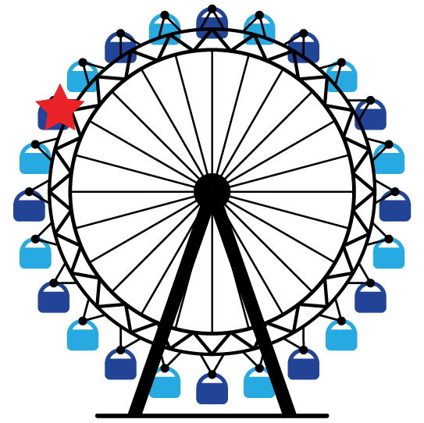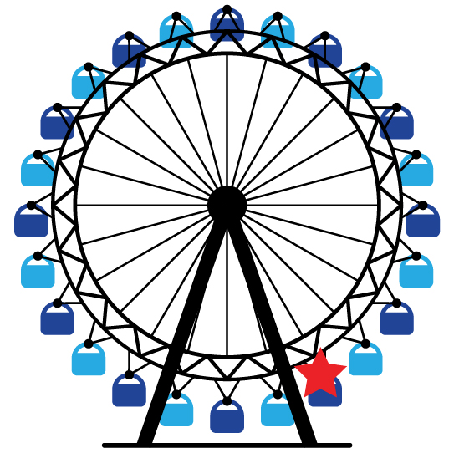

__________ wedges __________ wedges

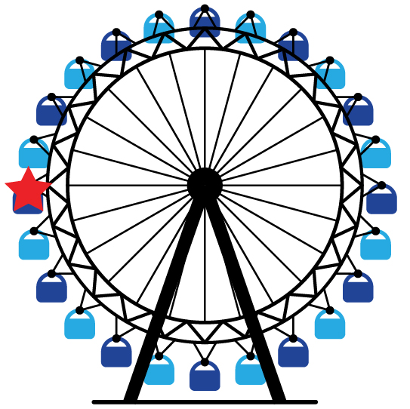  
  
  
  
  
  
  
  
  
  
  
  
  
  
  
  
  
  
__________ wedges __________ wedges

Use your angle-measuring tool that you cut out to measure each angle. Write the number of wedges under each angle.

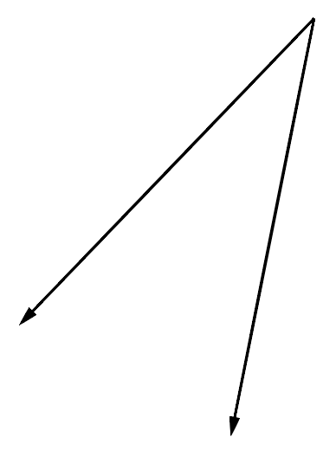

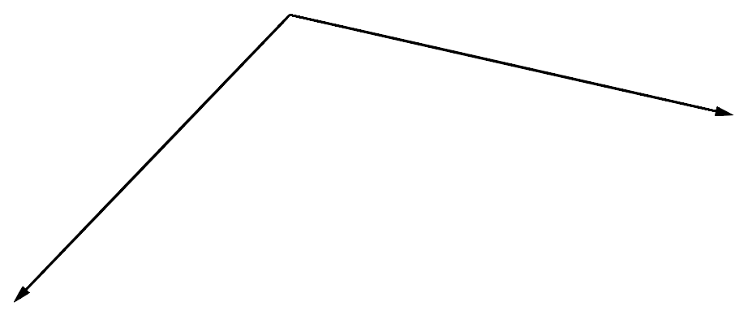

__________ wedges __________ wedges

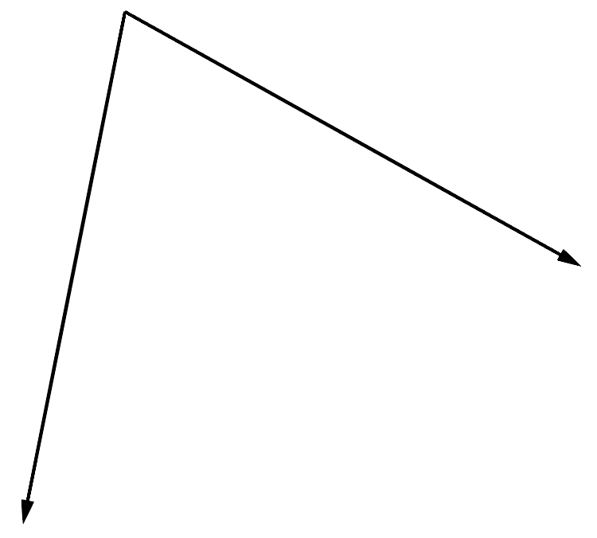

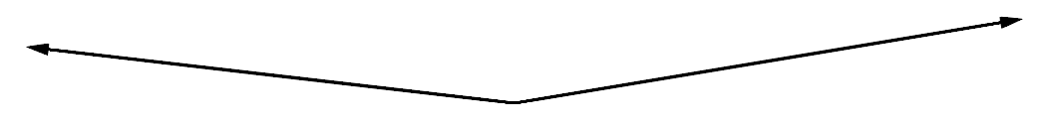

__________ wedges __________ wedges

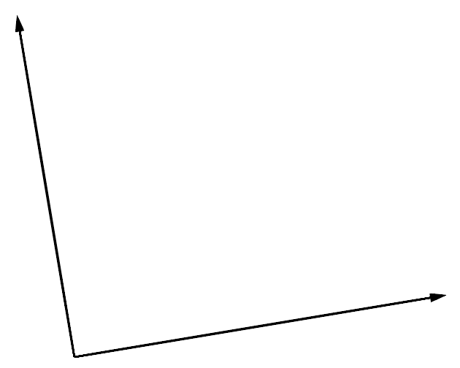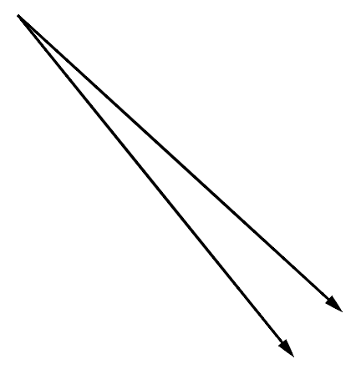

__________ wedges __________ wedges

Extend a ray in one of the angles. Use your angle-measuring tool that you cut out to measure that same angle.

How many wedges is the angle after extending the ray?

Did the number of wedges in the angle change after extending the ray? Explain why or why not.

Measurement of Angles

INSTRUCTIONAL ACTIVITY SUPPLEMENT

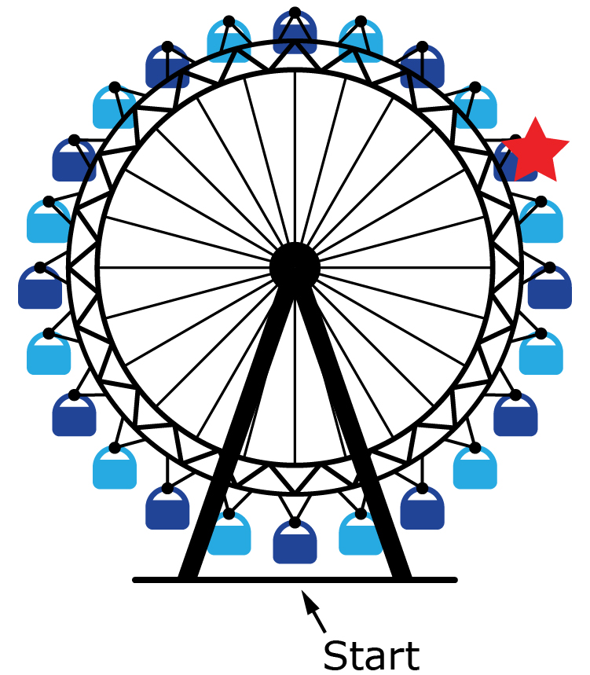Lesson 1

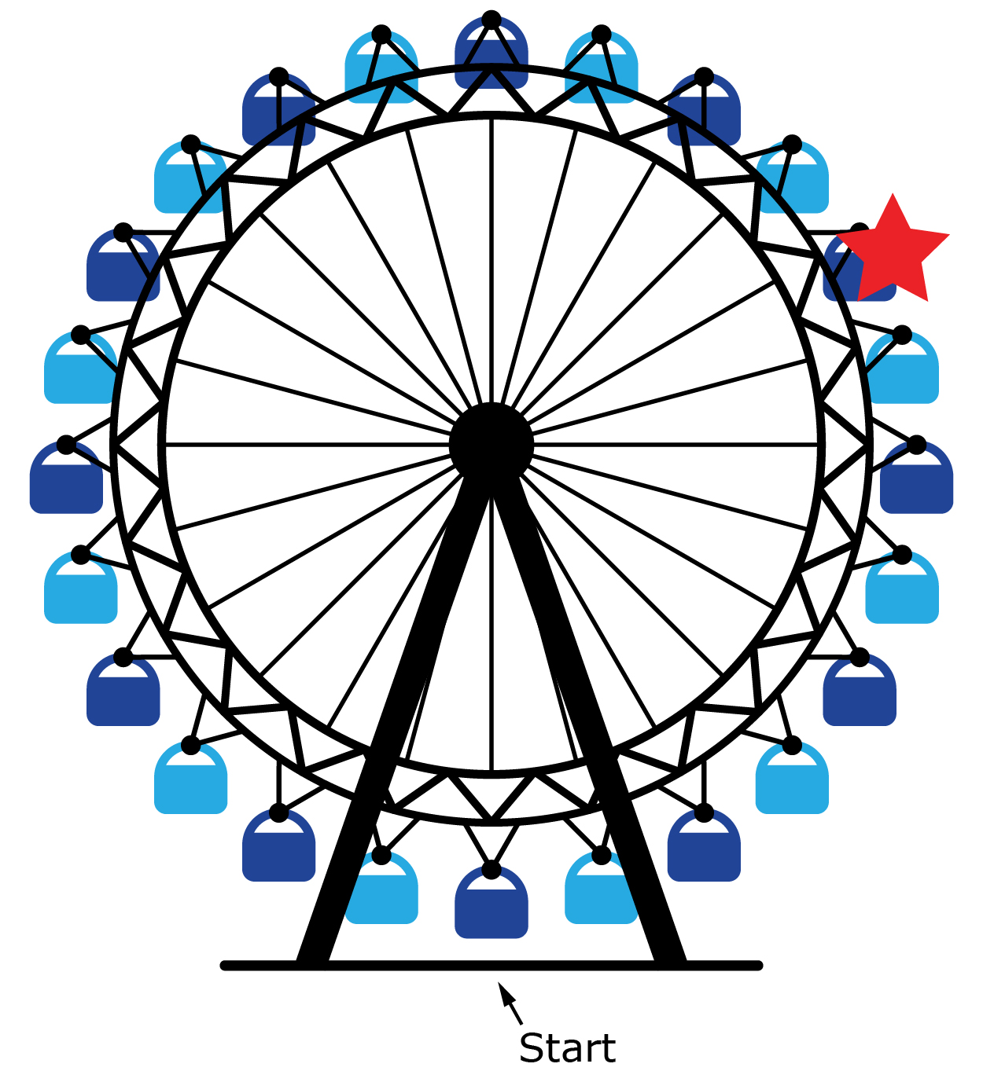

Measurement of Angles

Lesson 2

1. Write what you know about *degrees* in the space below. Provide at least one real-world example that includes an angle measurement in degrees.

1. 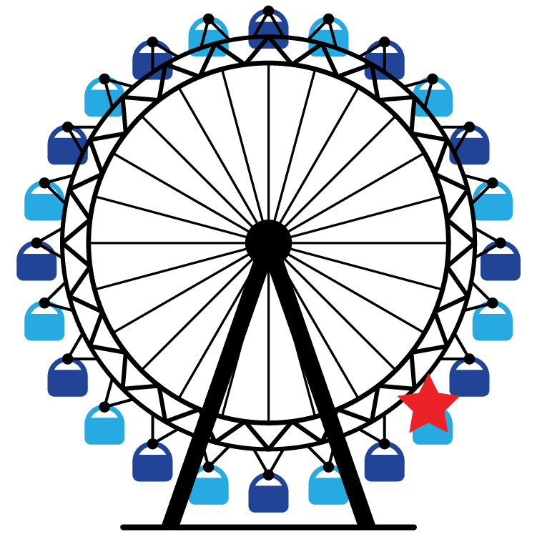Using a protractor, measure the angle given by the starred location on the Ferris wheel. Use the bottommost point of the Ferris wheel as the starting point, and assume the Ferris wheel rotates counterclockwise.

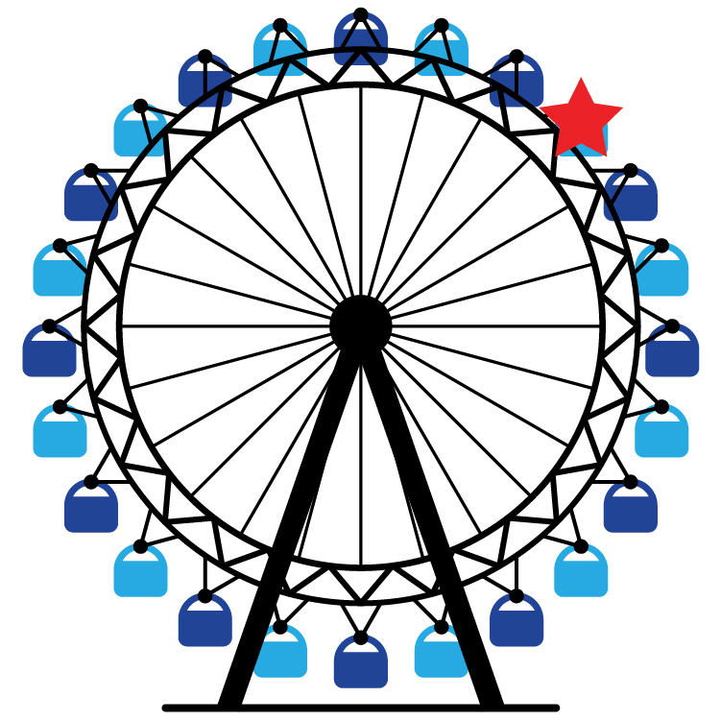

______ degrees ______ degrees

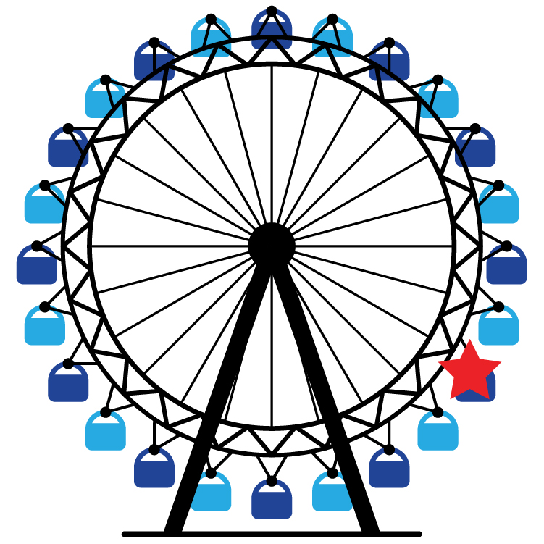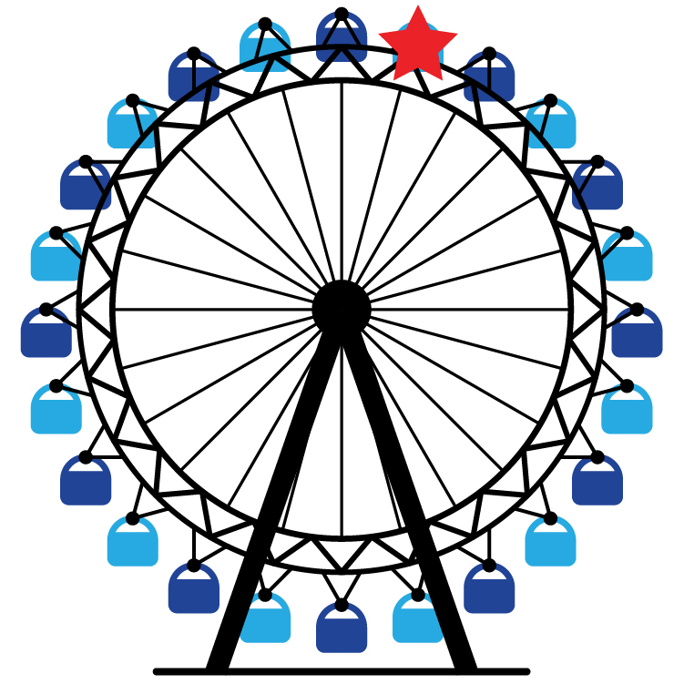

______ degrees ______ degrees

1. Using a protractor, measure the angle marked in the slice of pizza.



______ degrees ______ degrees

1. Draw the angle measure indicated for each Ferris wheel.

A 53° turn. A 78° turn.

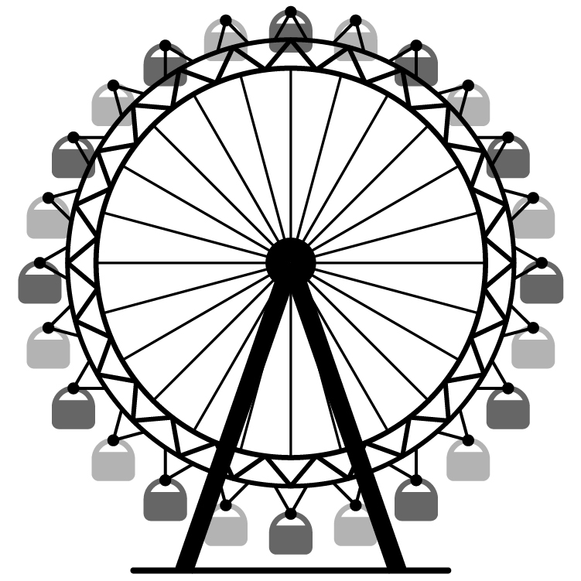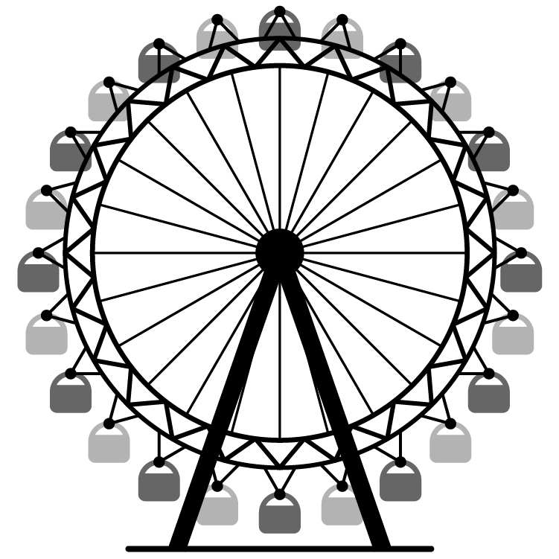

1. Draw the angle measure indicated for each slice of pizza. Use one of the existing cuts as the initial side of the angle.

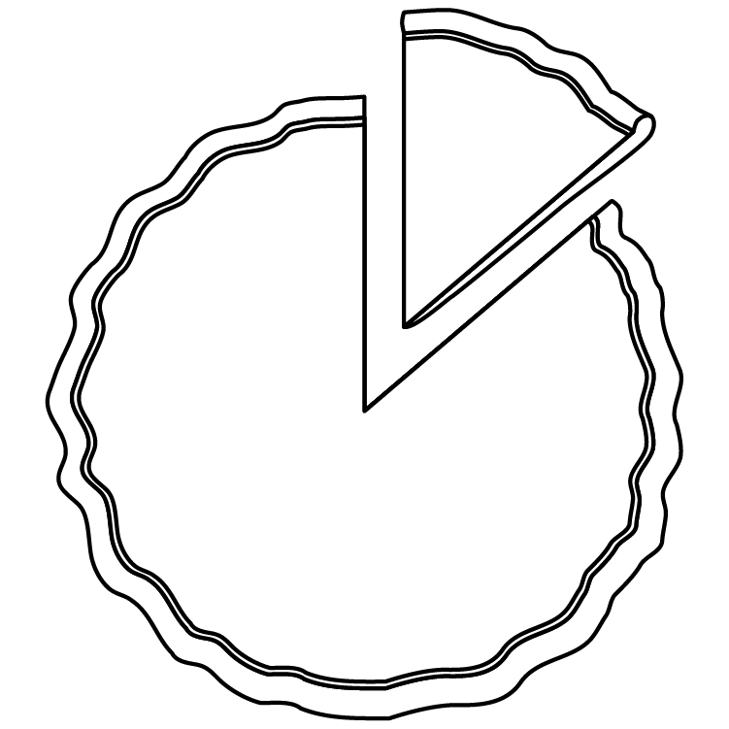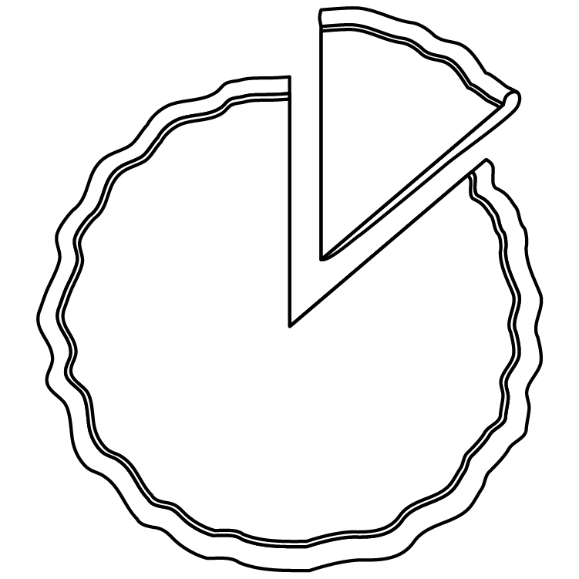A 112° slice of pizza A 177° slice of pizza

1. In the space provided below, draw a 25° angle.

7. In the space provided below, draw a 149° angle.

Measurement of Angles

1. Use a protractor to measure each of the following angles.
2. Draw an angle with the given degree measure.
   1. 27o

* 1. 119o

* 1. 90o

1. Describe each of the following terms.
   1. Angle
   2. Degree
   3. Ray
2. Why is it important to have a standard unit to measure angles?

1. Without using a protractor, state whether you believe the angles have the same measure or different measures. Explain your reasoning.

1. Color or shade in the portion of the Ferris wheel between the two angle measures given. Assume that the Ferris wheel starts at the bottom and turns counterclockwise.
   1. Between 0o and 180o
   2. Between 180o and 360o
   3. Between 90o and 180o