Comparing Fractions

Lesson 1

|  |  |
| --- | --- |
| **___________________________________**  **___________________________________** | **___________________________________**  **___________________________________** |
| **___________________________________**  **___________________________________** | **___________________________________**  **___________________________________** |
| **___________________________________**  **___________________________________** | **___________________________________**  **___________________________________** |
| **___________________________________**  **___________________________________** | **___________________________________**  **___________________________________** |
| **___________________________________**  **___________________________________** | **___________________________________**  **___________________________________** |
| **___________________________________**  **___________________________________** | **___________________________________**  **___________________________________** |

0

1

Comparing Fractions

INSTRUCTIONAL ACTIVITY SUPPLEMENT

Lesson 1

|  |  |  |
| --- | --- | --- |
|  |  |  |
|  |  |  |
|  |  |  |
|  |  |  |

|  |  |  |
| --- | --- | --- |
|  |  |  |
|  |  |  |
|  |  |  |
|  |  |  |

Comparing Fractions

Lesson 2

1. Show using the given circle as a whole.

1. Show using the given rectangle as a whole.

1. Show on the number line provided.

1. Show on the number line provided.

1. Which is greater, or ?
   1. Support your answer using a number line or picture.

* 1. Support your answer using words.

* 1. Write the appropriate inequality symbol in the box to compare the two fractions.

Compare Fractions

INSTRUCTIONAL ACTIVITY SUPPLEMENT

Lesson 2

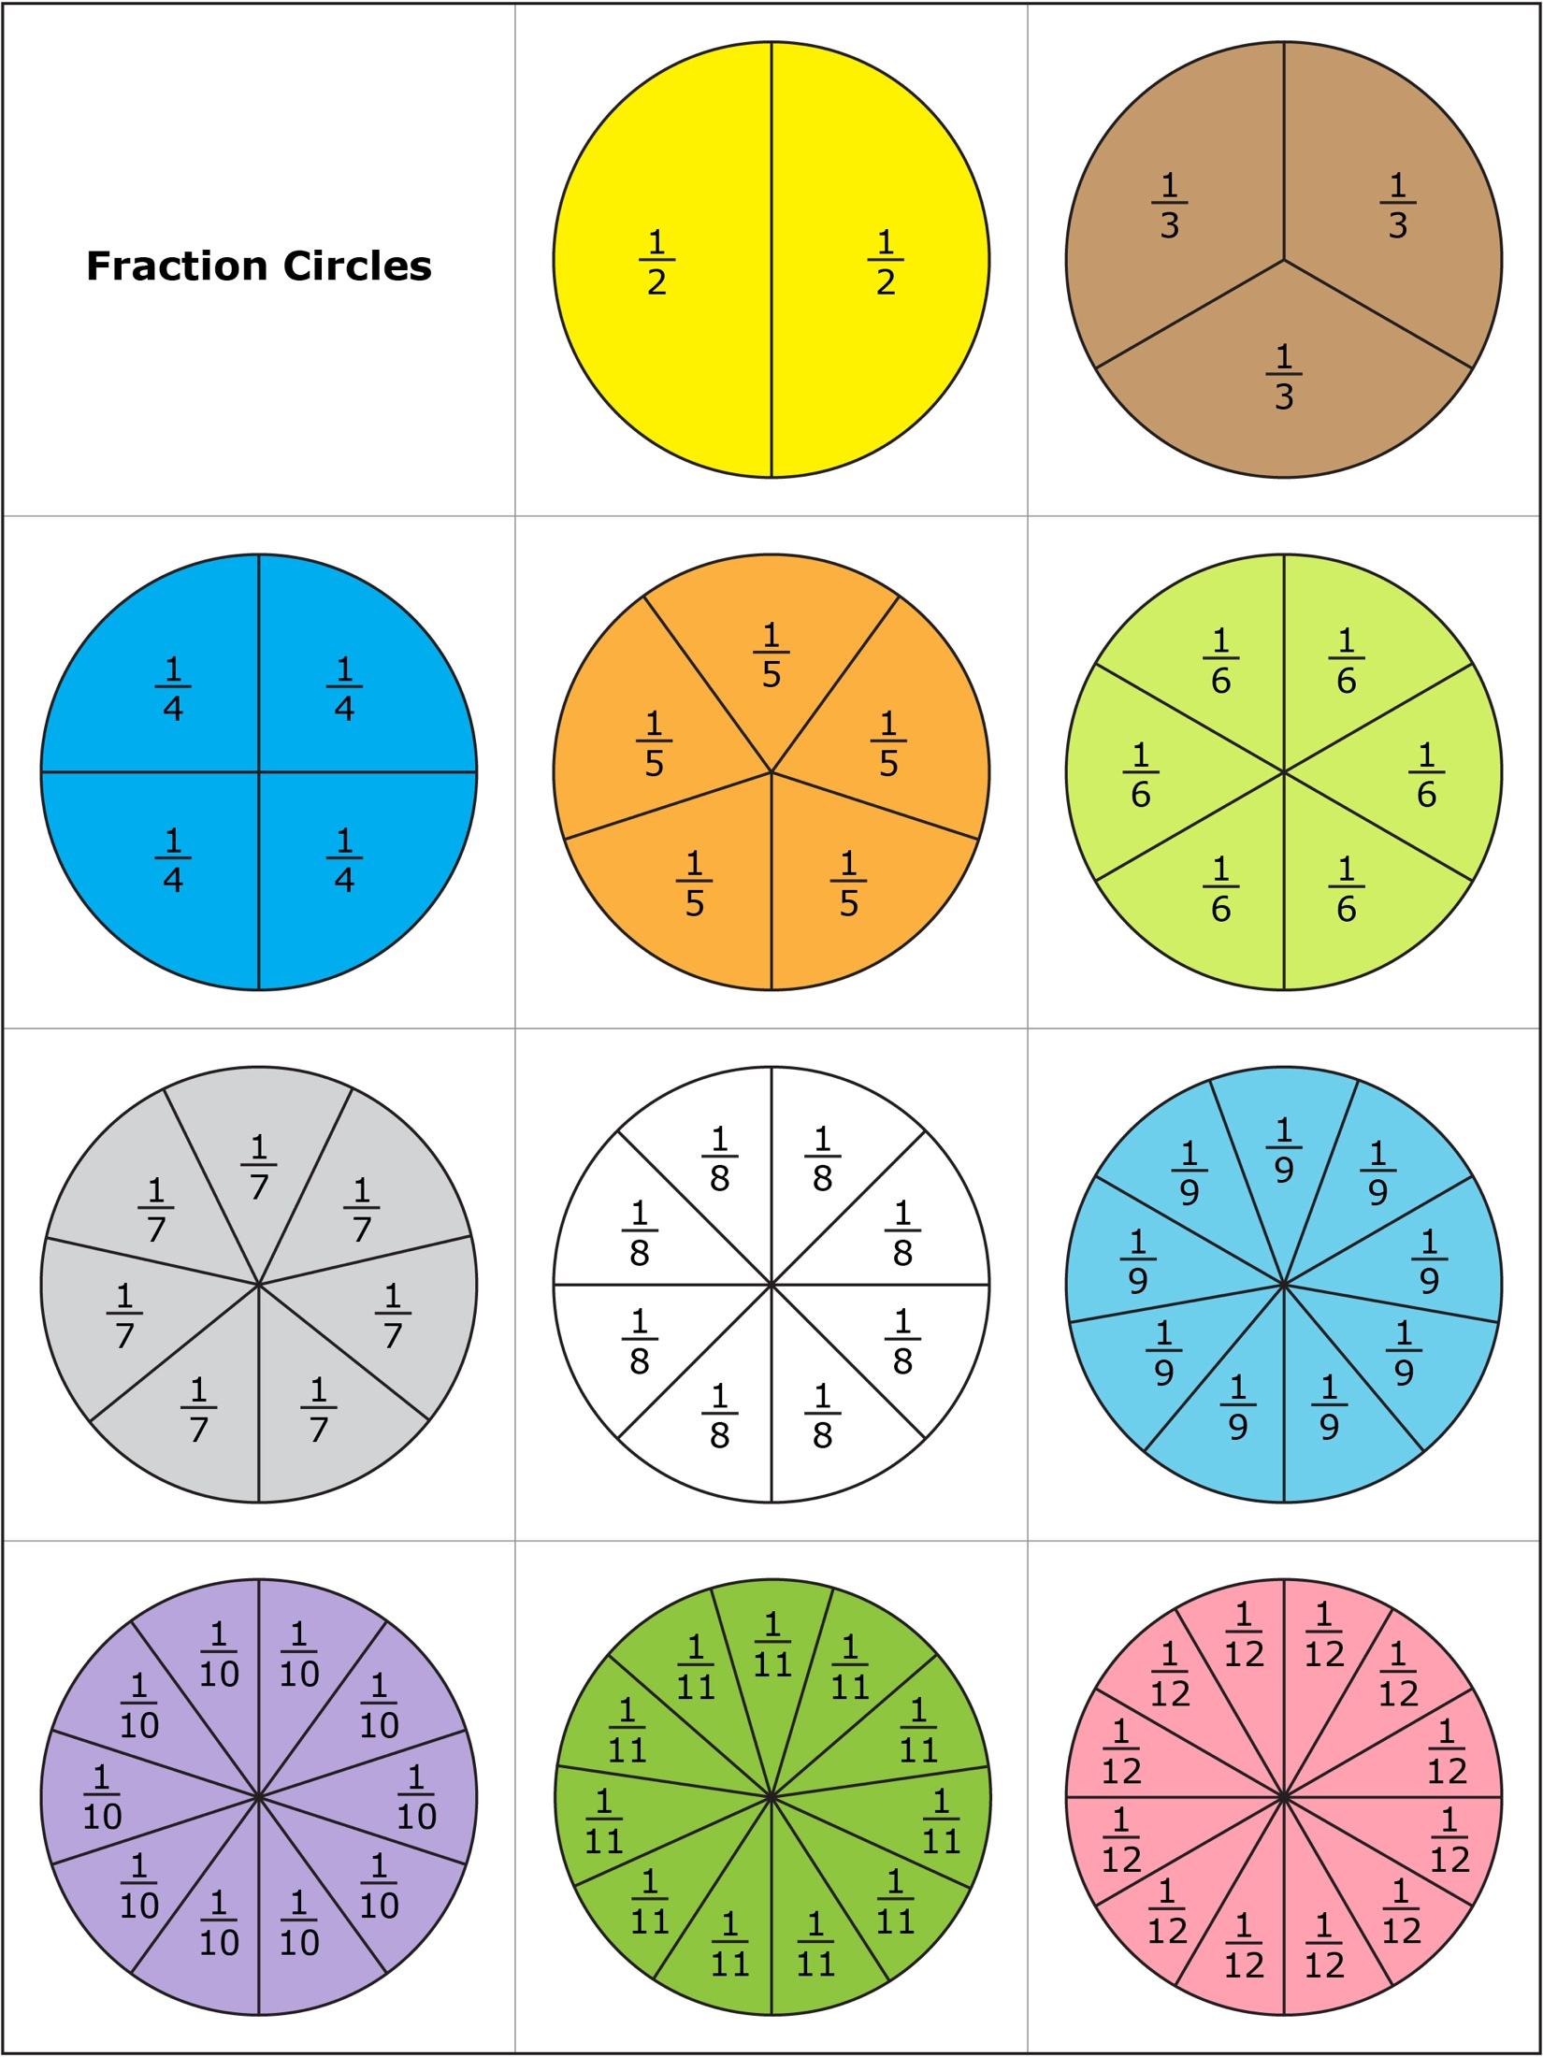



Comparing Fractions

Lesson 3

1. What is a common denominator?
2. Give an example of two fractions that have a common denominator.
3. Give an example of two fractions that do not have a common denominator.
4. a. Rewrite the fraction to have a **denominator** of 12.

b. Use your answer from part (a) to tell whether or is greater, or whether the two fractions are equivalent.

1. a. Rewrite the fraction to have a **numerator** of 6.

b. Use your answer from part (a) to tell whether or is greater, or whether the two fractions are equivalent.

1. Write the least common denominator for and .

1. Write the least common denominator for and . Then list another common denominator for the two fractions.

1. Find the least common denominator for the following pairs of fractions. **Then**, rewrite one or both fractions with the least common denominator. **Lastly**, circle the greater fraction.
   1. and

b. and

c. and

1. Write the least common multiple of the following pairs of numbers.
   1. 3 and 6
   2. 3 and 7
   3. 2 and 5
   4. 9 and 4
2. State the least common denominator for the following pairs of fractions.
   1. and
   2. and
   3. and
3. Find the least common denominator for the following pairs of fractions. **Then**, rewrite one or both fractions with the least common denominator. **Lastly**, circle the greater fraction.
   1. and
   2. and
   3. and

Comparing Fractions

INSTRUCTIONAL ACTIVITY SUPPLEMENT

Lesson 4

Example:

|  |  |  |
| --- | --- | --- |
| Student 1 Student 2  6  4  1st roll  1st roll  <  4  3  A Explanation:  2nd roll  2nd roll  is greater than 1, and is , (or ) greater than 1. Since is greater than , is greater than . | Student 1 Student 2  A Explanation: | Student 1 Student 2  A Explanation: |
| Student 1 Student 2  A Explanation: | Student 1 Student 2  A Explanation: | Student 1 Student 2  A Explanation: |
| Student 1 Student 2  A Explanation: | Student 1 Student 2  A Explanation: | Student 1 Student 2  A Explanation: |
| Student 1 Student 2  A Explanation: | Student 1 Student 2  A Explanation: | Student 1 Student 2  A Explanation: |

Comparing Fractions

Lesson 1-4

1. James ate three slices of a cherry pie that was cut into eight equal-size pieces. Luke ate three slices of an equally sized apple pie that was cut into six equal-size pieces.
   1. What fraction of a whole pie did each boy eat?

* 1. Which boy ate more pie? Tell how you know with words.

* 1. Represent the two fractions on the number line.

1

0

1. 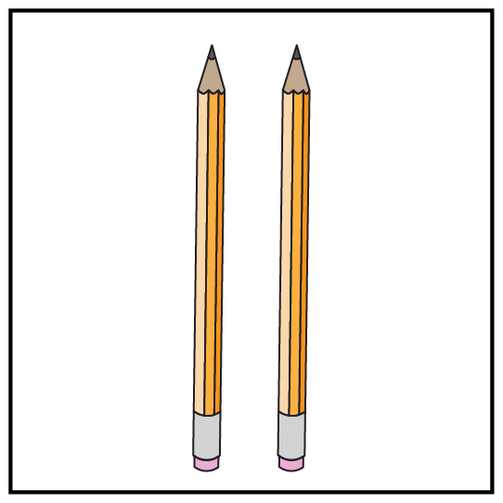Ms. Harvey has a set of 20 pencils. Yesterday of the pencils were used. Today of the pencils are being used. On which day were more pencils used? Explain in words how you know.
   1. Support your answer by creating and using a number line.

* 1. Support your answer by creating and using an area model.

1. Olivia, Peyton, and Justin each ordered a large pizza. Olivia ate of her pizza, Peyton ate of her pizza, and Justin ate of his pizza. Who ate the most pizza? Explain how you know.
2. Order the following fractions from least to greatest.

1. 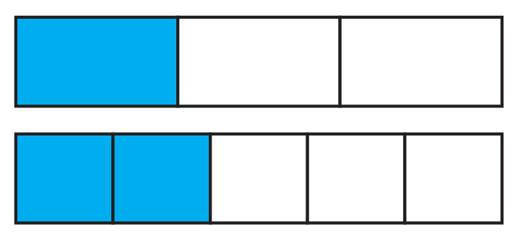Use the fraction model to answer the following questions. One whole is one long rectangle.  
     
     
   1. What two fractions are shown by the shaded regions?

* 1. Place both fractions on the same number line.

0

1

* 1. Write a statement comparing the two fractions symbolically.

1. Tell whether the following fractions are less than or greater than one-half. Explain how you know.



1. Rewrite the following fraction(s) to have a common denominator.

and

* 1. What do you know about the rewritten fractions?

1. 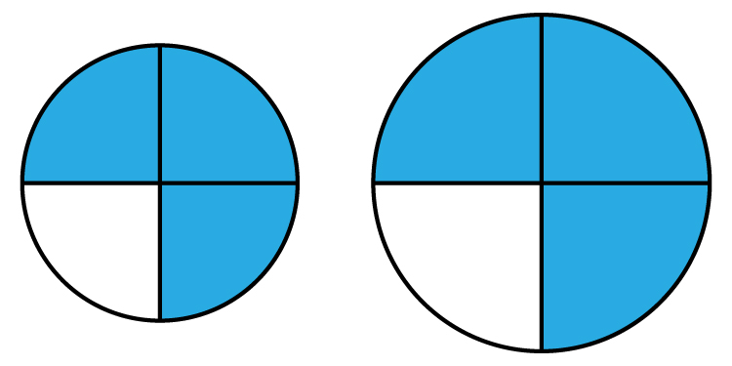Use the two fraction models to answer the following questions.  
     
     
     
   1. What fraction is represented by the two drawings?
   2. Are the two fractions equal? Why or why not?

1. 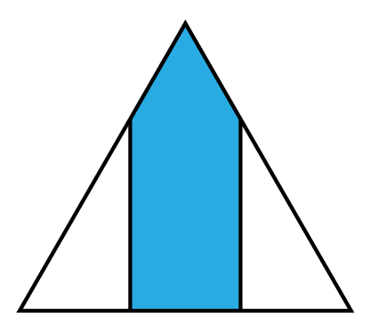Jessica partitioned this triangle in an attempt to represent . Explain her mistake.

1. Look at and . Do the 4s represent the same thing in these two fractions? Explain.
2. Are and equal because they have the same numbers? Explain.
3. How can be greater than when both have a numerator of 5?

1. How does the numerator relate to the denominator when the amount is less than one? Equal to one? More than one?