Multiplying Fractions and Whole Numbers

INSTRUCTIONAL ACTIVITY SUPPLEMENT

Lesson 1

Jack is making cookies for the bake sale. In order to have enough cookies to sell, he is making five batches of his regular cookie recipe. The recipe calls for teaspoon of salt. How much total salt will he need?

1. Write down an estimate for how much total salt Jack needs.
2. Write the multiplication sentence that represents this scenario.
3. Represent by skip counting on the number line.

1. Draw repeated groupings to represent .
2. Draw fraction strips representing .

1. What is the total amount of salt that Jack needs? Between which two whole numbers does your answer lie?
2. What if the recipe called for teaspoon of salt? How much total salt would he need? Create a model to find the answer.
3. Between which two whole numbers does your answer lie?
4. If the total amount of salt used was teaspoons, how much salt is in one batch of cookies? Create a model, write the multiplication sentence, and find the answer.

Lucy has 15 shirts, and of them have long sleeves. How many long-sleeve shirts does Lucy have?

1. Write down an estimate of the how many long-sleeved shirts Lucy has.
2. Write the multiplication sentence that represents this scenario.
3. Represent by skip counting on the number line.

1. Draw repeated groupings to represent .
2. Draw fraction strips representing .
3. How many long-sleeve shirts does Lucy have?

Multiplying Fractions and Whole Numbers

INSTRUCTIONAL ACTIVITY SUPPLEMENT

Lesson 2

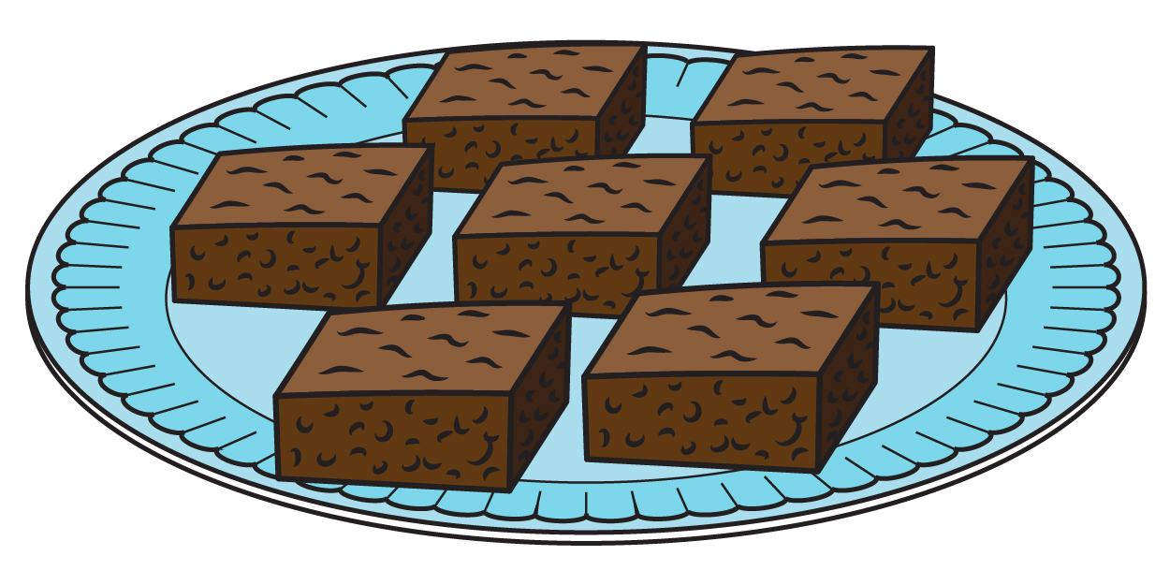Heather is making brownies for the school bake sale and decides to double her recipe. The original recipe calls for cup of flour. How much total flour does she need?

1. Write down an estimate for how much total flour Heather needs.
2. Write the multiplication sentence that represents this scenario.
3. Draw fraction strips representing .
4. Draw repeated groupings to represent .
5. Represent by skip counting on the number line.

1. 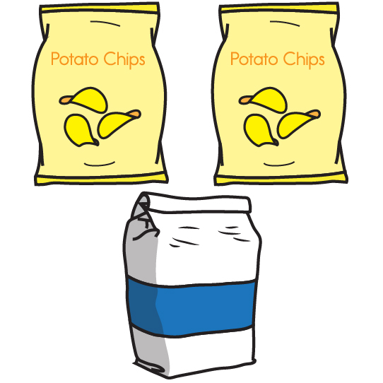What is the total amount of flour that Heather needs? Between which two whole numbers does your answer lie?
2. 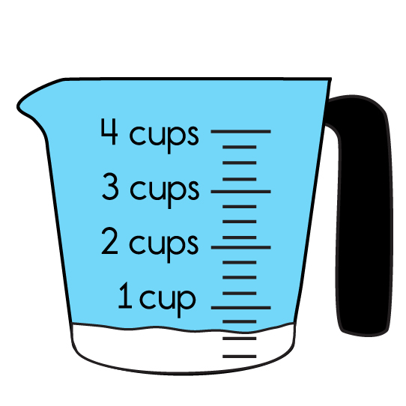What if the recipe called for cup of flour? How much total flour would Heather need? Between which two whole numbers does your answer lie?

1. If the total amount of flour used for the double recipe was cups, how much flour is in one batch of brownies? Use a model to answer the question.

The bake sale had a total of 30 brownie pans, and of them contained nuts. If you are allergic to nuts, how many brownie pans are you unable to eat?

1. Write an estimate for how many brownie pans contain nuts.
2. Write the multiplication sentence representing this scenario.
3. Draw fraction strips representing .

1. Draw repeated groupings to represent .

1. Represent by skip counting on the number line.

1. How many brownie pans contain nuts?

Multiplying Fractions and Whole Numbers

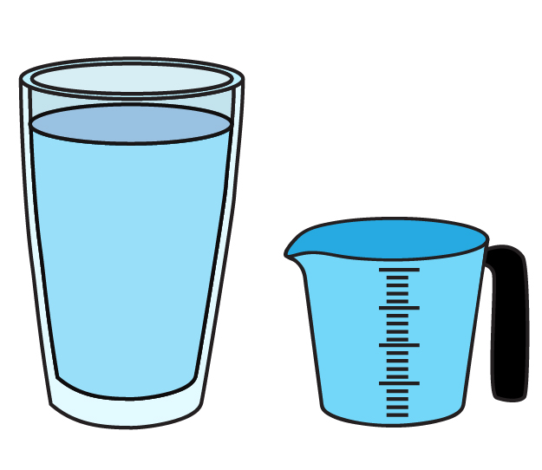Lesson 3

1. Jessica fills six glasses with liter of water. Fill in the blanks in the following number sentence to show how many total liters of water Jessica used.
2. 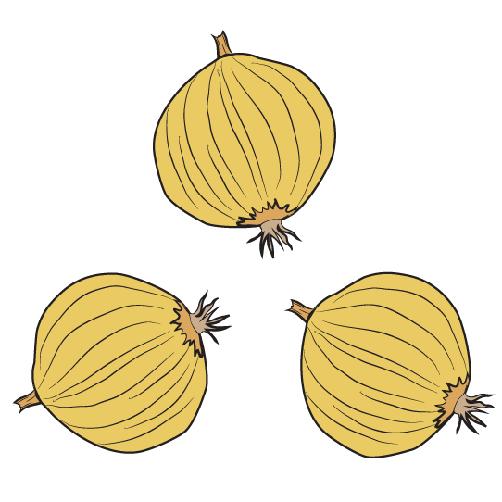Katie’s mom buys three onions at the store. Each onion weighs of a pound. How many pounds of onions does Katie’s mom have? Show a multiplication sentence representing your answer.

1. 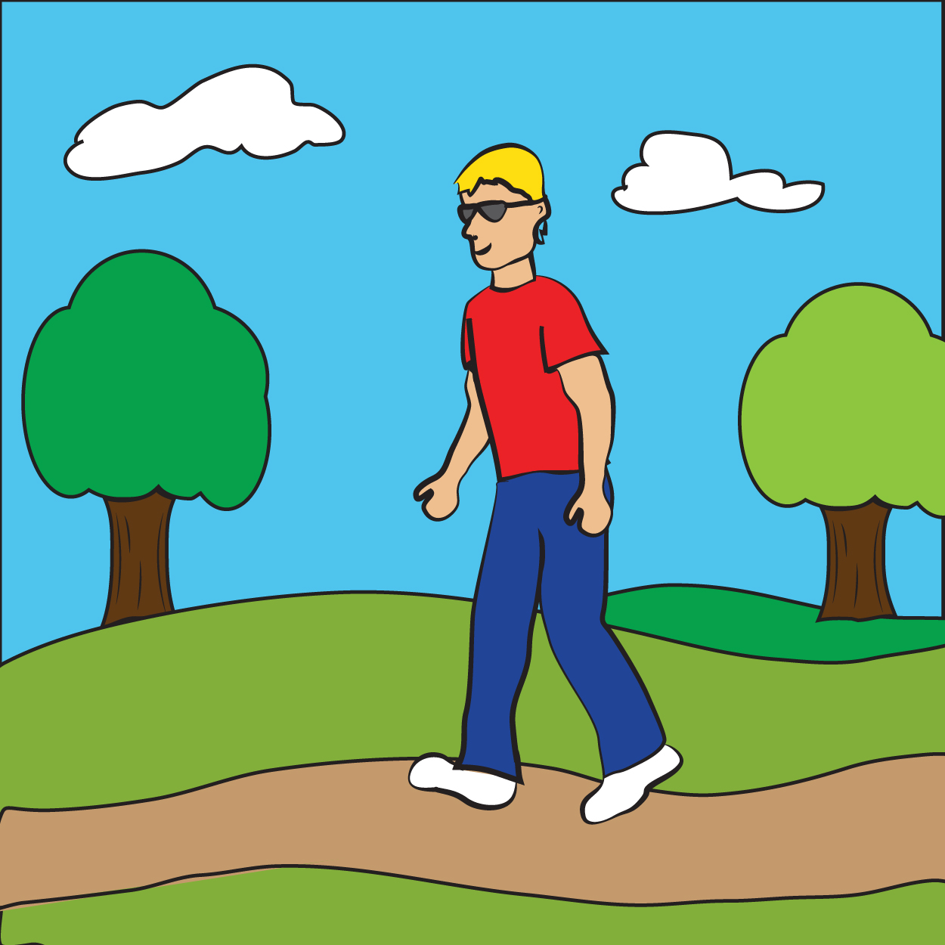George walks of a mile to his friend Michael’s house. George and Michael walk of a mile to the park. George and Michael return to Michael’s house for dinner, and then George walks back to his own house. How many miles did George walk in total? Draw a model to represent your answer.
2. 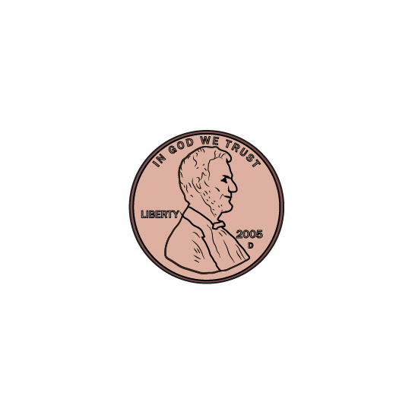Buster has a coin collection with a total of 100 coins. of his collection is pennies. How many pennies are in Buster’s collection?

1. 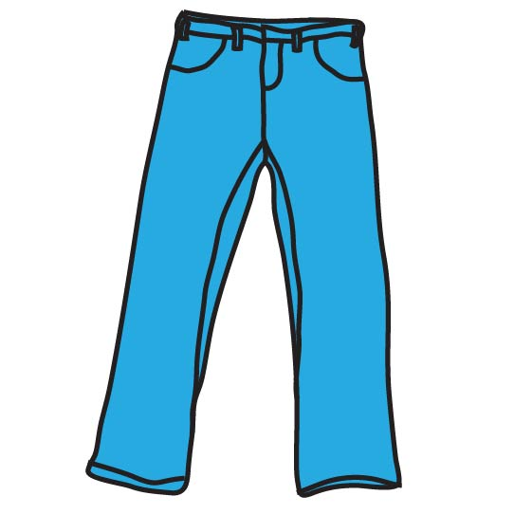Jeans that regularly cost $20.00 are on sale for off. How much money is being subtracted from the regular price?

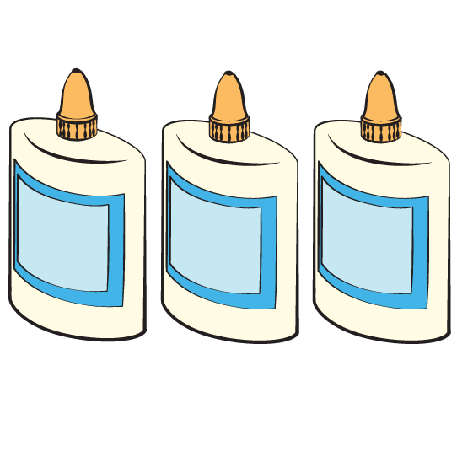

1. At the end of the school year, Ms. Jackson has 12 glue bottles that are each full. How many full bottles of glue can she make?

1. 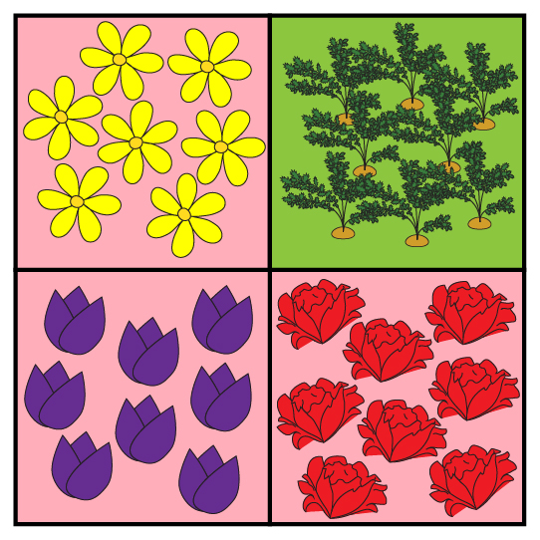Gretchen’s garden is flowers and vegetables. There are three types of flowers in the garden: roses, daisies, and tulips. What fraction of the garden is made up of tulips?

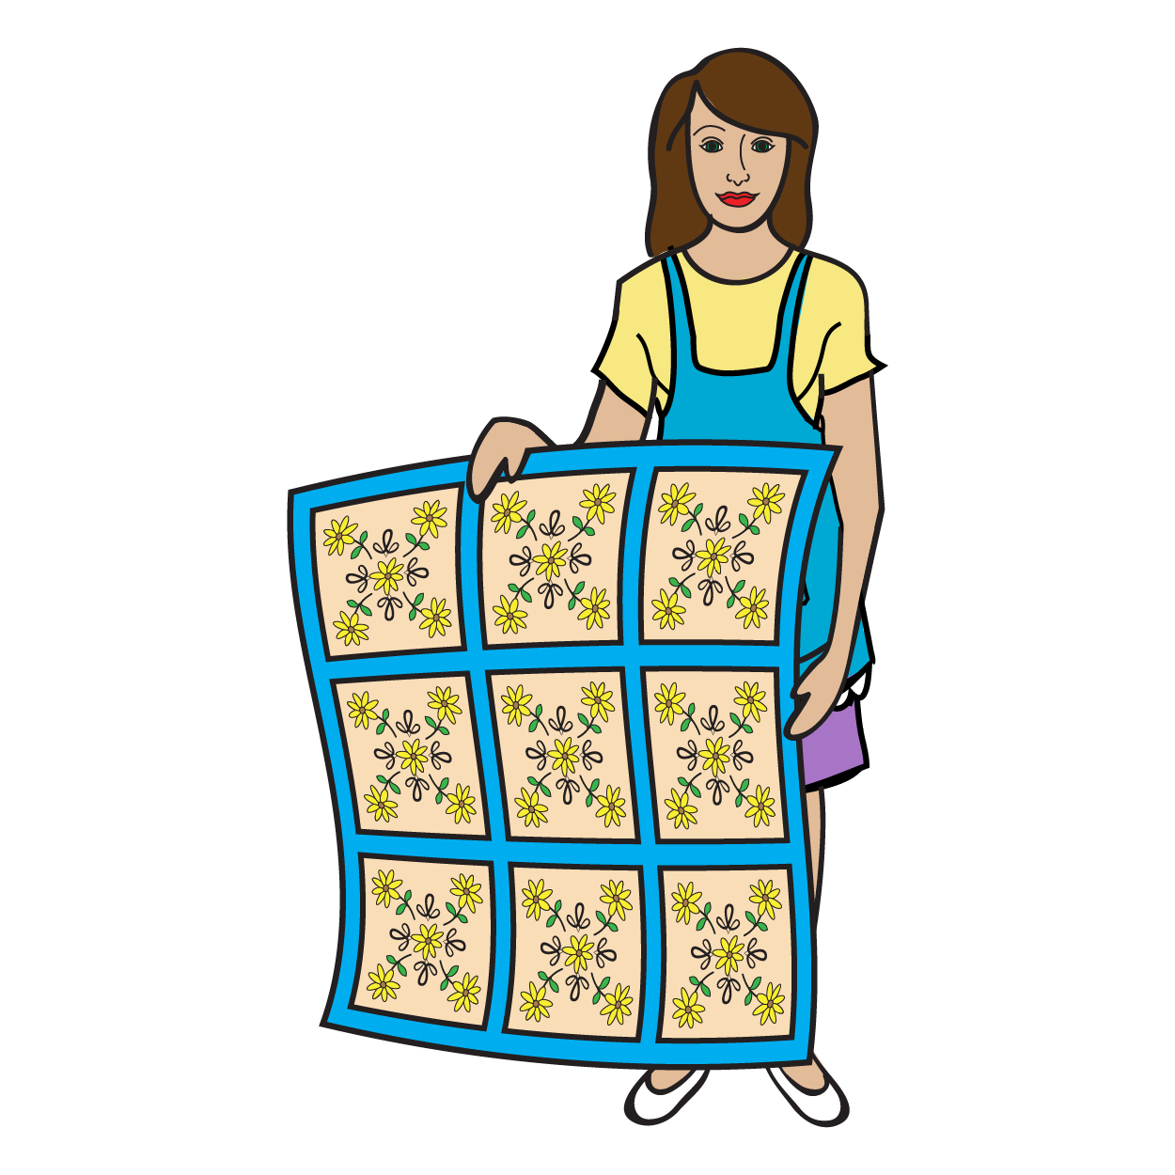

1. Priscilla is buying fabric for a quilt. She gets of a yard of fabric in five different colors. How many yards of fabric does she buy in total?

Multiplying Fractions and Whole Numbers

Lesson 4

1. Jessica fills six glasses with liter of water. Fill in the blanks in the following number sentence to show how many total liters of water Jessica used.
2. Katie’s mom buys three onions at the store. Each onion weighs of a pound. How many pounds of onions does Katie’s mom have? Show a multiplication sentence representing your answer.
3. George walks of a mile to his friend Michael’s house. George and Michael walk of a mile to the park. George and Michael return to Michael’s house for dinner, and then George walks back to his own house. How many miles did George walk in total? Draw a fraction model to represent your answer.

1. Buster has a coin collection with 100 total coins. of his collection is pennies. How many pennies are in Buster’s collection? Show a multiplication sentence representing your answer.
2. Jeans regularly cost $21.00 and are on sale for off. How much money is being subtracted from the regular price? Show a multiplication sentence representing your answer.

1. At the end of the school year, Ms. Jackson has 10 glue bottles that are each full. How many full bottles of glue can she make? Show a multiplication sentence representing your answer, then rewrite it as an addition sentence.
2. 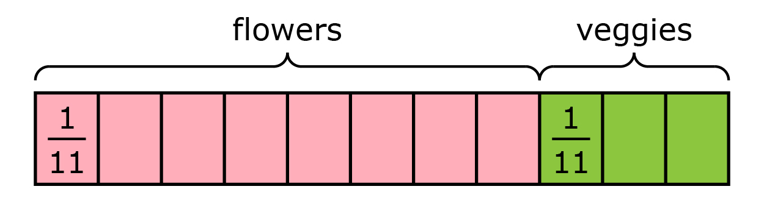Gretchen’s garden is flowers and vegetables. There are 2 types of flowers in the garden: roses and tulips. What fraction of the garden is made up of tulips? Label the area of the garden that is tulips.
3. Priscilla buys fabric for a quilt. She gets of a yard of fabric in 5 different colors. How many yards of fabric does she have in total? Draw a fraction model to represent your answer.

Multiplying Fractions and Whole Numbers

INSTRUCTIONAL ACTIVITY SUPPLEMENT

Lesson 5

A virus has deleted of your emails, and you only have 3 emails left. How many emails were in your inbox before the virus?

* Draw a fraction model to represent this situation.

* Write a multiplication sentence that represents the number of emails you had **at the start of the day**.

* + Use the previous multiplication sentence to represent the situation as a number of equal-size groups.   
      
      
    _________________ groups of ______________ size.
* Write a multiplication sentence to represent the number of emails that were **deleted** by the virus.

* + Write the previous multiplication sentence as an addition sentence.

* + Tell which is more efficient, the addition sentence or the multiplication sentence.

* Your friend had 8 emails **before** the same virus deleted of her emails. She set up the following multiplication sentence to represent how many emails were lost.

Circle all equivalent representations in the table.

|  |  |  |
| --- | --- | --- |
|  |  |  |
|  |  |  |
|  |  |  |
|  |  |  |

* + Write an email to your email service provider explaining what happened. Tell how many emails you lost, and explain how you know.

Multiplying Fractions and Whole Numbers

Lesson 1–5

1. 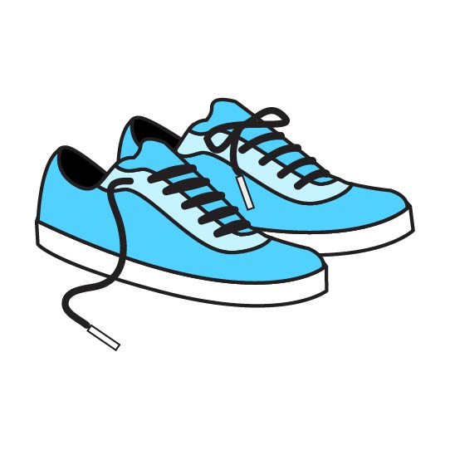Charlie has 15 pairs of shoes, and of the pairs are sneakers.
   1. Draw a visual representation of all Charlie’s shoes. Indicate which shoes are sneakers and which shoes are not sneakers by color-coding your representation.

* 1. Tell how many pairs of sneakers Charlie has.

* 1. Explain in words how you know.

1. You are buying ice cream for 9 guests at your birthday party. On average, each person will eat of a pint of ice cream.
   1. Write an addition sentence to represent the situation.

* 1. Write a multiplication sentence to represent the problem.
  2. Tell how many total pints the guests will eat by solving the multiplication sentence you wrote in 2.b. Write your answer in simplest fraction form.

* 1. Tell how many pints you must buy at the grocery store if ice cream is only sold by the pint.

1. 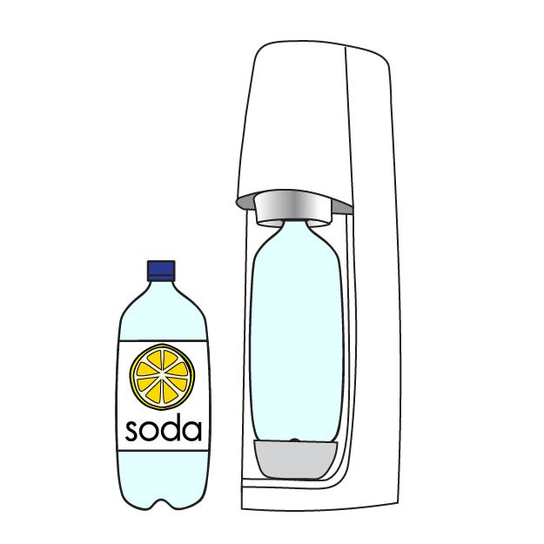You are serving soda at your party, and you fill each guest’s cup full.
   1. Write a multiplication sentence representing the total amount of cups filled.
   2. Use the previous multiplication sentence to represent the situation as a number of equal-size groups.  
        
        
      ____­_____________ groups of size ____­_____________.
   3. Solve your multiplication sentence from 3.a. Show all work.

1. Represent in three other equivalent forms.
2. Circle the greater expression, or circle both if they are equal.
3. You decide to invite 24 people to your birthday.
   1. You have $4.00 to mail the invitations, and each card costs of a dollar to send. Do you have enough money to send the invitations, or will you need to ask to borrow some money? Estimate to determine your answer.

* 1. Only of those invited can attend. How many people can come to your party? Show your work.

* 1. How many people invited cannot come to your party? Show your work.