Classifying Geometric Shapes

INSTRUCTIONAL ACTIVITY SUPPLEMENT A

Lesson 2

Single-property category labels

One acute angle

Two acute angles

Three acute angles

One right angle

Two right angles

Four right angles

One obtuse angle

Two obtuse angles

One pair of perpendicular sides

Two pairs of perpendicular sides

One pair of parallel sides

Two pairs of parallel sides

One pair of opposite sides that are the same length

Two pairs of opposite sides that are the same length

Four sides are the same length

One pair of adjacent sides that are the same length

Square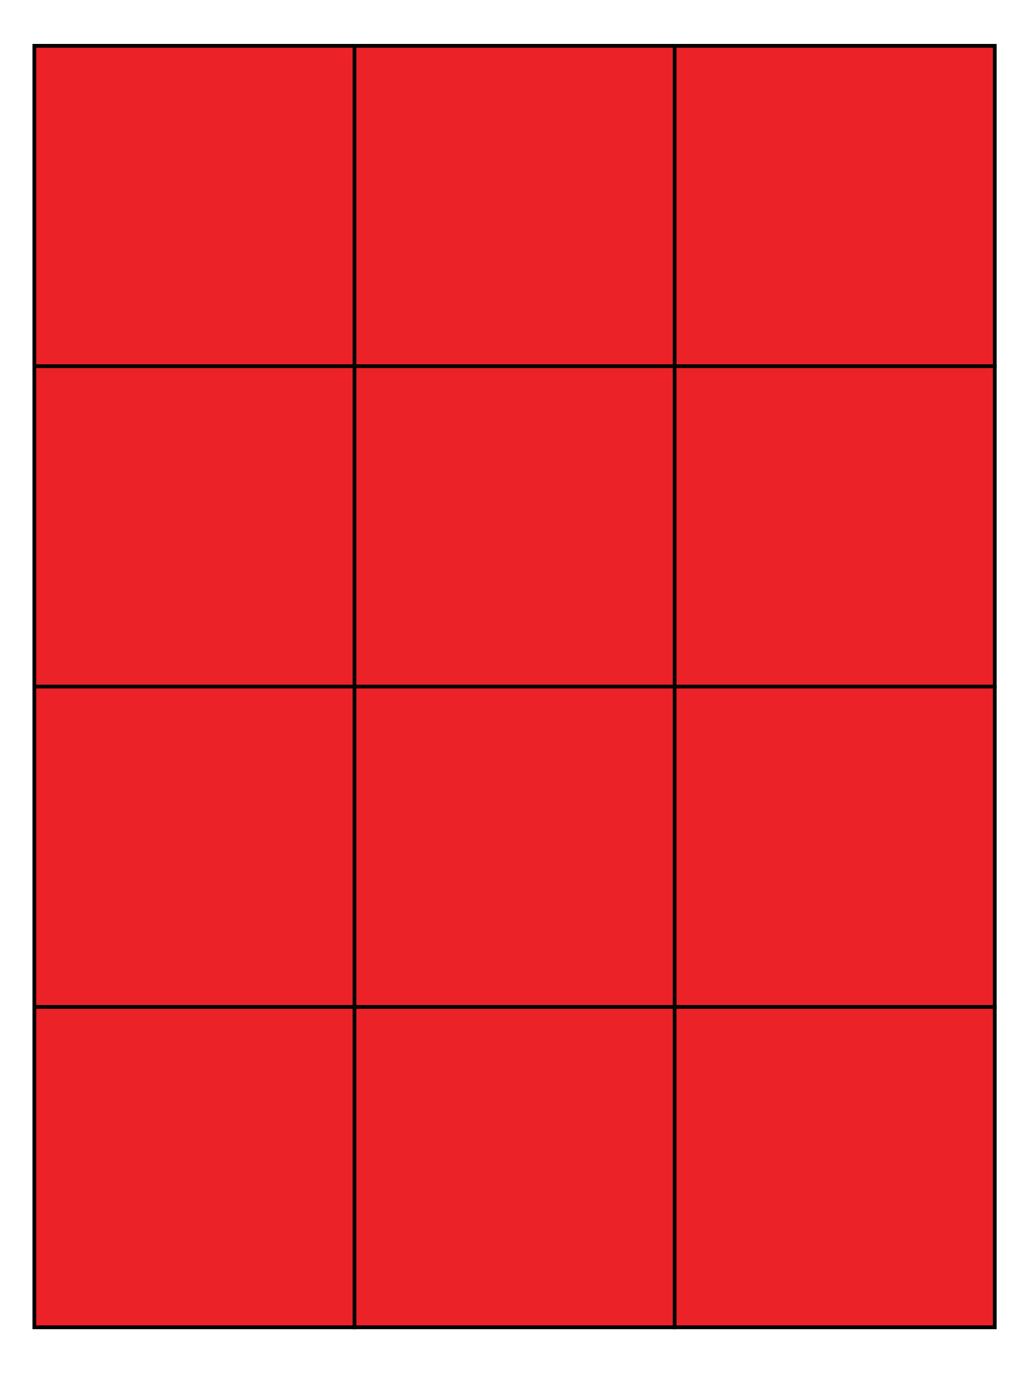

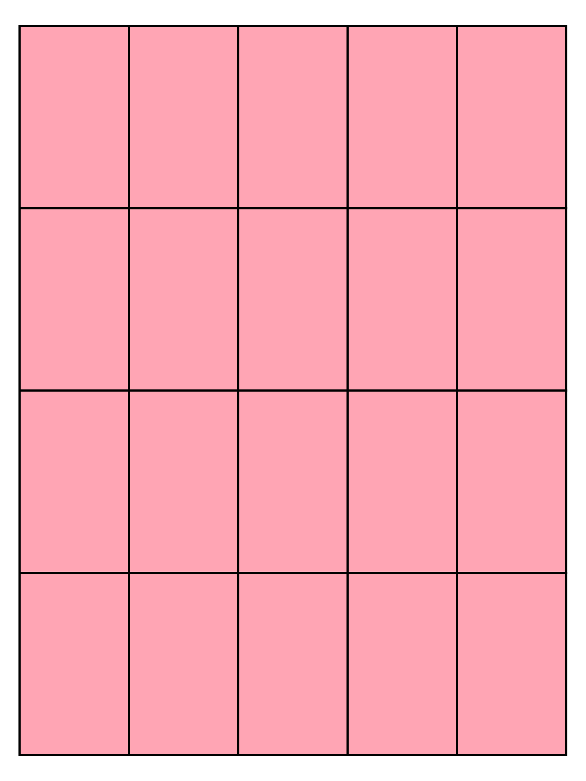Rectangle

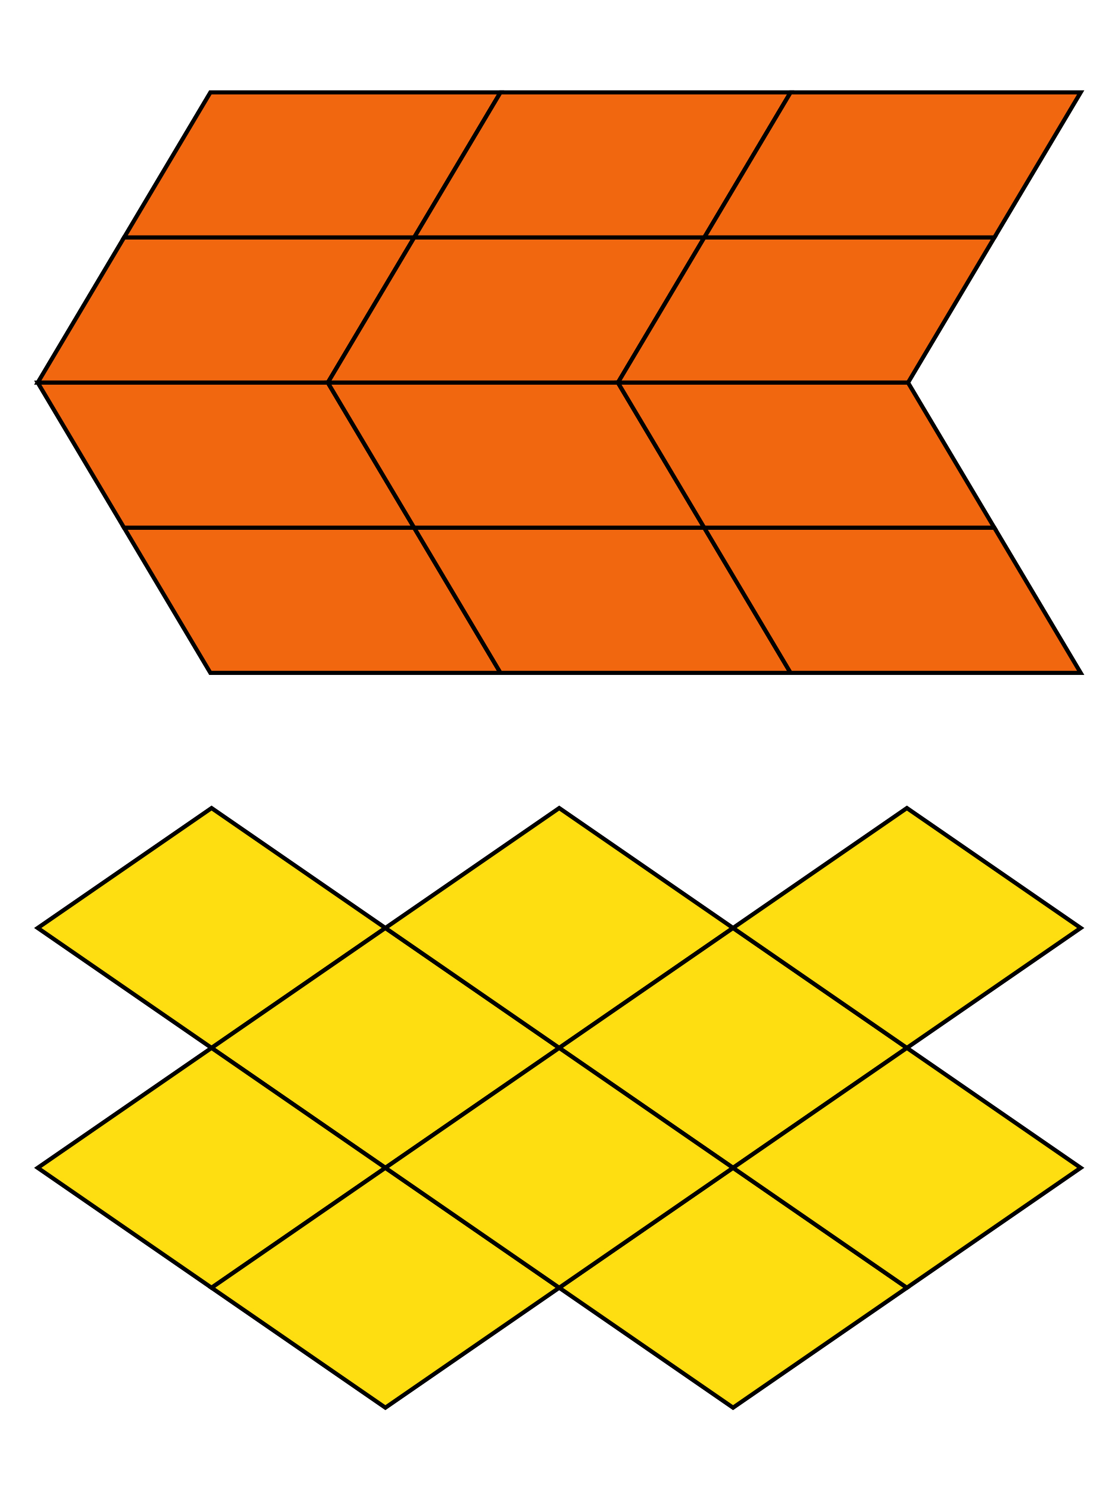Parallelogram

Rhombus

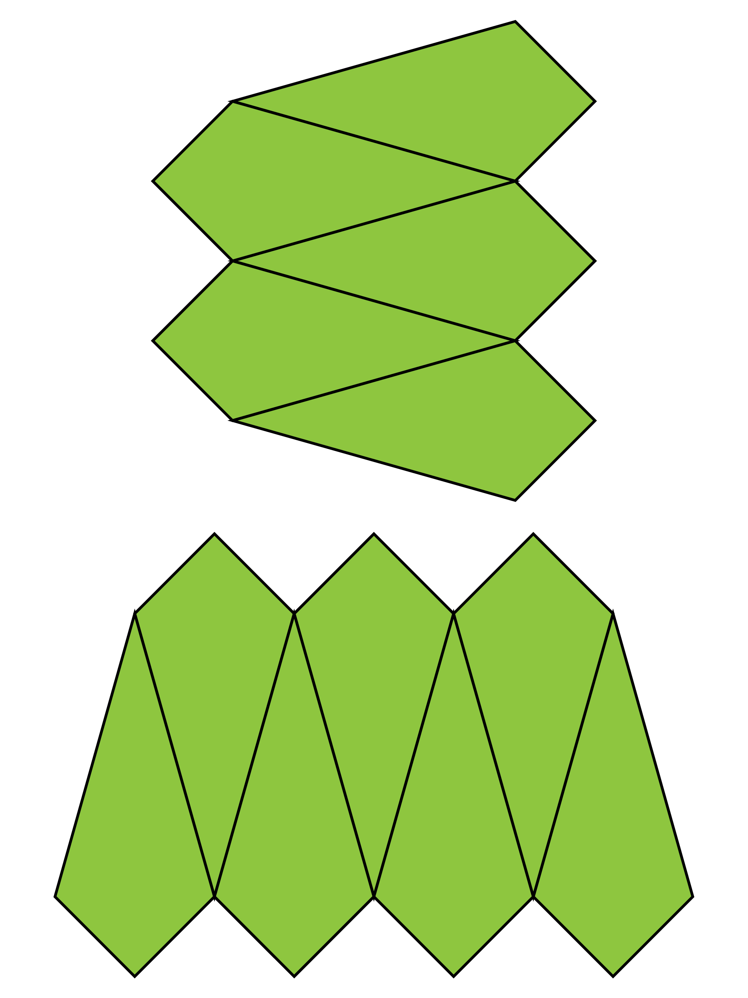Kite

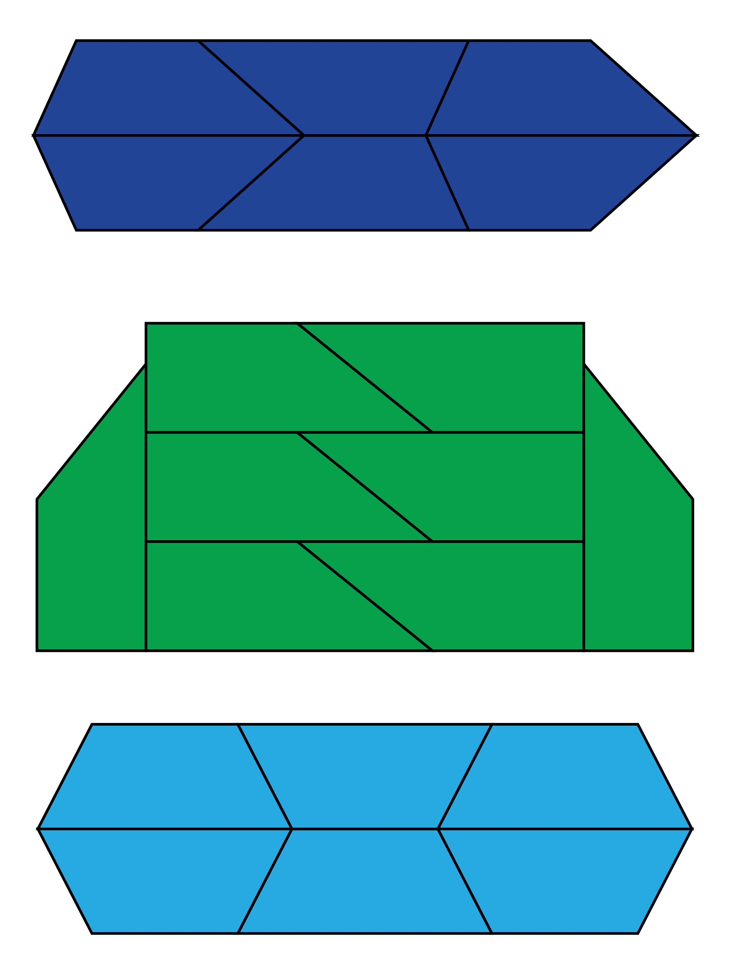Non-right, non-isosceles trapezoid

Right trapezoid

Isosceles trapezoid

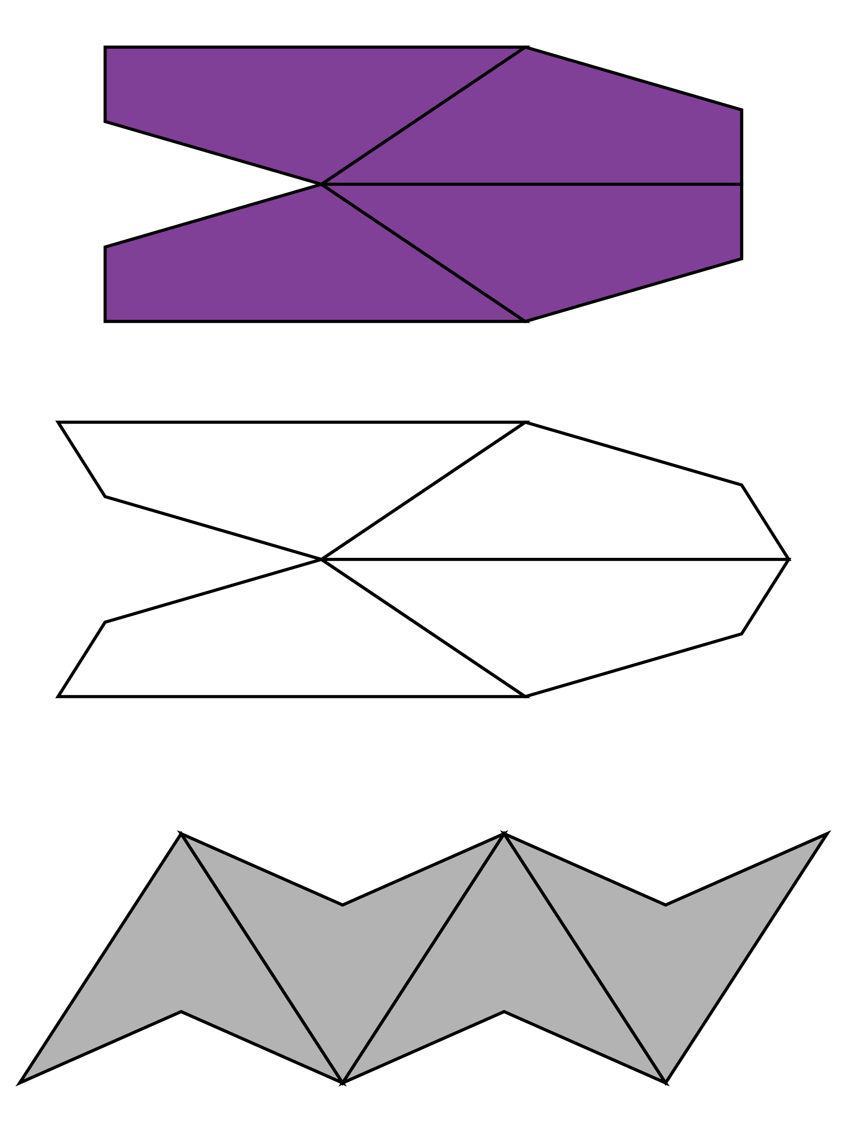General quadrilateral with one right angle

Convex quadrilateral with no right angles

Concave quadrilateral

Square

Rectangle

Parallelogram

Rhombus

Kite

Non-right, non-isosceles trapezoid

Right trapezoid

Isosceles trapezoid

General quadrilateral with one right angle

Convex quadrilateral with no right angles

Concave quadrilateral

Classifying Geometric Shapes

Lesson 3

| Shape | **Properties** |
| --- | --- |
| CETE_General:Projects:LMFA Resources:Math:5th Grade:M.G.B.4 Classifying Two-dimensional Shapes:Drafts:isosceles trapezoid.jpg |  |
| CETE_General:Projects:LMFA Resources:Math:5th Grade:M.G.B.4 Classifying Two-dimensional Shapes:Drafts:kite_no_right.jpg |  |
| CETE_General:Projects:LMFA Resources:Math:5th Grade:M.G.B.4 Classifying Two-dimensional Shapes:Drafts:trapezoid with right angle.jpg |  |

Classifying Geometric Shapes

Lesson 3

| Shape | **Properties** |
| --- | --- |
| CETE_General:Projects:LMFA Resources:Math:5th Grade:M.G.B.4 Classifying Two-dimensional Shapes:Drafts:isosceles trapezoid.jpg |  |
| CETE_General:Projects:LMFA Resources:Math:5th Grade:M.G.B.4 Classifying Two-dimensional Shapes:Drafts:kite_no_right.jpg |  |
| CETE_General:Projects:LMFA Resources:Math:5th Grade:M.G.B.4 Classifying Two-dimensional Shapes:Drafts:trapezoid with right angle.jpg |  |
| CETE_General:Projects:LMFA Resources:Math:5th Grade:M.G.B.4 Classifying Two-dimensional Shapes:Drafts:kite_right.jpg |  |
| CETE_General:Projects:LMFA Resources:Math:5th Grade:M.G.B.4 Classifying Two-dimensional Shapes:Drafts:non-right and non-isosceles.jpg |  |
| CETE_General:Projects:LMFA Resources:Math:5th Grade:M.G.B.4 Classifying Two-dimensional Shapes:Drafts:parallelogram.jpg |  |
| CETE_General:Projects:LMFA Resources:Math:5th Grade:M.G.B.4 Classifying Two-dimensional Shapes:Drafts:quadrilateral with right.jpg |  |
| CETE_General:Projects:LMFA Resources:Math:5th Grade:M.G.B.4 Classifying Two-dimensional Shapes:Drafts:square.jpg |  |
| CETE_General:Projects:LMFA Resources:Math:5th Grade:M.G.B.4 Classifying Two-dimensional Shapes:Drafts:quadrilateral without right.jpg |  |
| CETE_General:Projects:LMFA Resources:Math:5th Grade:M.G.B.4 Classifying Two-dimensional Shapes:Drafts:rhombus.jpg |  |
| CETE_General:Projects:LMFA Resources:Math:5th Grade:M.G.B.4 Classifying Two-dimensional Shapes:Drafts:rectangle.jpg |  |

Classifying Geometric Shapes

INSTRUCTIONAL ACTIVITY SUPPLEMENT

Lesson 4

Multiple-Property Category Labels

Four sides

One or more pairs of parallel sides

Two pairs of parallel sides

Four sides are the same length

Two pairs of adjacent sides that are the same length

Four right angles

Four right angles and all sides are the same length

Classifying Geometric Shapes

STUDENT ACTIVITY

1. Pairs of geometric shapes are shown below. Name each shape and use the list of Geometric Properties to describe the properties for each shape. Then list the properties that are common to each pair of shapes.

Geometric Properties

number of acute angles number of right angles  
number of obtuse angles number of sides  
number of pairs of parallel sides number of pairs of perpendicular sides  
number of sides of equal length number of opposite sides of equal length

|  |  |
| --- | --- |
| Name of Shape: | Name of Shape: |
| CETE_General:Projects:LMFA Resources:Math:5th Grade:M.G.B.4 Classifying Two-dimensional Shapes:Drafts:quadrilateral without right.jpg | CETE_General:Projects:LMFA Resources:Math:5th Grade:M.G.B.4 Classifying Two-dimensional Shapes:Drafts:isosceles trapezoid.jpg |
| Properties | |
|  |  |
| Common Properties  What properties are the same for these two shapes? | |
| Name of Shape: | Name of Shape: |
| CETE_General:Projects:LMFA Resources:Math:5th Grade:M.G.B.4 Classifying Two-dimensional Shapes:Drafts:parallelogram.jpg | **CETE_General:Projects:LMFA Resources:Math:5th Grade:M.G.B.4 Classifying Two-dimensional Shapes:Drafts:rectangle.jpg** |
| Properties | |
|  |  |
| Common Properties  What properties are the same for these two shapes? | |

|  |  |
| --- | --- |
| Name of Shape: | Name of Shape: |
| CETE_General:Projects:LMFA Resources:Math:5th Grade:M.G.B.4 Classifying Two-dimensional Shapes:Drafts:square.jpg | **CETE_General:Projects:LMFA Resources:Math:5th Grade:M.G.B.4 Classifying Two-dimensional Shapes:Drafts:rhombus.jpg** |
| Properties | |
|  |  |
| Common Properties  What properties are the same for these two shapes? | |

1. Consider the kite pictured below.

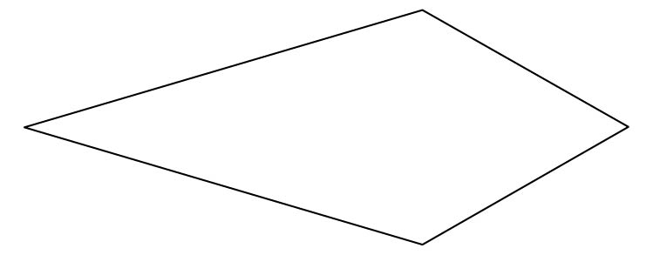

* 1. List the properties of a kite.

* 1. What properties does a kite share with a quadrilateral?

1. Consider the parallelogram and rhombus pictured below.

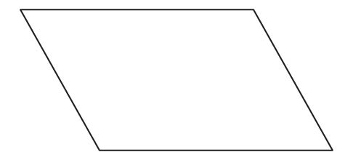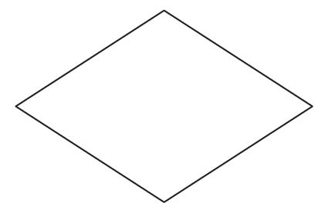

* 1. What are the common properties of a parallelogram and a rhombus?

* 1. What properties are different for a parallelogram and a rhombus?

1. John thinks that any rectangle is also a parallelogram. Do you think John is correct? Explain your thinking using the properties of rectangles and parallelograms.
2. What is the relationship between a square and a rectangle? Is any square also a rectangle, or is any rectangle also a square? Explain your thinking using the properties of rectangles and squares.