Recognize and Measure Volume with Unit Cubes

Lesson 1

Part 1:

My prediction is that Box _____ will have a greater volume because:

Part 2:

Measuring tool used: ________________________________________________

|  |  |  |
| --- | --- | --- |
|  | Box 1 | Box 2 |
| Number of scoops |  |  |

Which box has the greater volume? Explain your reasoning.

Part 3:

Measuring tool used: ________________________________________________

|  |  |  |  |  |
| --- | --- | --- | --- | --- |
| Material |  | |  | |
|  | Box 1 | Box 2 | Box 1 | Box 2 |
| Predicted Amount |  |  |  |  |
| Actual Amount |  |  |  |  |

Part 4:

Prism 1:

Prism 2:

Prism 3:

Part 5:

1. What does it mean for an object to have volume?
2. How does the volume of Box 1 compare to the volume of Box 2? Explain your reasoning.
3. Explain why smaller, more uniform items will fill a container more fully than items that are more irregular in shape.
4. What is one new thing you learned today?
5. What is one thing you still have a question about or do not understand?

Recognize and Measure Volume with Unit Cubes

Lesson 2

A unit cube is ____________________________________________________________.

My drawing of a unit cube:

The volume of an object is labeled as ______________________________, because

1. I think the volume is _________________________________________________________.

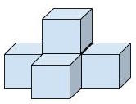

The actual volume is ______________________________________________________.

2. I think the volume is __________________________________________________________.

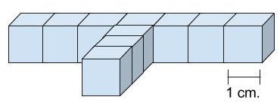

The actual volume is ______________________________________________________.

3. I think the volume is __________________________________________________________.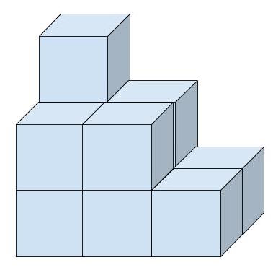

The actual volume is ______________________________________________________.

4. I think the volume is ________________________________________________________.

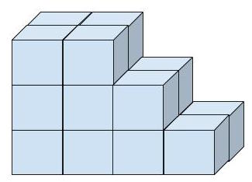

The actual volume is ______________________________________________________.

5. I think the volume is __________________________________________________________.

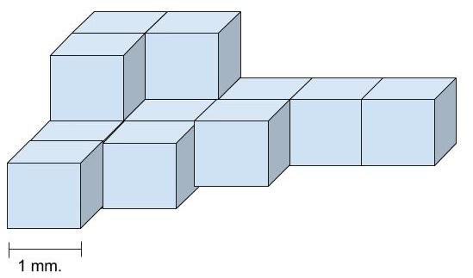

The actual volume is ______________________________________________________.

Recognize and Measure Volume with Unit Cubes

INSTRUCTIONAL ACTIVITY SUPPLEMENT

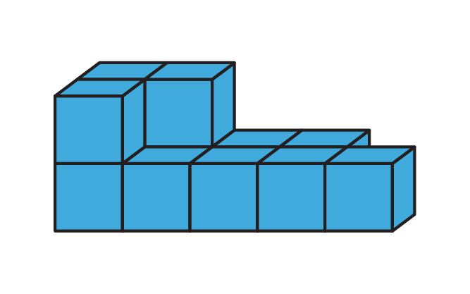Lesson 2

Determine the volume of the figure.

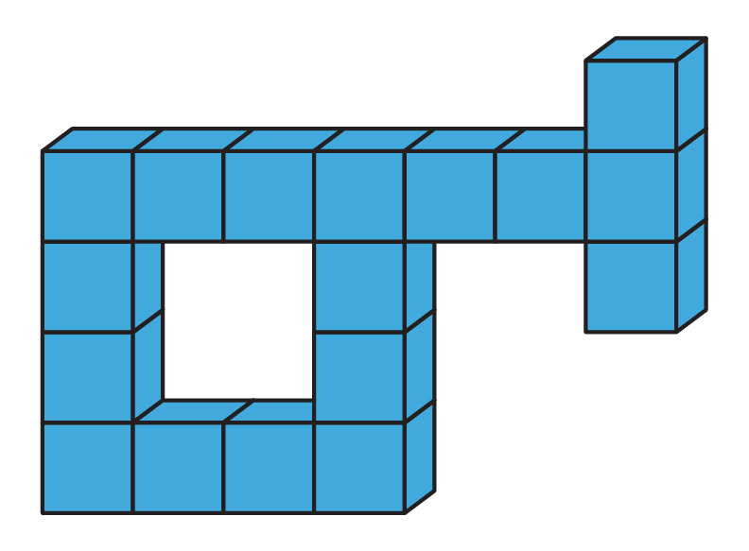

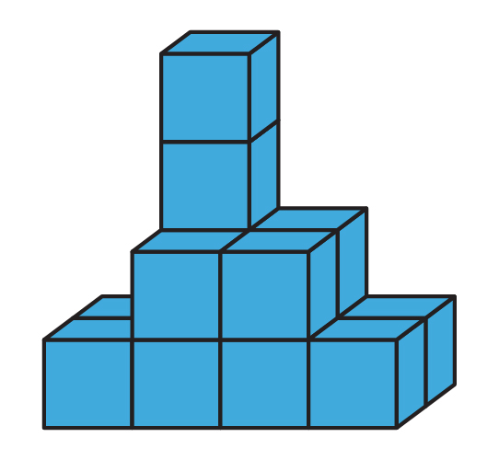

Determine the volume of the figure.

Determine the volume of the figure.

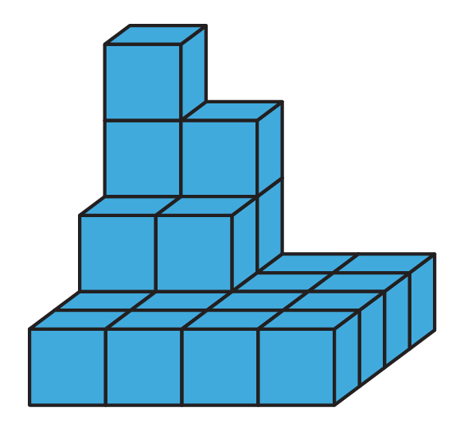

Determine the volume of the figure.

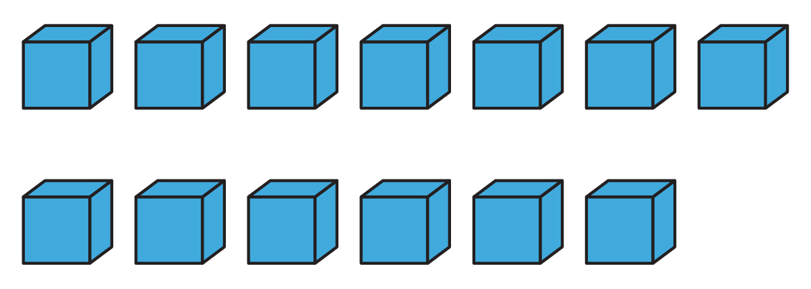

Create a figure with a volume of 13 cubic units.

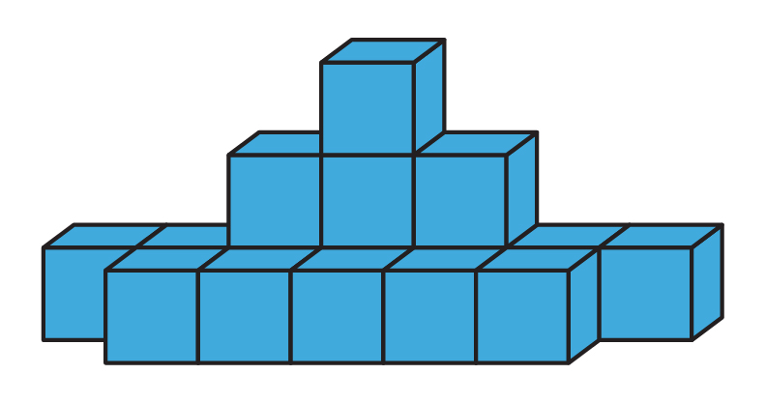

Determine the volume of the figure.

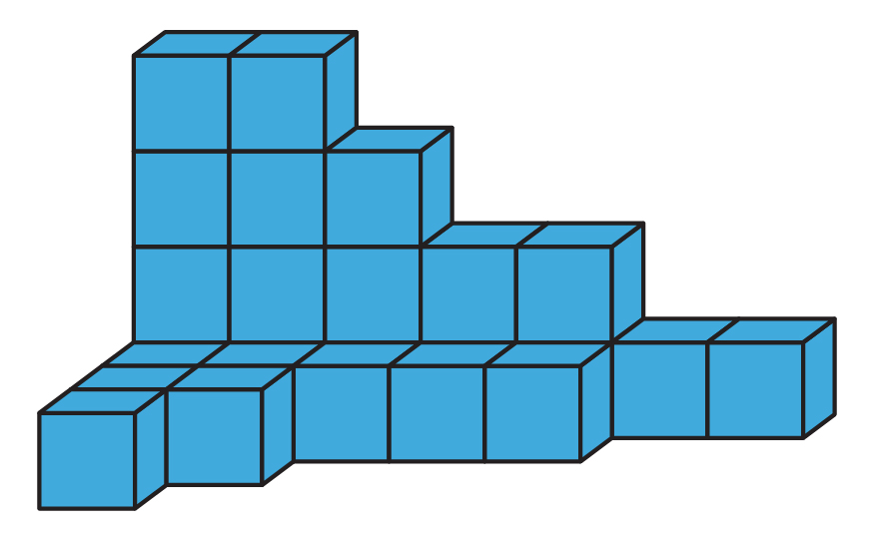

Determine the volume of the figure.

Determine the volume of the figure.

Create a figure that has a volume of 20 cubic units.

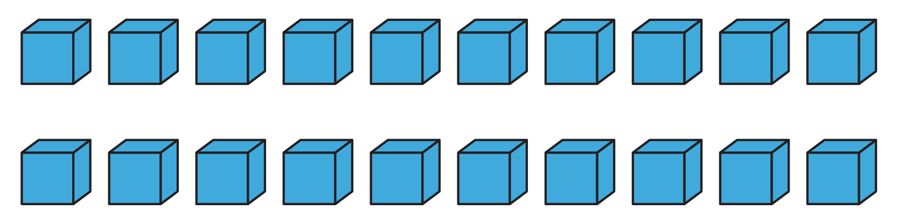

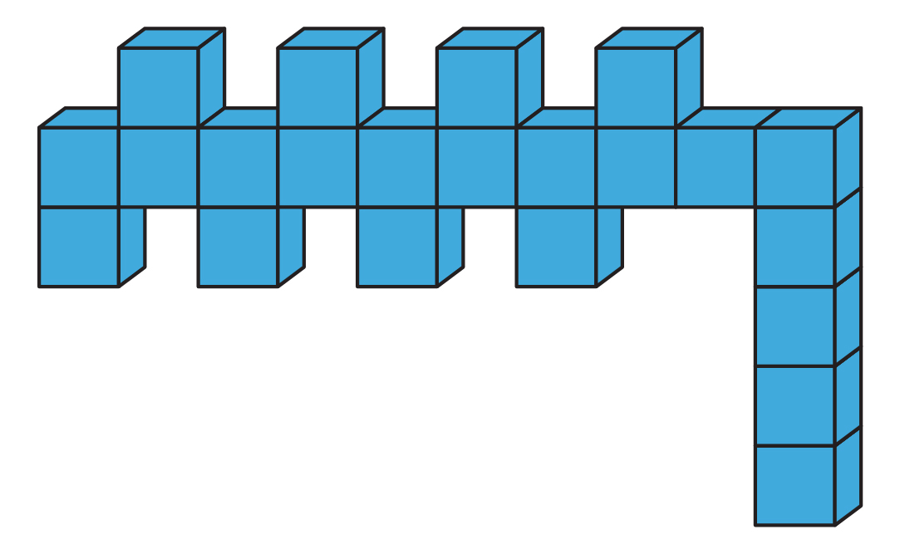

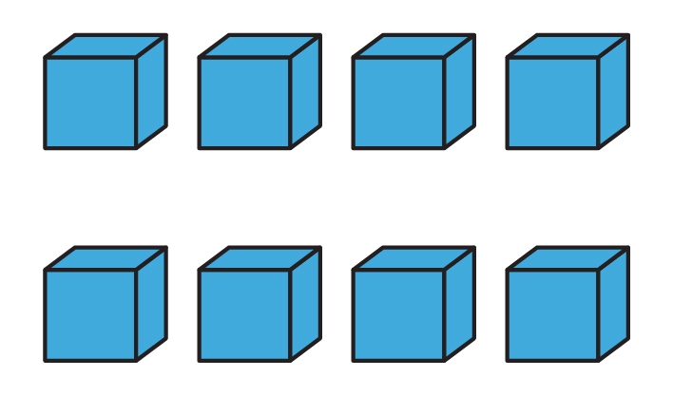

Create a figure that has a volume of eight cubic units.

Recognize and Measure Volume with Unit Cubes

Lesson 3

Brainstorm characteristics of rectangular prisms.

Characteristics of Rectangular Prisms:

Box 1: ____________________________________________________

Volume: ________________________________ cubic units

Box 2: ____________________________________________________

Volume: ________________________________ cubic units

Box 3: ____________________________________________________

Volume: ________________________________ cubic units

Rectangular Prism 1:

Rectangular Prism 2:

Rectangular Prism 3:

Use the task cards to complete the table. Use the figure label (A, B, C, etc.) to identify the task card in the “Figure” column. Explain how you determined the volume of the rectangular prism.

|  |  |  |
| --- | --- | --- |
| Figure | Volume | Explanation |
|  |  |  |
|  |  |  |
|  |  |  |
|  |  |  |
|  |  |  |
|  |  |  |
|  |  |  |
|  |  |  |

Recognize and Measure Volume with Unit Cubes

INSTRUCTIONAL ACTIVITY SUPPLEMENT

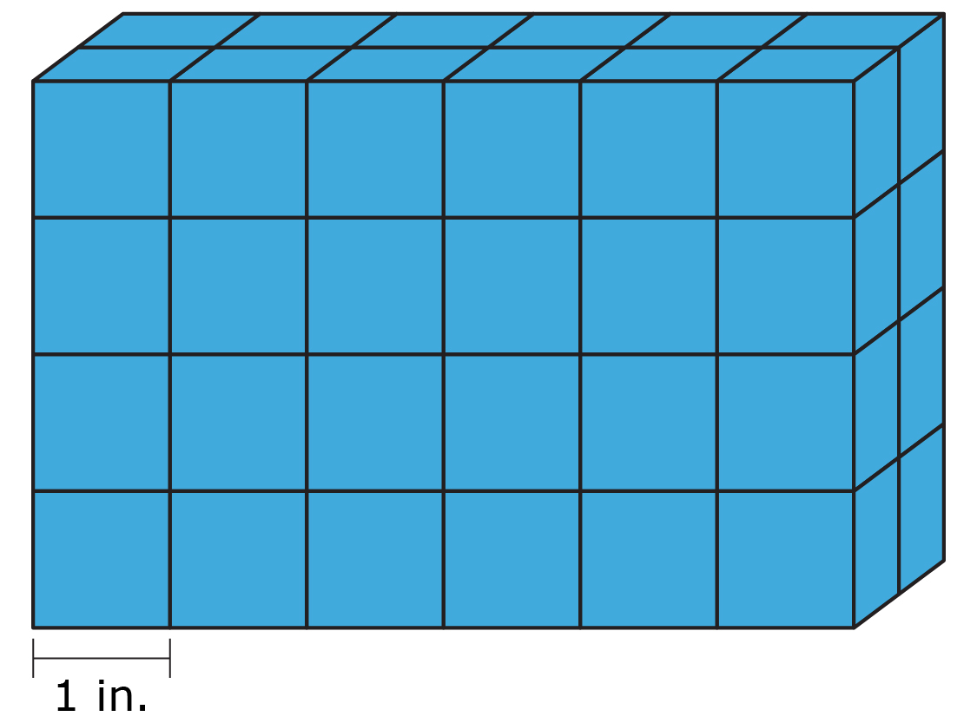Lesson 3

Figure A

Figure B

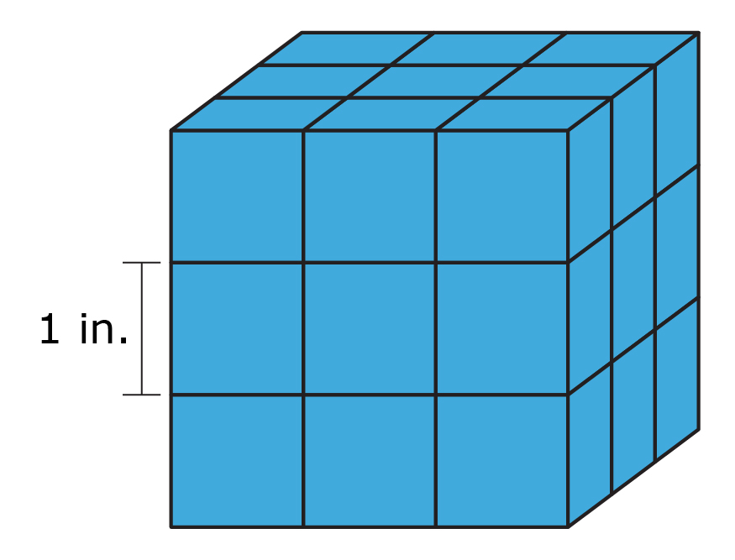

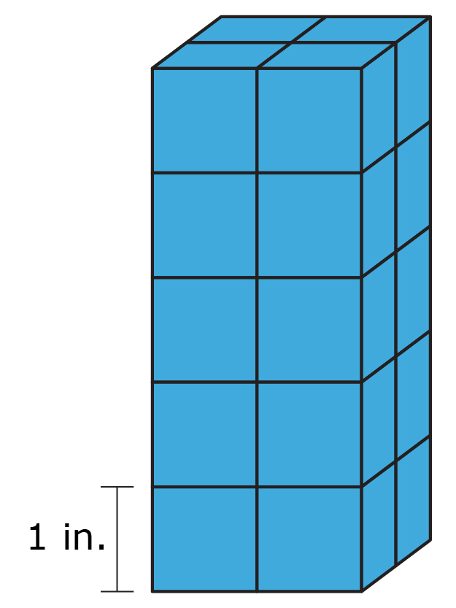

Figure C

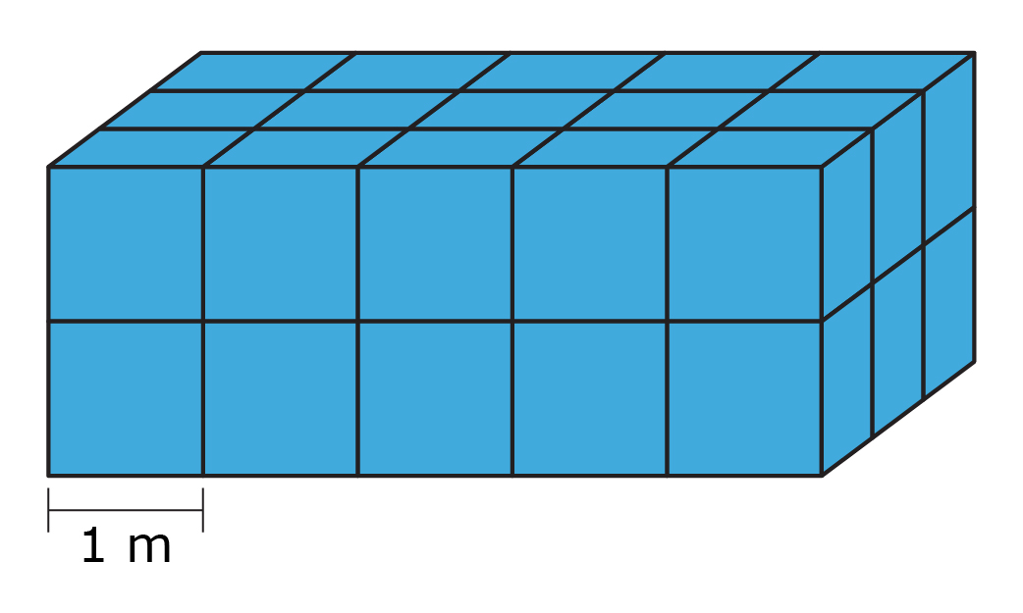

Figure D

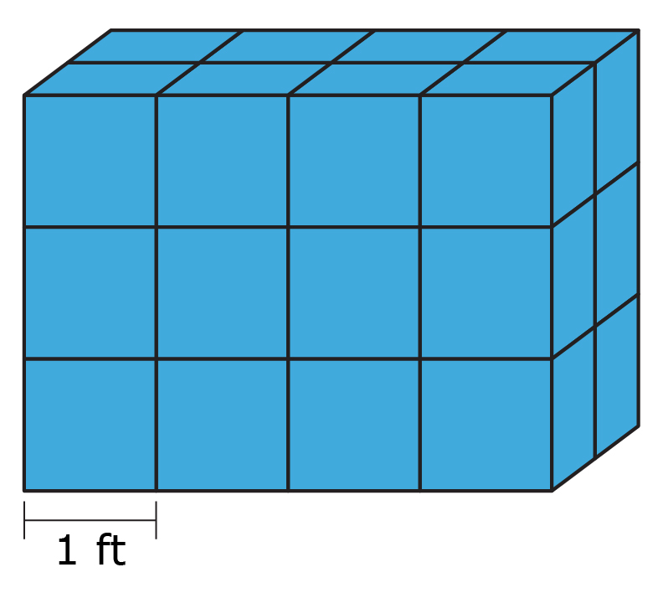

Figure E

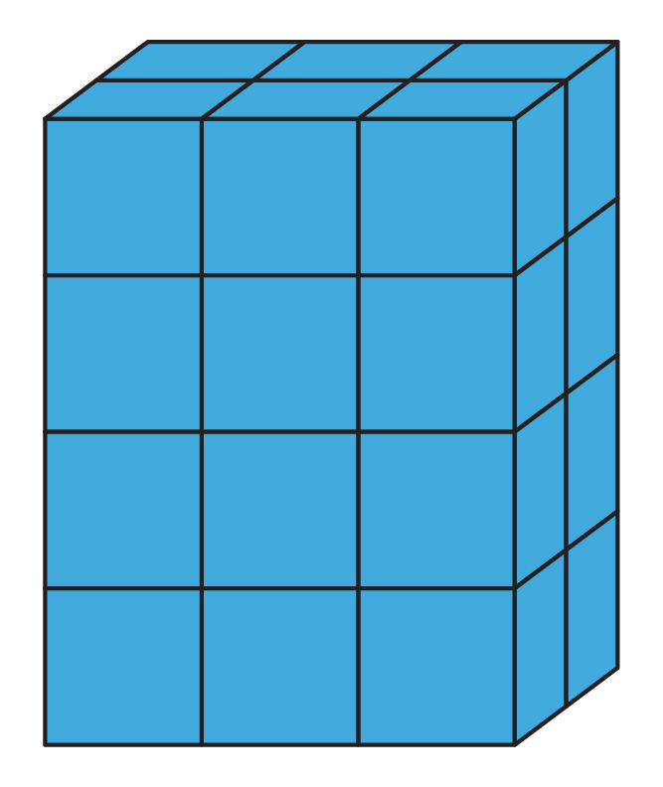

Figure F

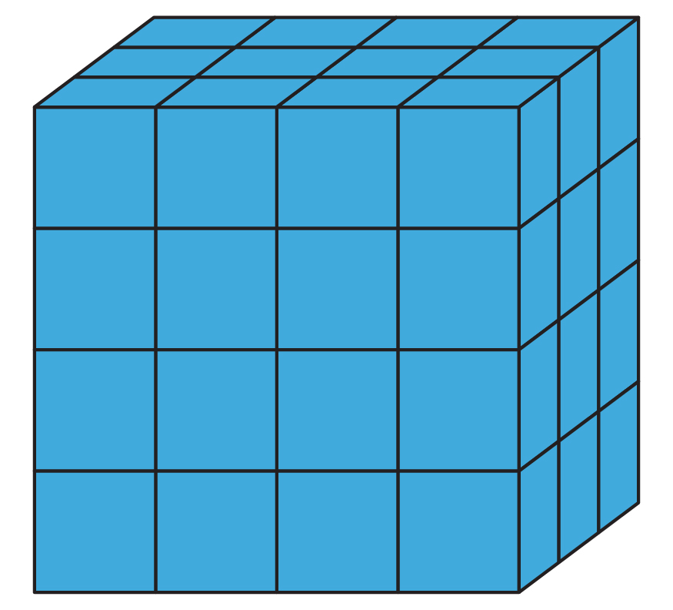

Figure G

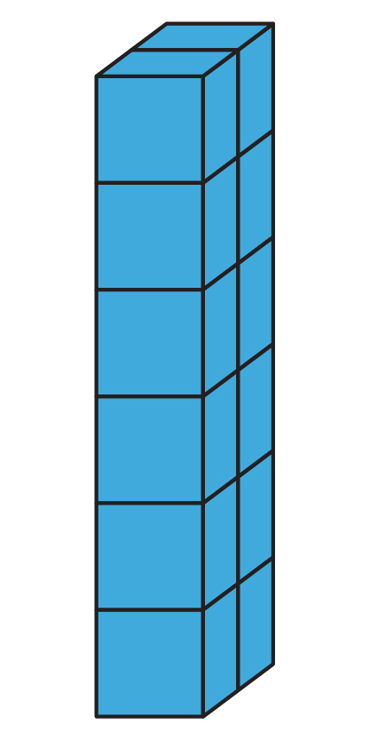

Figure H

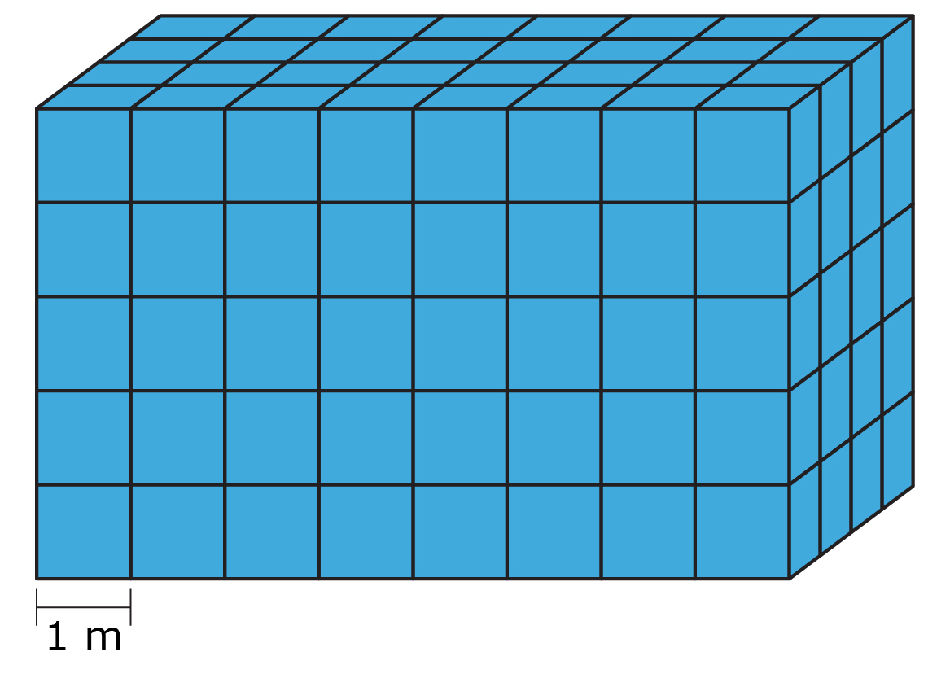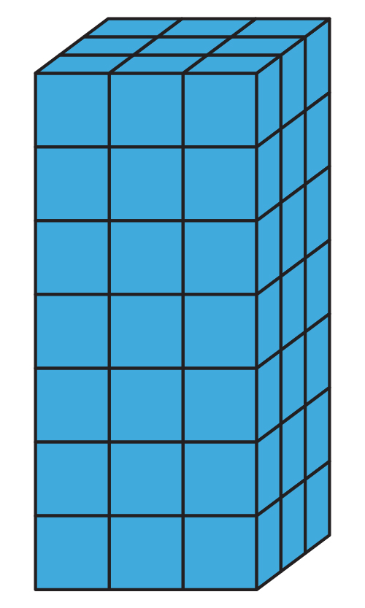

Figure I

Figure J

Recognize and Measure Volume with Unit Cubes

Lessons 1 – 4

1. Order the containers from least to greatest according to their volume.
   1. Less __________ Greater __________

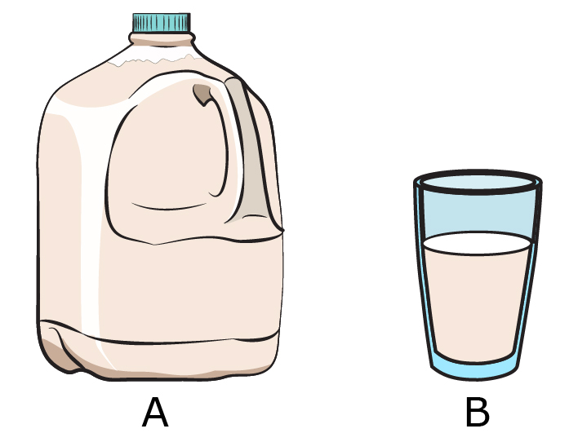

* 1. Less __________ Greater __________

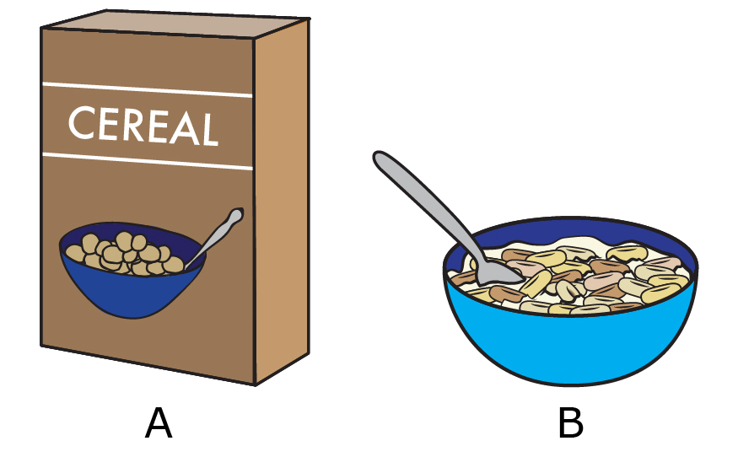

* 1. Least __________, __________, __________ Greatest

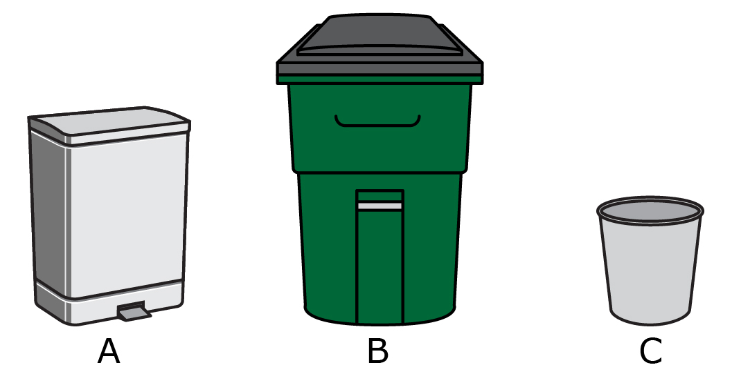

1. Answer the following questions in complete sentences.
   1. 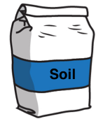Sonia’s fifth grade science class was planting a school garden. Sonia was in charge of filling one of the planting beds with soil. Sonia used her shovel to scoop and add soil to the planting bed. By the time the planting bed was full, Sonia had filled her shovel 28 times. What is the volume of the planting bed in scoops of soil?
   2. 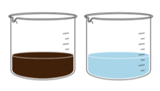 Frankie and Johnny each have a full beaker for their science experiment. Johnny’s beaker has 50 milliliters of water, and Frankie’s beaker has 250 milliliters of vinegar. Which beaker has a greater volume? How do you know?
   3. Maggie and Anna were organizing their craft supplies. They had four different-size containers for different materials. They stored the containers on the shelf, with the largest container on the left and the smallest container on the right. One container contained 2 cups of sequins, one container held 4 cups of cotton balls, one container had 3 cups of beads, and the fourth container had 1 cup of glitter. Each container was filled completely. List the containers from greatest to least according to volume, as they would appear on the shelf.

1. Identify the measurement unit for each unit cube.
   1. 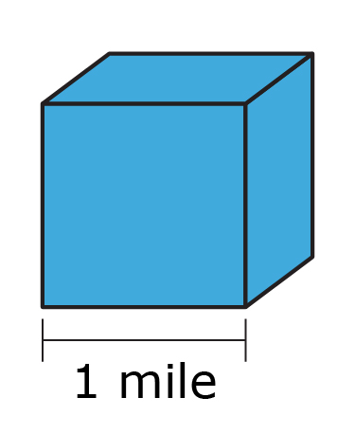

1 cubic ______________________

* 1. 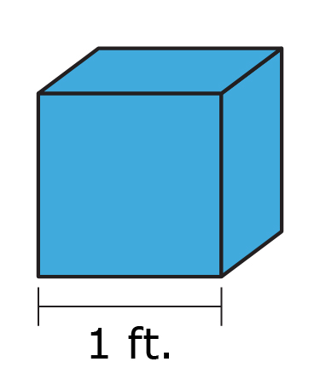

1 __________________________

* 1. 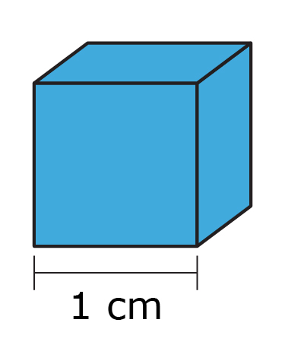

__________________________

1. Determine the volume of each figure. Be sure to include the unit label.
   1. ________________________________________

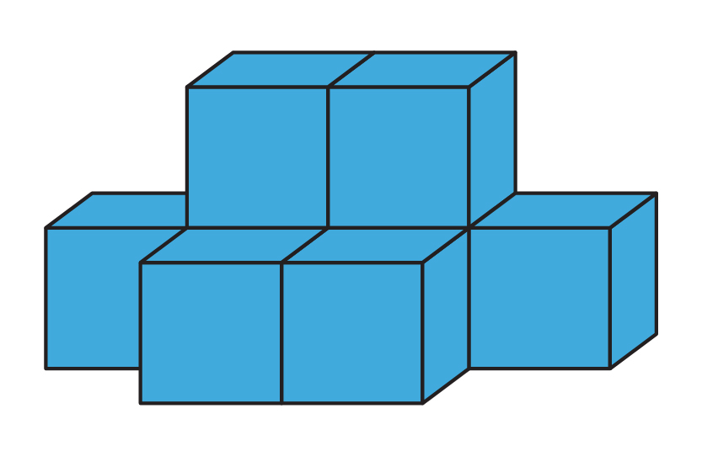

* 1. ________________________________________

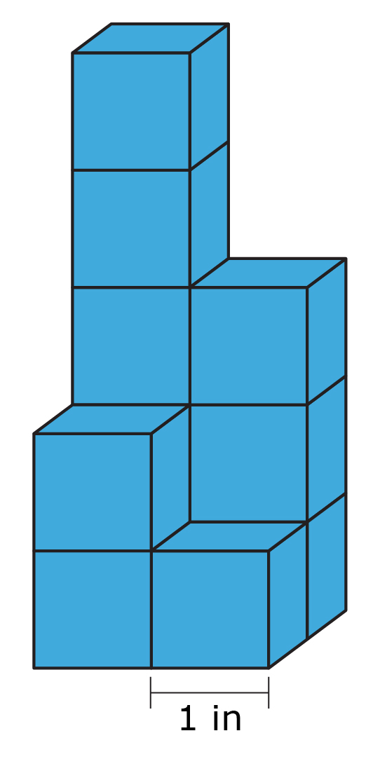

* 1. ________________________________________

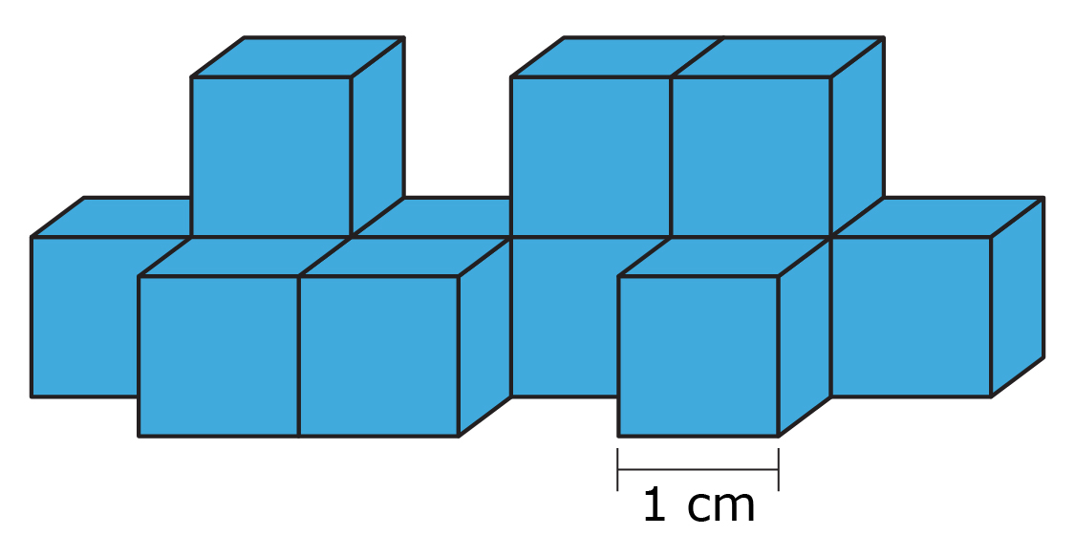

* 1. ________________________________________

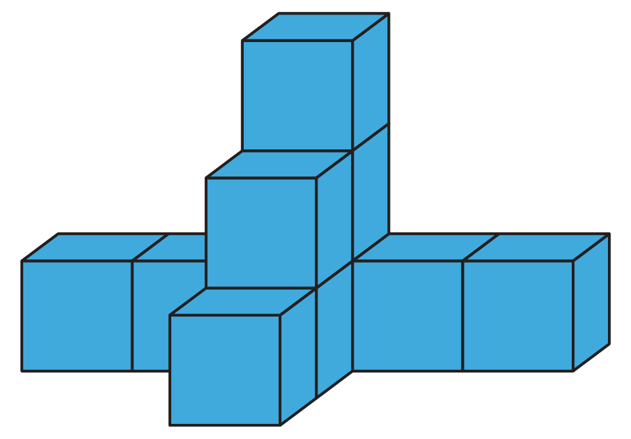

1. Determine the volume of each figure. Be sure to include the unit label.
   1. ________________________________________

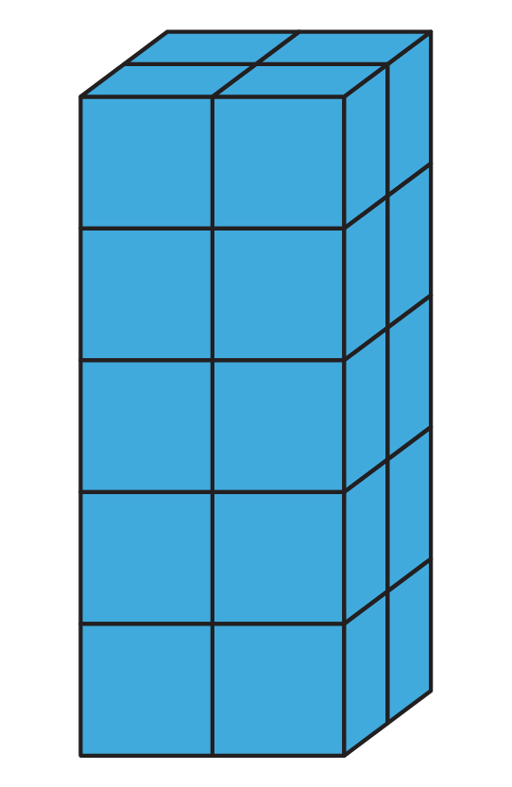

* 1. ________________________________________

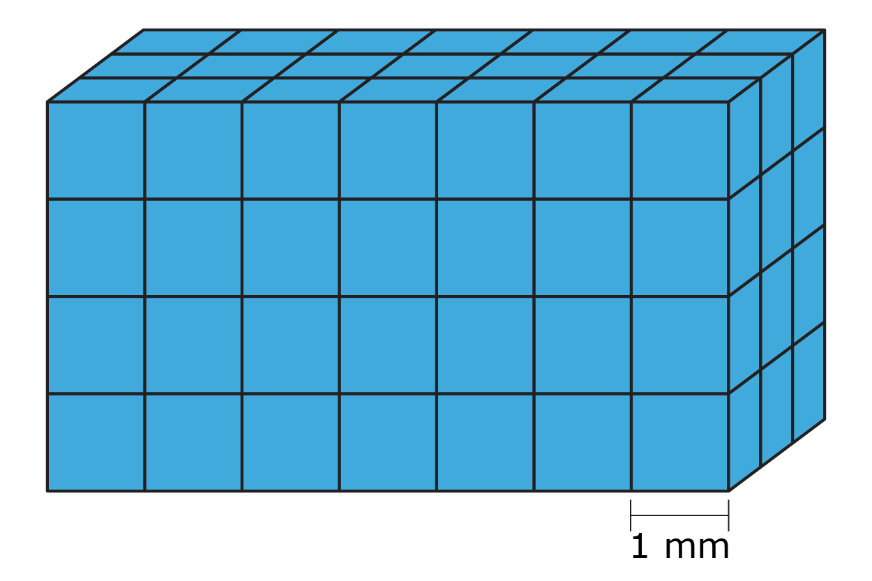

* 1. ________________________________________

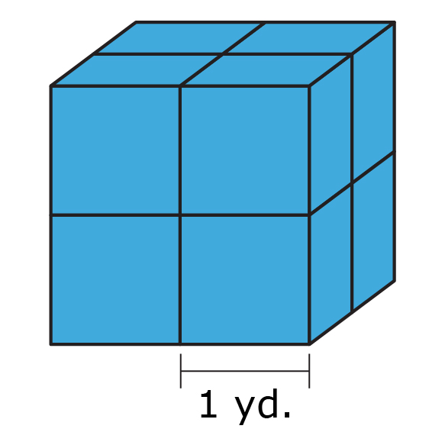

* 1. ________________________________________

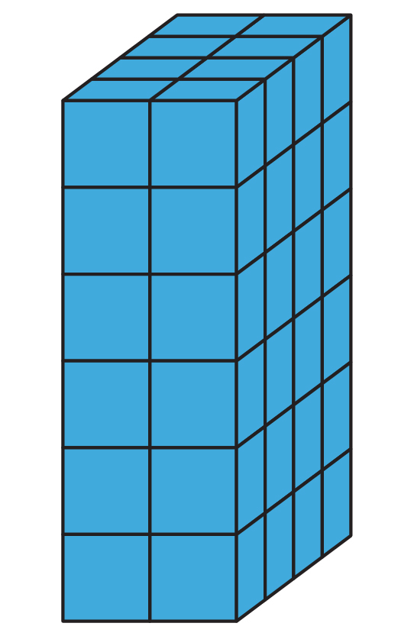

1. 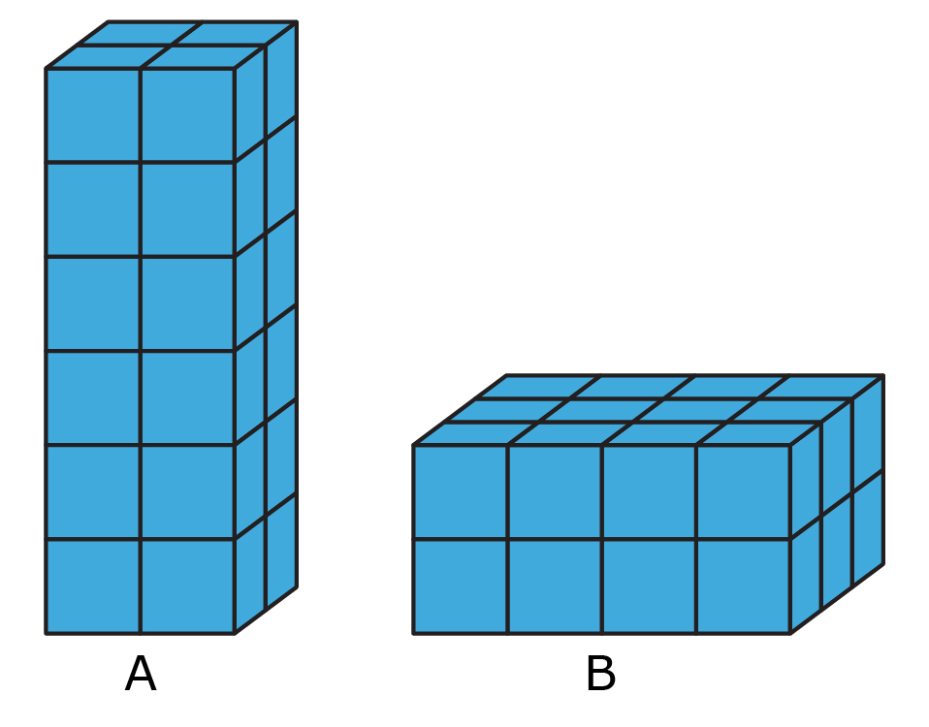Use figures A and B to answer the following questions.
   1. What is the volume of figure A?

* 1. What is the volume of figure B?

* 1. Create and complete a Venn diagram comparing and contrasting figure A and figure B.

1. 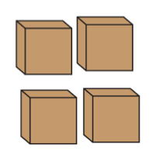Walt was packing sugar cubes into a shoe box for his science project. It took 432 sugar cubes to fill the shoe box, and each sugar cube had a side length of one centimeter. What is the volume of the shoe box?