Analyzing Algebraic Patterns and Relationships

Lesson 1

1. Identify the pattern and draw the next two designs in the sequence.



2. Complete the table.

|  |  |  |  |  |
| --- | --- | --- | --- | --- |
| Number of Triangles | 1 | 2 | 3 |  |
| Number of Sides |  |  |  | 12 |

|  |  |
| --- | --- |
| 7 | 10 |
|  |  |

3. Describe in words the pattern that is represented in Questions 1 and 2.

4. Complete the table.

|  |  |  |  |  |  |  |
| --- | --- | --- | --- | --- | --- | --- |
| *x* | 2 | 4 | 6 | 8 | 10 | 12 |
| *y* |  |  |  |  |  |  |

where *x* = the number of quadrilaterals, and *y* = the number of sides

5. Describe in words the pattern that is represented in Question 5 between corresponding pairs.

6. Draw the next four shapes in the pattern.



7. Complete the table using the pattern in Question 6.

|  |  |
| --- | --- |
| Number in the pattern | Number of sides |
| 1 | 4 |
| 2 |  |
| 3 |  |
| 4 |  |
| 5 |  |
| 6 |  |
| 7 |  |
| 8 |  |
| 9 |  |
| 10 |  |
| 11 |  |
| 12 |  |
| 13 |  |

8. Describe in words the pattern that is represented in Question 6.

9. Explain how the pattern from Question 6 is different from the pattern in Question 1.

10. Without using pattern blocks to show the pattern, how many sides will the 20th shape have? How do you know?

11. Draw the next shape in the pattern.

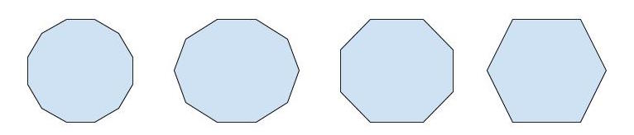

12. Complete the table using the pattern in Question 11.

|  |  |
| --- | --- |
| Number in the pattern | Number of sides |
| 1 |  |
| 2 |  |
| 3 |  |
| 4 |  |
| 5 |  |
| 6 |  |

13. Describe in words the pattern that is represented in Question 11.

14. Describe in words the following pattern.



Analyzing Algebraic Patterns and Relationships

INSTRUCTIONAL ACTIVITY SUPPLEMENT

Lesson 1

Triangles



Quadrilaterals



Circles



Pentagons



Hexagons



Analyzing Algebraic Patterns and Relationships

INSTRUCTIONAL ACTIVITY SUPPLEMENT

Lesson 2

Task Card 1

Adam and Mark are saving money every week for new video games. Adam starts with $10 and saves $1 each week. Mark starts with $5 and saves $3 each week. How much money will Adam and Mark each have after four weeks?

Identify each rule, then finish the table and complete a graph to determine the answer.

|  |  |  |  |  |  |
| --- | --- | --- | --- | --- | --- |
| Adam | 10 |  |  |  |  |
| Mark | 5 |  |  |  |  |
| Week | 0 | 1 | 2 | 3 | 4 |

Task Card 2

The Corner Market sells fruit baskets with apples and bananas. Each basket contains four apples and three bananas. How many apples and bananas are there in five fruit baskets?

Identify each rule, then finish the table and complete a graph to determine the answer.

|  |  |  |  |  |  |
| --- | --- | --- | --- | --- | --- |
| Apples | 4 |  |  |  |  |
| Bananas | 3 |  |  |  |  |

Task Card 3

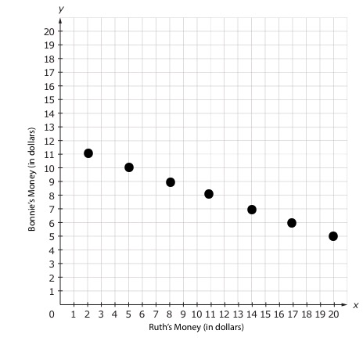

On Monday, Ruth has $20 and Bonnie has $5. Ruth spends $3 every day, and Bonnie saves $1 every day. After six days, how much money will Ruth and Bonnie have?

Use the information in the problem situation and the graph to identify the rule and complete the table.

Task Card 4

Use the table to identify the rule and complete a graph. Explain how you determined each rule.

|  |  |  |  |  |  |
| --- | --- | --- | --- | --- | --- |
| Rule: | 1 | 2 | 3 | 4 | 5 |
| Rule: | 18 | 14 | 10 | 6 | 2 |

Task Card 5

Kerri loves to collect colorful socks. Kerri uses four drawers on her dresser to store her colorful sock collection. Each drawer contains 4 pairs of socks. How many pairs of colorful socks does Kerri have? Kerri uses an additional drawer to store her 4 pairs of formal socks. How many pairs of colorful socks and formal socks does Kerri own altogether?

Identify each rule, then finish the table and complete a graph to determine the answer.

|  |  |  |  |  |  |
| --- | --- | --- | --- | --- | --- |
| Number of Drawers | 1 |  |  |  |  |
| Pairs of Socks | 4 |  |  |  |  |

Task Card 6

The Cupcake Club uses 2 cups of powdered sugar and 1 cup of flower for one dozen cupcakes. How many cups of powdered sugar and cups of flower will they have used for seven dozen cupcakes?

Identify each rule, then complete a table and a graph to determine the answer.

Part Two: Analyze each rule and explain if each rule represents a growing pattern or a shrinking pattern.

Task Card 8

Rachel and Jashawn each have $20 for school lunches. Rachel spends $3 every day on the regular lunch. Jashawn spends $4 every day on the regular lunch plus two extra items: yogurt and cookies. How much money will Rachel and Jashawn have left after five days?

Identify each rule, then complete a table and a graph to determine the answer.

Part Two: Analyze each rule and explain if each rule represents a growing pattern or a shrinking pattern.

Alissa and Janie are participating in the reading challenge at school. Alissa reads for one hour each night, and Janie reads for two hours each night. How many hours will Alissa and Janie have read in five days?

Use the information in the problem situation and the graph to identify the rule and complete the table.

Task Card 7

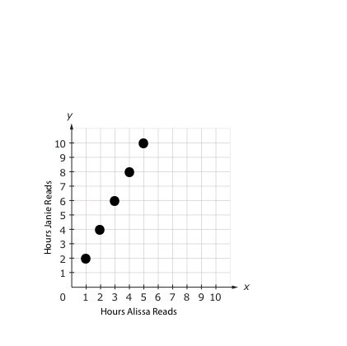

Analyzing Algebraic Patterns and Relationships

Lesson 3

1. Complete the table, determine a rule between the corresponding terms, and create an equation.

Samantha is collecting can tabs for a fundraiser. She plans to collect tabs for six weeks. If Samantha collects 12 tabs each week, how many tabs will Samantha collect in six weeks?

Rule:

Equation:

|  |  |
| --- | --- |
| Week | Number of Can Tabs |
|  |  |
|  |  |
|  |  |
|  |  |
|  |  |
|  |  |

2. Samantha’s fund raiser has been extended to 12 weeks. Using your equation from Question 1, determine how many tabs Samantha will collect if she continues to collect 12 tabs a week.

3. Complete the table, identify and plot coordinate pairs, and analyze the graph to determine the relationship between the corresponding *x-* and *y*-values.

Marcus is saving money for a new pair of shoes. He has $15. If Marcus saves $2 every week, how much money will he have in four weeks?

|  |  |  |  |  |  |
| --- | --- | --- | --- | --- | --- |
| Week |  |  |  |  |  |
| Money Saved |  |  |  |  |  |

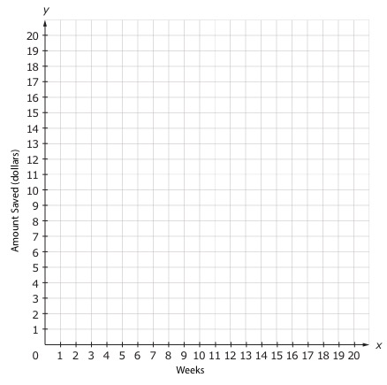Coordinate Pairs:

Explain the relationship between the corresponding terms.

4. Complete the table, identify and plot coordinate pairs, and analyze the graph to determine the relationship between the corresponding *x-* and *y*-values.

Marcus wants his shoes sooner, so he decides to save $5 every week instead of $2. He has $15. How many weeks will it take him to save $60?

|  |  |
| --- | --- |
| Week | Money Saved |
|  |  |
|  |  |
|  |  |
|  |  |
|  |  |
|  |  |
|  |  |
|  |  |
|  |  |
|  |  |
|  |  |
|  |  |
|  |  |

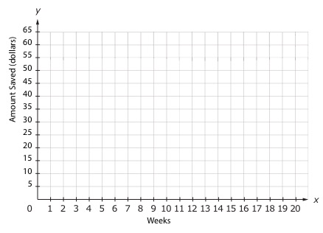

Explain the relationship between the *x*-values and the *y*-values.

5. Complete the table using the following rule. *y* = *x* 5 – 4

|  |  |
| --- | --- |
| *x* | *y* |
|  |  |
|  |  |
|  |  |
|  |  |
|  |  |
|  |  |

6. Graph the corresponding terms as coordinate pairs on the coordinate grid.

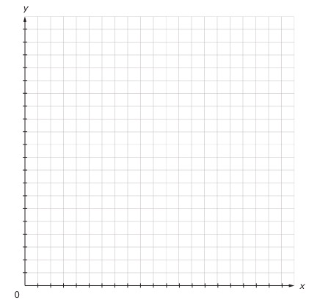

Coordinate Pairs:

7. Answer the following questions based on today’s lesson.

a. What is one thing you feel confident about teaching a peer?

b. What is one thing that you are not sure you understand?

c. What is one thing that you do not understand?

Analyzing Algebraic Patterns and Relationships

INSTRUCTIONAL ACTIVITY SUPPLEMENT

Lesson 3

**Memory: Match the Rule**

Place cards face down and spread out so that they do not overlap. One student should turn over two cards.

* If the cards are an algebraic relationship and a representation that match, then the student keeps both cards and goes again.
* If the cards are both algebraic relationships or are both representations, then the student turns both cards face down and it is the next student’s turn.
* If the cards are an algebraic relationship and a representation that do not match, then the student turns both cards face down and it is the next student’s turn.

Students should continue take turns until there are no more cards remaining.

|  |  |  |  |  |  |  |  |  |  |  |  |  |  |
| --- | --- | --- | --- | --- | --- | --- | --- | --- | --- | --- | --- | --- | --- |
| *y =* 2*x* | 2*x* = *y* | 2 $∙$*x* = *y* | |  |  | | --- | --- | | *x* | *y* | | 4 | 8 | | 5 | 10 | | 6 | 12 | | 7 | 14 | |
|  | Sam’s Market sells fruit baskets. Each basket contains 4 apples, 3 bananas, and 2 oranges. How many oranges are used to make 5 fruit baskets? | 3*x* = *y* | *y =* 3*x* |
| *y = 3 $∙$* *x* | |  |  | | --- | --- | | *x* | *y* | | 1 | 3 | | 2 | 6 | | 3 | 9 | | 4 | 12 | |  | Lucy is saving money for a new phone case. She saves $3 every week. How much money will Lucy have after eight weeks? |

|  |  |  |  |  |  |  |  |  |  |  |  |  |  |
| --- | --- | --- | --- | --- | --- | --- | --- | --- | --- | --- | --- | --- | --- |
| *y = 4 $∙$* *x* | 4 $∙$*x* = *y* | 4*x* = *y* | |  |  | | --- | --- | | *x* | *y* | | 5 | 20 | | 6 | 24 | | 7 | 28 | | 8 | 32 | |
|  | Johnny runs four laps at the track every day. How many laps has Johnny run after 10 days? | *y =* 5*x* | 5*x* = *y* |
| 5 $∙$*x* = *y* | |  |  | | --- | --- | | *x* | *y* | | 3 | 15 | | 4 | 20 | | 5 | 25 | | 6 | 30 | |  | The elementary school is hosting a change drive. If each class collects $5 in coins, how much money will 23 classes collect? |
| *y = 6 $∙$* *x* | 6 $∙$*x* = *y* | 6*x* = *y* | |  |  | | --- | --- | | *x* | *y* | | 1 | 6 | | 2 | 12 | | 3 | 18 | | 4 | 24 | |

|  |  |  |  |
| --- | --- | --- | --- |
|  | Mateo walks six blocks each day (three blocks to school and three blocks home). How many total blocks does Mateo walk in five days? | *y =* 7*x* | *y = 7 $∙$* *x* |
| 7 $∙$*x* = *y* | |  |  | | --- | --- | | *x* | *y* | | 3 | 21 | | 4 | 28 | | 5 | 35 | | 6 | 42 | |  | Every month Natalie spends $7 on snacks at school. How much money will Natalie spend on snacks in five months? |

Analyzing Algebraic Patterns and Relationships

Lessons 1 – 3

1. Use the following pattern to answer the questions.

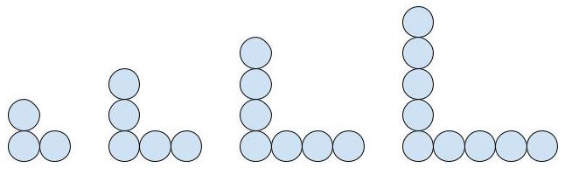

* 1. Extend the pattern and draw the next three stages.

* 1. Describe in words the pattern that is represented.
  2. Use the pattern to complete the following table.

|  |  |  |  |  |  |  |  |
| --- | --- | --- | --- | --- | --- | --- | --- |
| Stage | 1 | 2 |  |  |  |  |  |
| Total Number of Circles | 3 | 5 |  |  |  |  |  |

1. Use the following pattern to answer the questions.  
   1. What is the next image in the sequence? How do you know?
   2. Is the sequence a growing, shrinking, or repeating pattern? How do you know?
   3. Use the pattern to complete the following table.

|  |  |
| --- | --- |
| Sequence Number | Number of Squares |
|  |  |
|  |  |
|  |  |
|  |  |
|  |  |
|  |  |
|  |  |
|  |  |
|  |  |
|  |  |

* 1. 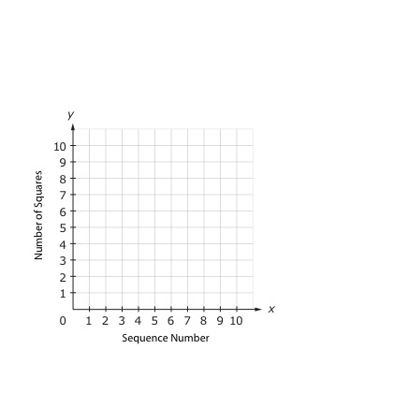Identify the coordinate pairs for the corresponding terms in the table and graph them on the coordinate grid.

Coordinate Pairs:

1. Madison and Malaki are saving money. Madison has $10 in her account, and she saves $1 each week. Malaki has $7 in his account, and he saves $2 each week.
   1. Identify the rule for Madison and Malaki then complete the table.

|  |  |  |  |  |  |  |
| --- | --- | --- | --- | --- | --- | --- |
| Madison  Rule: | 10 |  |  |  |  |  |
| Malaki  Rule: | 7 |  |  |  |  |  |

* 1. How much money will Madison and Malaki have after five weeks?

* 1. List the ordered pairs from the corresponding terms. Note that Madison is labeled on the *x*-axis and Malaki is labeled on the *y*-axis.

* 1. Graph the ordered pairs on the coordinate grid.

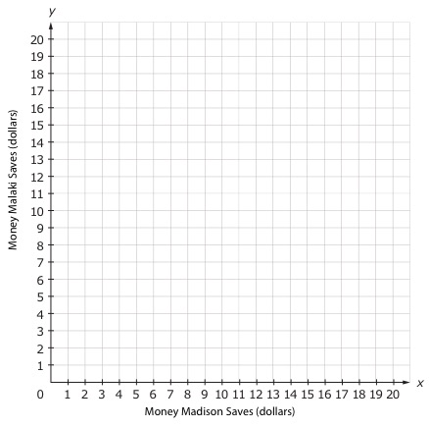

1. Maggie runs two miles at each soccer practice.
   1. Complete the table using the problem situation.

|  |  |  |  |  |  |
| --- | --- | --- | --- | --- | --- |
| Number of practice days |  |  |  |  |  |
| Total distance run |  |  |  |  |  |

* 1. How many miles will Maggie have run after five days of soccer practice?
  2. Identify and plot coordinate pairs from the table. Be sure to label the *x-* and *y*-axes.

Coordinate Pairs:

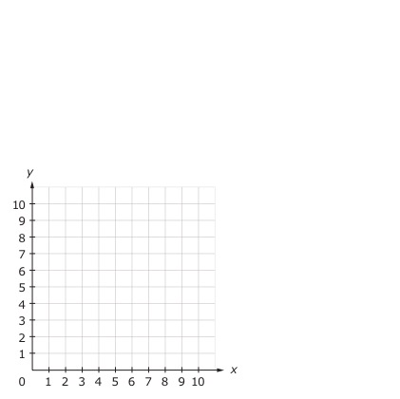

* 1. What is the relationship between the *x-* and *y*-values?

1. Matthew and Andrew are saving money to buy new video games. Matthew starts with $5 and saves $3 a week. Andrew starts with $2 and saves $4 a week.
   1. Complete the table using the problem situation.

|  |  |  |
| --- | --- | --- |
| Week | Matthew | Andrew |
|  |  |  |
|  |  |  |
|  |  |  |
|  |  |  |
|  |  |  |

* 1. How much money will Matthew and Andrew each have after four weeks?
  2. Identify two sets of coordinate pairs: one for Matthew and one for Andrew. Use two different colors to graph the coordinate pairs on the coordinate grid. Be sure to label the *x-*axis for the time in weeks and the *y*-axis for the amount of money saved in dollars.  
     Coordinate pairs:

Matthew Andrew

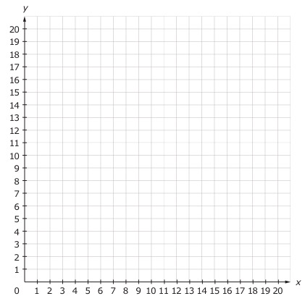

* 1. Describe the relationship between the *x-* and *y*-values for both Matthew and Andrew.

Matthew:

Andrew: