Ratios and Equivalent Ratios

Lesson 2

1. Lemonade can be easily made using a concentrate and water. A common recipe using frozen lemonade concentrate requires one can of concentrate mixed with three cans of water.

Write the ratio of lemonade concentrate to water.

What information does the ratio give?

Using the common recipe, fill in the ratio table below.

|  |  |  |  |  |  |  |  |  |  |
| --- | --- | --- | --- | --- | --- | --- | --- | --- | --- |
| **Common Recipe** | | | | | | | | | |
| **Cans of concentrate** | 1 | 2 | 3 | 4 | 5 | 6 | 7 | 8 | 9 |
| **Cans of water** |  |  |  |  |  |  |  |  |  |

What patterns do you notice in the ratio table?

1. On the grid, graph the ratio table in Question 1 by plotting the pairs of values. Label each axis to show which value is graphed along that axis.

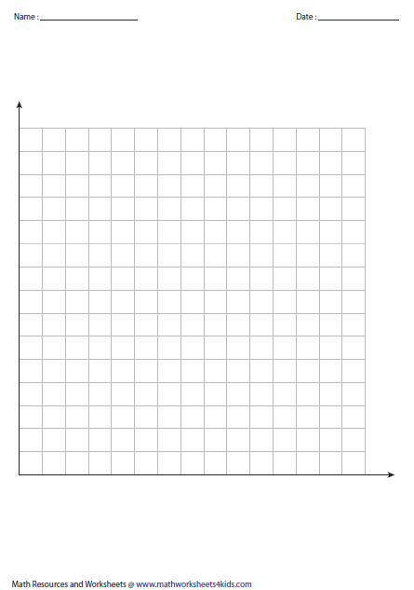

What relationship do you notice about the plotted points?

How does the graph show the relationship between the corresponding amounts of water and concentrate in the common recipe?



1. Javion is making a batch of lemonade for his soccer tournament. If he uses 10 cans of lemonade concentrate, how many cans of water will Javion need? Justify your reasoning.

1. 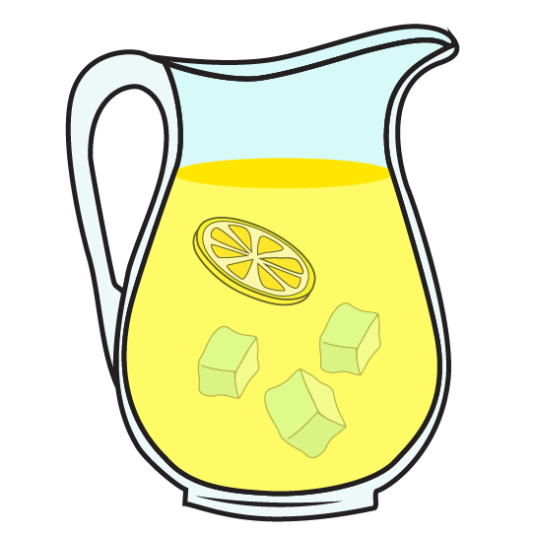Alyssa is following the common recipe to make an extra large batch of lemonade for a fundraiser. If she uses 42 cans of water, how many cans of lemonade concentrate will Alyssa use? Justify your reasoning.

1. Tony doesn’t follow the common recipe. When his father taught him how to make lemonade, Tony learned a recipe instructing to mix four cans of water with every one can of lemonade concentrate.

What information does the ratio give?

Using Tony’s recipe, fill in the ratio table below.

|  |  |  |  |  |  |  |  |  |  |
| --- | --- | --- | --- | --- | --- | --- | --- | --- | --- |
| **Tony’s Recipe** | | | | | | | | | |
| **Cans of concentrate** | 1 | 2 | 3 | 4 | 5 | 6 | 7 | 8 | 9 |
| **Cans of water** |  |  |  |  |  |  |  |  |  |

What patterns do you notice in the ratio table?

1. On the grid, graph the ratio table in Question 5 by plotting the values. Label each axis to show which value is graphed along that axis.



What relationship do you notice about the plotted points?

How does the graph show the relationship between the corresponding amounts of water and concentrate in Tony’s recipe?

1. Which lemonade recipe will produce a stronger lemon flavor: the common recipe or Tony’s recipe? Justify your reasoning.
2. 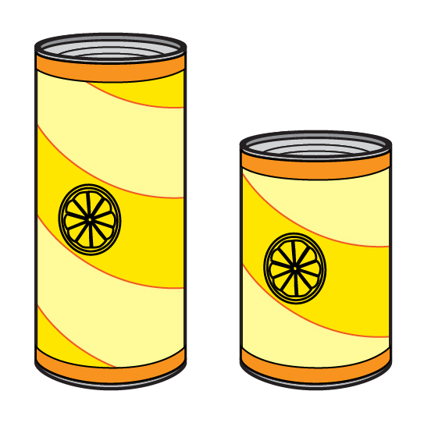Flynna and Clarke found two different sized cans of lemonade concentrate in the grocery store: one large and one small. Both cans have instructions to mix one can of concentrate with three cans of water. Flynna thinks that because the two recipes are the same, each batch of lemonade will taste the same, even though the two cans are different sizes. Clarke says that because one can is larger, the lemonade made from the larger can will have a stronger lemon flavor. Who is correct? Justify your reasoning.

Ratios and Equivalent Ratios

Lesson 3

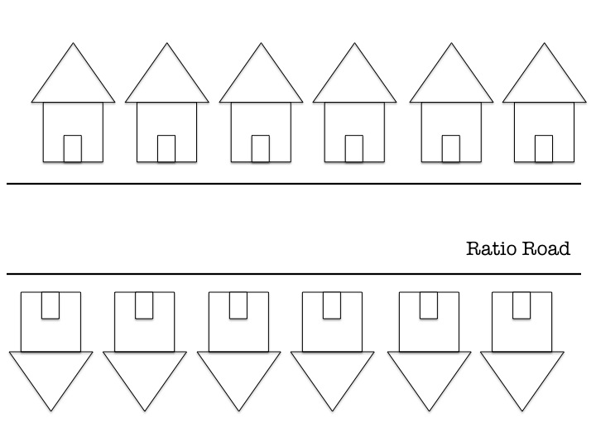

Ratios and Equivalent Ratios

INSTRUCTIONAL ACTIVITY SUPPLEMENT

Lesson 3

Ratio Road is a nice neighborhood filled with interesting sights. On the given picture, draw the details for the houses based on the neighbors’ observations below. For each observation, explain how you decided what to draw on your picture.

1. Abbey sees a variety of colored doors in the neighborhood. She sees that 1 in 3 houses have blue doors. Abbey also notices that 1 in every 6 houses have red doors. None of the other doors match.

1. Fred notices that many of the houses are white. In fact, 6 out of the 12 houses are white. All of the other houses are either gray or blue.

1. Roger sees that flamingos are popular on Ratio Road. A ratio of houses equivalent to 1 in 4 have at least one flamingo in the front yard. Two thirds of those houses also have gnomes with their flamingos.

1. Dawn counts that 3 out of every 4 houses have dogs.

1. Many of the houses have cars in front, while the others park their cars in the garage behind the house. 2 out of every 6 houses use their garage.

1. Bernardo always leaves his bike in his front yard, just like 1 out of every 4 of the neighborhood kids.

1. Tamar observes many trees and counts that 5 of 6 houses have trees in the yard.

1. Fiorella loves to tend to her flowers. She is not alone, as 2 in 3 houses have flowerbeds in the front.

Ratios and Equivalent Ratios

Lessons 1—3

1. There are 7 red candies, 5 green candies, and 2 white candies in a bag.

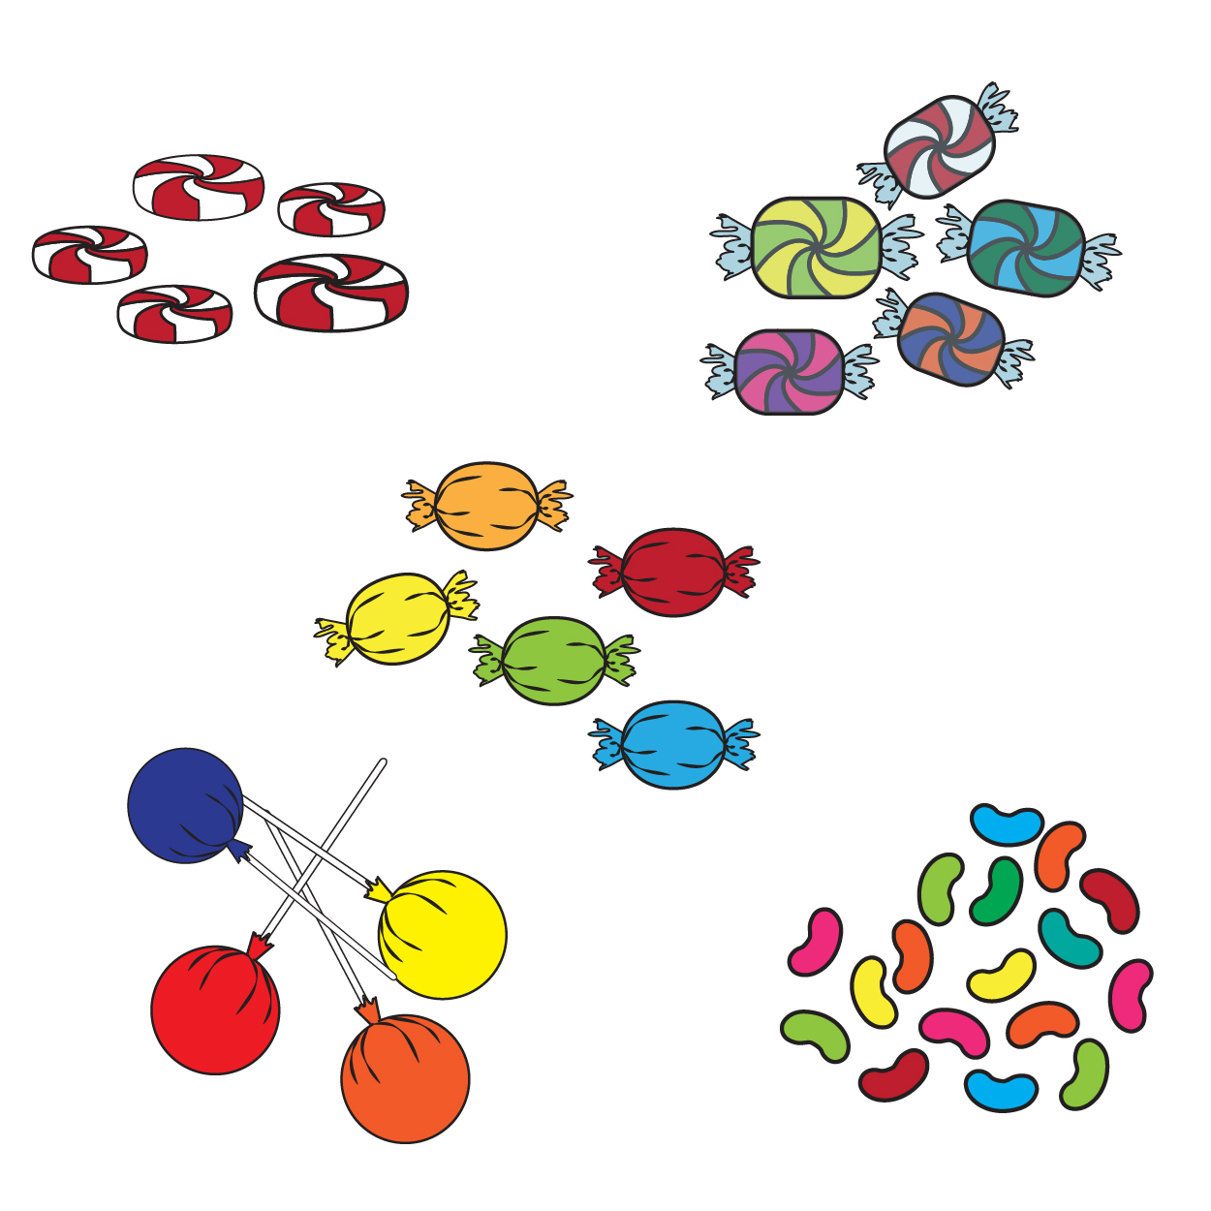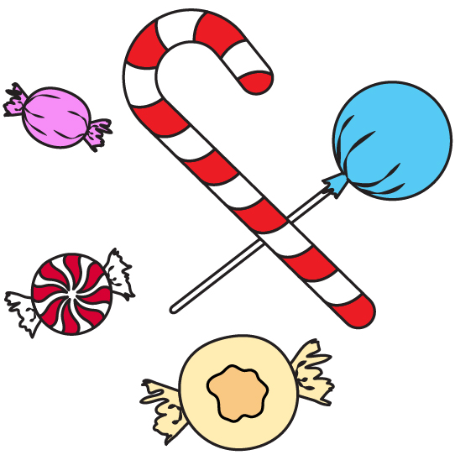

* 1. What does the ratio 5:14 represent? Circle one answer and justify your reasoning.

|  |  |
| --- | --- |
| a) The ratio of red candies to green candies | b) The ratio of green candies to the total |
| c) The ratio of the total to white candies | d) The ratio of red candies to white candies |

Justification:

* 1. Is the 5:14 ratio a part-to-part or a part-to-whole ratio? Justify your answer.
  2. Write a ratio for each of the three answer choices in Problem 1.a that did **not** match the ratio 5:14.

1. 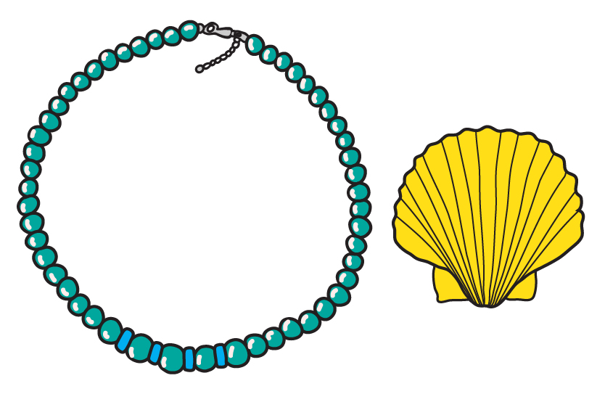Lorne collects stickers, bracelets, and seashells. Lorne has collected 30 stickers, 18 bracelets, and 12 seashells.
   1. Write three different part-to-whole ratios comparing the individual items to the total collection.
   2. Write three different ratios comparing any two different types of items in Lorne’s collection.

1. A soccer coach is planning for the next season. Fill in the table to help the coach plan.

|  |  |  |  |  |  |
| --- | --- | --- | --- | --- | --- |
| **Number of Soccer Balls** | 1 | 2 | 3 | 4 | 5 |
| **Number of Players** | 3 |  |  |  |  |

* 1. Explain the relationship between the number of soccer balls and the number of players.
  2. If the coach is now planning for the entire league and wants to keep the same ratio of players to soccer balls, how many soccer balls are needed for 120 players? Explain your procedure.
  3. Graph the values from the table on the coordinate grid. Label each axis to show what value is graphed along that axis.



* 1. What relationship do you notice about the plotted points?

1. 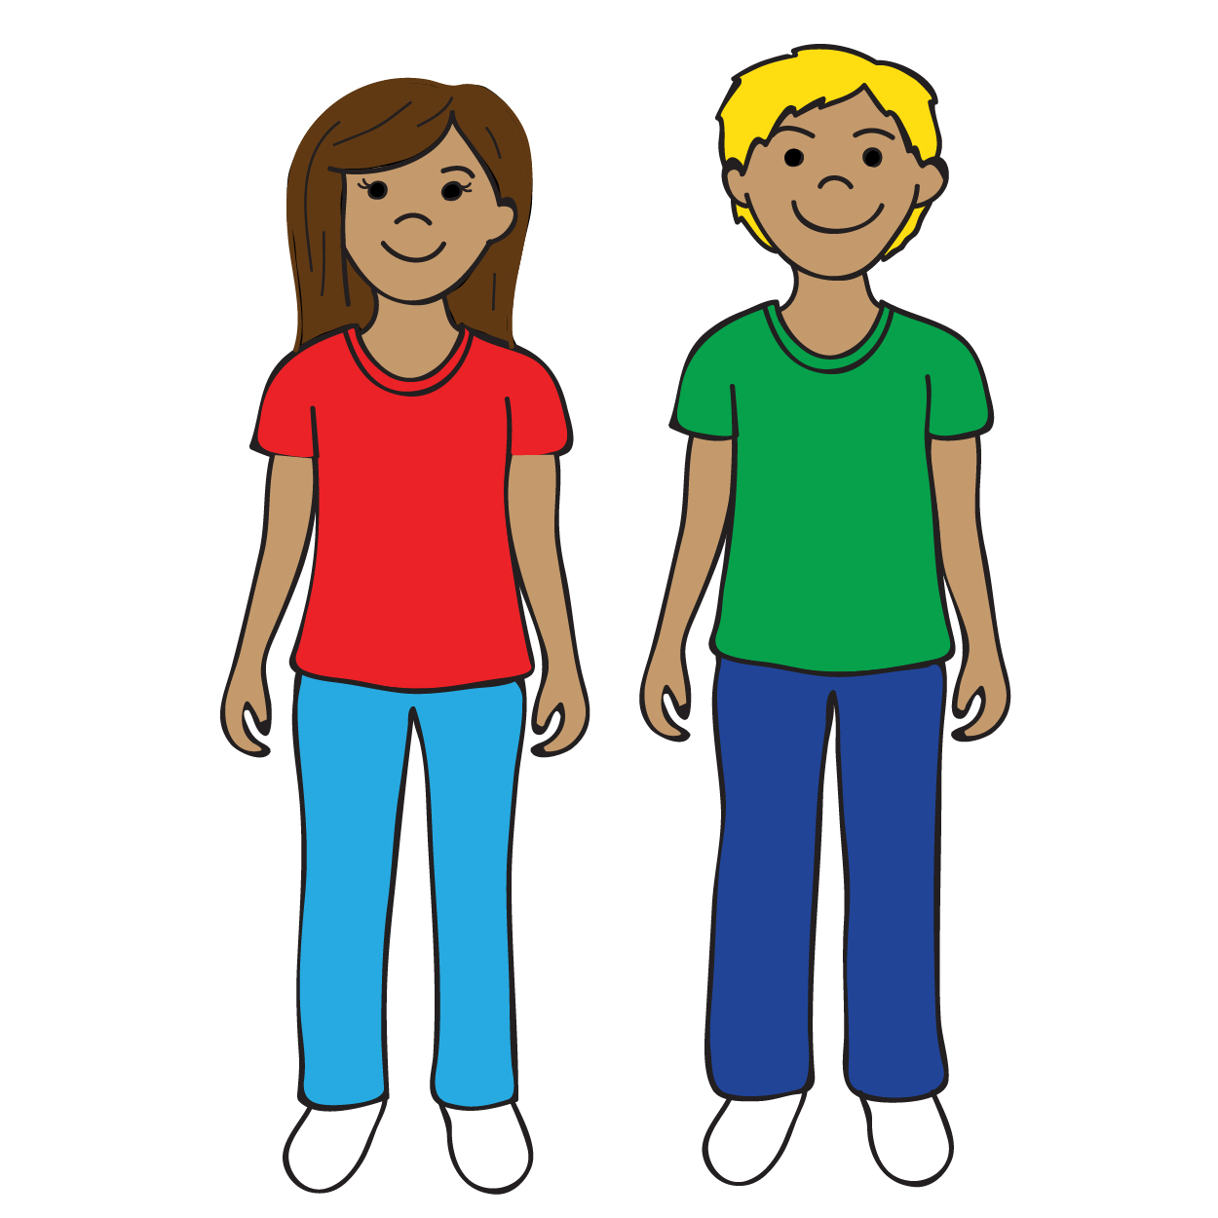Rita’s class has 14 girls and 16 boys.
   1. How does the ratio 14:16 describe Rita’s class?

* 1. How does the ratio 14:30 describe Rita’s class?

* 1. If Rita’s class is to be divided into teams of girls versus boys, which ratio would be most useful? Explain your reasoning.

1. There are blue, green, and red marbles in a bag. The ratio of blue marbles to green marbles is 3 to 2.
   1. Which answer choice represents the possible marbles in the bag? Circle one answer and explain your choice.

|  |  |
| --- | --- |
| a) B, B, B, G, G, G, G, R, R | b) B, B, B, B, G, G, G, G, G, G, R, R, R, R |
| c) B, B, B, B, B, B, G, G, G, G, R, R, R, R | d) B, B, B, B, G, G, G, G, R, R, R, R |

* 1. Amanda says there is another possible answer that is not listed. What possibility could Amanda have in mind?
  2. Mikel agrees with Amanda that there is an answer not listed. Is it possible that Amanda and Mikel are thinking about different sets of marbles, but both of those different sets have a 3:2 ratio of blue to green marbles? Support your decision with reasoning.