Division of Fractions

Lesson 1

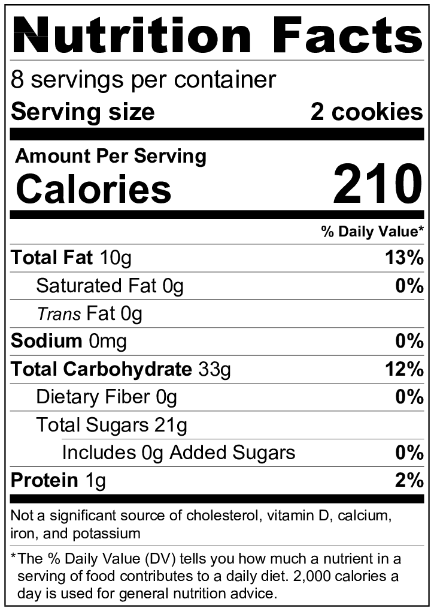

1. 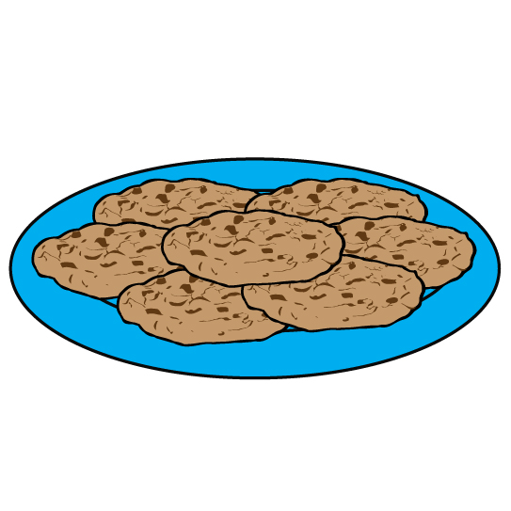How many cookies are in the container? Show your work, or explain how you know.



1. Your teacher ate 6 cookies last night. How many servings did your teacher eat?
2. Your teacher ate 5 cookies the night before last. How many servings did your teacher eat?
3. Your teacher will eat 4 cookies tomorrow night. How many servings will your teacher eat?

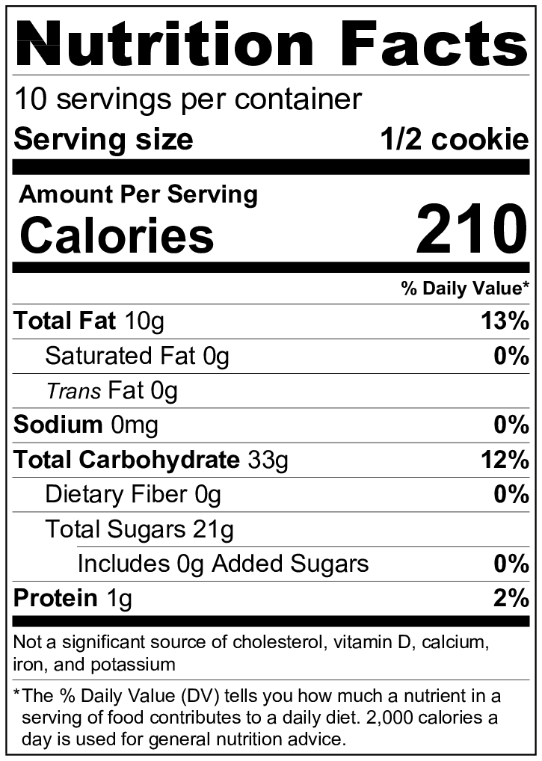

1. How many cookies are in the container? Show your work, and explain how you know.

1. If your teacher ate 1 cookie, how many servings did your teacher eat?
2. If your teacher ate of a cookie, how many servings did your teacher eat?
3. If your teacher ate of a cookie, how many servings did your teacher eat?
4. If your teacher ate of a cookie, how many servings did your teacher eat?
5. If your teacher ate of a cookie, how many servings did your teacher eat?
6. If your teacher ate of a cookie, how many servings did your teacher eat?
7. What strategies did you use to answer the questions?
8. What patterns do you see in your answers?

Division of Fractions

INSTRUCTIONAL ACTIVITY SUPPLEMENT

 Lesson 1



Division of Fractions

Lesson 2

Use the **common-denominator strategy** to solve the following problems.

1. 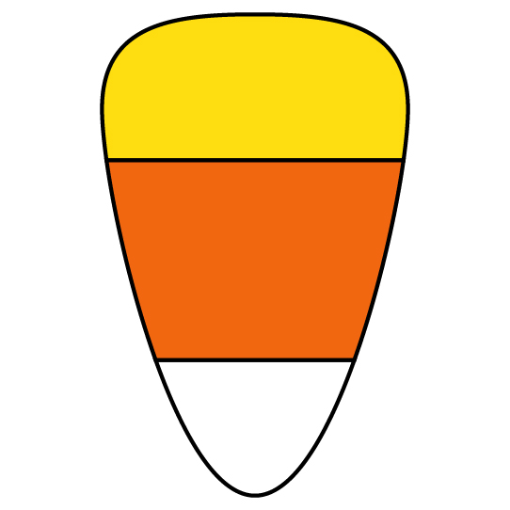Shelley has of a pound of candy corn. She is splitting the candy corn into snack bags. Each snack bag has of a pound of candy corn. How many snack bags can she fill?  
   1. Write a division problem representing the scenario.
   2. Rewrite the division problem with common denominators.
   3. Solve the division problem from part b to tell how many bags Shelley can fill.
2. Solve:
3. Solve:

1. Solve:

1. Solve:
2. 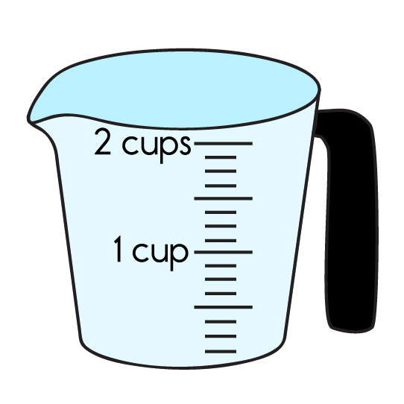Sohail needs to measure out cups of flour for a recipe. Unfortunately, he only has a measuring cup. How many cups will he need to measure out cups?

1. Curtis is making cookies for a party. Each dozen calls for of a cup of sugar. If Curtis has cups of sugar to use, how many dozens of cookies can he make?
2. 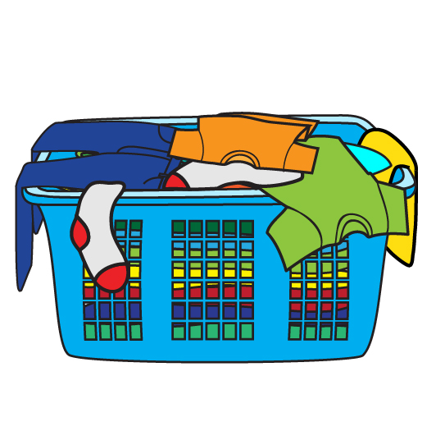Josh is doing several loads of laundry. Each load takes of a cup of laundry detergent. How many loads can Josh do if there are 5 cups of laundry detergent in the container?

Division of Fractions

Lesson 3

1. Ms. Underwood has feet of ribbon. She wants to use her ribbon to make smaller pieces that are of a foot in length. How many smaller pieces can she make? Write an equation, and solve the problem using the invert-and-multiply strategy.
2. 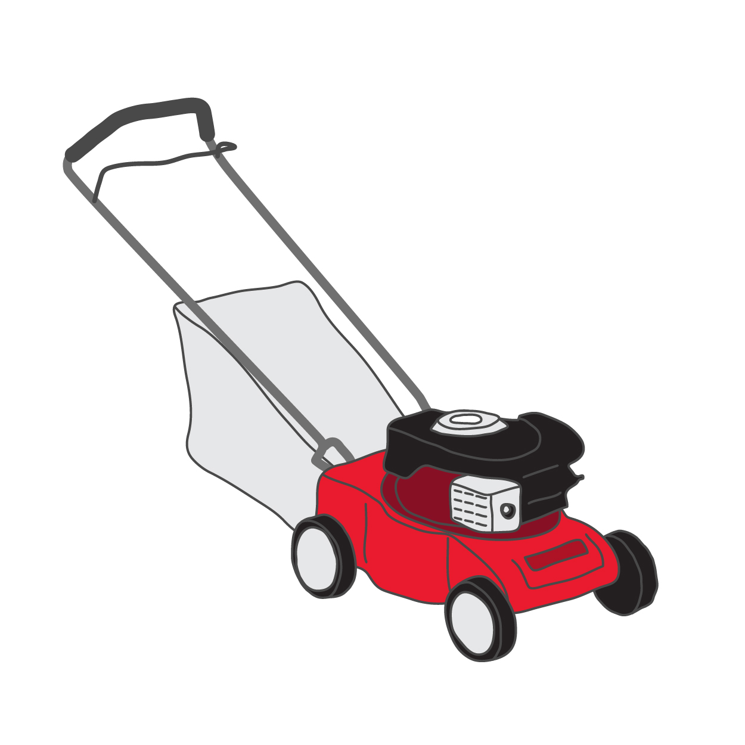It takes Marie of an hour to mow of her yard. How long will it take to mow her whole yard? Write an equation, and solve the problem using the invert-and-multiply strategy. Give your answer in hours as an improper fraction or mixed numbers.
3. It takes Marie of an hour to mow of her yard. How much of the yard will be mowed in 1 hour? Write an equation, and solve the problem using the invert-and-multiply strategy.

1. Susan eats cookies. If a serving size is of a cookie, how many servings did Susan eat? Write an equation, and solve the problem using the invert-and-multiply strategy.
2. Solve the problem using the invert-and-multiply strategy.
3. Solve the problem using the invert-and-multiply strategy.

1. Solve the problem using the invert-and-multiply strategy.
2. Solve the problem using the invert-and-multiply strategy.

Division of Fractions

INSTRUCTIONAL ACTIVITY SUPPLEMENT A

Lesson 3

Display the following 10 division-of-fractions problems around the classroom or in the hallway. The students will participate in a “gallery walk”, so named because they will quietly go to each problem and read and answer the question, as if the problems were hanging in an art gallery. They do not need to be answered in order, but the problems should be answered on the corresponding problem space in the Instructional Activity Supplement B.

Question 1

Question 2

Question 3

Question 4

Question 5

Question 6

Question 7

Question 8

Question 9

Question 10

Division of Fractions

INSTRUCTIONAL ACTIVITY SUPPLEMENT B

Lesson 3

Question 1: ____________ ______

Question 2: ____________ ______

Question 3: ____________ ______

Question 4: ____________ ______

Question 5: ____________ ______

Question 6: ____________ ______

Question 7: ____________ ______

Question 8: ____________ ______

Question 9: ____________ ______

Question 10: ____________ ______

Division of Fractions

INSTRUCTIONAL ACTIVITY SUPPLEMENT

Lesson 4

|  |  |
| --- | --- |
|  |  |
|  |  |
|  |  |
|  |  |
|  |  |
|  |  |
|  |  |

|  |  |
| --- | --- |
|  |  |
|  |  |
|  |  |
|  |  |
|  |  |
|  |  |
|  |  |

|  |  |
| --- | --- |
|  |  |
|  |  |
|  |  |
|  |  |
|  |  |
|  |  |
|  |  |

|  |  |
| --- | --- |
|  | How many are in ? |
| How many are in? | It takes Lori half an hour to knit of a scarf. How long does it take her to knit the whole scarf? |
| How many halves are in ? |  |
|  | How much chocolate will 5 people get if they fairly divide pounds? |
|  | Eric paints walls in hours. How many walls can he paint in 1 hour? |
| Patrick mows of a lawn in hours. How many lawns can he mow in 1 hour? |  |
| How many are in ? |  |

Division of Fractions

Lesson 1-3

1. Annabelle has pounds of candy to share with her class. She wants to give each classmate of a pound of candy. How many classmates can Annabelle give candy to?
   1. Find the solution using a length model.
   2. Find the solution using the common-denominator method. Show all your work.
   3. Find the solution using the invert-and-multiply method. Show all your work.
2. Kirbie has pizzas. If a serving size is of a pizza, how many servings of pizza does he have?
   1. Find the solution using fraction bars.
   2. Find the solution using the common-denominator method. Show all your work.
   3. Find the solution using the invert-and-multiply method. Show all your work.
3. Use the following graphic to answer the questions.

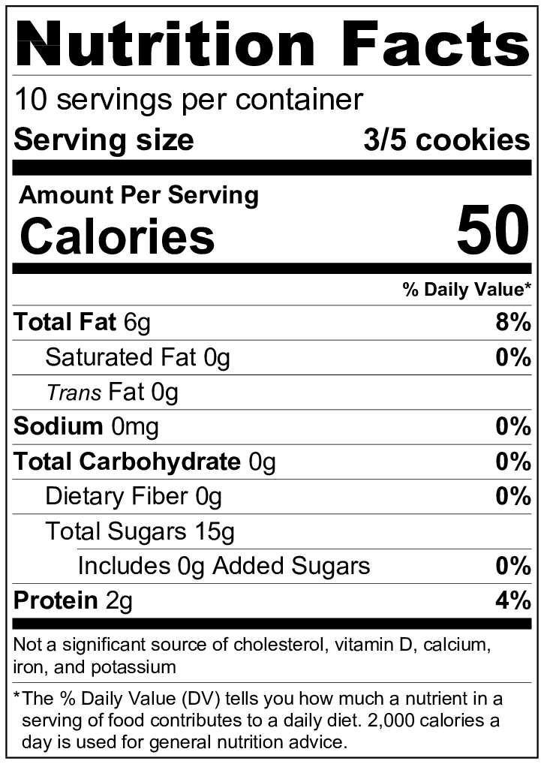

* 1. Write and solve an equation to find the total number of cookies in the container.
  2. How many servings is 4 cookies?
  3. How many servings is of a cookie?

1. Write a story problem that would be solved with the division problem . Include the answer to the division problem.

1. Solve the following division problems using the common-denominator method. Show all your work.
2. Solve the following division problems using the invert-and-multiply method. Show all your work.