Scale Drawings and Measurement

INSTRUCTIONAL ACTIVITY SUPPLEMENT

Lesson 1

**Directions:**

Study the puzzle piece you have been given. You will need to enlarge the puzzle piece and the image it contains by the scale factor provided. Keep in mind that the thickness of the lines will also need to increase by the given scale factor. When you have recreated the puzzle piece to its enlarged size, its color should be consistent with the original puzzle piece.

Scale Drawings and Measurement

Lesson 2

1. Determine the lengths (in inches) of the following sides of the scale drawing:
   1. AB
   2. BC
   3. CD
   4. DE
   5. EF
   6. FG
   7. GH
   8. HI
2. Use the given scale factor to determine the actual length of the sides:
   1. AB
   2. BC
   3. CD
   4. DE
   5. EF
   6. FG
   7. GH
   8. HI

1. Describe the geometric shape(s) that make up the following rooms:
   1. Kitchen
   2. Bathroom
   3. Bedroom
   4. Living Room
2. Find the actual area of the kitchen. Show all your work.

1. Find the actual area of the living room. Show all your work.

1. Find the actual area of the bedroom. Show all your work.

1. Find the actual area of the bathroom. Show all your work.

1. Determine the cost per square foot of carpet and write it here:

1. Determine the cost per square foot of hardwood and write it here:

1. Suppose your task is to choose the flooring that should be installed in the house. Decide what type of flooring you think should be installed in each room.  
   1. Living Room:_______________
   2. Kitchen:_______________
   3. Bathroom:_______________

Bedroom:_______________

1. Determine the cost to put your chosen flooring in the following rooms:  
   1. Living Room:_______________
   2. Kitchen:_______________
   3. Bathroom:_______________
   4. Bedroom:_______________
2. What is the total square footage of the house?
3. What is the total cost of the flooring for all rooms?
4. Write a proposal of your chosen flooring and their associated costs. This should be a summary of what you have calculated on this worksheet, as well as a justification of your choices.

Scale Drawings and Measurement

INSTRUCTIONAL ACTIVITY SUPPLEMENT

**E**

Lesson 2

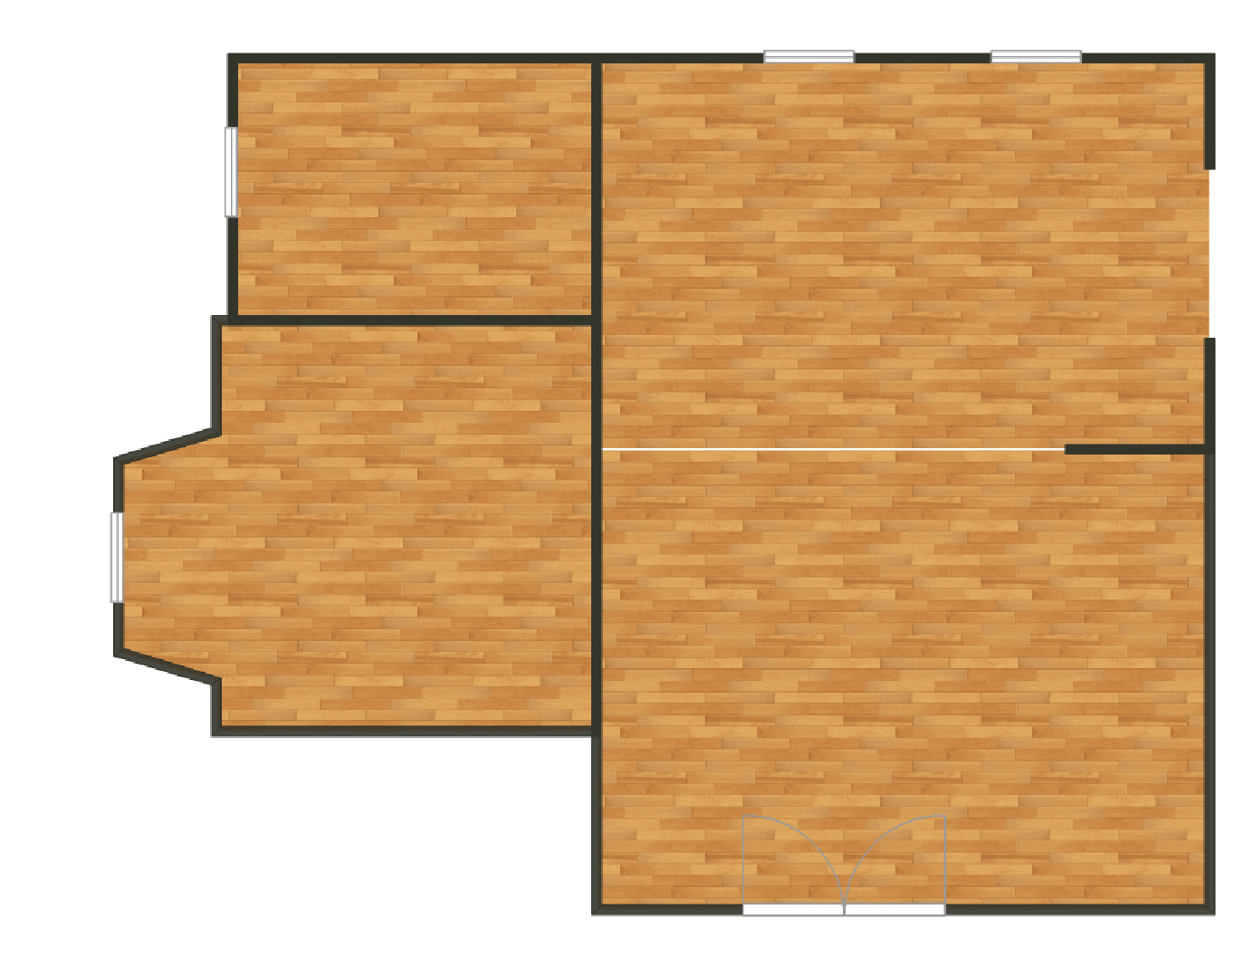

**B**

**H**

**C**

**D**

**G**

**F**

inch = 2 feet

**I**

**A**

**Kitchen**

**Living Room**

**Bathroom**

**Bedroom**

Scale Drawings and Measurement

Lesson 3

1. Give the scale factor of your scale drawing: ___________________
2. Calculate and label the dimensions of your scale drawing.
3. Fill out the table for the corresponding lengths and widths of your drawing.

|  |  |  |  |  |  |  |
| --- | --- | --- | --- | --- | --- | --- |
|  | **Length on scale drawing** | **Actual length** | **Width on scale drawing** | **Actual width** | **Area on scale drawing** | **Actual area** |
| **Bathroom** |  |  |  |  |  |  |
| **Living Room** |  |  |  |  |  |  |
| **Kitchen** |  |  |  |  |  |  |
| **Increase factor** |  | |  | |  | |

1. By what factor did the length and width of your scale drawing increase?

1. By what factor did the area of your scale drawing increase? How does this factor compare to the factors in Question 4? Why do you think this is the case?

Scale Drawings and Measurement

INSTRUCTIONAL ACTIVITY SUPPLEMENT

Lesson 3

**Instructions:**

In order to create a presentation-sized floor plan, you will reproduce the scale drawing of the floor plan from Lesson 2. The new scale drawing will be larger, so that a builder or homeowner could easily see your design.

**Requirements:**

* The scale drawing should take up at least 75 percent of the poster board.
* The scale factor should be displayed on the poster board.
* All calculated dimensions should be labeled.
* Recreate the flooring in your scale model using construction paper and colored pencils.

Use the space below to show your work calculating the dimensions on the enlarged scale drawing.

Scale Drawings and Measurement

Lessons 1 – 4

1. Tell whether each of the following scale factors represents an enlargement or reduction of the original figure. Explain your reasoning.
   1. 3:4
   2. 1 to 2



1. 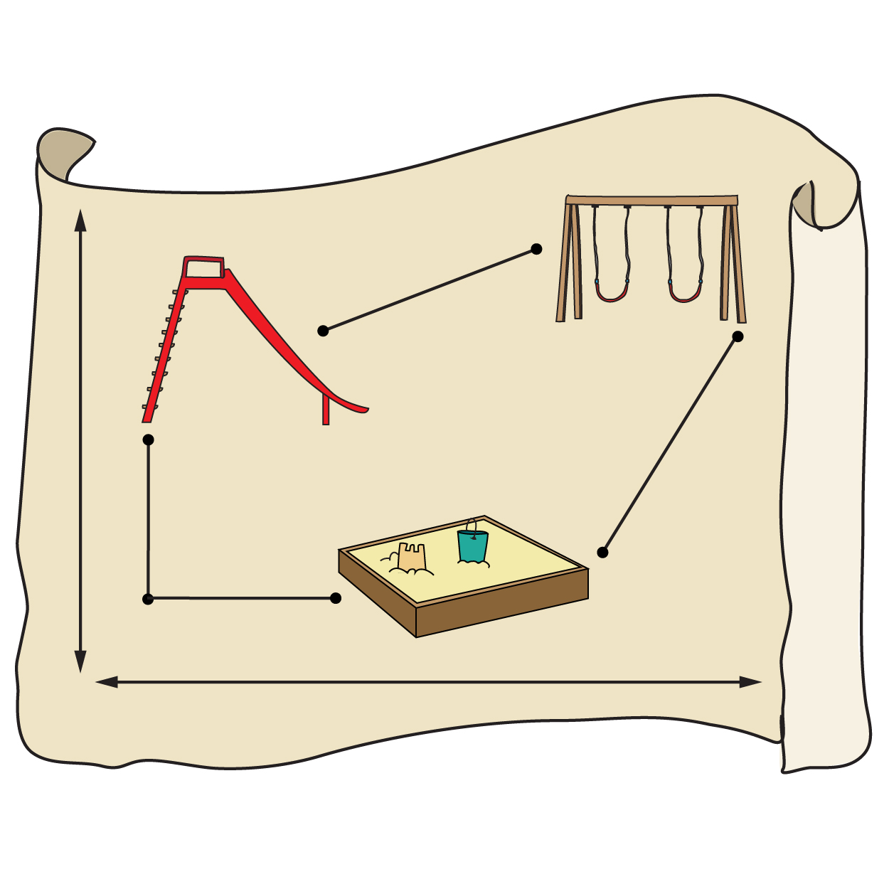A map of a new playground has a scale factor of 1:50.
   1. If the actual length of the monkey bars is 10 feet, what is the length of the monkey bars on the map? Give your answer in feet and inches.
   2. If the length of the slide on the map is three inches, what is the actual length of the slide?
2. Alex builds dollhouses that are smaller versions of existing houses. The scale factor for a dollhouse is 1:5.

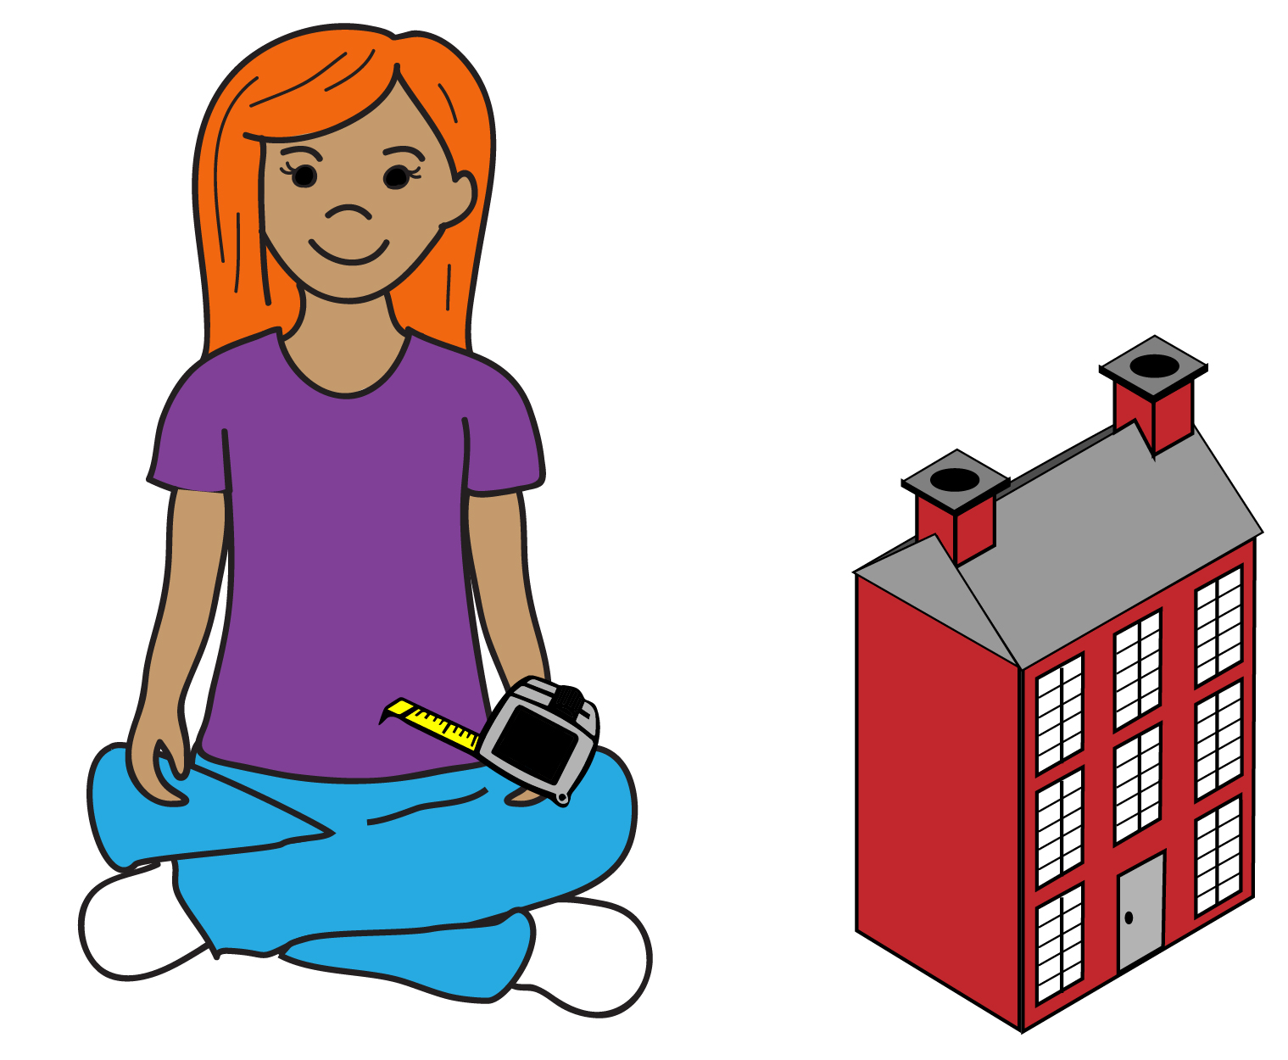

* 1. What is the scale factor for the area of the rooms in the dollhouse?
  2. If a room in the model house has an area of 2.5 square feet, what is the actual area of the room?
  3. If the length of a kitchen wall on the dollhouse is 19.5 inches, what is the actual length of the wall?

1. By what factor does the area of a circle increase if the radius (the length from the center of the circle to a point on the circle) increases by a factor of 6? Explain your reasoning.

radius

1. Use your knowledge of scale factors to complete the following table. Note that the dimensions provided do not apply to the same figure. Therefore, the area of Figure 3 cannot be calculated by multiplying the length of Figure 1 by the width of Figure 2; understanding of scale factor must be used.

|  |  |  |  |  |  |  |  |  |  |
| --- | --- | --- | --- | --- | --- | --- | --- | --- | --- |
| Scale Factor |  | Length of Figure 1 on Scale Drawing (inches) | Actual Length of Figure 1 (inches) |  | Width of Figure 2 on Scale Drawing (centimeters) | Actual Width of Figure 2 (centimeters) |  | Area of Figure 3 on Scale Drawing (inches2) | Actual Area of Figure 3 (inches2) |
| 1:5 | 4 |  |  | 35 | 20 |  |
| 2:1 |  | 45 | 3 |  |  | 450 |
|  | 3 | 9 | 13 |  | 65 |  |
|  |  | 4 | 18 | 3 | 108 |  |